Consumer Carer Focus Group Report
Communication at end-of-life in hospital
WA Cancer and Palliative Care Network

Contents
Introduction 1
Focus group and methodology 2
Themes 4
Definition of a good death 4
1. Patient focus – Respecting what they want 5
2. Lack of general palliative care knowledge 5
3. Communication – upfront, timely and respectful 6
4. Early conversations about goals of care – at diagnosis 7
5. Involvement in the decision-making process 8
6. Continuity of care across health services 8
7. Workforce capacity 9
Suggestions for the future 10
Appendices 11
Appendix A: Recruitment flyer 11
Appendix B: Information for participants 12

Introduction
A consumer carer focus group to discuss communication at the end-of-life in hospital was held on Thursday 19 February 2015 at the Health Consumers’ Council, East Perth.

The focus group was convened and hosted by the WA Cancer and Palliative Care Network (WACPCN) in partnership with the Health Consumers’ Council. The WACPCN provides clinical and policy direction for WA palliative care as part of WA Department of Health.

The purpose of the focus group was to discuss carer and consumer experiences with communication at end-of-life in the WA hospital setting to:
- Provide a carer/consumer perspective to the WA Clinical Senate debate on Friday 6 March 2015. The Senate debated the topic ‘Great expectations: Planning for expected deaths in acute health settings’. The focus of the debate was:
  - How can we better support people who die in hospital?
  - What can be done in hospital to support people to die at home or in the community?
- Inform the work of the WACPCN including the activities within the Continuum for End-of-Life Framework (CELF).
The focus group did not discuss the broader successes or failures of healthcare, but specifically preparation for end-of-life and achieving a good death.

This report includes an overview of the focus group and methodology, a discussion of the key themes identified from the focus group, suggestions for the future, and appendices including the recruitment flyer and information provided to participants.

Focus group and methodology
A total of eleven people attended the focus group, including eight carers/consumers and three staff from the WA Cancer and Palliative Care Network (WACPCN).

Participants were adults with advanced life-limiting illness (or their families) who were receiving or had received end-of-life care in a WA hospital setting in the last five years. Participants were recruited via dissemination of a flyer (see Appendix A) through various networks and screened to ensure the group had a mix of current and relevant experiences.

The topic and scope was communication at end-of-life in WA hospitals from diagnosis or decline to before the terminal care phase. Experiences that were out-of-scope but contributed to the discussion included specialist palliative care and end-of-life care at home and in the community.

One staff member from the WACPCN facilitated the discussion using the pre-determined questions. The focus of the WA Clinical Senate debate was outlined on a whiteboard as a strategy to keep discussion in-scope. Another staff member used a laptop to document responses in real-time and begin identifying themes. The staff member presented some of the participant responses and emerging themes at the end of the focus group as a strategy to clarify that the information had been captured appropriately and to validate participant’s responses. The participants then had opportunity to add anything further or missed in the discussion to take to the WA Clinical Senate to inform their debate. The third staff member had extensive experience in palliative care and was present to provide clarification and support if participants felt distressed during the focus group.

Participants were provided with a handout that included the focus group questions and further information including support services (see Appendix B). Participants received payment or equivalent in vouchers through the Health Consumer’s Council for their attendance.

Questions discussed in the focus group included:
- What do you think is a definition of a good death?
- What information and conversations would have been useful for you when you were in hospital / in hospital with your loved one?
- Was the information you were given appropriate, timely, and respectful?
- Is there anything about your experience that stands out as having made a positive or negative difference?
- Did you feel involved in decisions that were made about your / their care?
- What could have made your experience better?

Advice was sought from staff at the WA Psycho-Oncology Service at Sir Charles Gairdner Hospital, and the Cancer and Palliative Care Research and Evaluation Unit at the University of Western Australia to check that the questions were asked in a respectful and appropriate manner, and that appropriate support strategies were in place for participants.

An aim of the focus group was to create a secure space for participants to feel comfortable sharing their experiences with the group. Strategies to create a secure space and support participation included:
- Stating that no identifying information would be reported and that participation would remain anonymous. De-identified information would be collated, compiled into a report and presented to the WA Clinical Senate to inform their discussion.
- Requesting that participants respect others in the room and the information they shared by not repeating any details.
- Encouraging participants to contact their support network they usually talk to about these things if they felt upset or distressed in the days following the focus group.
Participants contributed very emotional and raw experiences. Some participants approached the staff member who was available to provide support and their presence was a valuable resource on the day given the sensitive nature of the discussions.

Follow-up calls were completed with participants three days after the focus group to thank participants for their involvement and to check their emotional state given the sensitive nature of the discussions. All participants responded positively to this contact and some provided further information that was captured as part of the focus group discussion.

Two participants from the focus group were approached to present at the WA Clinical Senate on Friday 6 March 2015. The focus group themes and responses were compiled and presented to inform the debate on ‘Great expectations: Planning for expected deaths in acute health settings’. Mrs Helen Povey and Ms Ann Jones presented ‘The consumers’ and carers’ perspective: Communication at end-of-life in hospital’ with Mrs Povey presenting the focus group findings and Ms Jones presenting the learnings from her lived experience leading up to her mother entering palliative care weeks earlier.

Themes
The focus group responses were analysed using qualitative data analysis techniques. The key themes identified through the focus group are as follows (see Figure 1).
Figure 1: Focus group themes

The following are some of the responses and a discussion for each of the key themes.

Definition of a good death
The focus group begun by asking participants ‘what do you think is a definition of a good death?’ Some responses by participants included:
“Pain free”
“Timely, consistent information so then the family can make the best decision for their care when they are dying.”
“Time. Letting the patient have as long as the journey takes. Respecting what the patient wants.”
“(Living through this caring experience) I am now evaluating how I’d like to die.”

Participant responses appeared consistent with the World Health Organisation definition of palliative care:
‘Palliative care is an approach that improves the quality of life of patients and their families facing the problem associated with life-threatening illness, through the prevention and relief of suffering by means of early identification, impeccable assessment and treatment of pain and other problems, physical, psychosocial and spiritual’ (WHO 2015).
These responses indicated that consumers and carers in the focus group desired a holistic healthcare approach by health professionals to end-of-life care.

Patient focus – Respecting what they want
Some of the responses that related to the theme ‘patient focus – respecting what they want’ included:
“My concerns extend to hospital. When I go to emergency (with my father), they don’t understand his wishes.”
“There was little communication with the family. If she was awake, they would talk to her (the patient), but that wasn’t appropriate as I had Enduring Power of Guardianship. The information needs to include the family and not just the patient.”
“I should have given the Advance Health Directive to all teams (health services they were accessing). I might have been told (to do this), but I didn’t register it. I should’ve have known how better to spread information, about how to give out the Advance Health Directive (to health professionals). The Nurse felt distressed about the decision of not wanting to go to hospital. They need to listen to patient’s wants and for the patient to know how to communicate it.”

A positive response about respecting patient wishes was:
“They had a paragraph in their Living Will that discussed what they wanted as a good death…..It made a real difference with care in the hospital.”

Patient-centred care is the overarching focus of WA Health. Patient-centred care is a focus on the needs, preferences and outcomes relevant to the patient and their family. This is achieved by both an organisation and individual commitment to ensure that patients are informed, motivated and prepared across the stages of their condition, injury or event.
It was reported by consumers and carers in the focus group that patient-centred care was not always present with progressive life-limiting illness. Increased community awareness and health professional training relating to Advance Health Directives and Advance Care Planning may enable better delivery of general healthcare with end-of-life care goals in mind.

Lack of general palliative care knowledge
The focus group discussion indicated a lack of general palliative care knowledge in both patients and health professionals. This included the sub-themes of:
  - Lack of understanding of what palliative care encompassed.
  - Lack of understanding of when palliative care was appropriate.

Responses that related to a general lack of understanding of what palliative care encompassed included:
“Palliative care is associated with cancer, but palliative care is to do with all life-limiting illnesses. Many don’t understand that.”
“Palliative care is associated with terminal care. There needs to be education of what palliative care is, that it is not just short-term end-of-life care.”

Responses that related to a general lack of understanding of when palliative care was appropriate from both a patient’s and health professional’s perspective included:
“The GP signed her onto palliative care and we were very happy about the fact that she was on palliative care, then the consultant said “it’s far too early, sign her off” and hung up.”
“Once we got to specialist palliative care, it was generally good, but the lead up to it in terms of end-of-life care, we felt we were fighting.”
“She’s only been palliative for a week. But it was really the communication to get her to that point that is really the issue”.
“I don’t understand palliative care; I’ve just been doing it (caring for their family member).”
“The Nurses were shocked I asked these questions (about moving her to palliative care).”

Developing community and health professional awareness and skills to recognise progressive life-limiting illness and the benefits of palliative care is a recommendation for health reform in the WA Health system.

Communication – upfront, timely and respectful
Some of the responses that related to communication that was upfront, timely and respectful included:
“Conversations and information on end-of-life need to be tailored and a choice given about how and when it’s received, so whether it is given bit by bit or all at once is dependent on the patient.”
“The system coming to us rather than us forcing their hand (to communicate what was happening with their family member’s medical care).”
“Communication is so important. People are emotional and they may fail to understand the information. People (health professionals) can’t just blurt out the information. It needs to be a two-way conversation as the patient or family may not understand. I want health professionals to explain to patients and families, and then check they understand.”
“The palliative care teams were good, the hospital consultants were not. It seemed that doctors were the best ones to give advice, but they were never there to give you the information.”

Responses that related to upfront communication included:
“Have some idea of time (left). People working in that area should have an idea of the time they have left, but they were loath to give me a timeframe or rough idea. I wanted to know what it was in simple terms (not medical language).”
“I thought I knew what the final stages would be…she then went into a funny breathing rhythm, her hand was floppy, she took staccato breaths. I asked the junior doctors ‘is it ok to leave (to go home)’. They said ‘no go home, she’s just sleeping’. The Nurse called at 1am and explained that she stopped breathing”.

The following response related to timely communication:
“Five of us waited for five hours for the information. We were told that the consultant was going to give us this information. They stuck their head in and said they were going to do handover and then speak to us. We later found out the consultant went home. I think the conversation was too hard for them.”

Another response related to respectful communication:
“Human determination and how they accept their own pending death needs to be considered within palliative care, for example end-of-life and the period in which people are dying, it’s not just a medical experience … it’s a human experience.”

Striving for upfront, timely and respectful communication is a goal of all healthcare and is not unique to palliative care. Consumers and carers in the focus group repeatedly raised this theme, which may indicate a gap in health professional training on how to approach these sensitive issues, particularly when progressive life-limiting illness is present. This theme reaffirms that the safety and quality adage of ‘right information, right person, right time’ is also applicable to patients with progressive life-limiting illness and in the palliative care system.

Early conversations about goals of care – at diagnosis
When participants were asked ‘when is the best time to have these conversations’, responses included:
“At diagnosis, early.”
“When it’s cancer, they’re interested in having the conversation. They’re not interested in their wishes when it’s dementia.”
“My experience with specialist palliative care is fine, but at the consultant level to do with their diagnosis and hospitals and specialists, it was not a good experience.”
These responses indicate that consumers and carers in the focus group were willing to have conversations about goals of care early, and that these conversations should not just be limited to those with cancer.

A positive experience reported by a participant was:
“The Nurse asked right before leaving hospital to go home, about whether he had an Advance Health Directive. She said to fill it out and to make sure you have it always on you”.

Having the conversation with a patient and their family about death is reportedly one of the hardest conversations to have as a health professional. Consumers and carers in the focus group reported that these conversations are not happening early enough and relates to the theme of ‘upfront, timely and respectful communication’ for health professionals to be able to recognise and communicate a patient’s irreversible clinical deterioration.
Developing health professional’s awareness and skills in recognising progressive life-limiting illness, identification of when palliative care may be appropriate, and early conversations about goals of care is recommended for health reform in WA.

Involvement in the decision-making process
Some of the responses that related to involving the patient and family in the decision-making process included:
“We need to involve carers and consumers in the decision-making process, or at least try to. I noticed they had stopped giving him fluids, and they hadn’t told us. But they put the emphasis on ‘turning off the ventilator’ when they had already stopped giving him fluids.”
“It felt like the hospital had made the decision on when they were going to die, not us (the patient or family). We wanted a little bit more time with him.”
“It’s hard for experts (health professionals) to listen to non-experts (carers), when they are the experts of their loved one. Listen to the carers and consumers a bit more.”
“The more planning there is to do with patient outcomes, then the better the hospital experience will be.”

Patient-centred care strives to involve patients and their families in the decision-making process. Consumers and carers in the focus group reported that patient/family involvement in the decision-making process may not have been managed effectively in patients with progressive life-limiting illness or with terminal care in the WA hospital setting.
A system that supports health professionals to have the conversations early with patients and their family on who could make decisions on behalf of the patient and what goals of care they would like will promote their involvement in the decision-making process.

Continuity of care across health services
Feedback about continuity of care across health services included:
“They kept asking about the Advance Health Directive, but they didn’t check (for it). There needs to be more robust measures to check about who has it. They are not checking whether or where the Advance Health Directive is (located).”
“Health professionals won’t write it in the patient’s file properly, or put it at the front of their file (Enduring Power of Guardianship).”
“The NHS in England is more aware of palliative care. They share information across the services and the information is given to the GP.”
“The information needs to be shared with the family, health professionals and services. There is repetition of information across health services. It’s not just about the palliative care plan, but their care in general across health services.”

A suggestion to rectify this was:
“Utilising E-Health records as an existing tool to centralise records for patients and health teams. The idea is there, but the public and health professionals don’t use them, it is paper-based forms still. Clinicians have huge influence on how they can manage information and should be using the tools already out there and lead change with existing tools.”

Moving between or admittance into health services was reported to be a barrier when communicating patient care plans for both patients and health professionals.

A standardised process across services to enable quick and effective identification and respect of Advance Health Directives, Advance Care Planning, Living Wills and Enduring Power of Guardianship will assist the communication of patient’s end-of-life care goals with health professionals across the system.

Workforce capacity
Some of the responses that related to workforce capacity included:
“Health professionals are people and have feelings too, we forget that sometimes.”
“There is education on the front-line about how to share that information, but it might be their first time having to deliver this information to families and patients.”

The WA Health Strategic Intent 2010-2015 includes ‘supporting our team’ as one of the pillars to improve, promote and protect the health of Western Australians. It was acknowledged by some participants of the focus group that some health professionals may not have the skills or system support to be able to recognise and address patient and family needs with progressive life-limiting illness.
System support to develop health professional’s awareness and skills in recognising and addressing progressive life-limiting illness will develop a workforce capable of meeting the growing demands and expectations of healthcare at end-of-life.

Suggestions for the future
The issues raised in the focus group are not unique to palliative care, but applicable to the healthcare system in general when addressing progressive life-limiting illness. Consumers and carers raised issues that reinforced the needs and priorities previously identified by the WA Cancer and Palliative Care Network (WACPCN) that will be considered by the Continuum for End-of-Life Framework (CELF).

The suggestions for the future based on the focus group responses include:
- Increase community awareness and health professional training relating to Advance Health Directives and Advance Care Planning to enable better delivery of general healthcare with end-of-life care goals in mind.
- Develop community and health professional awareness and skills to recognise progressive life-limiting illness and the benefits of palliative care.
- Promote the safety and quality adage of ‘right information, right person, right time’ for health professionals working with patients with progressive life-limiting illness and in the palliative care system.
- System support to develop health professional’s awareness and skills in recognising progressive life-limiting illness, identification of when palliative care may be appropriate, and early conversations about goals of care.
- Promote a system that supports health professionals to have the conversations early with patients and their family on who could make decisions on behalf of the patient and what goals of care they would like to better involve them in the decision-making process.
- A standardised process across services to enable quick and effective identification and respect of Advance Health Directives, Advance Care Planning, Living Wills and Enduring Power of Guardianship to assist communication of patient’s end-of-life care goals with health professionals across the system.

The focus group findings were presented to the WA Clinical Senate on Friday 6 March 2015 to inform their debate. The WA Clinical Senate is putting forward recommendations for health reform in this area to be considered by the State Health Executive Forum in late March 2015. This information will also be used to inform the work of the WACPCN including the activities within the Continuum for End-of-Life Framework (CELF).

In summary, consumer and carer focus group responses indicate that many parts of the health system see death as failure. A culture shift from this attitude is only possible through small incremental change, and raising awareness of palliative care may be the first step in addressing this cultural attitude. A response from the focus group that summed up the discussion that is not only reflective of end-of-life care and communication, but healthcare in general was:
“It’s a failure of the system, not individuals.”

Appendices

Appendix A: Recruitment flyer
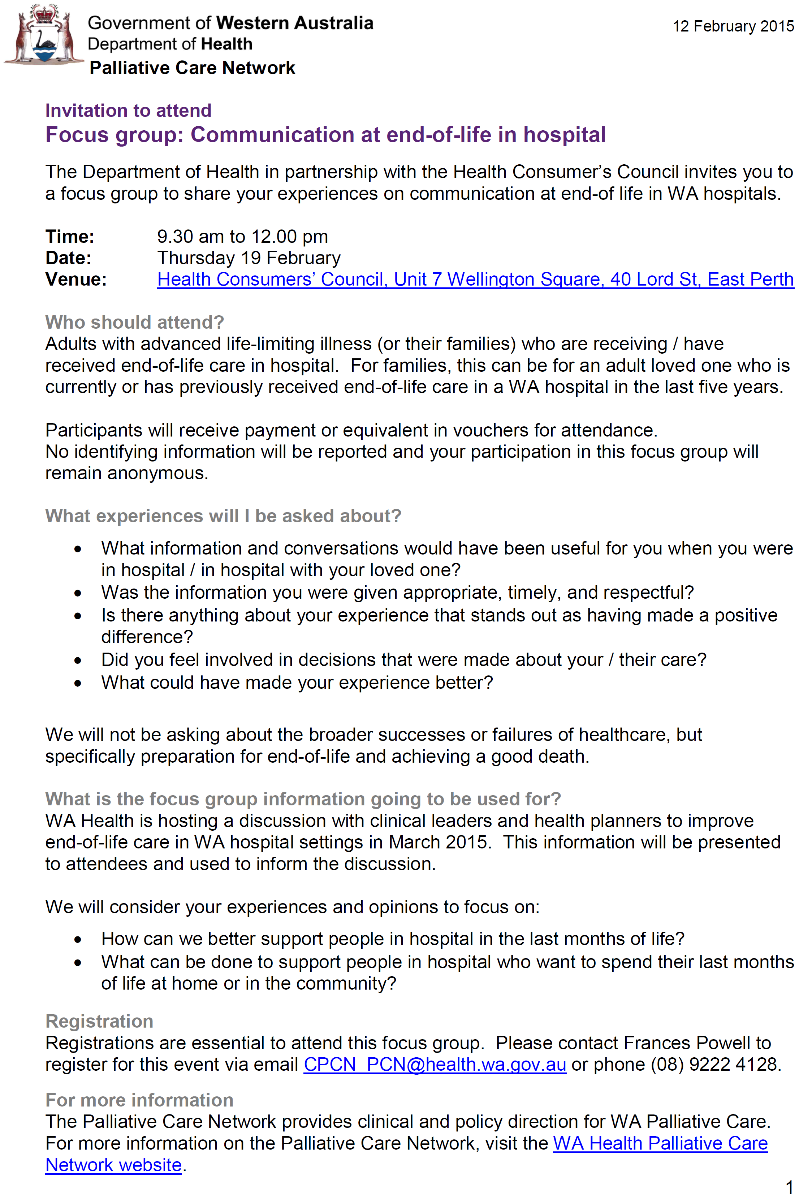

Appendix B: Information for participants
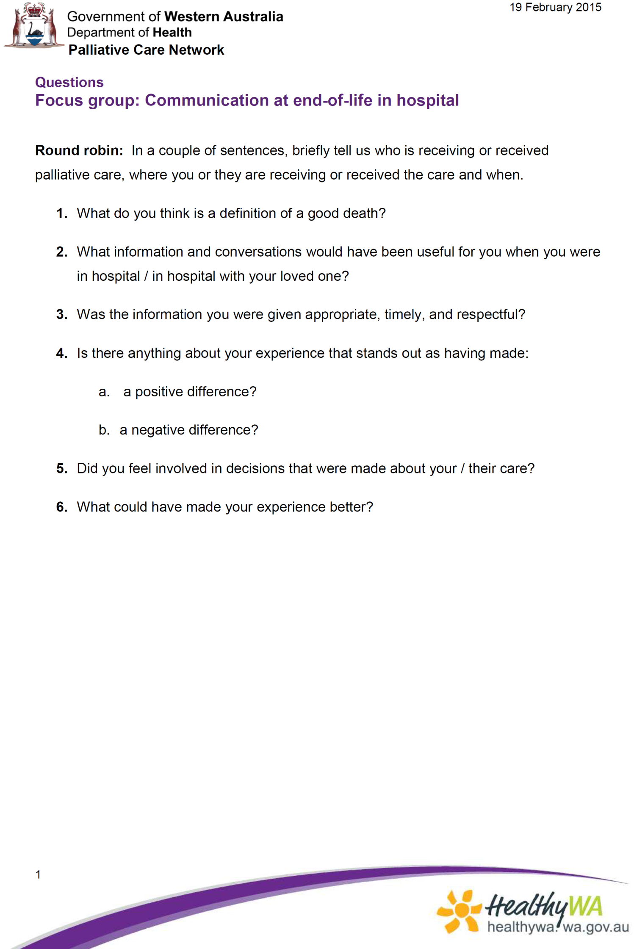
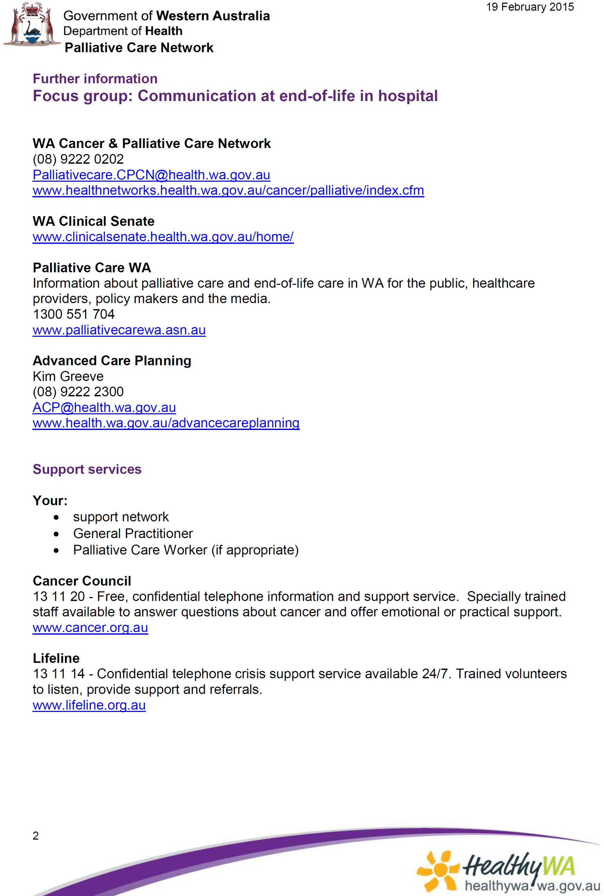

This document can be made available in alternative formats
on request for a person with a disability.
© Department of Health 2015
Copyright to this material is vested in the State of Western Australia unless otherwise indicated. Apart from any fair dealing for the purposes of private study, research, criticism or review, as permitted under the provisions of the Copyright Act 1968, no part may be reproduced or re-used for any purposes whatsoever without written permission of the State of Western Australia.

