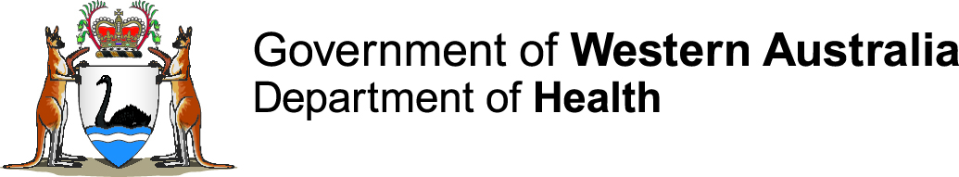

Patient Information: Reporting Oversupplied Persons

What does oversupplied mean?
This information is intended to assist patients when a health professional has formed the belief that the patient is oversupplied with Schedule 8 medicines.
The Medicines and Poisons Act 2014 requires that a health practitioner report a person who is oversupplied to the Department of Health, within 48 hours of forming this belief.
The legislation requires the Department of Health to keep a record of all oversupplied persons. This information is part of the Drugs of Addiction Record.
Oversupplied person means a person who has over a period of time obtained, or obtained prescriptions for, quantities of drugs of addiction that are greater than is reasonably necessary for therapeutic use.
Drugs of addiction refers to any Schedule 8 medicine (such as opioid pain relievers, stimulant medicines, medicinal cannabis and some benzodiazepines).

What happens to oversupplied persons?
The addition of a person’s name to the Drugs of Addiction Record is intended to assist with ongoing medical treatment with these medicines.
If your name is on the Record and you require a prescription for a Schedule 8 medicine, your medical practitioner must apply to the Department of Health to obtain authorisation, before prescribing. For authorisation, the medical practitioner may need to observe certain conditions designed to prevent oversupply.
Being on the record does not stop a medical practitioner administering doses of these medicines when immediate medical care is necessary (for example, in a hospital).
Information about any person on the Record may be provided to health professionals, for patients under their care, for the purposes of medical treatment. Information on the Record is not used for other purposes and this privacy is protected by the law. It is not available to employers, police or other Government agencies.
You may have discussed being oversupplied with your health practitioner and been asked to sign a patient acknowledgment. If not, then the Department of Health is required to contact you to advise that a report has been received and to explain the consequences of being on the Record.

If you have received a letter, and do not believe that you should be placed on the Record, you have 28 days to respond in writing to the Department of Health to explain why. If no written response is received within this period, your details will be included on the Drugs of Addiction Record.
Please address any correspondence to:
Medicines and Poisons Regulation Branch
PO Box 8172
PERTH Business Centre WA 6849
You will need to include certified copies of your identification documents to ensure the Department of Health is corresponding with the correct person. Details of evidence of identity requirements are available on the HealthyWA website (see below).

How do I come off the Record?
Provided you have not misused any prescribed S8 medicines or tried to source these type of drugs to sell or use for non-therapeutic purposes, for at least two years, your doctor can apply on your behalf to have your name removed from the Record. You will be required to have certain medical tests as part of this process. Your doctor must have been treating you for at least two years. Doctors can contact the Department of Health for further guidance on this process.
You can apply to have the Record about yourself amended or removed. You will need to provide evidence to support your request. If the reason you want the Record about you removed is because you have been drug free and not sought drugs for at least two years, it is recommended you ask your doctor to apply on your behalf.
Your request needs to be made in writing and be accompanied by certified copies of documents supporting your identity, which include photographic identification and your address. Details of evidence of identity requirements are available on the HealthyWA website (see below).
Please address any correspondence to:
Chief Executive Officer
Medicines and Poisons Regulation Branch
PO Box 8172
PERTH Business Centre WA 6849
If, after 5 years following the initial report, there is no direct or indirect contact with the Department of Health that relates to your use of a drug of addiction, your details will be automatically removed from the Record.

More information
For more information visit the HealthyWA website:
https://healthywa.wa.gov.au/Articles/A_E/Drugs-of-dependence
For information about evidence of identity requirements scroll down to: How can I get my name off the record?
Email: MPRB@health.wa.gov.au

