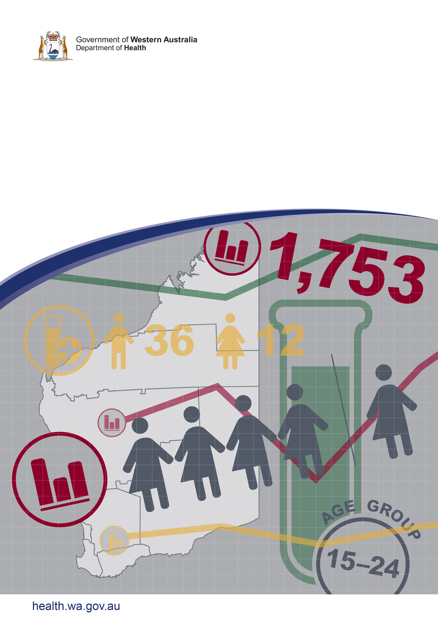**­­Acknowledgments**

The Epidemiology of Notifiable Sexually Transmitted Infections and Blood-Borne Viruses in Western Australia 2019 – Appendix

We acknowledge the many doctors, nurses and pathology laboratories that have provided the notifications and testing data upon which this report is based.

**Contributors/Editors**

Kellie Mitchell, Byron Minas and Carolien Giele

Communicable Disease Control Directorate

Department of Health, Western Australia

PO Box 8172

Perth Business Centre

Western Australia 6849

Telephone: (08) 9222 4222 (switchboard)

Facsimile: (08) 9222 0227

Web: ww2.health.wa.gov.au

**Disclaimer**

Every endeavour has been made to ensure that the information provided in this document was accurate at the time of writing. However, infectious disease notification data are continuously updated and subject to change.

Copyright to this material is vested in the State of Western Australia unless otherwise indicated. Apart from any fair dealing for the purposes of private study, research, criticism or review, as permitted under the provisions of the Copyright Act 1968, no part may be reproduced or re-used for any purposes whatsoever without written permission of the State of Western Australia.

PUBLISHED BY

This publication has been produced by the **Department of Health, Western Australia**.

# The Epidemiology of Notifiable Sexually Transmitted Infections and Blood-Borne Viruses in Western Australia 2019 – Appendix

# Contents

List of Tables iii

List of Figures v

Abbreviations vi

Terminology used in Tables/Figures vii

# List of Tables

Table 1 Population health regions for notification purposes by postcode, 2019 8

Table 2 Number and age-specific rate of STI notifications by sex, WA, 2019 9

Table 3 Number and ASR of chlamydia notifications by region and sex, WA, 2019 10

Table 4 Number, crude rate and ASR of chlamydia notifications by region, WA, 2010 to 2019 11

Table 5 Number and ASR of chlamydia notifications by region and Aboriginality, WA, 2019 12

Table 6 Number and ASR of chlamydia notifications by Aboriginality and sex, WA, 2019 13

Table 7 Number and proportion of chlamydia notifications by where infection was acquired and sex, WA, 2019 13

Table 8 Number and crude rate of chlamydia notifications by state and territory, Australia, 2019 13

Table 9 Number and age-specific rate of chlamydia notifications by sex and Aboriginality, WA, 2019 14

Table 10 Number and age-specific rate of chlamydia notifications by region and Aboriginality, WA, 2019 15

Table 11 Number and ASR of gonorrhoea notifications by region and sex, WA, 2019 16

Table 12 Number, crude rate and ASR of gonorrhoea notifications by region, WA, 2010 to 2019 17

Table 13 Number and ASR of gonorrhoea notifications by region and Aboriginality, WA, 2019 18

Table 14 Number and ASR of gonorrhoea notifications by Aboriginality and sex, WA, 2019 19

Table 15 Number and proportion of gonorrhoea notifications by where infection was acquired and sex, WA, 2019 19

Table 16 Number and crude rate of gonorrhoea notifications by state and territory, Australia, 2019 19

Table 17 Number and age-specific rate of gonorrhoea notifications by sex and Aboriginality, WA, 2019 20

Table 18 Number and age-specific rate of gonorrhoea notifications by region and Aboriginality, WA, 2019 21

Table 19 Number, crude rate and ASR syphilis notifications by region and sex, WA, 2019 25

Table 20 Number, crude rate and ASR of infectious syphilis notifications by region, WA, 2010 to 2019 26

Table 21 Number, crude rate and ASR of non-infectious syphilis notifications by region, WA, 2010 to 2019 27

Table 22 Number, crude rate and ASR of total syphilis notifications by region, WA, 2010 to 2019 28

Table 23 Number and age-specific rate of infectious syphilis notifications by sex and Aboriginality, WA, 2019 29

Table 24 Number and age-specific rate of non-infectious syphilis notifications by sex and Aboriginality, WA, 2019 30

Table 25 Number and age-specific rate of total syphilis notifications by sex and Aboriginality, WA, 2019 31

Table 26 Number and age-specific rate of infectious syphilis notifications by region and Aboriginality, WA, 2019 32

Table 27 Number and age-specific rate of non-infectious syphilis notifications by region and Aboriginality, WA, 2019 33

Table 28 Number and ASR of syphilis notifications by region, disease status and Aboriginality, WA, 2019 36

Table 29 Number and ASR of syphilis notifications by Aboriginality, disease status and sex, WA, 2019 37

Table 30 Number and proportion of syphilis notifications by where infection was acquired, disease status and sex, WA, 2019 38

Table 31 Number and crude rate of infectious syphilis notifications by state and territory, Australia, 2019 38

Table 32 Number and crude rate of non-infectious syphilis notifications by state and territory, Australia, 2019 39

Table 33 Number and ASR of HIV notifications by sex, WA, 2019 39

Table 34 Number, crude rate and ASR of HIV notifications, WA, 2010 to 2019 40

Table 35 Number of HIV notifications by Aboriginality, WA, 2015 to 2019 40

Table 36 Number, crude rate and ASR of hepatitis B notifications by region and sex, WA, 2019 43

Table 37 Number, crude rate and ASR of newly acquired hepatitis B notifications by region, WA, 2010 to 2019 44

Table 38 Number, crude rate and ASR of unspecified hepatitis B notifications by region, WA, 2010 to 2019 45

Table 39 Number, crude rate and ASR of total hepatitis B notifications by region, WA, 2010 to 2019 46

Table 40 Number and ASR of hepatitis B notifications by region, disease status and Aboriginality, WA, 2019 48

Table 41 Number and ASR of hepatitis B notifications by Aboriginality, disease status and sex, WA, 2019 49

Table 42 Number and proportion of hepatitis B notifications by where infection was acquired, disease status and sex, WA, 2019 50

Table 43 Number and crude rate of newly acquired hepatitis B notifications by state and territory, Australia, 2019 50

Table 44 Number and crude rate of unspecified hepatitis B notifications by state and territory, Australia, 2019 51

Table 45 Number and ASR of hepatitis C notifications by region and sex, WA, 2019 53

Table 46 Number, crude rate and ASR of newly acquired hepatitis C notifications by region, WA, 2010 to 2019 54

Table 47 Number, crude rate and ASR of unspecified hepatitis C notifications by region, WA, 2010 to 2019 55

Table 48 Number, crude rate and ASR of total hepatitis C notifications by region, WA, 2010 to 2019 56

Table 49 Number and ASR of hepatitis C notifications by region, disease status and Aboriginality, WA, 2019 58

Table 50 Number and ASR of hepatitis C notifications by Aboriginality, disease status and sex, WA, 2019 59

Table 51 Number and proportion of hepatitis C notifications by where infection was acquired, disease status and sex, WA, 2019 60

Table 52 Number and crude rate of newly acquired hepatitis C notifications by state and territory, Australia, 2019 60

Table 53 Number and crude rate of unspecified hepatitis C notifications by state and territory, Australia, 2019 61

# List of Figures

Figure 1 Number of chlamydia notifications by sex, WA, 2010 to 2019 10

Figure 2 Number of chlamydia notifications by Aboriginality, WA, 2010 to 2019 12

Figure 3 Number of gonorrhoea notifications by sex, WA, 2010 to 2019 16

Figure 4 Number of gonorrhoea notifications by Aboriginality, WA, 2010 to 2019 18

Figure 5 Number of syphilis notifications by disease status, WA, 2010 to 2019 22

Figure 6 Number of infectious syphilis notifications by sex, WA, 2009 to 2018 23

Figure 7 Number of non-infectious syphilis notifications by sex, WA, 2009 to 2018 24

Figure 8 Number of infectious syphilis notifications by Aboriginality, WA, 2010 to 2019 34

Figure 9 Number of non-infectious syphilis notifications by Aboriginality, WA, 2010 to 2019 35

Figure 10 Number of HIV notifications by sex, WA, 2010 to 2019 39

Figure 11 Number of HIV notifications by Aboriginality, WA, 2010 to 2019 40

Figure 12 Number of hepatitis B notifications by disease status, WA, 2010 to 2019 41

Figure 13 Number of newly acquired hepatitis B notifications by sex, WA, 2010 to 2019 41

Figure 14 Number of unspecified hepatitis B notifications by sex, WA, 2010 to 2019 42

Figure 15 Number of newly acquired hepatitis B notifications by Aboriginality, WA, 2010 to 2019 47

Figure 16 Number of unspecified hepatitis B notifications by Aboriginality, WA, 2010 to 2019 47

Figure 17 Number of hepatitis C notifications by disease status, WA, 2010 to 2019 51

Figure 18 Number of newly acquired hepatitis C notifications by sex, WA, 2010 to 2019 52

Figure 19 Number of unspecified hepatitis C notifications by sex, WA, 2010 to 2019 52

Figure 20 Number of newly acquired hepatitis C notifications by Aboriginality, WA, 2010 to 2019 57

Figure 21 Number of unspecified hepatitis C notifications by Aboriginality, WA, 2010 to 2019 57

# Abbreviations

|  |  |
| --- | --- |
| ACT | Australian Capital Territory |
| ASR(s) | Age-standardised notification rate(s) per 100,000 population |
| AUS (Total) | Australia |
| DoH | Department of Health Western Australia |
| NNDSS | National Notifiable Diseases Surveillance System |
| NSW | New South Wales |
| NT | Northern Territory |
| PHU | Public Health Unit |
| QLD | Queensland |
| SA | South Australia |
| TAS | Tasmania |
| VIC | Victoria |
| WA | Western Australia |

# Terminology used in Tables/Figures

|  |  |
| --- | --- |
| Age-specific rate | Notification rate for a specified age group. Both numerator and denominator refer to the same age group. Expressed per 100,000 persons in that age group |
| Age-standardised rate (ASR) | Notification rate adjusted to take account of differences in age composition when rates for different populations are compared. Expressed per 100,000 population |
| Crude rate | Calculated by dividing the number of notifications by the population. Not adjusted for age or other factors. Expressed per 100,000 population |
| Infectious syphilis | Primary syphilis + secondary syphilis + early latent (less than two years duration) |
| N/A | Not applicable |
| Non-infectious syphilis | Syphilis infection of more than two years or unknown duration |
| Notification rate | See crude rate and age-standardised rate |
| Number | Number of notifications reported to the DoH/state and territory health authorities |
| Rate ratio (Aboriginal:non-Aboriginal) | Aboriginal to non-Aboriginal rate ratio =  ASR (Aboriginal) / ASR (non-Aboriginal) |
| Rate ratio (Male:Female) | Male to female rate ratio =  ASR (male) / ASR (female) |
| Total hepatitis B notifications | Newly acquired hepatitis B + unspecified hepatitis B |
| Total hepatitis C notifications | Newly acquired hepatitis C + unspecified hepatitis C |
| Total syphilis notifications | Infectious syphilis + non-infectious syphilis |

Table 1 Population health regions for notification purposes by postcode, 2019



Table 2 Number and age-specific rate of STI notifications by sex, WA, 2019



Notes: Number = Number of notifications reported to the DoH

Rate (Age group) = Age-specific rate

Rate (WA Total) = Age-standardised notification rate per 100,000 population

Infectious syphilis = Primary syphilis + Secondary syphilis + Early latent syphilis (less than two years duration)

Non-infectious syphilis = More than two years or unknown duration

Total syphilis = Infectious syphilis + Non-infectious syphilis

WA (Total) includes one chlamydia, six gonorrhoea, three infectious syphilis and three non-infectious syphilis notifications among transgender people

Notifications from Christmas Island, Curtin, Leonora, Perth and Yongah Hill Immigration Detention Centres have been excluded

Figure 1 Number of chlamydia notifications by sex, WA, 2010 to 2019



Notes: WA (Total) includes two transgender notifications in 2015, one transgender notification in 2016, three transgender notifications in 2018 and three transgender notifications in 2019

WA (Total) includes two notifications in 2015, one notification in 2016, three notifications in 2018 and three notifications in 2019 among transgender people

Notifications from Christmas Island, Curtin, Leonora, Perth and Yongah Hill Immigration Detention Centres have been excluded

Table 3 Number and ASR of chlamydia notifications by region and sex, WA, 2019



Notes: Number = Number of notifications reported to the DoH

ASR = Age-standardised notification rate per 100,000 population

Rate ratio (Male:Female) = ASR (Male) / ASR (Female)

Metropolitan = East Metropolitan + North Metropolitan + South Metropolitan

Column totals include cases with overseas or unknown addresses, which are not shown in the table

WA (Total) includes three transgender notifications

Notifications from Christmas Island, Curtin, Leonora, Perth and Yongah Hill Immigration Detention Centres have been excluded

Table 4 Number, crude rate and ASR of chlamydia notifications by region, WA, 2010 to 2019



Notes: Number = Number of notifications reported to the DoH

Crude = Crude notification rate per 100,000 population

ASR = Age-standardised notification rate per 100,000 population

Metropolitan = East Metropolitan + North Metropolitan + South Metropolitan

Column totals include cases with overseas or unknown addresses, which are not shown in the table

Notifications from Christmas Island, Curtin, Leonora, Perth and Yongah Hill Immigration Detention Centres have been excluded

Figure 2 Number of chlamydia notifications by Aboriginality, WA, 2010 to 2019



Notes: Notifications from Christmas Island, Curtin, Leonora, Perth and Yongah Hill Immigration Detention Centres have been excluded

Table 5 Number and ASR of chlamydia notifications by region and Aboriginality, WA, 2019



Notes: Number = Number of notifications reported to the DoH

ASR = Age-standardised notification rate per 100,000 population

% (Total) = Number (Unknown) / Total number (Region)

Rate ratio (Aboriginal:non-Aboriginal) = ASR (Aboriginal) / ASR (non-Aboriginal)

Metropolitan = East Metropolitan + North Metropolitan + South Metropolitan

Calculations by Aboriginality are based on notifications of known Aboriginal status only (i.e. notifications of unknown Aboriginal status are excluded)

Column totals include cases with overseas or unknown addresses, which are not shown in the table

Notifications from Christmas Island, Curtin, Leonora, Perth and Yongah Hill Immigration Detention Centres have been excluded

Table 6 Number and ASR of chlamydia notifications by Aboriginality and sex, WA, 2019



Notes: Number = Number of notifications reported to the DoH

ASR = Age-standardised notification rate per 100,000 population

Rate ratio (Male:Female) = ASR (Male) / ASR (Female)

Rate ratio (Aboriginal:non-Aboriginal) = Aboriginal to non-Aboriginal rate ratio = ASR (Aboriginal) / ASR (non-Aboriginal)

N/A = Not applicable

Calculations by Aboriginality are based on notifications of known Aboriginal status only (i.e. notifications of unknown Aboriginal status are excluded)

WA (Total) includes three transgender notifications

Notifications from Christmas Island, Curtin, Leonora, Perth and Yongah Hill Immigration Detention Centres have been excluded

Table 7 Number and proportion of chlamydia notifications by where infection was acquired and sex, WA, 2019



Notes: Number = Number of notifications reported to the DoH

% Total = Number of notifications (Where infection acquired) / Total number of notifications (Sex) or overall

WA (Total) includes three notifications among transgender people

Notifications from Christmas Island, Curtin, Leonora, Perth and Yongah Hill Immigration Detention Centres have been excluded

Table 8 Number and crude rate of chlamydia notifications by state and territory, Australia, 2019



Notes: Number = Number of notifications reported to state and territory health authorities

Crude rate = Crude rate per 100,000 population

Data sourced from NNDSS, extracted 11 August 2020; data are provisional and subject to future revision

Table 9 Number and age-specific rate of chlamydia notifications by sex and Aboriginality, WA, 2019



Notes: Number = Number of notifications reported to the DoH

Rate (Age group) = Age-specific rate

Rate (WA Total) = Age-standardised notification rate per 100,000 population

% (Total) = Number (Unknown) / Total number (Age group)

N/A = Not applicable

Rate ratio (Aboriginal:non-Aboriginal) = Aboriginal to non-Aboriginal rate ratio = Aboriginal rate (Age group) / non-Aboriginal rate (Age group)

Calculations by Aboriginality are based on notifications of known Aboriginal status only (i.e. notifications of unknown Aboriginal status are excluded)

WA (Total) includes three notifications among transgender people

Notifications from Christmas Island, Curtin, Leonora, Perth and Yongah Hill Immigration Detention Centres have been excluded

Table 10 Number and age-specific rate of chlamydia notifications by region and Aboriginality, WA, 2019



Notes: Number = Number of notifications reported to the DoH

Rate (Age group) = Age-specific rate

Rate (WA Total) = Age-standardised notification rate per 100,000 population

N/A = Not applicable

Metropolitan = East Metropolitan + North Metropolitan + South Metropolitan

Calculations by Aboriginality are based on notifications of known Aboriginal status only (i.e. notifications of unknown

Aboriginal status are excluded)

Column totals include cases with overseas or unknown addresses, which are not shown in the table

Notifications from Christmas Island, Curtin, Leonora, Perth and Yongah Hill Immigration Detention Centres have been excluded

Figure 3 Number of gonorrhoea notifications by sex, WA, 2010 to 2019



Notes: WA (Total) includes one notification each in 2015, 2017 and 2018, and six notifications in 2019 among transgender people

Notifications from Christmas Island, Curtin, Leonora, Perth and Yongah Hill Immigration Detention Centres have been excluded

Table 11 Number and ASR of gonorrhoea notifications by region and sex, WA, 2019



Notes: Number = Number of notifications reported to the DoH

ASR = Age-standardised notification rate per 100,000 population

Rate ratio (Male:Female) = ASR (Male) / ASR (Female)

Metropolitan = East Metropolitan + North Metropolitan + South Metropolitan

Column totals include cases with overseas or unknown addresses, which are not shown in the table

WA (Total) includes six notifications among transgender people

Notifications from Christmas Island, Curtin, Leonora, Perth and Yongah Hill Immigration Detention Centres have been excluded

Table 12 Number, crude rate and ASR of gonorrhoea notifications by region, WA, 2010 to 2019



Notes: Number = Number of notifications reported to the DoH

Crude = Crude notification rate per 100,000 population

ASR = Age-standardised notification rate per 100,000 population

Metropolitan = East Metropolitan + North Metropolitan + South Metropolitan

Column totals include cases with overseas or unknown addresses, which are not shown in the table

Notifications from Christmas Island, Curtin, Leonora, Perth and Yongah Hill Immigration Detention Centres have been excluded

Figure 4 Number of gonorrhoea notifications by Aboriginality, WA, 2010 to 2019



Notes: Notifications from Christmas Island, Curtin, Leonora, Perth and Yongah Hill Immigration Detention Centres have been excluded

Table 13 Number and ASR of gonorrhoea notifications by region and Aboriginality, WA, 2019



Notes: Number = Number of notifications reported to the DoH

ASR = Age-standardised notification rate per 100,000 population

% (Total) = Number (Unknown) / Total number (Region)

Rate ratio (Aboriginal:non-Aboriginal) = ASR (Aboriginal) / ASR (non-Aboriginal)

Metropolitan = East Metropolitan + North Metropolitan + South Metropolitan

Calculations by Aboriginality are based on notifications of known Aboriginal status only (i.e. notifications of unknown Aboriginal status are excluded)

Column totals include cases with overseas or unknown addresses, which are not shown in the table

Notifications from Christmas Island, Curtin, Leonora, Perth and Yongah Hill Immigration Detention Centres have been excluded

Table 14 Number and ASR of gonorrhoea notifications by Aboriginality and sex, WA, 2019



Notes: Number = Number of notifications reported to the DoH

ASR = Age-standardised notification rate per 100,000 population

Rate ratio (Male:Female) = ASR (Male) / ASR (Female)

Rate ratio (Aboriginal:non-Aboriginal) = ASR (Aboriginal) / ASR (non-Aboriginal)

N/A = Not applicable

Calculations by Aboriginality are based on notifications of known Aboriginal status only (i.e. notifications of unknown Aboriginal status are excluded)

WA (Total) includes six notifications among transgender people

Notifications from Christmas Island, Curtin, Leonora, Perth and Yongah Hill Immigration Detention Centres have been excluded

Table 15 Number and proportion of gonorrhoea notifications by where infection was acquired and sex, WA, 2019



Notes: Number = Number of notifications reported to the DoH

% Total = Number of notifications (Sex & Where infection acquired) / Total number of notifications (Sex) or overall

WA (Total) includes six notifications among transgender people

Notifications from Christmas Island, Curtin, Leonora, Perth and Yongah Hill Immigration Detention Centres have been excluded

Table 16 Number and crude rate of gonorrhoea notifications by state and territory, Australia, 2019



Notes: Number = Number of notifications reported to state and territory health authorities

Crude rate = Crude rate per 100,000 population

Data sourced from NNDSS, extracted 11 August 2020; data are provisional and subject to future revision

Table 17 Number and age-specific rate of gonorrhoea notifications by sex and Aboriginality, WA, 2019



Notes: Number = Number of notifications reported to the DoH

Rate (Age group) = Age-specific rate

Rate (WA Total) = Age-standardised notification rate per 100,000 population

% (Total) = Number (Unknown) / Total number (Age group)

Rate ratio (Aboriginal:non-Aboriginal) = Aboriginal to non-Aboriginal rate ratio = Aboriginal rate (Age group) / non-Aboriginal rate (Age group)

N/A = Not applicable

Calculations by Aboriginality are based on notifications of known Aboriginal status only (i.e. notifications of unknown

Aboriginal status are excluded)

WA (Total) includes six notifications among transgender people

Notifications from Christmas Island, Curtin, Leonora, Perth and Yongah Hill Immigration Detention Centres have been excluded

Table 18 Number and age-specific rate of gonorrhoea notifications by region and Aboriginality, WA, 2019



Notes: Number = Number of notifications reported to the DoH

Rate (Age group) = Age-specific rate

Rate (WA Total) = Age-standardised notification rate per 100,000 population

N/A = Not applicable

Metropolitan = East Metropolitan + North Metropolitan + South Metropolitan

Calculations by Aboriginality are based on notifications of known Aboriginal status only (i.e. notifications of unknown

Aboriginal status are excluded)

Column totals include cases with overseas or unknown addresses, which are not shown in the table

Notifications from Christmas Island, Curtin, Leonora, Perth and Yongah Hill Immigration Detention Centres have been excluded

Figure 5 Number of syphilis notifications by disease status, WA, 2010 to 2019



Notes: Infectious syphilis = Primary syphilis + Secondary syphilis + Early latent syphilis (less than two years duration)

Non-infectious syphilis = More than two years or unknown duration

Total syphilis = Infectious syphilis + Non-infectious syphilis

In addition to the number of notifications above, one case of Congenital syphilis was notified to the DoH in 2010, two cases were notified in 2013, one case was notified in 2018, and one case was notified in 2019

Notifications from Christmas Island, Curtin, Leonora, Perth and Yongah Hill Immigration Detention Centres have been excluded

Figure 6 Number of infectious syphilis notifications by sex, WA, 2009 to 2018



Notes: Infectious syphilis = Primary syphilis + Secondary syphilis + Early latent syphilis (less than two years duration)

WA (Total) includes one transgender notification in 2015, two transgender notifications in 2016 and three transgender notifications in 2018

Notifications from Christmas Island, Curtin, Leonora, Perth and Yongah Hill Immigration Detention Centres have been excluded

Figure 7 Number of non-infectious syphilis notifications by sex, WA, 2009 to 2018



Notes: Non-infectious syphilis = More than two years or unknown duration

WA (Total) includes one transgender notification in 2018

Notifications from Christmas Island, Curtin, Leonora, Perth and Yongah Hill Immigration Detention Centres have been excluded

Table 19 Number, crude rate and ASR syphilis notifications by region and sex, WA, 2019



Notes: Number = Number of notifications reported to the DoH

ASR = Age-standardised notification rate per 100,000 population

Rate ratio (Male:Female) = ASR (Male) / ASR (Female)

Infectious syphilis = Primary syphilis + Secondary syphilis + Early latent syphilis (less than two years duration)

Non-infectious syphilis = More than two years or unknown duration

Total syphilis = Infectious syphilis + Non-infectious syphilis

Metropolitan = East Metropolitan + North Metropolitan + South Metropolitan

Column totals include cases with overseas or unknown addresses, which are not shown in the table

WA (Total) includes three infectious syphilis notifications and three non-infectious syphilis notifications among transgender people

Notifications from Christmas Island, Curtin, Leonora, Perth and Yongah Hill Immigration Detention Centres have been excluded

Table 20 Number, crude rate and ASR of infectious syphilis notifications by region, WA, 2010 to 2019



Notes: Number = Number of notifications reported to the DoH

Crude = Crude notification rate per 100,000 population

ASR = Age-standardised notification rate per 100,000 population

Infectious syphilis = Primary syphilis + Secondary syphilis + Early latent syphilis (less than two years duration)

Metropolitan = East Metropolitan + North Metropolitan + South Metropolitan

Column totals include cases with overseas or unknown addresses, which are not shown in the table

Notifications from Christmas Island, Curtin, Leonora, Perth and Yongah Hill Immigration Detention Centres have been excluded

Table 21 Number, crude rate and ASR of non-infectious syphilis notifications by region, WA, 2010 to 2019



Notes: Number = Number of notifications reported to the DoH

Crude = Crude notification rate per 100,000 population

ASR = Age-standardised notification rate per 100,000 population

Non-infectious syphilis = More than two years or unknown duration

Metropolitan = East Metropolitan + North Metropolitan + South Metropolitan

Column totals include cases with overseas or unknown addresses, which are not shown in the table

Notifications from Christmas Island, Curtin, Leonora, Perth and Yongah Hill Immigration Detention Centres have been excluded

Table 22 Number, crude rate and ASR of total syphilis notifications by region, WA, 2010 to 2019



Notes: Number = Number of notifications reported to the DoH

Crude = Crude rate per 100,000 population

ASR = Age-standardised notification rate per 100,000 population

Total syphilis = Infectious syphilis + Non-infectious syphilis

Metropolitan = East Metropolitan + North Metropolitan + South Metropolitan

Column totals include cases with overseas or unknown addresses, which are not shown in the table

In addition to the number of notifications above, one case of Congenital syphilis was notified to the DoH in 2010, two cases were notified in 2013, one case was notified in 2018, and one case was notified in 2019

Notifications from Christmas Island, Curtin, Leonora, Perth and Yongah Hill Immigration Detention Centres have been excluded

Table 23 Number and age-specific rate of infectious syphilis notifications by sex and Aboriginality, WA, 2019



Notes: Number = Number of notifications reported to the DoH

Rate (Age group) = Age-specific rate

Rate (WA Total) = Age-standardised notification rate per 100,000 population

% (Total) = Number (Unknown) / Total number (Age group)

Rate ratio (Aboriginal:non-Aboriginal) = Aboriginal to non-Aboriginal rate ratio = Aboriginal rate (Age group) / non-Aboriginal rate (Age group)

Infectious syphilis = Primary syphilis + Secondary syphilis + Early latent syphilis (less than two years duration)

N/A = Not applicable

WA (Total) includes three transgender notifications

Calculations by Aboriginality are based on notifications of known Aboriginal status only (i.e. notifications of unknown

Aboriginal status are excluded)

Notifications from Christmas Island, Curtin, Leonora, Perth and Yongah Hill Immigration Detention Centres have been excluded

Table 24 Number and age-specific rate of non-infectious syphilis notifications by sex and Aboriginality, WA, 2019



Notes: Number = Number of notifications reported to the DoH

Rate (Age group) = Age-specific rate

Rate (WA Total) = Age-standardised notification rate per 100,000 population

% (Total) = Number (Unknown) / Total number (Age group)

Rate ratio (Aboriginal:non-Aboriginal) = Aboriginal to non-Aboriginal rate ratio = Aboriginal rate (Age group) / non-Aboriginal rate (Age group)

Non-infectious syphilis = More than two years or unknown duration

N/A = Not applicable

Calculations by Aboriginality are based on notifications of known Aboriginal status only (i.e. notifications of unknown

Aboriginal status are excluded)

WA (Total) includes one transgender notification

Notifications from Christmas Island, Curtin, Leonora, Perth and Yongah Hill Immigration Detention Centres have been excluded

Table 25 Number and age-specific rate of total syphilis notifications by sex and Aboriginality, WA, 2019



Notes: Number = Number of notifications reported to the DoH

Rate (Age group) = Age-specific rate

Rate (WA Total) = Age-standardised notification rate per 100,000 population

% (Total) = Number (Unknown) / Total number (Age group)

Rate ratio (Aboriginal:non-Aboriginal) = Aboriginal to non-Aboriginal rate ratio = Aboriginal rate (Age group) / non-Aboriginal rate (Age group)

Total syphilis = Infectious syphilis + Non-infectious syphilis

N/A = Not applicable

Calculations by Aboriginality are based on notifications of known Aboriginal status only (i.e. notifications of unknown Aboriginal status are excluded)

WA (Total) includes four transgender notifications

Notifications from Christmas Island, Curtin, Leonora, Perth and Yongah Hill Immigration Detention Centres have been excluded

Table 26 Number and age-specific rate of infectious syphilis notifications by region and Aboriginality, WA, 2019



Notes: Number = Number of notifications reported to the DoH

Rate (Age group) = Age-specific rate

Rate (WA Total) = Age-standardised notification rate per 100,000 population

Infectious syphilis = Primary syphilis + Secondary syphilis + Early latent syphilis (less than two years duration)

N/A = Not applicable

Metropolitan = East Metropolitan + North Metropolitan + South Metropolitan

Calculations by Aboriginality are based on notifications of known Aboriginal status only (i.e. notifications of unknown

Aboriginal status are excluded)

Column totals include cases with overseas or unknown addresses, which are not shown in the table

Notifications from Christmas Island, Curtin, Leonora, Perth and Yongah Hill Immigration Detention Centres have been excluded

Table 27 Number and age-specific rate of non-infectious syphilis notifications by region and Aboriginality, WA, 2019



Notes: Number = Number of notifications reported to the DoH

Rate (Age group) = Age-specific rate

Rate (WA Total) = Age-standardised notification rate per 100,000 population

Non-infectious syphilis = More than two years or unknown duration

N/A = Not applicable

Metropolitan = East Metropolitan + North Metropolitan + South Metropolitan

Calculations by Aboriginality are based on notifications of known Aboriginal status only (i.e. notifications of unknown Aboriginal status are excluded)

Column totals include cases with overseas or unknown addresses, which are not shown in the table

Notifications from Christmas Island, Curtin, Leonora, Perth and Yongah Hill Immigration Detention Centres have been excluded

Figure 8 Number of infectious syphilis notifications by Aboriginality, WA, 2010 to 2019



Notes: Infectious syphilis = Primary syphilis + Secondary syphilis + Early latent syphilis (less than two years duration)

Notifications from Christmas Island, Curtin, Leonora, Perth and Yongah Hill Immigration Detention Centres have been excluded

Figure 9 Number of non-infectious syphilis notifications by Aboriginality, WA, 2010 to 2019



Notes: Non-infectious syphilis = More than two years or unknown duration

Notifications from Christmas Island, Curtin, Leonora, Perth and Yongah Hill Immigration Detention Centres have been excluded

Table 28 Number and ASR of syphilis notifications by region, disease status and Aboriginality, WA, 2019



Notes: Number = Number of notifications reported to the DoH

ASR = Age-standardised notification rate per 100,000 population

% (Total) = Number (Unknown) / Total number (Region and Disease status)

Rate ratio (Aboriginal:non-Aboriginal) = Aboriginal to non-Aboriginal rate ratio = ASR (Aboriginal) / ASR (non-Aboriginal)

Total syphilis = Infectious syphilis + Non-infectious syphilis

Metropolitan = East Metropolitan + North Metropolitan + South Metropolitan

Calculations by Aboriginality are based on notifications of known Aboriginal status only (i.e. notifications of unknown Aboriginal status are excluded)

Column totals include cases with overseas or unknown addresses, which are not shown in the table

Notifications from Christmas Island, Curtin, Leonora, Perth and Yongah Hill Immigration Detention Centres have been excluded

Table 29 Number and ASR of syphilis notifications by Aboriginality, disease status and sex, WA, 2019



Notes: Number = Number of notifications reported to the DoH

ASR = Age-standardised notification rate per 100,000 population

Rate ratio (Male:Female) = ASR (Male) / ASR (Female)

Rate ratio (Aboriginal:non-Aboriginal) = Aboriginal to non-Aboriginal rate ratio = ASR (Aboriginal) / ASR (non-Aboriginal)

Total syphilis = Infectious syphilis + Non-infectious syphilis

N/A = Not applicable

Calculations by Aboriginality are based on notifications of known Aboriginal status only (i.e. notifications of unknown Aboriginal status are excluded)

WA (Total) includes three infectious syphilis notifications and three non-infectious syphilis notifications among transgender people

Notifications from Christmas Island, Curtin, Leonora, Perth and Yongah Hill Immigration Detention Centres have been excluded

Table 30 Number and proportion of syphilis notifications by where infection was acquired, disease status and sex, WA, 2019



Notes: Number = Number of notifications reported to the DoH

% Total = Number of notifications (Where infection acquired and Disease status) / Total number of notifications (Sex) or overall

Total syphilis = Infectious syphilis + Non-infectious syphilis

WA (Total) includes three infectious syphilis notifications and three non-infectious syphilis notifications among transgender people

Notifications from Christmas Island, Curtin, Leonora, Perth and Yongah Hill Immigration Detention Centres have been excluded

Table 31 Number and crude rate of infectious syphilis notifications by state and territory, Australia, 2019



Notes: Number = Number of notifications reported to state and territory health authorities

Crude rate = Crude rate per 100,000 population

Data sourced from NNDSS, extracted 11 August 2020; data are provisional and subject to future revision. The follow-up and allocation of cases to infectious syphilis is highly dependent on public health follow-up, which is variable between jurisdictions. Trends between infectious and non-infectious syphilis cases within jurisdictions and over time therefore need to be interpreted cautiously.

Table 32 Number and crude rate of non-infectious syphilis notifications by state and territory, Australia, 2019



Notes: Number = Number of notifications reported to state and territory health authorities

Crude rate = Crude rate per 100,000 population

Data sourced from NNDSS, extracted 11 August 2020; data are provisional and subject to future revision. The follow-up and allocation of cases to infectious syphilis is highly dependent on public health follow-up, which is variable between jurisdictions. Trends between infectious and non-infectious syphilis cases within jurisdictions and over time therefore need to be interpreted cautiously.

Figure 10 Number of HIV notifications by sex, WA, 2010 to 2019

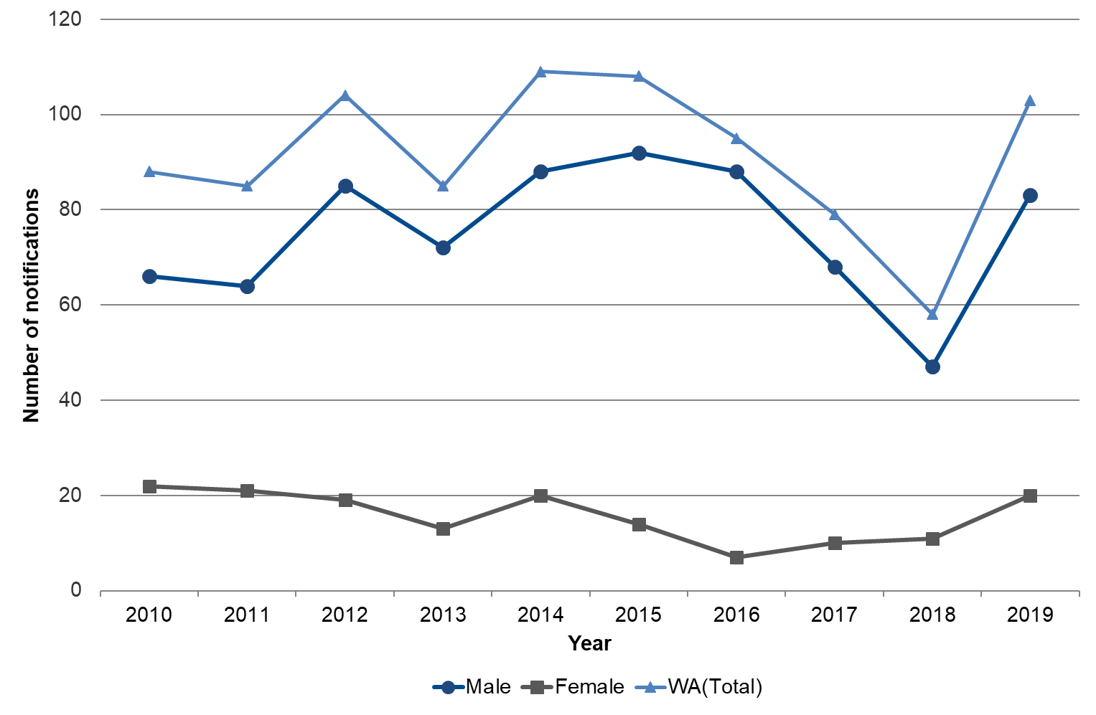

Notes: WA (Total) includes one transgender notification in 2014, two in 2015 and one in 2017

Table 33 Number and ASR of HIV notifications by sex, WA, 2019



Notes: Number = Number of notifications reported to the DoH

ASR = Age-standardised notification rate per 100,000 population

Total includes one transgender notification

Rate ratio (Male:Female) = ASR (Male) / ASR (Female)

Table 34 Number, crude rate and ASR of HIV notifications, WA, 2010 to 2019



Notes: Number = Number of notifications reported to the DoH

Crude = Crude notification rate per 100,000 population

ASR = Age-standardised notification rate per 100,000 population

Figure 11 Number of HIV notifications by Aboriginality, WA, 2010 to 2019

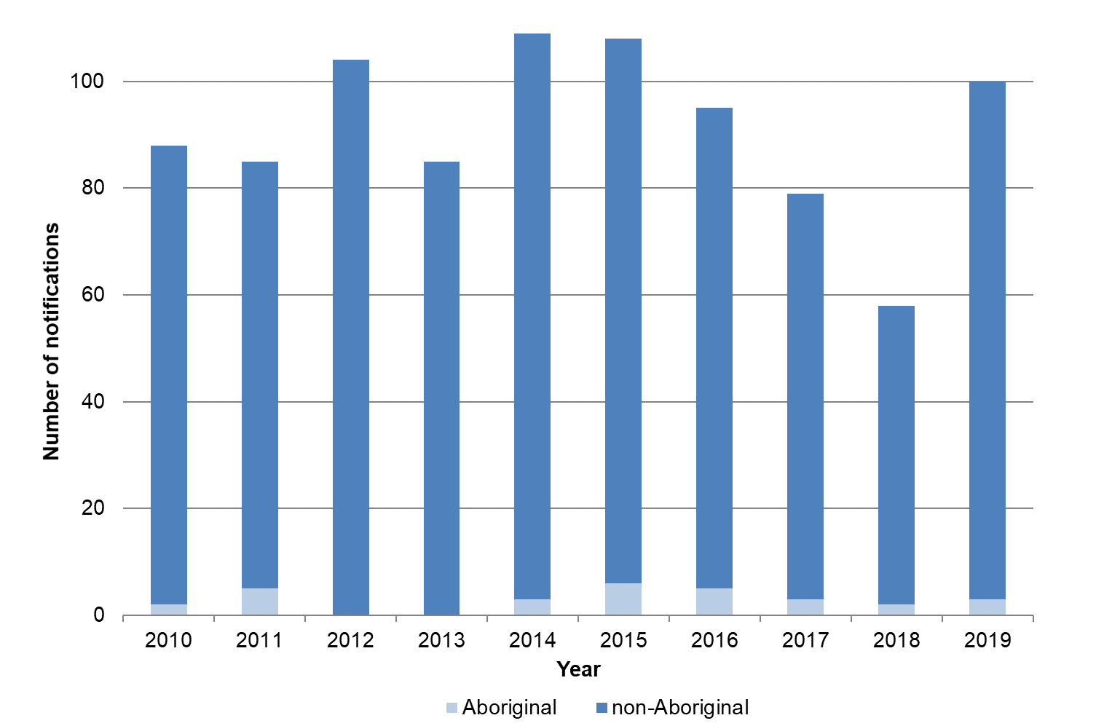

Table 35 Number of HIV notifications by Aboriginality, WA, 2015 to 2019



Notes: Number = Number of notifications reported to the DoH

ASR = Age-standardised notification rate per 100,000 population

Rate ratio (Aboriginal:non-Aboriginal) = ASR (Aboriginal) / ASR (non-Aboriginal)

Figure 12 Number of hepatitis B notifications by disease status, WA, 2010 to 2019



Notes: Notifications from Christmas Island, Curtin, Leonora, Perth and Yongah Hill Immigration Detention Centres have been excluded

Figure 13 Number of newly acquired hepatitis B notifications by sex, WA, 2010 to 2019



Notes: Notifications from Christmas Island, Curtin, Leonora, Perth and Yongah Hill Immigration Detention Centres have been excluded

Figure 14 Number of unspecified hepatitis B notifications by sex, WA, 2010 to 2019



Notes: Notifications from Christmas Island, Curtin, Leonora, Perth and Yongah Hill Immigration Detention Centres have been excluded

Table 36 Number, crude rate and ASR of hepatitis B notifications by region and sex, WA, 2019



Notes: Number = Number of notifications reported to the DoH

ASR = Age-standardised notification rate per 100,000 population

Rate ratio (Male:Female) = ASR (Male) / ASR (Female)

Total hepatitis B = Newly acquired hepatitis B + Unspecified hepatitis B

N/A = Not applicable

Metropolitan = East Metropolitan + North Metropolitan + South Metropolitan

Column totals include cases with overseas or unknown addresses, which are not shown in the table

Notifications from Christmas Island, Curtin, Leonora, Perth and Yongah Hill Immigration Detention Centres have been excluded

Table 37 Number, crude rate and ASR of newly acquired hepatitis B notifications by region, WA, 2010 to 2019



Notes: Number = Number of notifications reported to the DoH

Crude = Crude notification rate per 100,000 population

ASR = Age-standardised notification rate per 100,000 population

Metropolitan = East Metropolitan + North Metropolitan + South Metropolitan

Column totals include cases with overseas or unknown addresses, which are not shown in the table

Notifications from Christmas Island, Curtin, Leonora, Perth and Yongah Hill Immigration Detention Centres have been excluded

Table 38 Number, crude rate and ASR of unspecified hepatitis B notifications by region, WA, 2010 to 2019



Notes: Number = Number of notifications reported to the DoH

Crude = Crude notification rate per 100,000 population

ASR = Age-standardised notification rate per 100,000 population

Metropolitan = East Metropolitan + North Metropolitan + South Metropolitan

Column totals include cases with overseas or unknown addresses, which are not shown in the table

Notifications from Christmas Island, Curtin, Leonora, Perth and Yongah Hill Immigration Detention Centres have been excluded

Table 39 Number, crude rate and ASR of total hepatitis B notifications by region, WA, 2010 to 2019



Notes: Total hepatitis B = Newly acquired hepatitis B + Unspecified hepatitis B

Number = Number of notifications reported to the DoH

Crude = Crude notification rate per 100,000 population

ASR = Age-standardised notification rate per 100,000 population

Metropolitan = East Metropolitan + North Metropolitan + South Metropolitan

Column totals include cases with overseas or unknown addresses, which are not shown in the table

Notifications from Christmas Island, Curtin, Leonora, Perth and Yongah Hill Immigration Detention Centres have been excluded

Figure 15 Number of newly acquired hepatitis B notifications by Aboriginality, WA, 2010 to 2019



Notes: Notifications from Christmas Island, Curtin, Leonora, Perth and Yongah Hill Immigration Detention Centres have been excluded

Figure 16 Number of unspecified hepatitis B notifications by Aboriginality, WA, 2010 to 2019



Notes: Notifications from Christmas Island, Curtin, Leonora, Perth and Yongah Hill Immigration Detention Centres have been excluded

Table 40 Number and ASR of hepatitis B notifications by region, disease status and Aboriginality, WA, 2019



Notes: Number = Number of notifications reported to the DoH

ASR = Age-standardised notification rate per 100,000 population

% (Total) = Number (Unknown) / Total number (Region and Disease status)

Rate ratio (Aboriginal:non-Aboriginal) = Aboriginal to non-Aboriginal rate ratio = ASR (Aboriginal) / ASR (non-Aboriginal)

Total hepatitis B = Newly acquired hepatitis B + Unspecified hepatitis B

N/A = Not applicable

Metropolitan = East Metropolitan + North Metropolitan + South Metropolitan

Calculations by Aboriginality are based on notifications of known Aboriginal status only (i.e. notifications of unknown Aboriginal status are excluded)

Column totals include cases with overseas or unknown addresses, which are not shown in the table

Notifications from Christmas Island, Curtin, Leonora, Perth and Yongah Hill Immigration Detention Centres have been excluded

Table 41 Number and ASR of hepatitis B notifications by Aboriginality, disease status and sex, WA, 2019



Notes: Number = Number of notifications reported to the DoH

ASR = Age-standardised notification rate per 100,000 population

Rate ratio (Male:Female) = ASR (Male) / ASR (Female)

Total hepatitis B = Newly acquired hepatitis B + Unspecified hepatitis B

N/A = Not applicable

Calculations by Aboriginality are based on notifications of known Aboriginal status only (i.e. notifications of unknown Aboriginal status are excluded)

Notifications from Christmas Island, Curtin, Leonora, Perth and Yongah Hill Immigration Detention Centres have been excluded

Table 42 Number and proportion of hepatitis B notifications by where infection was acquired, disease status and sex, WA, 2019



Notes: Number = Number of notifications reported to the DoH

% Total = Number of notifications (Where infection acquired and Disease status) / Total number of notifications (Sex) or overall

Total hepatitis B = Newly acquired hepatitis B + Unspecified hepatitis B

Notifications from Christmas Island, Curtin, Leonora, Perth and Yongah Hill Immigration Detention Centres have been excluded

Table 43 Number and crude rate of newly acquired hepatitis B notifications by state and territory, Australia, 2019



Notes: Number = Number of notifications reported to state and territory health authorities

Crude rate = Crude rate per 100,000 population

Data sourced from NNDSS, extracted 11 August 2020; data are provisional and subject to future revision. The follow-up and allocation of cases to newly acquired hepatitis B is highly dependent on public health follow-up which is variable between jurisdictions. Trends between newly acquired and unspecified hepatitis B cases within jurisdictions and over time therefore need to be interpreted cautiously.

Table 44 Number and crude rate of unspecified hepatitis B notifications by state and territory, Australia, 2019



Notes: Number = Number of notifications reported to state and territory health authorities

Crude rate = Crude rate per 100,000 population

Data sourced from NNDSS, extracted 11 August 2020; data are provisional and subject to future revision. The follow-up and allocation of cases to newly acquired hepatitis B is highly dependent on public health follow-up which is variable between jurisdictions. Trends between newly acquired and unspecified hepatitis B cases within jurisdictions and over time therefore need to be interpreted cautiously.

Figure 17 Number of hepatitis C notifications by disease status, WA, 2010 to 2019



Notes: Notifications from Christmas Island, Curtin, Leonora, Perth and Yongah Hill Immigration Detention Centres have been excluded

Figure 18 Number of newly acquired hepatitis C notifications by sex, WA, 2010 to 2019



Notes: Notifications from Christmas Island, Curtin, Leonora, Perth and Yongah Hill Immigration Detention Centres have been excluded

Figure 19 Number of unspecified hepatitis C notifications by sex, WA, 2010 to 2019



Notes: Notifications from Christmas Island, Curtin, Leonora, Perth and Yongah Hill Immigration Detention Centres have been excluded

Table 45 Number and ASR of hepatitis C notifications by region and sex, WA, 2019



Notes: Number = Number of notifications reported to the DoH

ASR = Age-standardised notification rate per 100,000 population

Rate ratio (Male:Female) = ASR (Male) / ASR (Female)

Total hepatitis C = Newly acquired hepatitis C + Unspecified hepatitis C

N/A = Not applicable

Metropolitan = East Metropolitan + North Metropolitan + South Metropolitan

Column totals include cases with overseas or unknown addresses, which are not shown in the table

Notifications from Christmas Island, Curtin, Leonora, Perth and Yongah Hill Immigration Detention Centres have been excluded

Table 46 Number, crude rate and ASR of newly acquired hepatitis C notifications by region, WA, 2010 to 2019



Notes: Number = Number of notifications reported to the DoH

Crude = Crude notification rate per 100,000 population

ASR = Age-standardised notification rate per 100,000 population

Metropolitan = East Metropolitan + North Metropolitan + South Metropolitan

Column totals include cases with overseas or unknown addresses, which are not shown in the table

Notifications from Christmas Island, Curtin, Leonora, Perth and Yongah Hill Immigration Detention Centres have been excluded

Table 47 Number, crude rate and ASR of unspecified hepatitis C notifications by region, WA, 2010 to 2019



Notes: Number = Number of notifications reported to the DoH

Crude = Crude notification rate per 100,000 population

ASR = Age-standardised notification rate per 100,000 population

Metropolitan = East Metropolitan + North Metropolitan + South Metropolitan

Column totals include cases with overseas or unknown addresses, which are not shown in the table

Notifications from Christmas Island, Curtin, Leonora, Perth and Yongah Hill Immigration Detention Centres have been excluded

Table 48 Number, crude rate and ASR of total hepatitis C notifications by region, WA, 2010 to 2019



Notes: Total hepatitis C = Newly acquired hepatitis C + Unspecified hepatitis C

Number = Number of notifications reported to the DoH

Crude = Crude notification rate per 100,000 population

ASR = Age-standardised notification rate per 100,000 population

Metropolitan = East Metropolitan + North Metropolitan + South Metropolitan

Column totals include cases with overseas or unknown addresses, which are not shown in the table

Notifications from Christmas Island, Curtin, Leonora, Perth and Yongah Hill Immigration Detention Centres have been excluded

Figure 20 Number of newly acquired hepatitis C notifications by Aboriginality, WA, 2010 to 2019



Notes: Notifications from Christmas Island, Curtin, Leonora, Perth and Yongah Hill Immigration Detention Centres have been excluded

Figure 21 Number of unspecified hepatitis C notifications by Aboriginality, WA, 2010 to 2019



Notes: Notifications from Christmas Island, Curtin, Leonora, Perth and Yongah Hill Immigration Detention Centres have been excluded

Table 49 Number and ASR of hepatitis C notifications by region, disease status and Aboriginality, WA, 2019



Notes: Number = Number of notifications reported to the DoH

ASR = Age-standardised notification rate per 100,000 population

% (Total) = Number (Unknown) / Total number (Region and Disease status)

Rate ratio (Aboriginal:non-Aboriginal) = Aboriginal to non-Aboriginal rate ratio = ASR (Aboriginal) / ASR (non-Aboriginal)

Total hepatitis C = Newly acquired hepatitis C + Unspecified hepatitis C

N/A = Not applicable

Metropolitan = East Metropolitan + North Metropolitan + South Metropolitan

Calculations by Aboriginality are based on notifications of known Aboriginal status only (i.e. notifications of unknown Aboriginal status are excluded)

Column totals include cases with overseas or unknown addresses, which are not shown in the table

Notifications from Christmas Island, Curtin, Leonora, Perth and Yongah Hill Immigration Detention Centres have been excluded

Table 50 Number and ASR of hepatitis C notifications by Aboriginality, disease status and sex, WA, 2019



Notes: Number = Number of notifications reported to the DoH

ASR = Age-standardised notification rate per 100,000 population

Rate ratio (Male:Female) = ASR (Male) / ASR (Female)

Rate ratio (Aboriginal:non-Aboriginal) = Aboriginal to non-Aboriginal rate ratio = ASR (Aboriginal) / ASR (non-Aboriginal)

Total hepatitis C = Newly acquired hepatitis C + Unspecified hepatitis C

N/A = Not applicable

Calculations by Aboriginality are based on notifications of known Aboriginal status only (i.e. notifications of unknown Aboriginal status are excluded)

Notifications from Christmas Island, Curtin, Leonora, Perth and Yongah Hill Immigration Detention Centres have been excluded

Table 51 Number and proportion of hepatitis C notifications by where infection was acquired, disease status and sex, WA, 2019



Notes: Number = Number of notifications reported to the DoH

% Total = Number of notifications (Where infection acquired and Disease status) / Total number of notifications (Sex) or overall

Total hepatitis C = Newly acquired hepatitis C + Unspecified hepatitis C

Notifications from Christmas Island, Curtin, Leonora, Perth and Yongah Hill Immigration Detention Centres have been excluded

Table 52 Number and crude rate of newly acquired hepatitis C notifications by state and territory, Australia, 2019



Notes: Number = Number of notifications reported to state and territory health authorities

Crude rate = Crude rate per 100,000 population

Data sourced from NNDSS, extracted 11 August 2020; data are provisional and subject to future revision. The follow-up and allocation of cases to newly acquired hepatitis C is highly dependent on public health follow-up which is variable between jurisdictions. Trends between newly acquired and unspecified hepatitis C cases within jurisdictions and over time therefore need to be interpreted cautiously.

Table 53 Number and crude rate of unspecified hepatitis C notifications by state and territory, Australia, 2019



Notes: Number = Number of notifications reported to state and territory health authorities

Crude rate = Crude rate per 100,000 population

Data sourced from NNDSS, extracted 11 August 2020; data are provisional and subject to future revision. The follow-up and allocation of cases to newly acquired hepatitis C is highly dependent on public health follow-up which is variable between jurisdictions. Trends between newly acquired and unspecified hepatitis C cases within jurisdictions and over time therefore need to be interpreted cautiously.

**[Scan this QR code with your smart phone to go the WA Health website](http://www.health.wa.gov.au/)**

**This document can be made available in alternative formats   
on request for a person with a disability.**

© Department of Health 2021

Copyright to this material is vested in the State of Western Australia unless otherwise indicated. Apart from any fair dealing for the purposes of private study, research, criticism or review, as permitted under the provisions of the Copyright Act 1968, no part may be reproduced or re-used for any purposes whatsoever without written permission of the State of Western Australia.