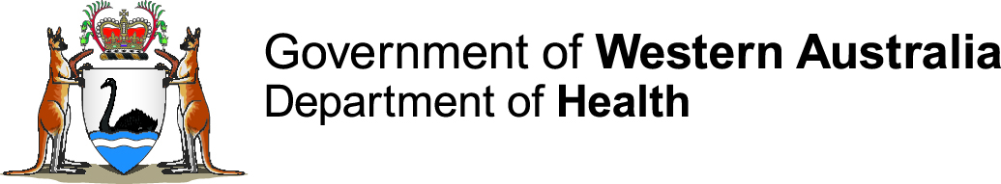

Disability Health Network

Consumer video transcript
Visual: Tony, headshot, facing camera
Text: ‘Tony, Disability Health Network member’
“My name's Tony Vardaro.
“I currently live in Vic Park, independently with carers coming in a couple of times a day.
Visual: Tony, approaching a notice board in his wheelchair. Tony stops to look at the notices and then keeps going.
“I have a social work degree which I got in 1983.
“I worked in rehabilitation with health professionals. I was a manager of disability services at Polytechnic where I worked with students with disabilities so that they got the support they needed to be able to study.
Visual: Tony, approaching an elevator. Tony presses the elevator button. The elevator doors open and Tony enters. The elevator doors close.
Visual: Tony, headshot, facing camera
“A lot of people think that because you've got a disability you've got a health issue which is not the case.
“I may see a doctor twice a year for a regular check up but I don't have other health needs.
“I quite severely broke my arm and at the time the occupational therapist suggested that maybe I should go into supported accommodation which is a nursing home.
“And I said "Yeah, in a pine box."
Visual: Tony’s sitting in his wheelchair, from the shoulders down.
Visual: Tony, headshot, facing camera
“I educated her and the doctor and the team working with me at the time that there's community support out there which would allow me to continue living in the community.
“When I worked in rehabilitation I found that other professional people really felt uncomfortable working with me because they didn't see me as an equal.
“I have needs in some things, like everybody else. There's some things that I can't do and I need support in doing them. Like cooking, feeding myself, shaving. They're not medical issues - they're just things that I need to do.
Visual: Tony heading away from camera in his wheelchair.
Visual: Tony, headshot, facing camera
“I would like to see the training of medical clinicians be different.
“Clinicians still see disability as a medical condition. I think that's something that with some cognitive restructuring can change.”
Text: ‘WA Health News health.wa.gov.au’
End of video

