Community Conversations for the WA Healthy Weight Action Plan 2019-2024
March 2018 to July 2019

Produced by Health Networks © WA Department of Health 2019
Copyright to this material is vested in the State of Western Australia unless otherwise indicated. Apart from any fair dealing for the purposes of private study, research, criticism or review, as permitted under the provisions of the Copyright Act 1968, no part may be reproduced or re-used for any purposes whatsoever without written permission of the State of Western Australia.
Suggested citation
Western Australian Department of Health. WA Healthy Weight Action Plan Consultation Report. Perth: Health Networks, Western Australian Department of Health; 2019.
Important disclaimer
All information and content in this Material is provided in good faith by the Western Australian Department of Health, and is based on sources believed to be reliable and accurate at the time of development. The State of Western Australia, the Western Australian Department of Health and their respective officers, employees and agents, do not accept legal liability or responsibility for the Material, or any consequences arising from its use.
Using the term Aboriginal
Within Western Australia, the term Aboriginal is used in preference to Aboriginal and Torres Strait Islander, in recognition that Aboriginal people are the original inhabitants of Western Australia. Aboriginal and Torres Strait Islander may be referred to in the national context and Indigenous may be referred to in the international context. No disrespect is intended to our Torres Strait Islander colleagues and community.
Acknowledgement
The authors acknowledge the use of several images in this document are courtesy of the World Obesity Federation.
Contact information
For further information contact Health Networks, Western Australian Department of Health on (08) 9222 0200 or healthpolicy@health.wa.gov.au.
Contents
Overview 2
Purpose of engagement 2
Guiding principles of engagement 2
Methods of engagement 3
Consultation in 2018 4
Obesity management services inventory 4
Obesity Collaborative Summit 9
Consultation in 2019 11
Consumer workshop 11
Strategy planning workshop 12
Action planning workshop 14
CitizenSpace consultation on draft Action Plan 16
Appendices 20
Appendix A: Obesity management services inventory questionnaire 20
Appendix B: Obesity management services inventory additional findings 29
Appendix C: CitizenSpace Survey 33

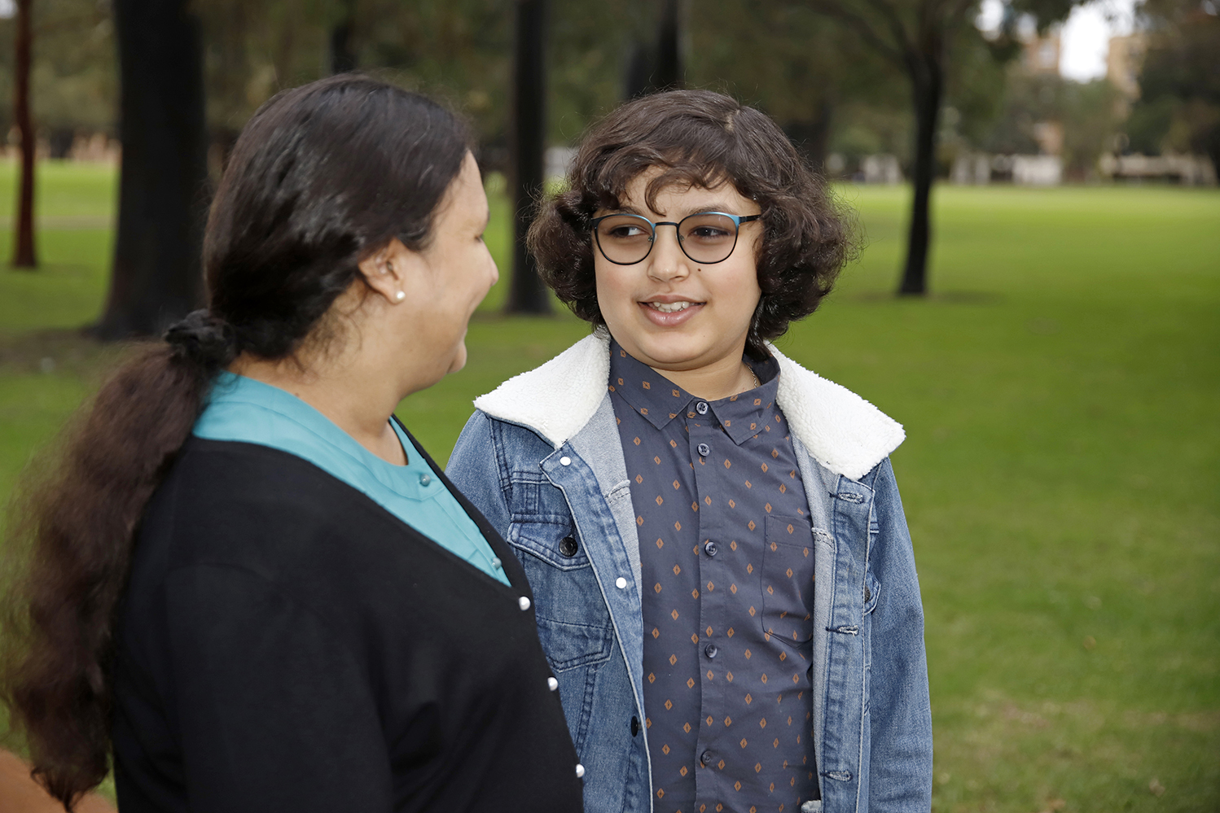

Overview
The WA Healthy Weight Action Plan 2019-2024 (hereafter, the Action Plan) was developed as a result of the Obesity Collaborative Project run by the Department of Health’s Health Networks Unit (HNU) in partnership with the WA Primary Health Alliance (WAPHA) and the Health Consumers’ Council (HCC). Extensive consultation was undertaken over a 17 month period with numerous stakeholders from across the health sector including consumers to inform the content of the Action Plan.
HCC was contracted by HNU and WAPHA to undertake the consumer engagement component of the consultation. Consultations with health professionals, health services, and policy and project staff were led by HNU. This Community Conversations report outlines the formal consultations undertaken by HNU. For information related to the consumer engagement, refer to Is weight a weight on your mind? Consumer Consultation Report.

Purpose of engagement
- To ensure the voices of people with lived experience of overweight and obesity drove the creation of actions that would support the delivery of change in the community.
- To ensure the Action Plan is based in evidence, the needs of the WA community, and will lead to practical and achievable change.

Guiding principles of engagement
Person & community centred | Consumer voices are embedded throughout the project. Peoples lived experiences of obesity management and their expectations are used to frame and centre all project deliverables.
Transformational and sustainable change | The Project focusses on engaging stakeholders and delivering outputs that create transformational and sustainable change within the health system.
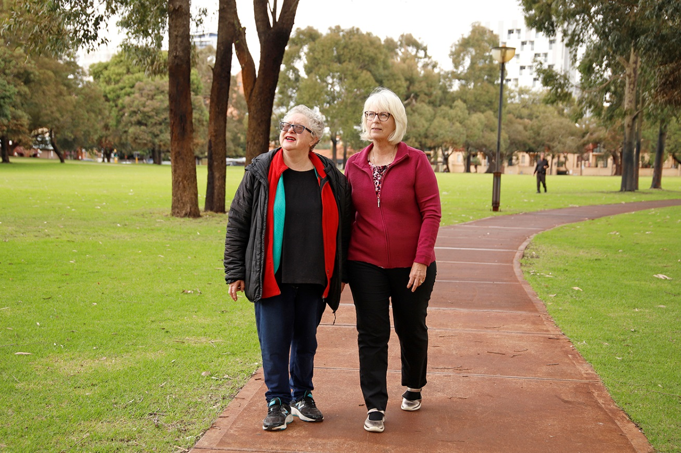

Methods of engagement
In addition to the formal consultation activities listed in Table 1, numerous people and organisations were consulted throughout the life of the project via targeted meetings, phone calls, and email correspondence. The purpose of this was to obtain specific advice and input to the development of the Action Plan related to their professional group or organisation. Given the targeted nature of the information provided during these informal conversations and the fact that they form a standard part of general project management, they have not been covered in this report.
Table 1: Summary of consultations for the WA Healthy Weight Action Plan
2018 |  | Lead
27 March to 27 April | Obesity management services inventory | HNU
June to August | Is weight a weight on your mind? | HCC
Est. 10 July | Facebook group | HCC
Est. July | Community Leaders Group | HCC
August to October | Gathering consumer stories | HCC
27 September to 11 October | Consumer workshops | HCC
September to October | Online consumer workshop | HCC
17 October to 2 November | Obesity Collaborative Summit | HNU
2019 |  | Lead
5 February | Consumer workshop | HCC
12 February | Strategy planning workshop | HNU
27 February | Action planning workshop | HNU
1 to 14 July | CitizenSpace consultation on draft Action Plan | HNU

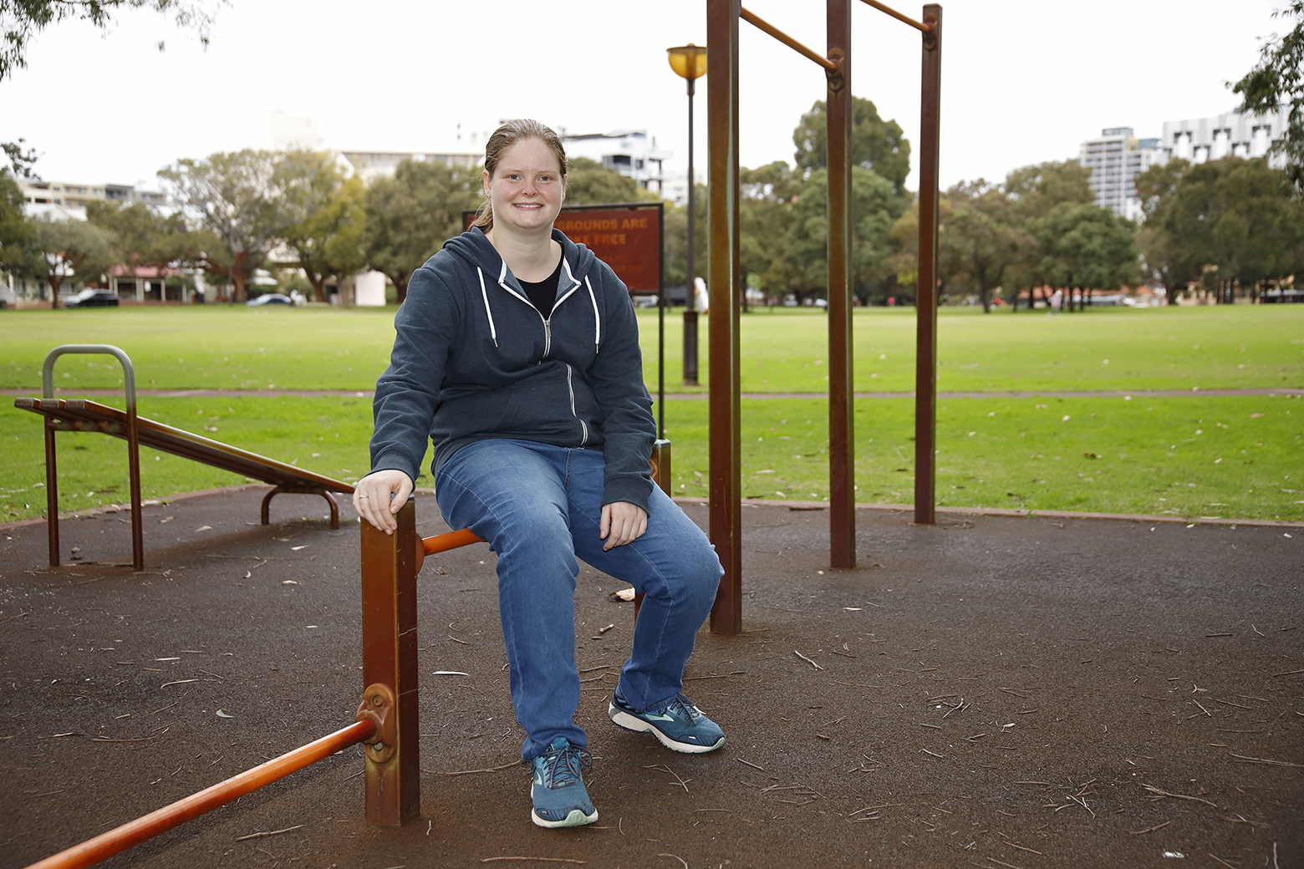

Consultation in 2018

Obesity management services inventory

Purpose
To collate information about the existing WA programs and services that focus on weight management to:
- obtain an understanding of what is already provided
- complement a literature review of research on good practice internationally, nationally, and in WA
- identify gaps in service and program delivery.

Target audience
- Service providers
- Professional colleges
- Non-government organisations (NGOs)

Use
Findings from the Obesity management services inventory:
- Provided an understanding of the gaps in services and opportunities to build on services that existed in WA to support people with overweight and obesity as well as the opportunities to enhance.
- Supported conversations with consumers as it help project staff understand how people use the existing services and programs.
- Allowed for broad comparisons and analysis between WA and the international and national locations that had successfully altered overweight and obesity trends.
- Identified gaps in health system processes related to service volume and mix, quality, monitoring, contracting and procurement that impacted services on the ground.

Method
An online survey was conducted via CitizenSpace which asked participants to provide information on the type of service or program they delivered. The survey was open from 27 March to 27 April 2018. It was advertised via the Health Networks Bulletin, Department of Health communications channels, Health Service Provider communication channels, and targeted emails to relevant professional colleges and non-government organisations for participation and circulation to their members and staff.
The survey contained two parts:
- Part 1: Obesity management services and program information
- Part 2: General gaps and comments. Additional information gathered about obesity management in general – people who did not have a program could choose to respond to part 2 only.
See Appendix A: Obesity management services inventory questionnaire.

The survey had the following limitations that should be considered when reviewing the findings:
- It was self-report as such other programs might exist and the organisations might have chosen not to complete the survey or were not aware of it.
- Organisations with policies for referrals rather than programs for overweight and obesity might not have considered the survey relevant to them.
- Analysis could only be done on the information provided or what was publically available on the internet which in some cases was limited.

Analysis
Program information from part 1 was analysed using:
- Behaviour Change Wheel
- CALO-RE Taxonomy
Programs were divided into the following categories that were informed by the Ottawa Charter for Health Promotion:
- Building Health Public Policy: Services which have existing assessments, policies, or processes to identify and refer patients within their own service
- Capacity Building - Individual: Programs for people who want to manage their weight
- Capacity Building - Service Provider: Programs, training, and/or advice for service providers looking to begin or improve a weight management program for individuals
- Reorientating Health Services: Organisations with established referral pathways or connections between different organisations to support people who want to manage their weight

Findings
Part 1: Obesity management services and program information
- 52 unique program responses
- 85% were publically funded through local, state, or federal government funding
- Program focus
  - 73% of programs’ primary focus was weight loss
  - 27% of programs’ primary focus was chronic disease management of which weight management was a component
- Delivery type
  - 58% of programs were structured (delivered as a discreet program with a defined start, finish, and length e.g. 6 weeks of 1 hour classes)
  - 42% were delivered ad hoc as the person needed services

Strengths to build on | Areas to reflect on
Individual programs
- Some programs offered group education sessions so the individual is not isolated  - Majority of the programs were delivered in the community – care closer to home  - Some programs staged the person’s progress from individual sessions to group sessions to ensure the person felt safe and secure, thus protecting their emotional wellbeing during a process which could cause emotional distress  - Several organisations tailored their program to the needs of the person  - Four programs were delivered as a partnership between a variety of service providers to enhance capacity and service diversity  - Information provided during the programs was often strengths based rather than based on fear of not changing behaviours | - Majority of programs dealt with the individual person in isolation from other people or their social and environmental context  - A disproportionate number of programs focussed on the changes an individual must make and did not incorporate, attempt to acknowledge, or alter the social determinants of the person’s health, or look at altering the habitual behaviours and triggers which impacted a person’s health choices or the choices they have the ability to make (e.g. enabling people’s access to healthy food and affordable food options)  - Majority of programs did not appear to leverage their group class structure to build peer-to-peer support networks, encourage modelling behaviour, and mentoring  - Many programs were time limited or delivered information or services within a discreet timeframe with little or no long term follow-up, support, or measurement  - The four most common CALO-RE techniques used (techniques 21, 1, 5, and 2) focus on giving information without demonstration or follow-up. This suggests that program designers could be interpreting the core problem as a lack of information about nutrition and exercise.
System considerations
- 50% of programs were based on state, national, or international guidelines or research evidence, suggesting a willingness and desire for programs to be evidence based.  - 43% of programs had conducted an evaluation and a further 30% had an evaluation planned or underway. Evaluation is critical to understanding if a program is delivering on its intended outcomes and aligning with community and system needs. There is an opportunity to ensure consistent high quality evaluations are conducted for all publically funded programs. | - Of the programs that provided their evaluation data, the majority of programs measured changes in knowledge but not behaviour; nor did they measure the quality of how the program was delivered.  - Only 9% used validated measures, such as statistical significance and patient activation, in their evaluation.  - While 27% followed up participants over a period of time after the intervention, only 1 program (bariatric surgery) indicated they followed up with participants past 12 months.  - Given the evaluation information provided, it is not possible to determine if the majority of programs have delivered long-term success in reducing their participants’ weight, impacting the causes of their weight gain, or improving their overall health.
Funding
- The vast majority of programs were no or low cost to the user thus increasing their accessibility.  - However, this also means they often did not generate an income; instead they relied on potentially unsustainable funding sources. | - Programs run by the WA health system were often funded from operational budgets rather than additional funding. This could limit their ability to grow to an effective level.  - However it does support their sustainability as funding is included in base budget estimates.
Location
- Numerous programs existed in the metropolitan area. | - Very few programs were delivered to a large geographical area creating inconsistent service delivery across WA.  - 9% of programs appear to have delivered excellent results in weight management for their participants based on evaluation data and several more appear to have potential to deliver positive outcomes based on the behaviour change techniques they use. However, the majority were limited geographically and would need to be reviewed further for scalability.
Population groups
- Existing programs delivered to a wide variety of populations indicating that there is an existing base of programs to build upon. | - There appears to be a need for more supports for child and family weight management and priority populations such as rural/remote people and Aboriginal communities.
See Appendix B: Obesity management services inventory additional findings.
Part 2: General gaps and comments
- 68 completed responses to part 2
  - 42 responded to part 1 and 2
  - 26 responded only to part 2
- Programs people were aware of:
  - 15 unique programs identified - LiveLighter and the Better Health Program were the most frequently mentioned
  - 6 international examples were identified
  - Suggests limited knowledge of existing services in WA and international practices
Table 2: Analysis of gaps and challenges identified by participants
Theme | Sub-theme | Description
Patient journey | Lack of Programs | Limitations of access to public programs that are no or low cost as well as the limitation in the diversity of programs that cater to different age groups, physical ability, weight category etc.
 | Access | Physical access to services due to transport, lack of equipment to support a person’s safe mobility when accessing services, and lack of state wide services.
 | Service Coordination | Lack of clear referral pathways, coordination of services to support a person’s journey from primary care to hospital services, management of multidisciplinary team or additional supporting services such as housing, as well as the limits of clear guidelines to support care coordination.
Priority populations | Aboriginal People | Aboriginal people were identified as being a key group that requires focus particularly in delivering culturally appropriate and safe services.
 | Child and Family Health | Young children and families should be targeted for intensive and whole of family services to prevent and manage obesity, particularly through school environments and policies such as food supply through canteens.
 | Rural | Rural and remote communities lack access to programs as well as having additional key environmental challenges such as limited access to fresh fruit and vegetables.
Individual needs assessment | Psychological capability | A person’s or family’s motivation, expectation of results, and emotional readiness for change is an important factor in success.
 | Conflicting needs | Many people have conflicting priorities in their lives which impact their ability (physically, financially, or emotionally) to prioritise healthy choices. Speaks to the social determinants of health.
Social Inputs | Food Security | Access to affordable healthy food options and the converse overabundance of kilojoule dense but low nutrient options particularly the lack of diversity and availability of healthy food choices in regional and remote areas.
 | Advertising/ Public Information | Social messaging and advertising that promote unrealistic body shapes and body image and expectations of attractiveness. This is complicated by conflicting health, exercise, and diet messages from many sources with competing agendas.
 | Infrastructure | Limited and inconsistent access to infrastructure to support health particularly active transport.
 | Social Norms | Social stigma related to overweight and obesity, and the limited social commentary on the complex causes and impact of obesity on an individual and their family promotes discrimination and victim blaming which perpetuate the problem.
Sustainability | Funding | Lack of consistent and sustainable funding for overweight and obesity prevention and management programs to support provision of required equipment to support people with a higher weight, and dedicated funding in a hospital setting for obesity services.
 | Government Priority | Lack of dedicated, high level focus on obesity and its complex causes. Limited resources have been consistently provided in a targeted whole of government manner to support the tackling of the causes from multiple perspectives.
 | Workforce | Limited skilled workforce to deliver services particularly in rural and remote settings.
 | Infrastructure | Provision of equipment to support the care of people in higher weight ranges.
 | Training | Limited training in manual handling and management of the complex requirements (social determinants of health) of people in higher weight ranges.
Policy, Legislation, & Regulation | Nil sub-themes | Making or advocating for changes to legislation that impact the advertising and sale of unhealthy food options.

Table 3: Analysis of potential solutions identified by participants
Theme | Description
Funding | Subsidising appointments for weight management.
Service Delivery | Included a range of recommendations focussing on long-term, sustainable, and multi-disciplinary service delivery.
Research | Working with research institutes and universities to use research to guide change.
Policy & Legislative change | Supporting, delivering, and implementing legislative changes that support healthy living.

Obesity Collaborative Summit

Purpose
For community and health service providers and planners, and consumers to collaborate on the key actions for the WA health system to take in the early intervention and management of overweight and obesity over the next five years.
See more detailed information in the Obesity Collaborative Summit 2018 summary report.

Target audience
- Health service executives
- Consumers
- Health professionals
- NGOs
- Peak bodies

Use
Findings from the Obesity Collaborative Summit were used to draft the content for the Action Plan.

Method
- Wednesday 17 October: in-person summit
  - Morning scene setting
  - Midday workshops related to challenges and opportunities in three main groups: Families, children and adolescents, and adults
  - Afternoon: voting on the top 3 to 5 actions from each group
- Monday 22 October to Friday 2 November: online workshop
  - Pre-recorded scene setting presentations
  - Collaborative brainstorming around the three main groups (families, child and adolescents and adults) using GroupMap

Findings
There were 178 attendees at the in-person summit on 17 October 2018 and 89 registrants for the online workshop.

What the community needs
Access | Ensure the WA Community has access to and the capacity to use a diverse range of support and intervention options that deliver what individuals or their family need:  - At a cost that is affordable  - In a location that is appropriate  - And in a variety of modalities
Care Coordination | The System is structured in a way that supports people to access care that can be personalised to their needs as they evolve over time, facilitated by coordinated and multidisciplinary care.
Community Education | Improve the health literacy of the WA community, including the health workforce, related to the causes of obesity, protective factors, and effective interventions.
Effective Services | Ensure that publicly funded healthy weight services and programs in WA deliver to a consistent quality level and are accountable for their quality.
To be respected and supported | Ensure that people do not feel judged by others in the community and those providing care. Ensuring that all services and support systems operate in a way that empowers people, recognise the issue is complex, and respect people to support them to work through options that fit their individual needs.
What the services needs
Evidence base | Create effective mechanisms to collect, share, and use international, national, and local evidence of best practice and quality services to support an informed community and workforce, effective care coordination, service commissioning, and continual quality improvement.
How we talk about weight | Recognising the stigma that is attached to being overweight or having an overweight child.  Changing the way we talk about weight as a system, an agency, and as individuals to an empowerment and strengths based model.  Ensuring the messages that the health authorities give to the community about weight and interventions are consistent and based on evidence to prevent confusion.
Workforce & Training | Ensure our health professionals are equipped with the skills, knowledge, and have the confidence to have conversations with their patients regarding their weight. Leverage the existing workforce to find innovative shared care models. Build capacity in high need areas.
What the system needs
Broad Collaboration | Working together across organisations to align messages, support the coordination of actions that tackle the factors that limit a person’s or families capacity to manage their weight, leverage innovation, and increase opportunities for targeted and opportunistic contact with high risk and vulnerable communities.
Commitment to long term sustainable change | There is meaningful commitment from decision makers to prioritise healthy weight as a number one priority for action, action is appropriately funded and supported over the long term, broad collaboration forms a central component of action, and action is multi-level.

Consultation in 2019

Consumer workshop

Purpose
Provide feedback to consumers about the progress of the project to date and obtain their feedback on the draft Strategy Areas that were developed from the Obesity Collaborative Summit.

Target audience
Members of the Community Leaders Group

Use
Feedback from this workshop helped make the strategy areas relevant to consumers and the participants developed the vision for the Action Plan.

Method
The workshop was held on 5 February from 3.00pm to 5.00pm. The session provided a brief overview of the Obesity Collaborative Project to date and then allowed time for group discussion of the Strategy Areas.
Participants were broken into three groups and given A3 paper with the draft strategies to discuss amongst themselves. They were asked:
- Whether the strategy area was relevant?
- Did it reflect the needs of people with overweight and obesity?
- What is missing?
The tables then discussed their comments as a group.

Findings
Ten people attended the workshop.
As part of the group discussion, it was decided that the Strategy Areas had little cohesion without a central vision to work towards. The participants spontaneously developed the vision for the Action Plan (this original vision was only adjusted slightly to improve syntax but otherwise remains unchanged and appears in the final Action Plan). Original vision: A society of individuals who support each other to maintain a healthy life
General findings:
- No Strategy Areas were removed and there was general consensus that they were appropriate however each table chose to edit the wording of the strategy areas which was translated into the next draft.
- Three additional areas were added. These were considered important but we incorporated into other strategy areas for the next draft.
  - Under what do the services need? “time” and “more peer workers” were added
  - Under what does the system need? “move from top down thinking to network thinking” was added
- Strategies under each area (community, service, system) need to be connected to be effective.

What does the community need? | - The health system is complex and difficult to navigate.  - Access and care coordination should consider accessibility in terms of time, location, a person’s capacity to use a service, flexibility, regional and remote access, and the different access needs of different communities such as children aged 0-7 years, people with disability, people with mental health, and Aboriginal People.  - Services should have the capacity to be tailored to the needs and circumstances of the individual person – not one size or solution fits all. Services should also include peer based services and that all services must be monitored and held to account.  - There is a need for respect, compassion, kindness and no judgement in service delivery.  - There is a lack of consistent, reliable, or credible information about what will work for weight loss. It was noted that improving health literacy was one side of the coin, with the other being improved health professional knowledge and communication skills when discussing sensitive issues such as weight. The consumers mentioned that communities want to have the information and ability to support themselves, not necessarily always relying on government services to drive change.
What do services need? | - Taking the best from the evidence and applying it in WA  - Making the options simple and easy for people to use including making it easy for health professionals to provide advice and support.  - Important to change the language to an empowerment approach around health rather than weight.  - Stigma was consistently raised as a significant barrier and that efforts need to be made to ensure health professionals are equipped with the skills and knowledge to have empathic and compassionate conversations.  - Importance of valuing professional development in this topic area so that health professionals are incentivised to undertake it.  - Importance of having time to support people in their health journey.
What does the system need? | - Importance of co-design. There was a strong focus on including consumers during the implementation of the Action Plan particularly in relation to designing workforce education packages. Partnership with consumers at every stage was a strong message: deliver, design, and connect WITH consumers at all stages.  - Need to look for long term sustainable options rather than short term solutions.  - Action and evaluation needs to be guided by principles and values.  - The structure of the health system and the way health is delivered needs to consider the importance of networks and hubs but with the community at the centre and not a government agency.

Strategy planning workshop

Purpose
To review and refine the draft vision, principles, and Strategy Areas that had been developed from the Obesity Collaborative Summit and consumer workshop.

Target audience
Health service executives responsible for implementation related decision making

Use
Feedback from this session was used to refine the Strategy Areas and ensure they were relevant and practical from a health service implementation perspective.

Method
- The workshop took place on 12 February 2019 from 1.00pm to 4.30pm.
- Discussed the draft vision as a group
- Workshop
  - Each of the Strategy Areas were put on papers on the wall
  - The station round method was used - participants worked in three groups and were given approximate 20 minutes at each of the three stations (community, service, system) to review the Strategy Areas and write down if they:
    - Love it i.e. keep the strategy area – if so they noted down what they liked
    - Live with it i.e. it might need some editing – if so they reworded the strategy area
    - Lament it i.e. it needs significant editing or needs to be removed – if so they reworded the strategy area or identified the reason why it needed to be removed
  - Participants were also asked to define ‘success’ or the desired outcomes for each category
- Discussion about the comments on each station as a group to create consensus particularly for strategy areas in the live with it and lament it categories.

Findings
Twenty one people from across the Health Service Providers, WAPHA, and HCC attended.
Feedback allowed the Strategy Areas to be reorganised and reworded to improve clarity and meaning. In addition, it was identified that there was repetition across different Strategy Areas in the categories. As such, the three categories were removed and Strategy Areas were consolidated which reduced the number from 13 to 7. The rewording allowed the actions to become more realistic and practical to implement and a consumer experience was included for each Strategy Area to demonstrate what the outcomes might look like for a consumer if the Strategy Area was successfully implemented. Including a review of desired outcomes helped to focus the actions under each Strategy Area to be more practical and targeted, ready for discussions at the next workshop on 27 February.
What does the community need? | - Majority of responses were willing to ‘live with’ the draft in its current form and have made the following suggested amendments:  - The Strategy Areas are aspirational - improve vs ensure, be more realistic and define scope, the explanations could apply to any health issue  - Consider the order of the Strategy Areas - maybe community education first as may avoid need for services  - Consider phrasing the description as if it was spoken by a community member e.g. care coordination: I have someone I can turn to and I trust who can help me get the care I need over time, I find it easy and affordable to access the care I need  - Desired outcomes for community level strategies;  - Care closer to home  - Staying healthy in the community  - Supported consumers  - Ability to access help/support/services earlier  - Improved self-management and support  - Evidence based services  - Reduces stigma regarding obesity  - Reduce discrimination towards people with overweight and obesity from within the system  - Support multiple weight loss attempts by people
What do services need? | - Majority of responses were willing to ‘live with’ the draft Strategy Areas in their current form  - The general comments about this section included:  - The term “services” needs to be more clearly defined as the current language used could result in publicly funded services/ NGOs/ GPs/ Primary not seeing these Strategy Areas as relevant to them  - Need to simplify the language and reduce the length of the strategy explanations.  - Desired outcomes for service level strategies  - Increased workforce capacity and skills  - Person centred cases  - Greater evidence-based services
What does the system need? | - Majority of responses were ‘love it’ on all Strategy Areas.  - The general comments about this section included:  - Define terms more clearly e.g. what is meant by ‘healthy weight’?  - Information sharing across the service and system  - Action needs to be embedded in future planning, strategic planning to look at re-funding opportunities  - Performance reporting might need to be considered  - Consideration should be given to the Action Plan being a living document, revisited and reviewed to ensure continued learning and amendment  - Desired outcomes from system level strategies  - KPIs and measures related to policy, system, interagency and individual population level  - Funding beyond the election cycle but include seed funding  - More people in the system doing something about obesity  - People accessing the system appropriately

Action planning workshop

Purpose
To review and refine the draft actions under each Strategy Area that had been developed from the Obesity Collaborative Summit and feedback from the Strategy planning workshop.

Target audience
Health service executives and staff responsible for implementing the Action Plan once it is released

Use
Feedback from this session was used to refine the actions and the Strategy Areas to ensure they were relevant and practical from a health service implementation perspective.

Method
- The workshop was help on 27 February 2019 from 11.00am to 4.30pm.
- World Café method was used
- Each table dealt with the actions under a single Strategy Area
- Participants were given A3 papers which outlined the outcomes, system response to the strategy area, key performance indicators, actions that would be the focus of the Action Plan for the 5 year timeframe, and additional actions that were seen as be more appropriate for the mid to long term (i.e. outside the 5 year time frame of the Action Plan).
- Participants were asked to:
  - Review the outcomes, key performance indicators, and the actions to determine if they were appropriate and reword where necessary.
  - Identify appropriate organisations who would lead the implementation of each action, the partner organisations who would need to be involved, and the likely timeframe to achieve the action.
  - Review the mid to long term actions to see if any of them could be brought forward into the 5 year timeframe.
- Participants were given 15 minutes and rotated through four stations each, they could choose which four of the seven Strategy Areas they wanted to work on.
- After the world café, there was a group discussion about each Strategy Area to develop consensus and understanding about the changes being recommended.

Findings
Sixteen people from across the Health Service Providers, WAPHA, and HCC attended.
As a result of the Action Planning Workshop the following changes were made:
- Key performance indicators were removed as they were seen as part of the implementation planning process that each lead organisation would undertake.
- Leads and partner organisations were allocated to actions based on group consensus.
- Actions were reworded to improve clarity and to simplify the language.
- Many mid to long term actions were brought up into the 5 year timeframe as there was a strong consensus that action is achievable in this space and the Action Plan should be decisive and aspirational.
- The system response was reframed as outcomes for the Strategy Area and the outcome was reframed as the consumer experience in the final Action Plan.
- Strategy Areas 4 (enabling best practice) and 7 (connect better) were seen as the highest priority and were listed as 1 and 2 in the next draft of the Action Plan. (This order was later adjusted based on further feedback and discussion with partners as “Connect better” and “Change the way were talk about weight” were seen as the critical pillars to success in the other five Strategy Areas).

CitizenSpace consultation on draft Action Plan

Purpose
Obtain feedback on a draft version of the Action Plan to ensure that the final product was easy to ready, supported system change, and actions reflected the information provided in previous consultations and that they were practical.

Target audience
People who had previously been involved in consultations for the Obesity Collaborative Project, including consumers who nominated to stay informed of the outcomes of the project.

Use
Findings from the CitizenSpace consultation were used to refine the draft Action Plan and create the final version for approval.

Method
The consultation was housed on CitizenSpace, WA Health’s consultation hub. Invitations to participate were sent via email. The consultation was open from 1 July to 14 July 2019.
The consultation requested feedback using a five point Likert scale on:
- the clarity, appropriateness, and feasibility of the Strategies for Action and associated actions
- the readability and appropriateness of the document as a whole
- whether it could lead to governance level change; and whether the Action Plan reflected the voice of people with lived experience.
In addition, participants could provide free-text responses to give more information or clarify their responses to the Likert scale questions. See Appendix C: CitizenSpace Survey for more information.

Findings
Overview
- 54 responses received
- 76% of people provided free text comments, suggest a high level of engagement with the topic
- Audience
  - 10% identified as a person with disability or a carer of a person with disability
  - 67% responded in their capacity as an employee of the health sector
  - 17% responded in their capacity as consumers or carers
- Area of work
  - 31% WA Health Service Providers
  - 22% other (University sector, local government, mental health and private consultancy)
  - 11% Department of Health employees
  - 11% Primary Care
  - 11% Non-government organisations
  - 4% other government agencies
- 85% provided their views as an individual, while 15% responded on behalf of an organisation
Positive feedback
- The majority of respondents agreed or strongly agreed that the Action Plan:
  - Clearly identified the type of action required to achieve change – 80%
  - Were based on current evidence – 81%
  - Could be feasibly implemented – 76%
- 78% of people felt the Action Plan was easy to read
- 78% agreed or strongly agreed that the Action Plan provided direction for future policy development
Areas for consideration
Quantitative results | Discussion
65% agreed or strongly agreed that the Action Plan provided direction for future service delivery. | Work was done to improve the connections between lessons learnt from international success and the actions as well as how the focus on changes at the system and service level will create a solid foundation for sustainable and quality service delivery. The Action Plan was reviewed to ensure that actions focussed on improving service delivery are specific, targeted, and clear.
54% agreed or strongly agreed the Action Plan would assist in improving the quality of services | The low number here was a concern given one of the Strategy Areas is devoted to quality improvement. Work was done to improve the connections between lessons learnt from international success and the actions as well as how the focus on changes at the system and service level will create a solid foundation for sustainable and quality service delivery.
57% felt the Action Plan reflects the needs of people living with overweight or obesity | The low number here was a concern for the team given the clear and primary focus of consultations and purpose of the Action Plan to work for consumers. In reviewing the free text comments, it is possible there was an unintended issue with some of the language used that might lead readers to interpret the Action Plan as reinforcing the individualised focus it seeks to reduce. Significant work was undertaken to ensure the language used in the Action Plan reflects the intent to reduce individual blame and reflect the voice and needs of consumers more clearly.
Qualitative theme |  | Response
Improve clarity of the document and the connection between the Strategies/Actions and the context/rationale provided in part 2 of the document |  | The Action Plan was split into two documents to reduce the overall document size and provide more space to draw connections. The main Companion Resources (context and evidence base for the Action Plan) was updated to improve clarity about what can be learnt from the successes from around the world and applied in a WA context. Actions within the Action Plan were reviewed to ensure:  - They reflect the elements of success identified from international examples to demonstrate that the Action Plan is based on solid evidence of what works.  - There is clear alignment between the identified barriers, successes, and the actions that are proposed.  Health at every size has been revisited as a concept and the focus on optimising healthy behaviours and moderate weight loss of 5-10% has been made much clearer to avoid the misconception that the Action Plan merely focusses on excess weight and the need to reduce it.
The document and actions are too broad to be an action plan and there is not enough specificity of how the actions will be implemented (i.e. funding, resource allocation, timelines etc.) |  | Actions were reviewed by the Project Leadership Group, the project team, and Clinical Excellence Division executive team to consider their language and remove ambiguity where possible. In many cases the language was simplified to make sure the purpose of actions was clear.  The “How to use the Action Plan” section was restructured to provide more clarity around the role of the Action Plan, the purpose of the WA Obesity Collaborative to support coordination of implementation, and the responsibility of local service providers to plan implementation that is tailored to the needs of their community.
Need to include prevention of overweight and obesity |  | The scope of the Action Plan remained unchanged (early intervention and management) as there is significant work and action already occurring in the preventive health space. However, clear definitions of these two concepts were included in the purpose of the Action Plan. In addition, comments were made throughout the Action Plan stating that teams seeking to implement actions related to early intervention and management should consider partnerships with local government and preventive teams where appropriate to align work.  The Strategic Alignment section of the Action Plan was made clearer to show how the Action Plan supports and aligns to existing preventive work. An infographic of the strategic alignment was also included as an appendix.
Improve clarity of the actions |  | Actions have been reviewed and updated where appropriate to incorporate and clarify:  - The role of carers in the support of people with overweight and obesity, particularly post-op care for people undergoing bariatric surgery  - Acknowledging people with greater needs or complexity  - People with chronic conditions, particularly diabetes  - Programs will be free or low cost
Include CALD communities |  | Culturally and linguistically diverse communities were added as a key community.
Provide more clarity on the partners |  | The partners created significant confusion due to a misinterpretation that the partners list represented a complete list of stakeholders and were mandatory to involve, which was not the intention. Partners were removed from the Action Plan as these will need to be considered separately by the teams who implement each action.
BMI is not an appropriate measure |  | In the absence of another universally accepted measure, BMI is used as the measure to categorise and apply actions to the appropriate community. The appendix explaining the use of BMI has been made clearer and referenced throughout the document, particularly in the scope section, for clarity.

Appendices

Appendix A: Obesity management services inventory questionnaire
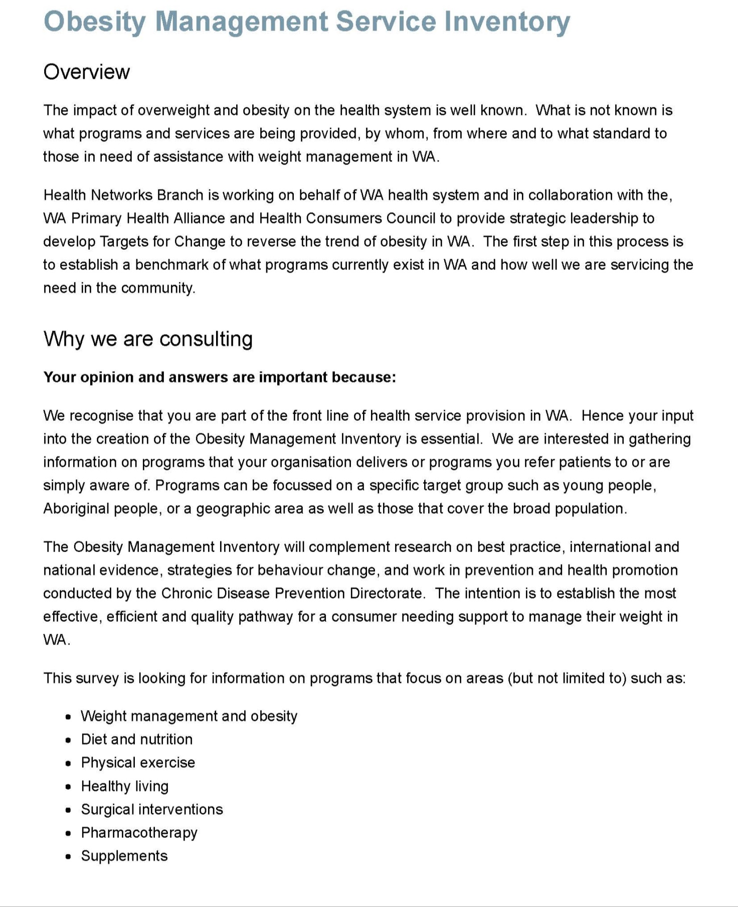
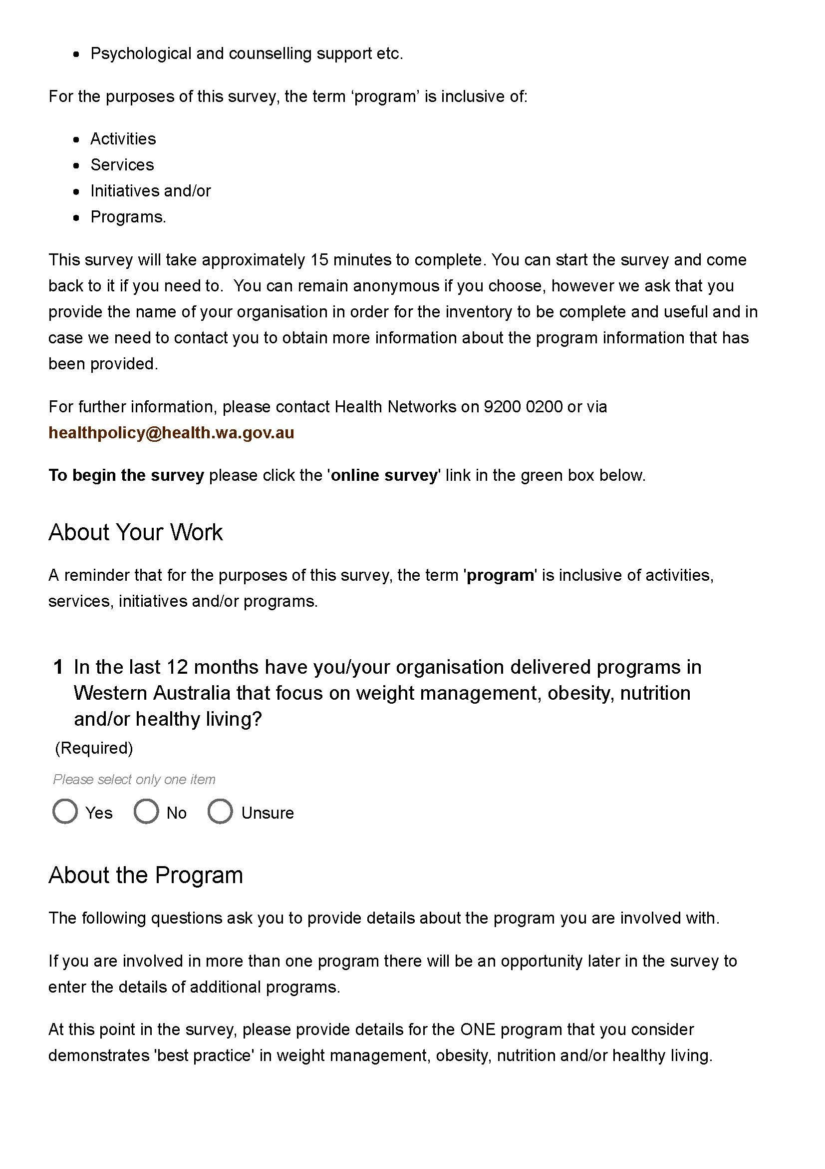
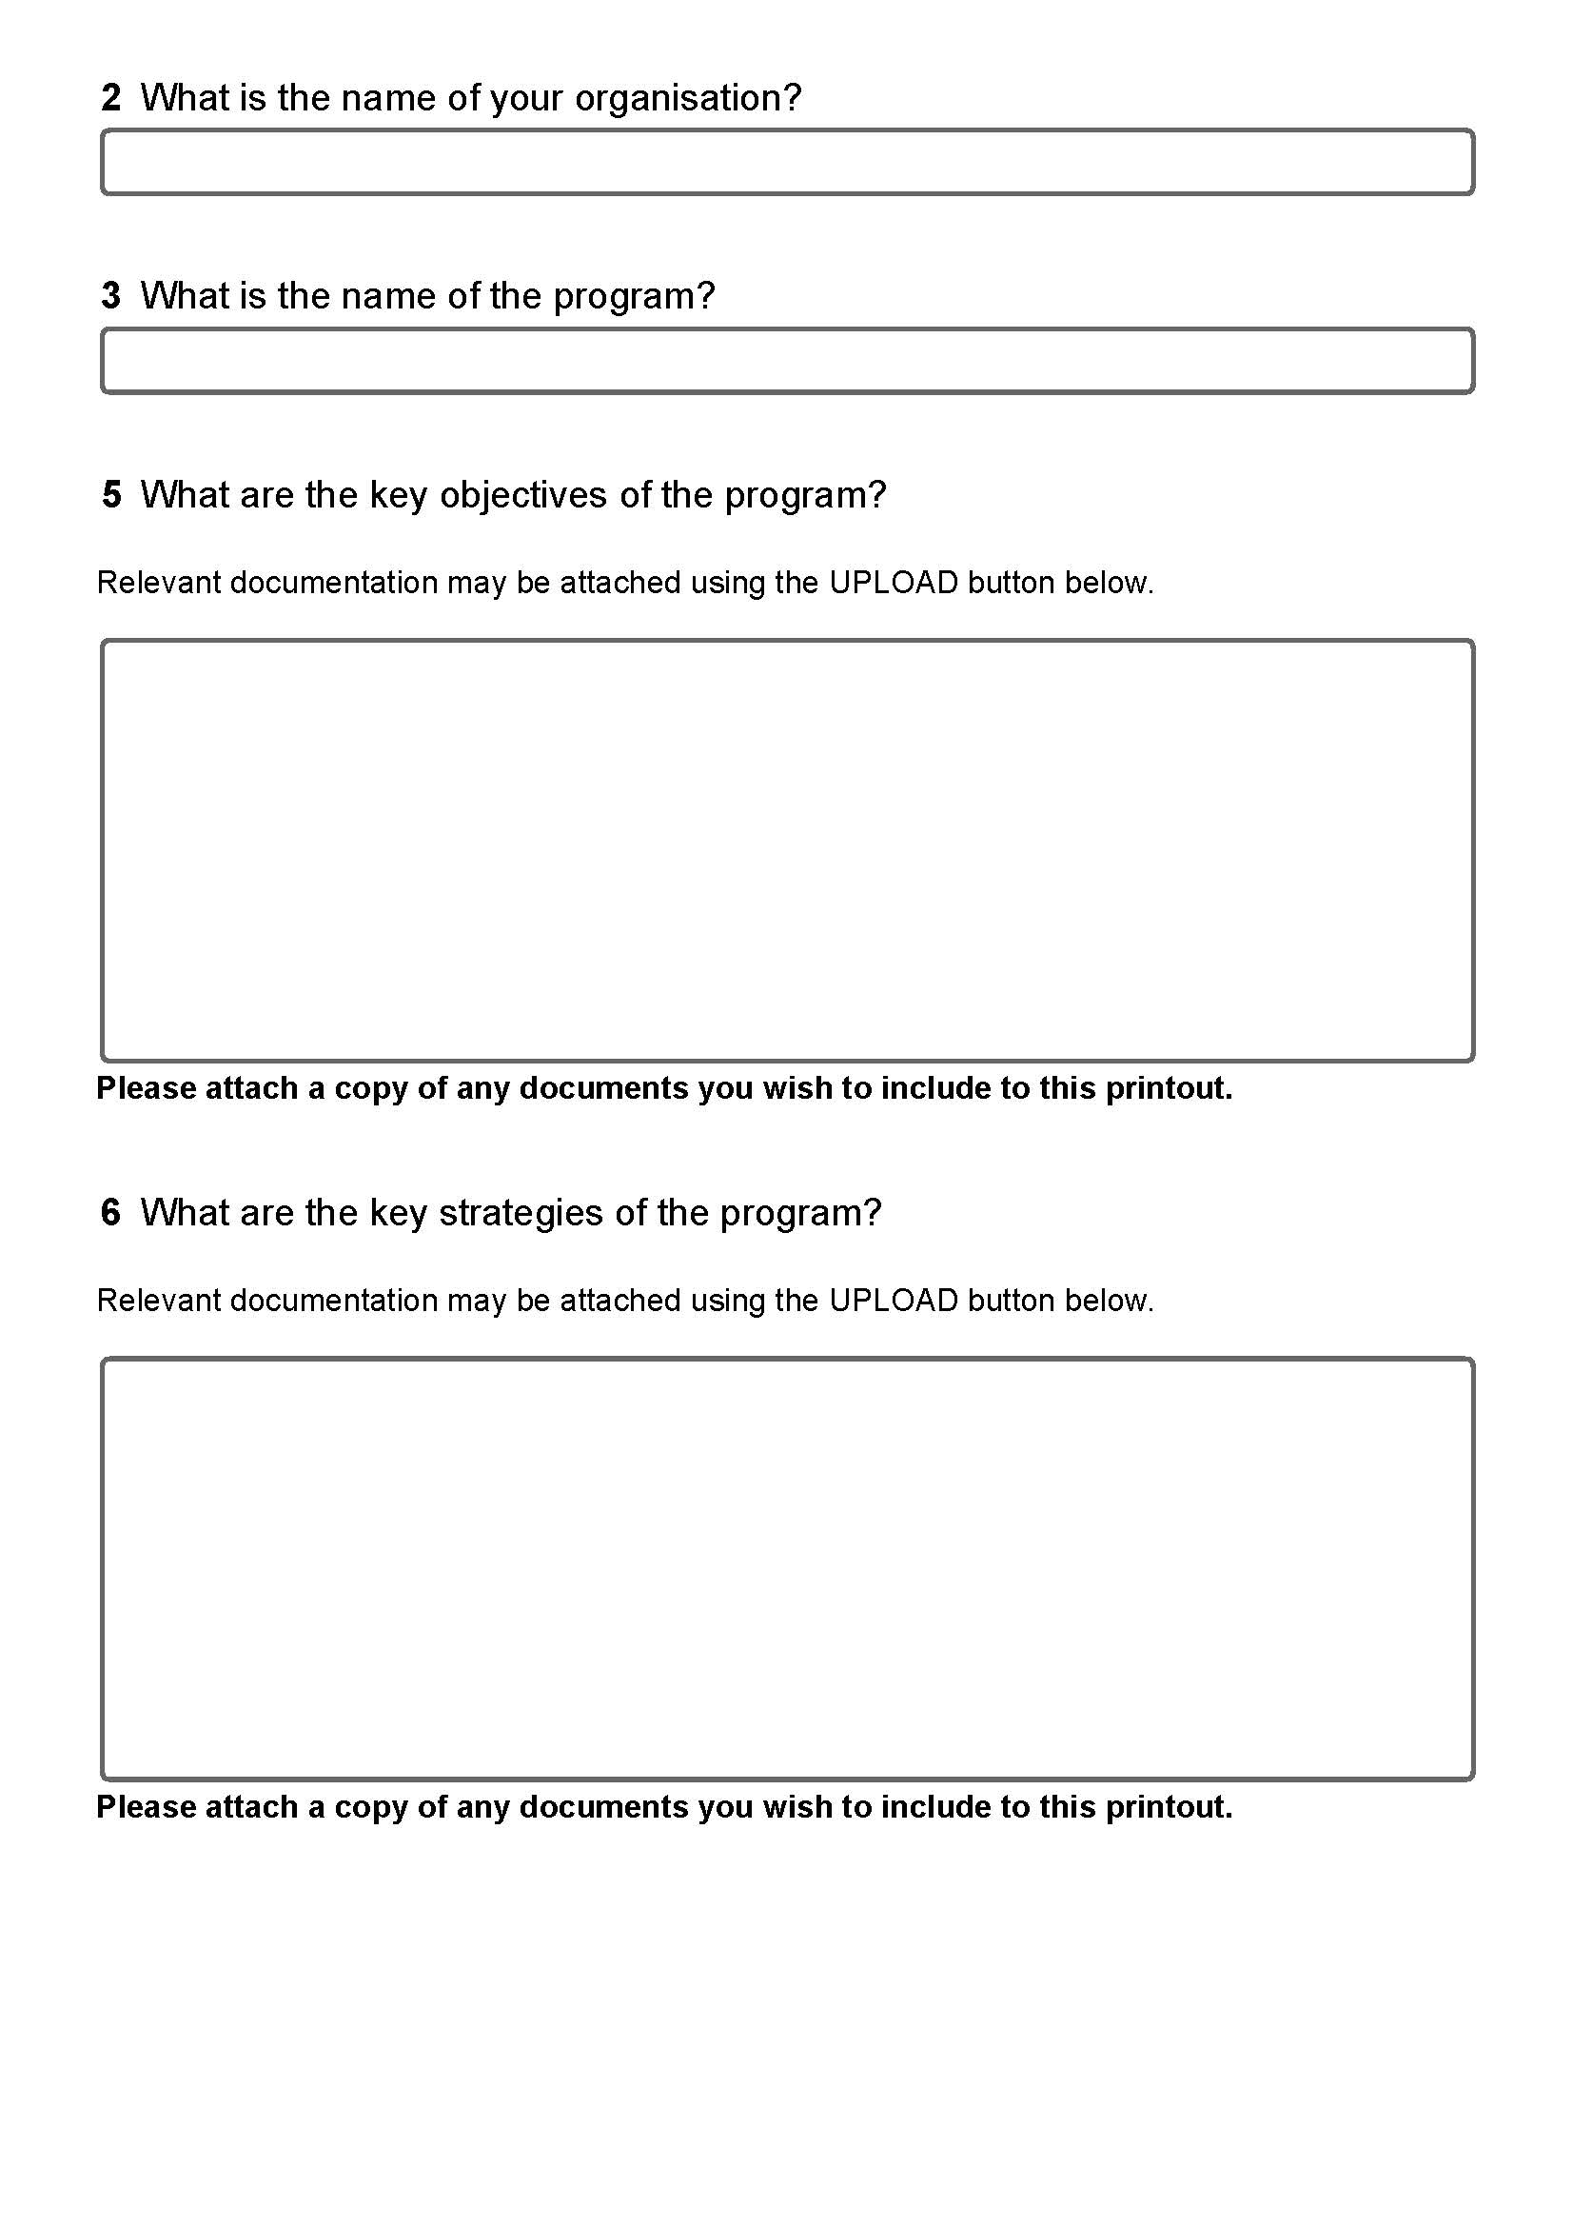
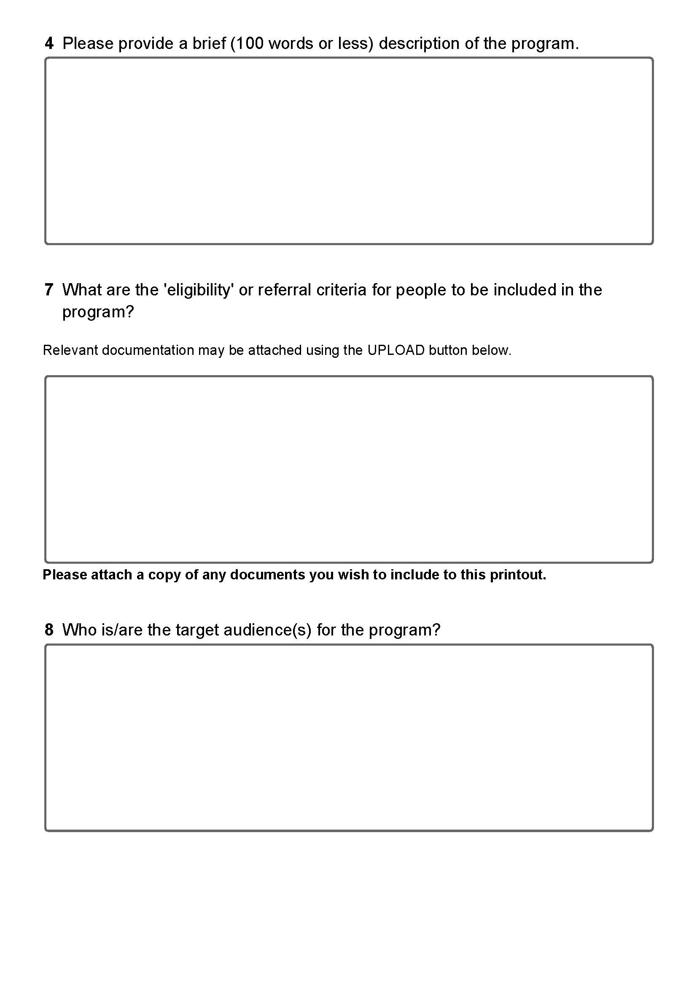
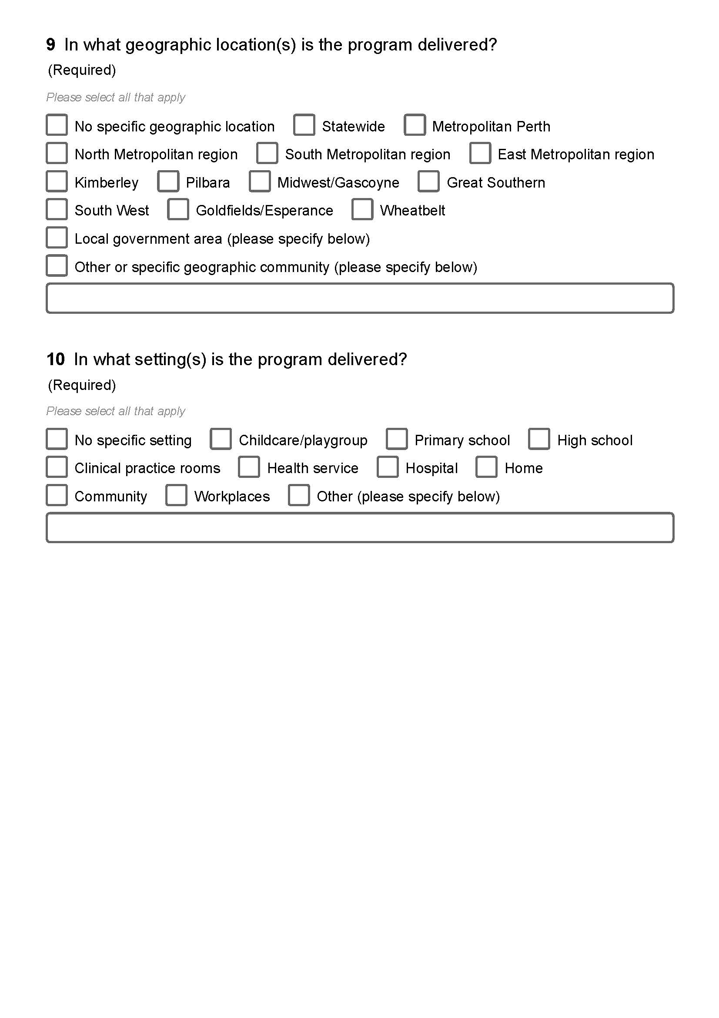
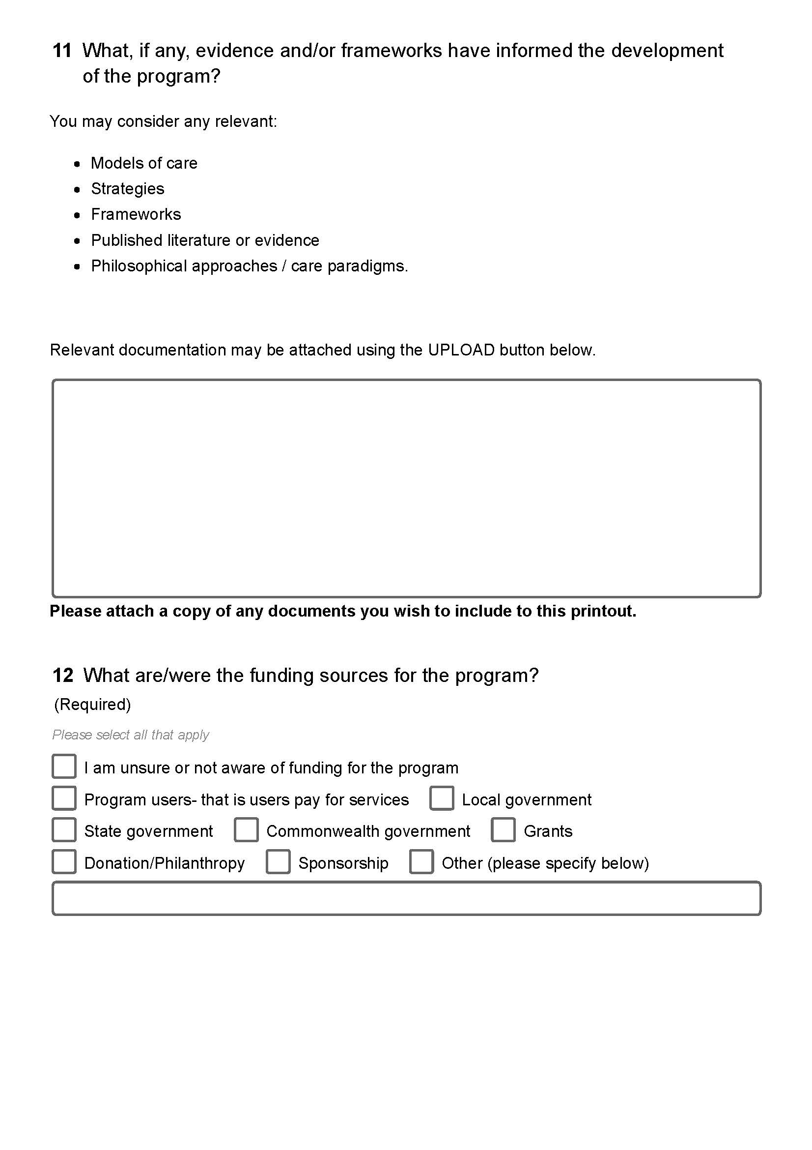
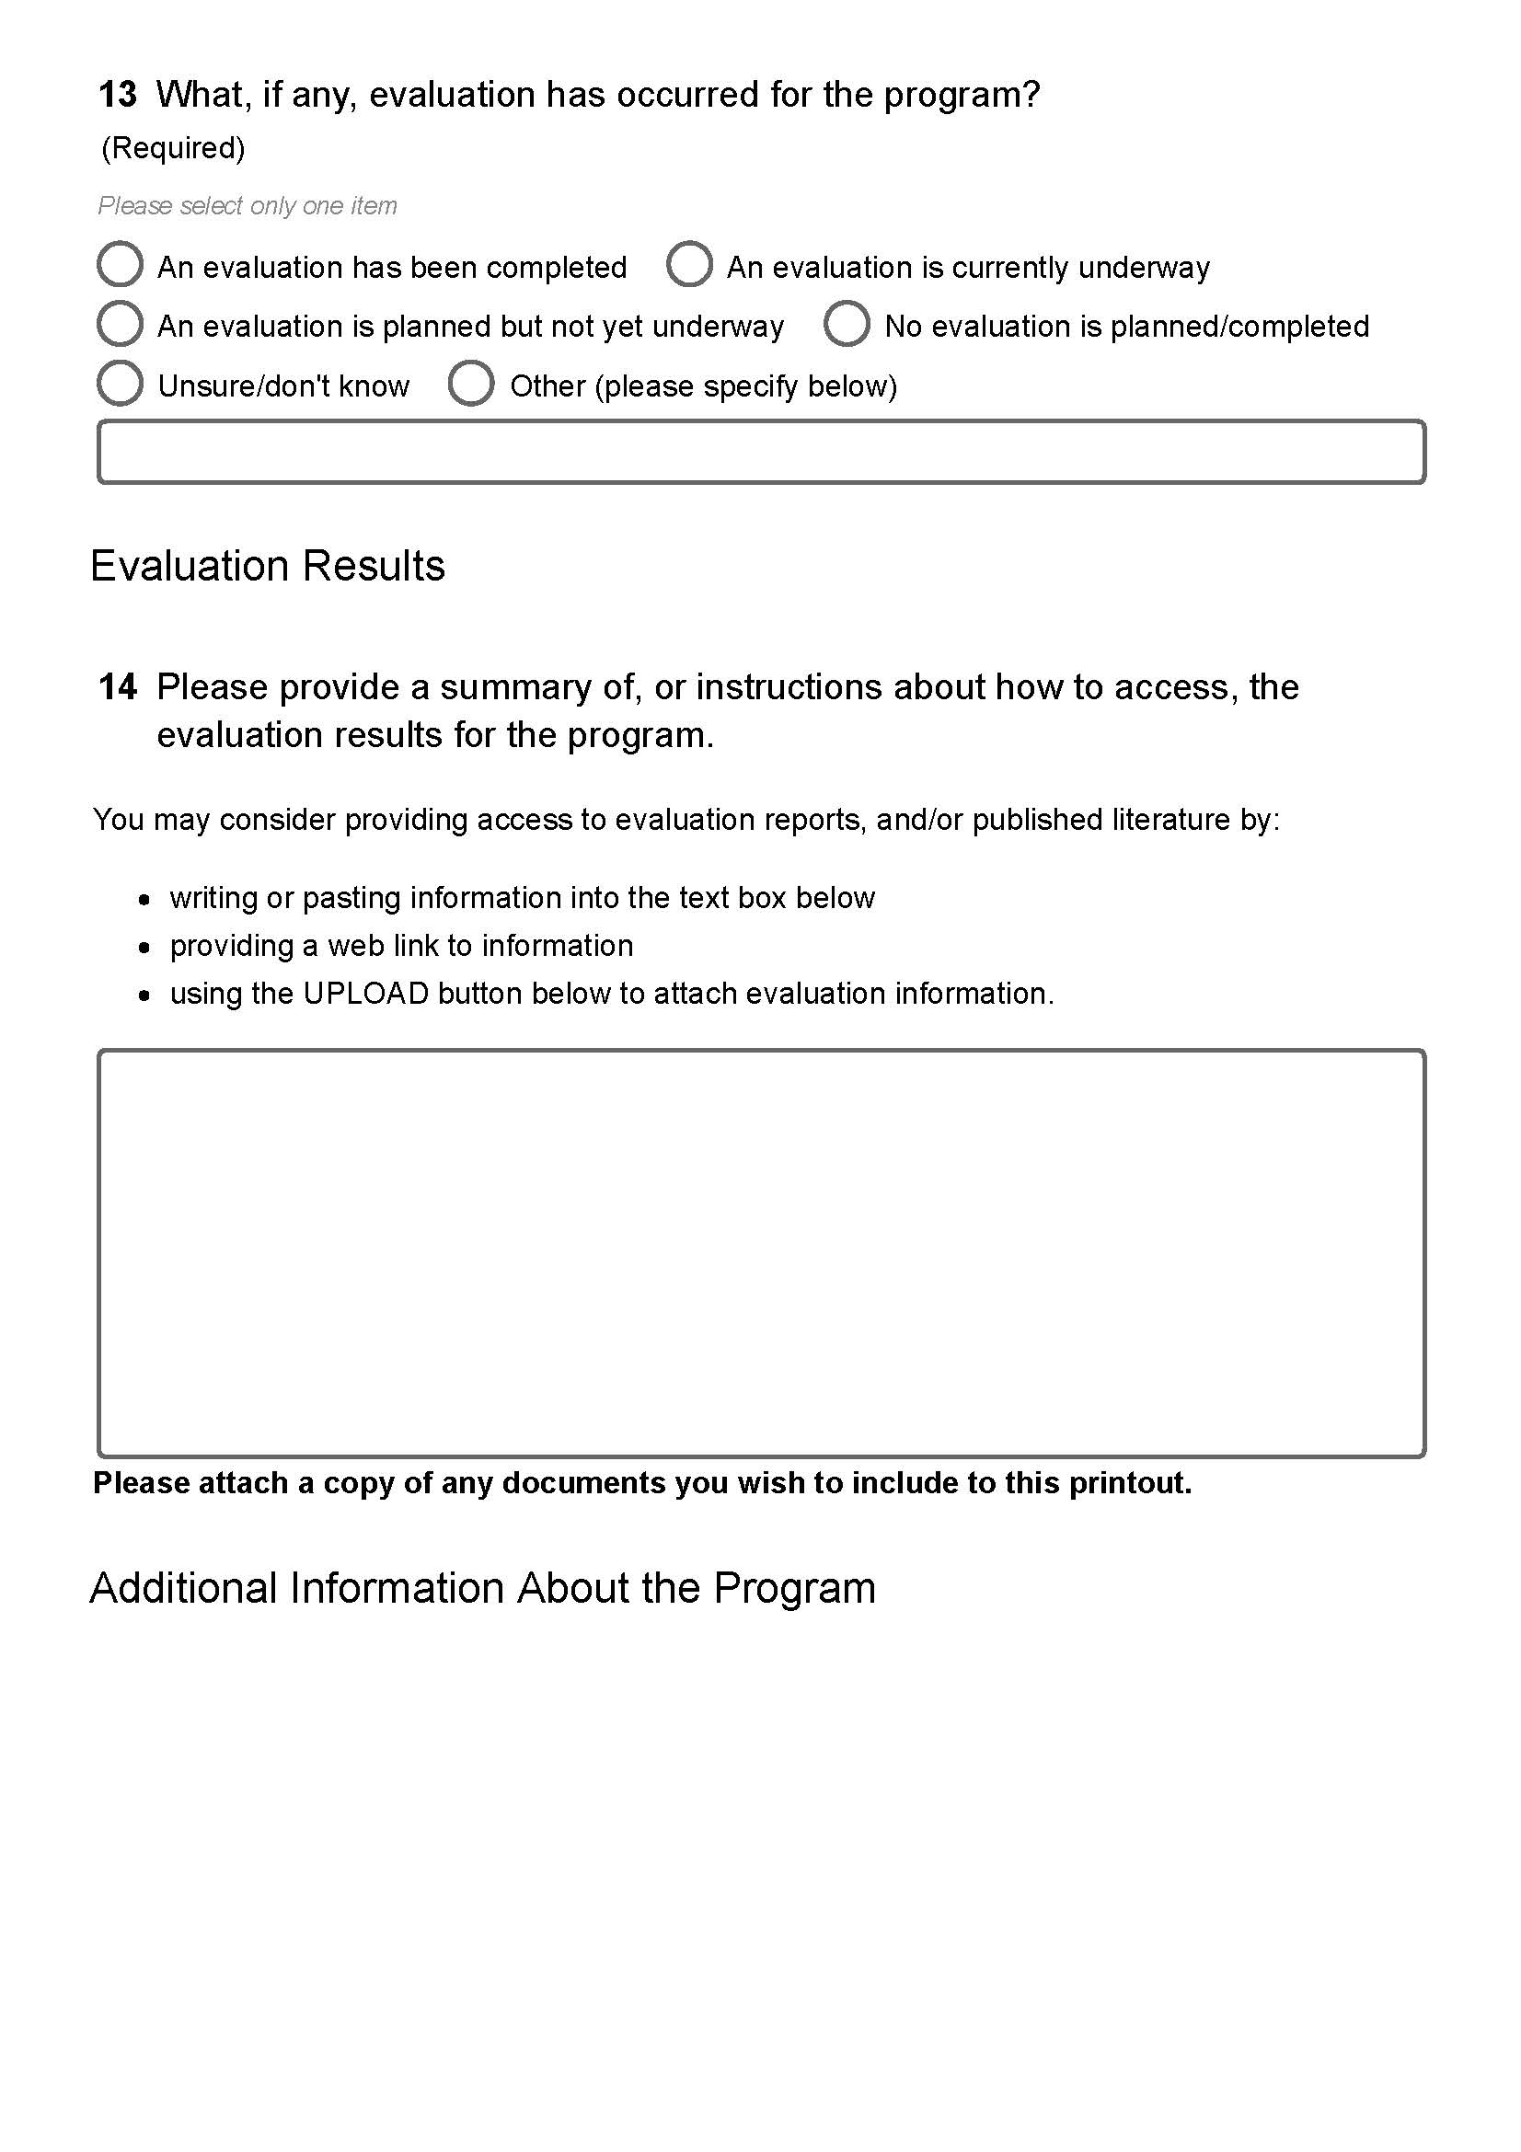
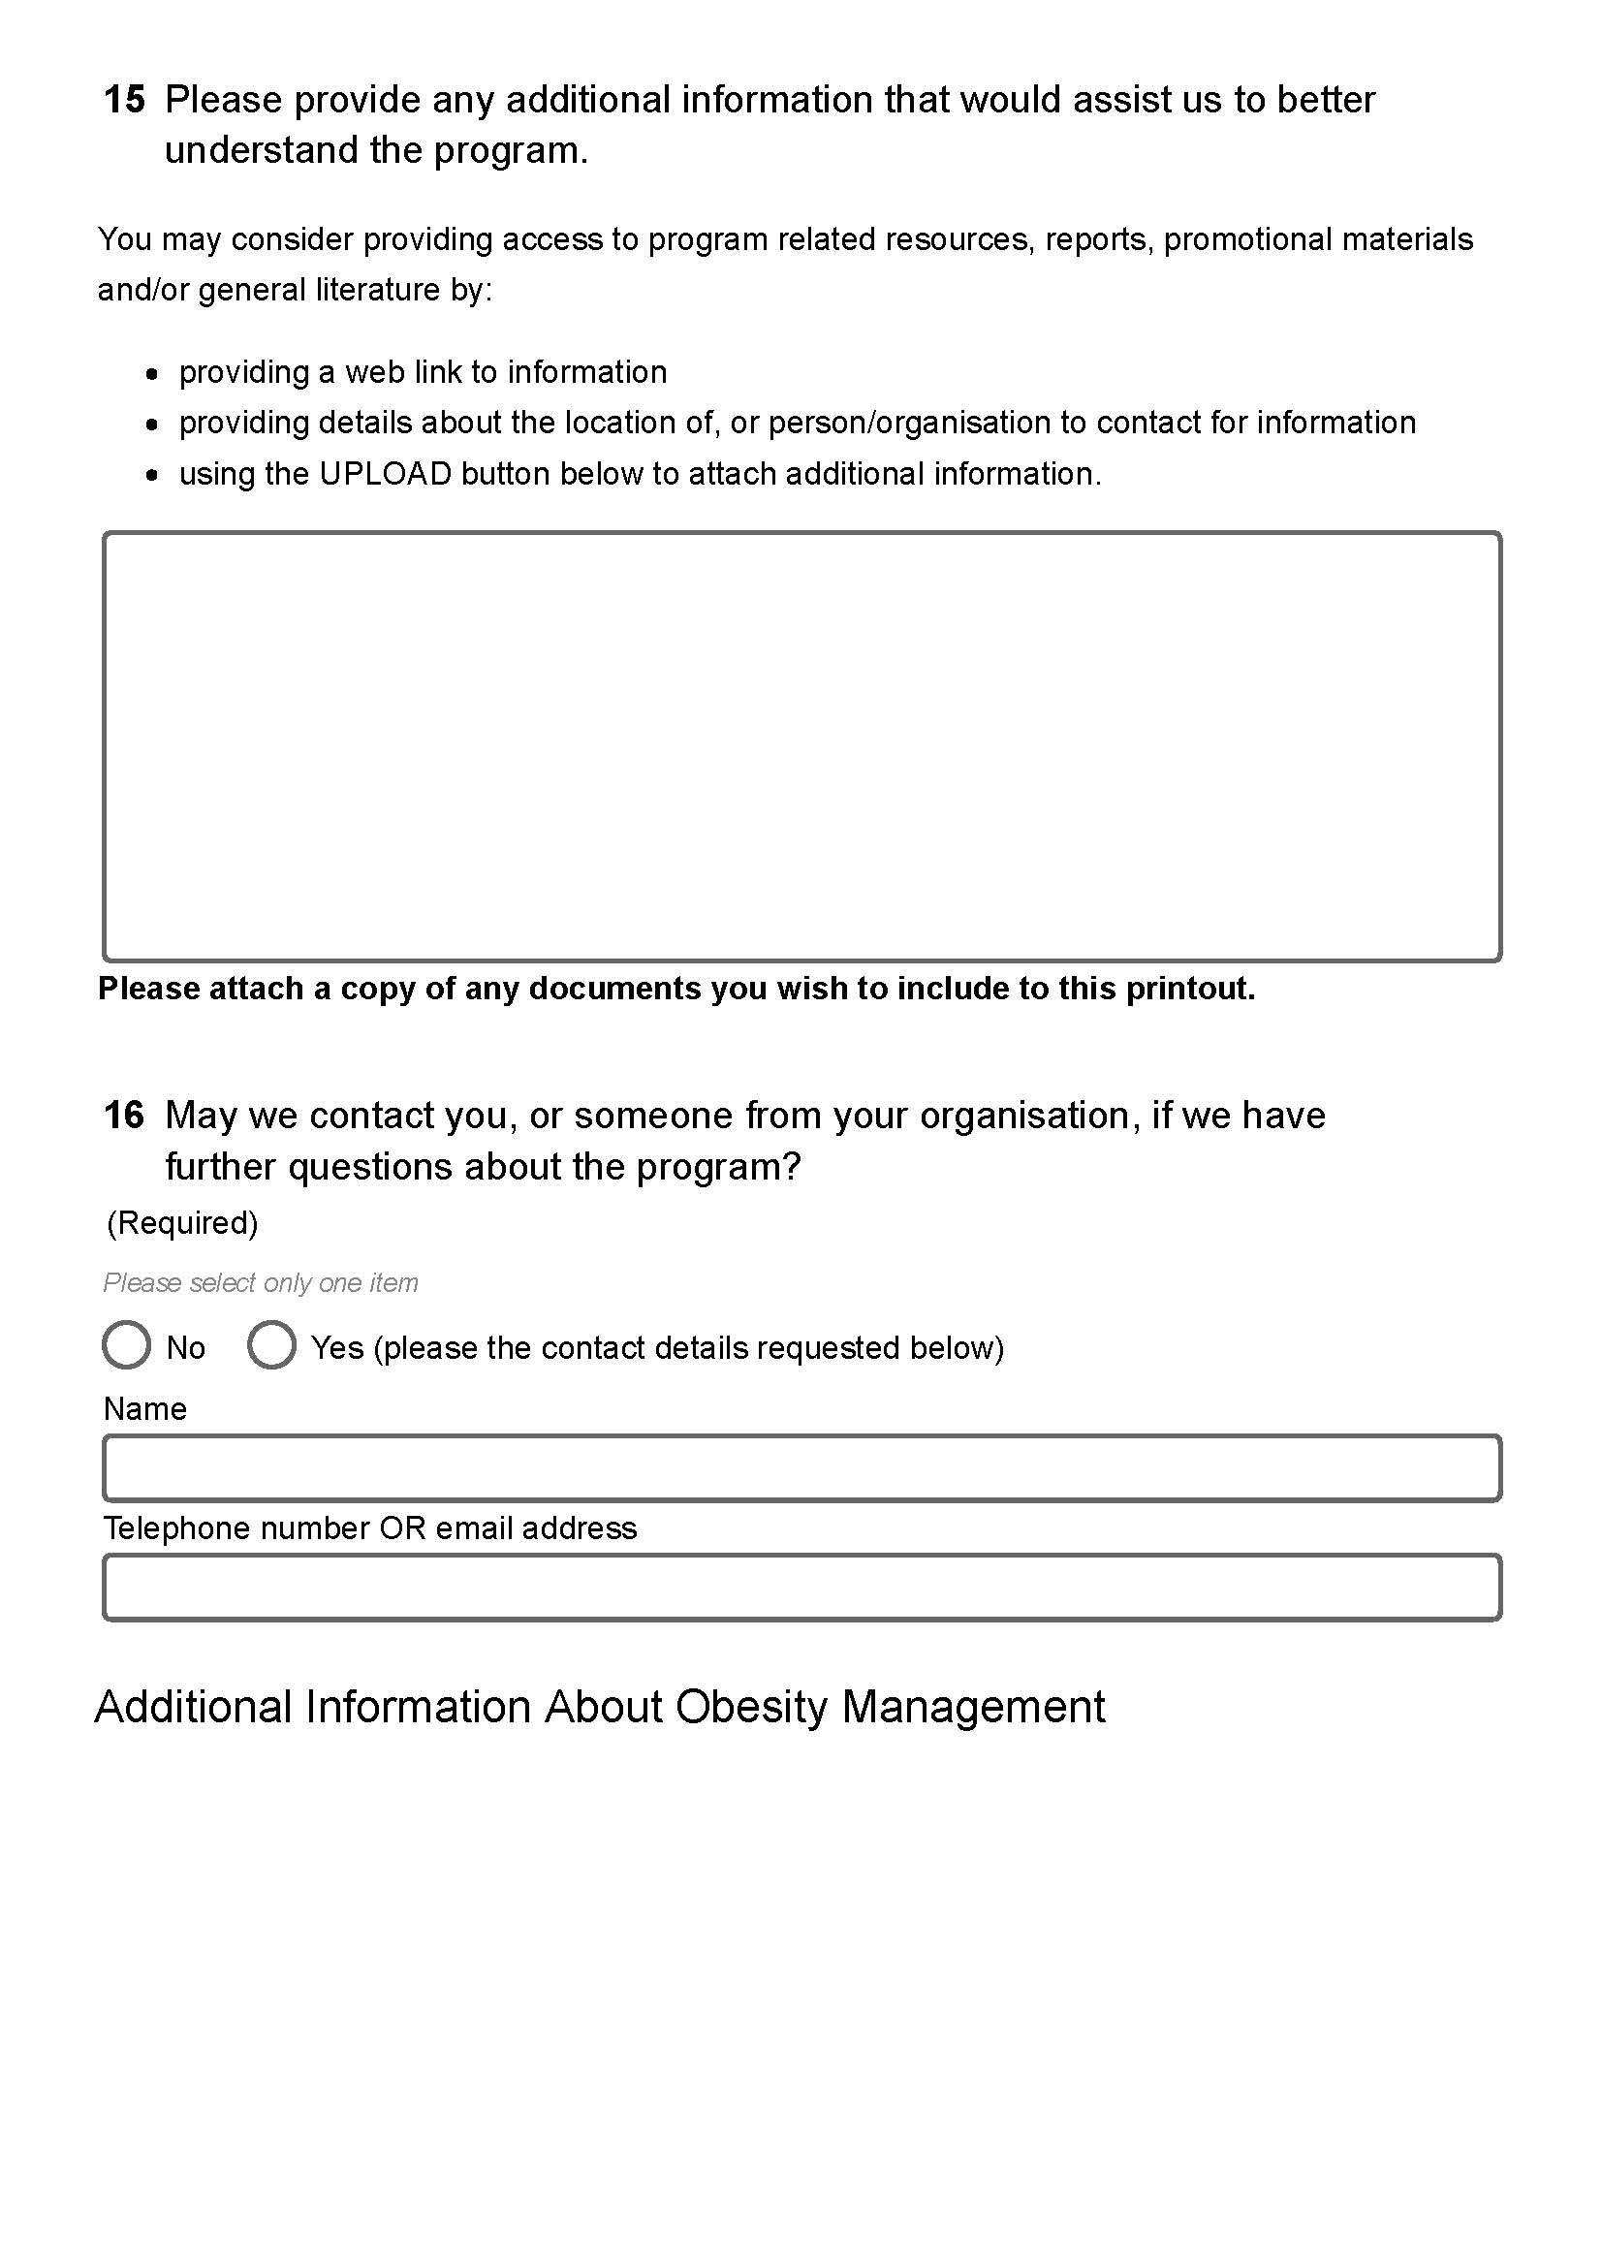
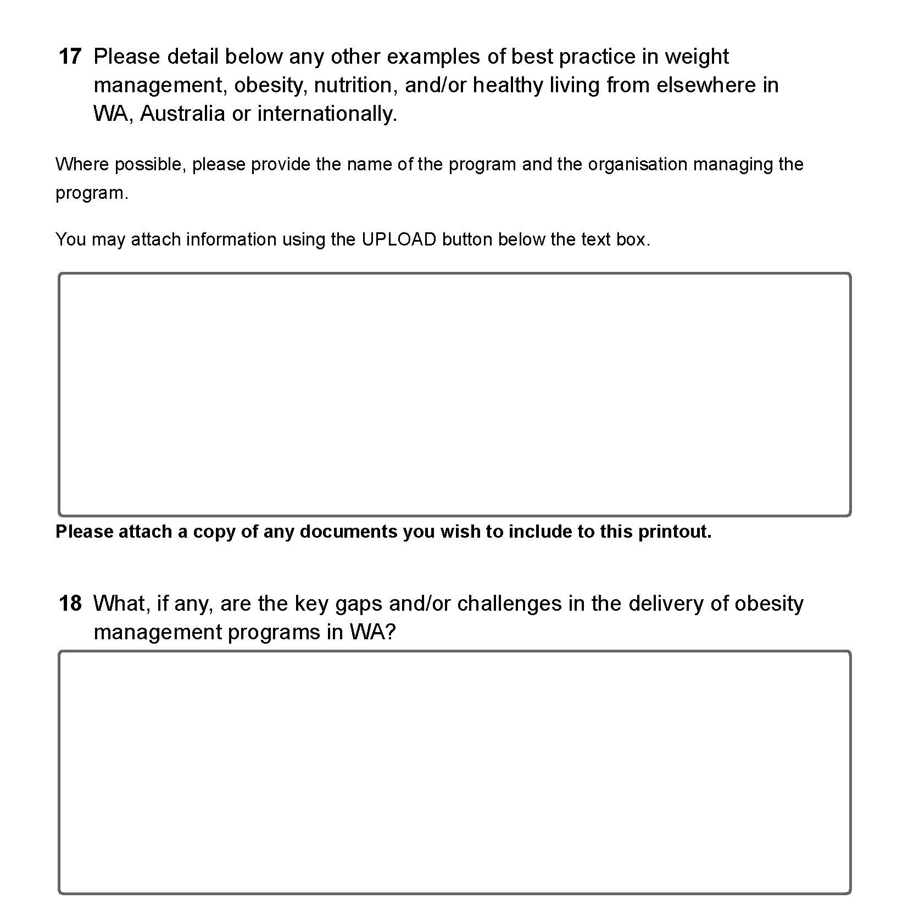

Appendix B: Obesity management services inventory additional findings
Priority populations:
- 14 programs catered explicitly for a priority population
  - 2 for Aboriginal people
  - 3 for people with disability
  - 9 for families
- Other populations mentioned:
  - Pregnant women
  - At risk of chronic disease
  - People with mental health conditions
  - Vulnerable groups
BMI range
- 19 programs catered for people of all BMI ranges. These programs were often focussed on general health improvement or chronic disease management rather than weight loss for people who were overweight or obese
- 21 programs could not be categorised as the information was not available publically or in the survey results
- Programs focusing specifically on weight loss for people above a healthy BMI:
  - 7 catered for people who are overweight or obese (BMI ≥ 25)
  - 4 catered for people who are obese (BMI ≥ 30)
  - 1 catered for people who are obese class II and III (BMI ≥ 35)
  - 1 specifically excluded people who were obese class III (BMI ≥ 40)

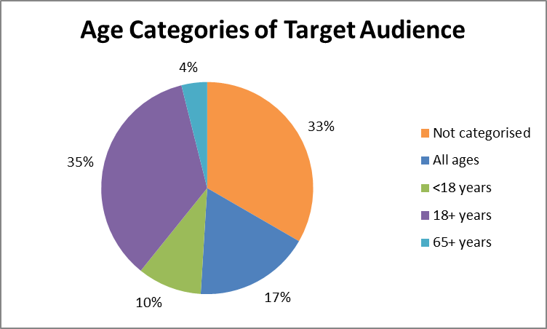
Note 1: 17 programs could not be categorised for age of their target audience as the information was not available publically or via survey results
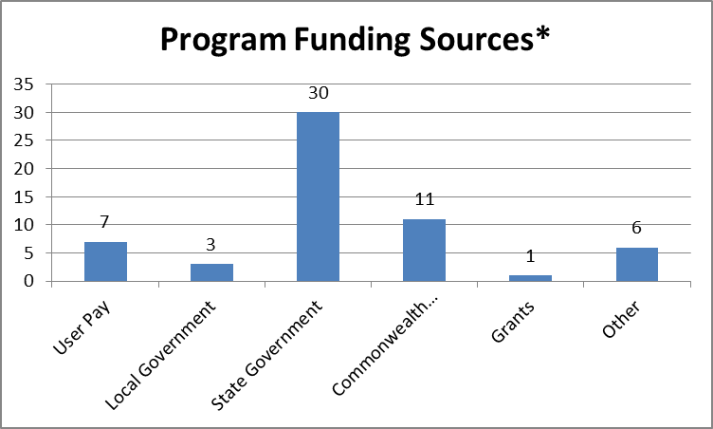
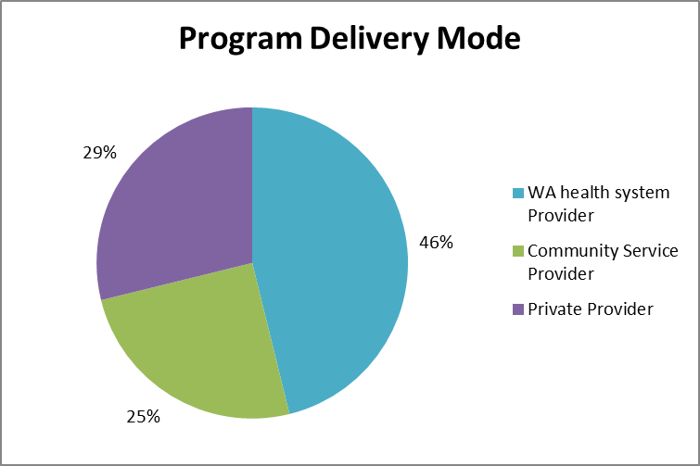
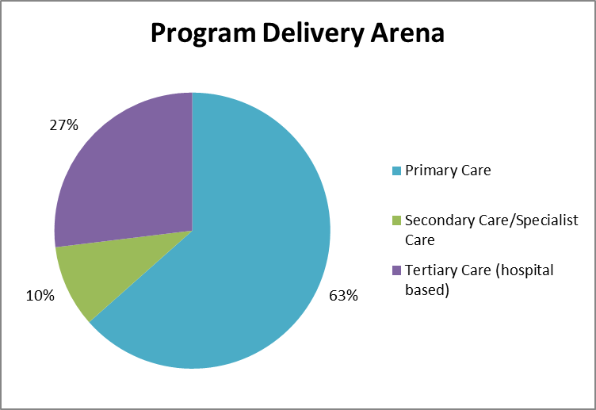
Note 2: Of the programs run in primary care - 39% are run by community service providers with government funding and 39% are private organisations
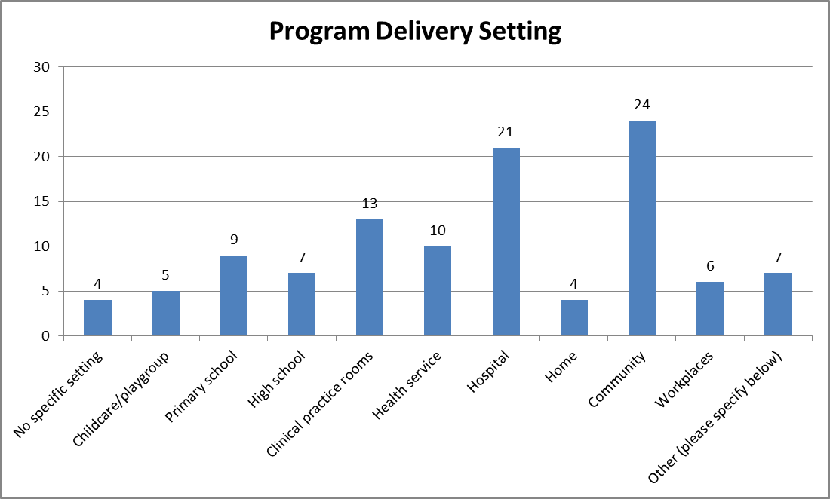
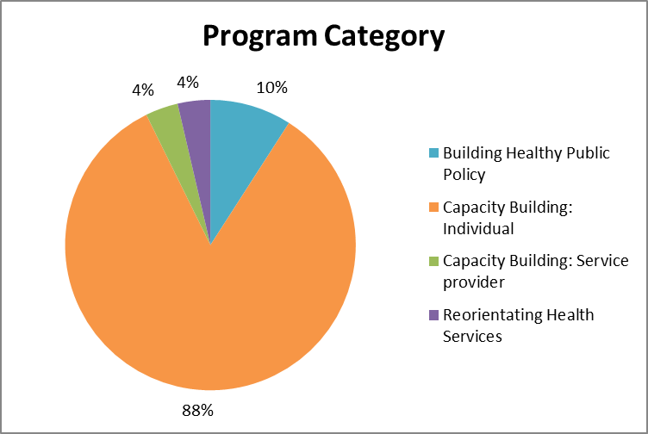
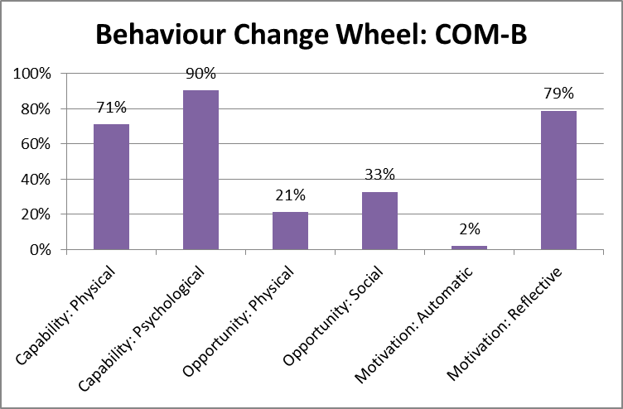
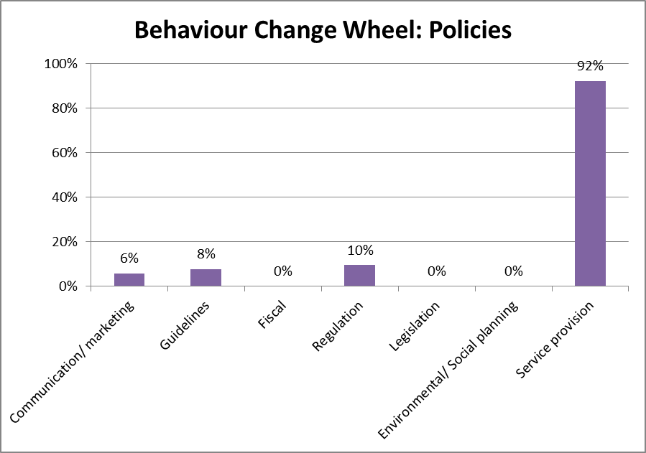
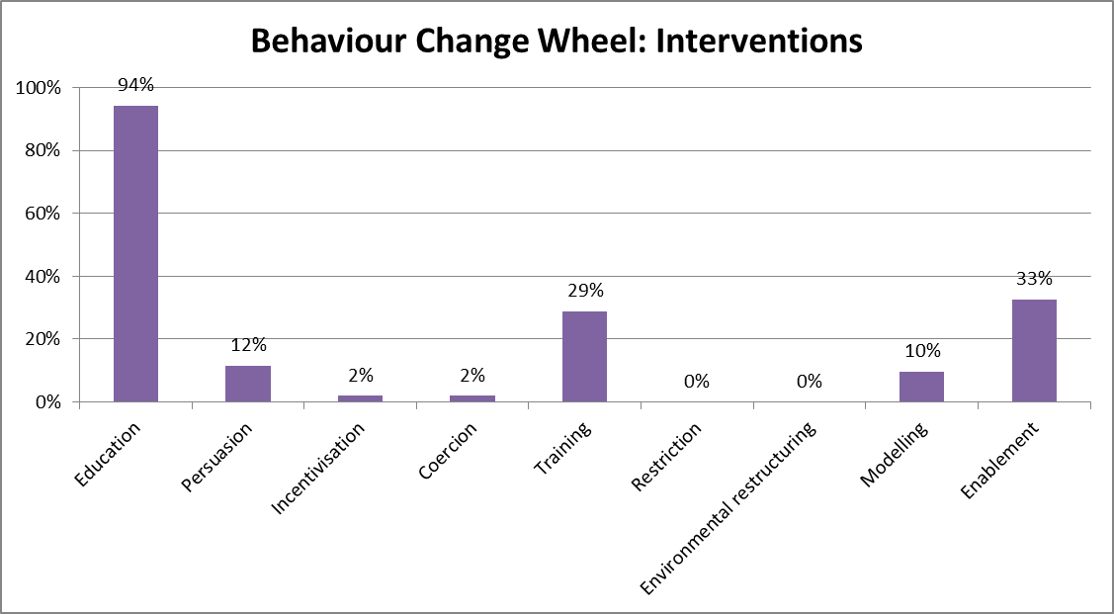

Appendix C: CitizenSpace Survey
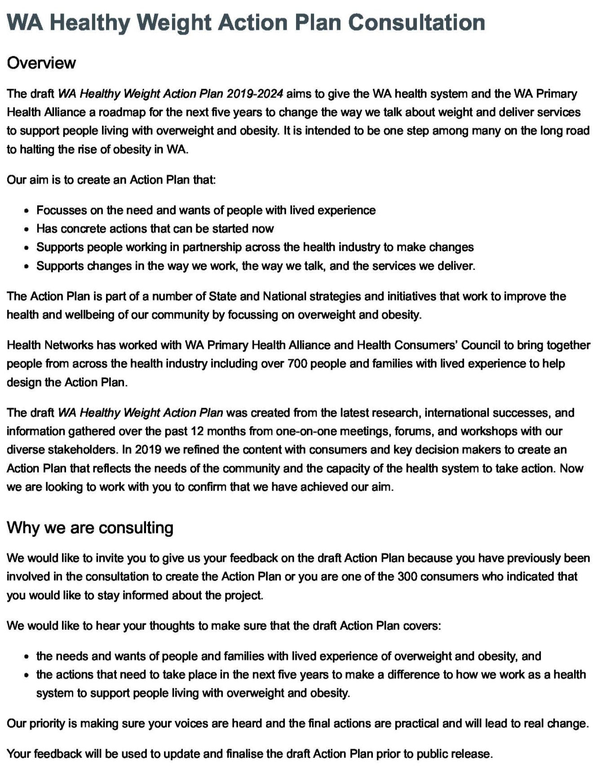
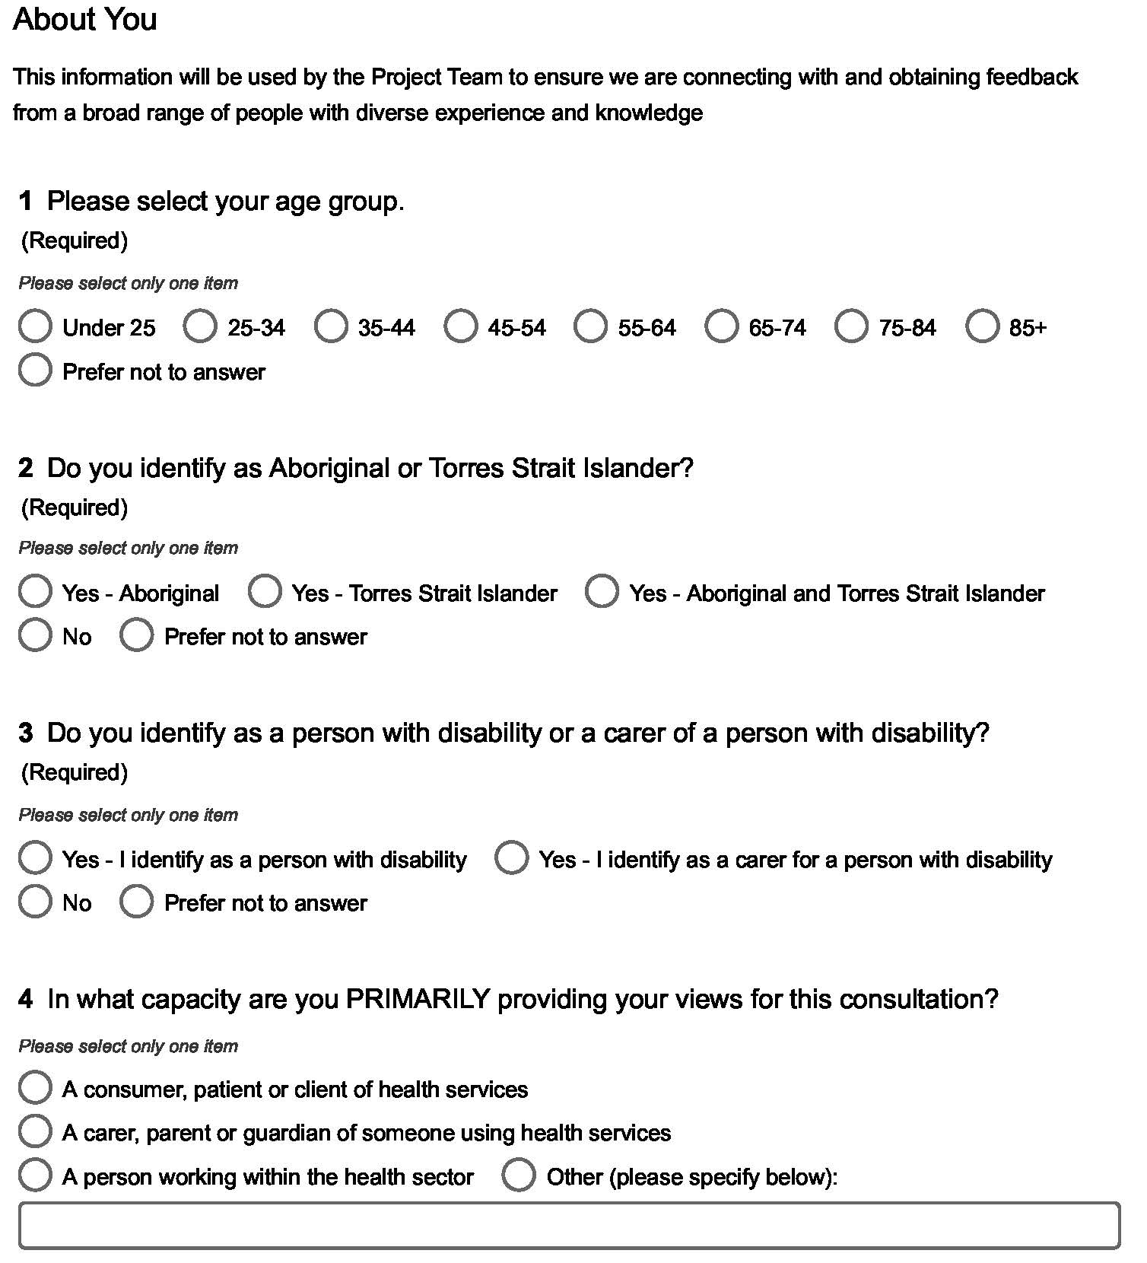

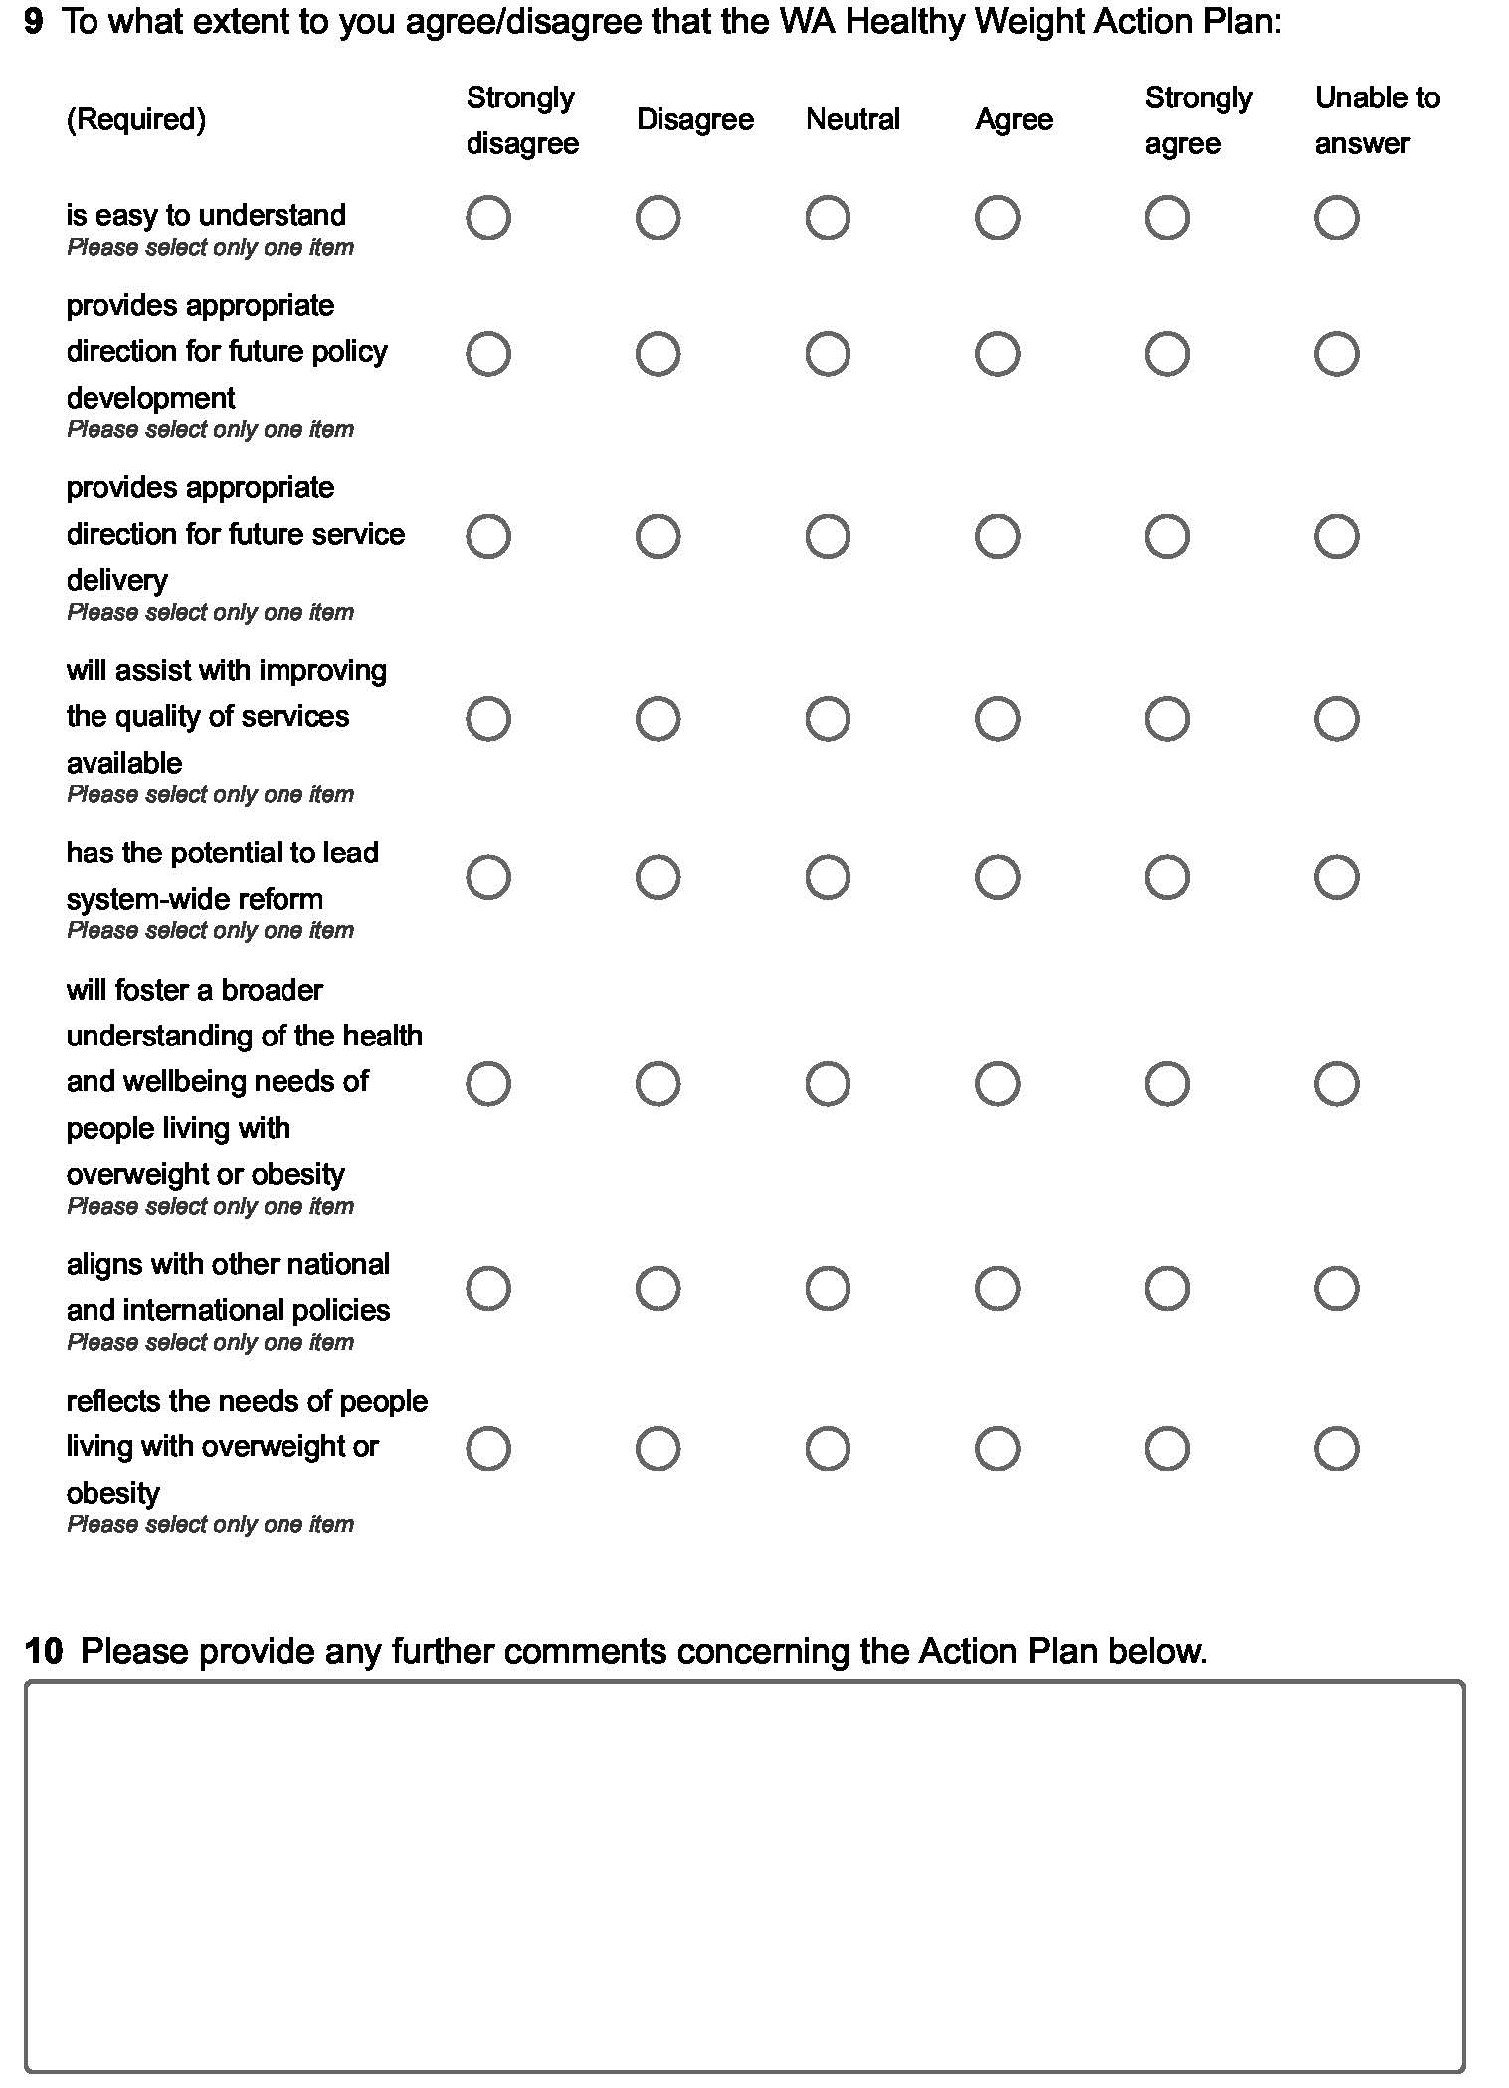

Michie, S., van Straalen, M., and West, R. “The behaviour change wheel: A new method for characterising and designing behaviour change interventions” Implementation Science 6 (2011)
Michie, S., Ashford, S., Sniehotta, F.F., Dombrowski, S.U., Bishop, A. and French, D.P. “A refined taxonomy of behaviour change techniques to help people change their physical activity and healthy eating behaviours: The CALORE taxonomy” Psychology & Health 26 (2011): 1479-1498

