Vision: A community that supports maintaining a healthy life
Purpose
The WA Healthy Weight Action Plan 2019-2024 is a map for action over the next five years to support coordinated activity that will positively impact the early intervention and management of overweight and obesity in WA. The Action Plan aligns to the Sustainable Health Review Final Report Strategy 1 Recommendation 2a: Halt the rise in obesity in WA by July 2024 and have the highest percentage of population with a healthy weight of all states in Australia by July 2029. It has been developed with input from people with experience as well as people who work in various roles in the health system.
Framework for action and desired outcomes
 | - Connect better | Coordinated approach and connected conversations to improving early intervention and weight management services across WA based on co-design and collaboration.
 | - Change how we talk about weight | Improved community, health professional and service provider understanding and attitudes related to the impact of stigmatisation of obesity on individuals, families and the community.
 | - Better access and care coordination | - People and families have access to a variety of publically funded options to support and empower them to improve their health and wellbeing and achieve a healthier weight.  - Clear service pathways exist that enable improved access to services, programs and support.  - Make every contact count.
 | - Build workforce capability and confidence | Create a more agile, responsive and well equipped health workforce to work in a person- and family-centred way to empower people to seek support in the early intervention and management of overweight and obesity.
 | - Quality improvement | Steps for quality improvement are embedded into system, service, and program design and accurate and reliable data is available for use as part of the quality improvement cycle.
 | - Innovation | Create mechanisms and opportunities to prototype innovative approaches that address the complexity of overweight and obesity at a community and service level.
 | - Empower the community to take action | - Improved communities health literacy related to overweight and obesity.  - Mechanisms are used to build and maintain partnerships between communities and all service providers in the design and delivery of early intervention and weight management services and programs.
Definitions
Early intervention  The provision of support or interventions to a person or family at the high end of the healthy weight range to prevent a foreseeable decline in their health | Management  The provision of support or interventions to a person or family with overweight or obesity that will enhance health and wellbeing outcomes, prevent further weight gain or support weight loss
Implementing the vision
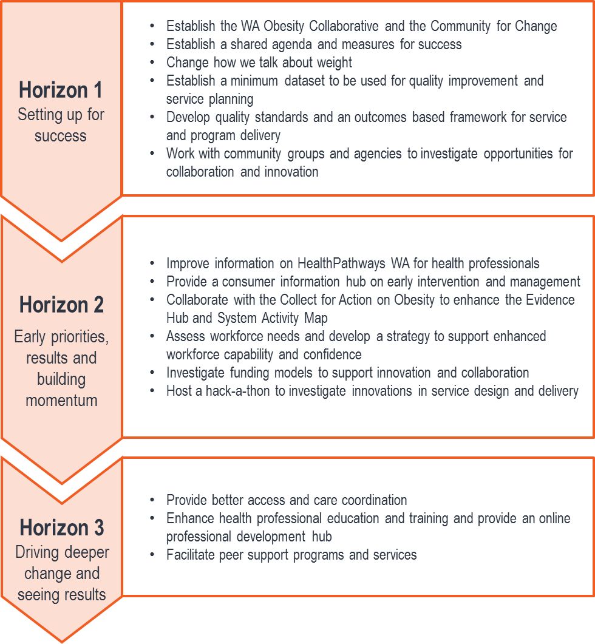
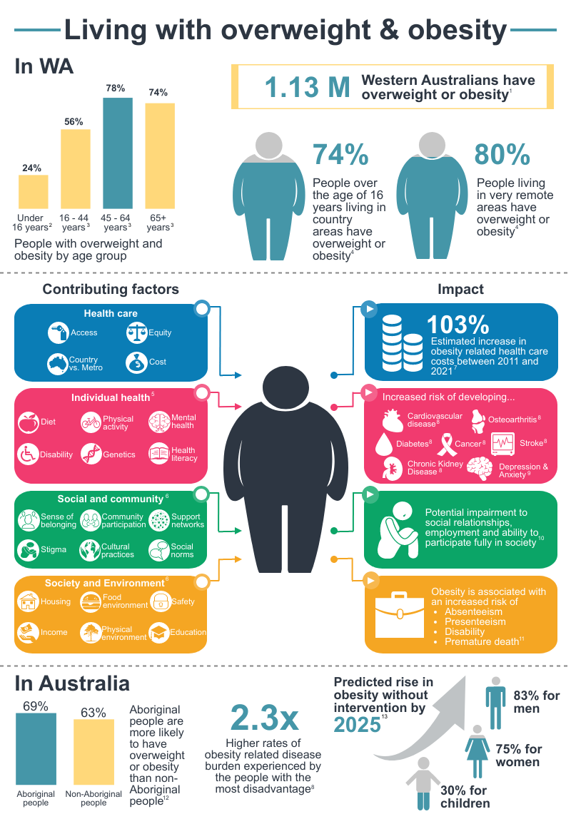

For more information
https://ww2.health.wa.gov.au/Articles/U_Z/WA-Healthy-Weight-Action-Plan

Health Networks, Western Australian Department of Health
(08) 9222 0200 or healthpolicy@health.wa.gov.au

