Quarterly Surveillance Report
Notifiable Sexually Transmissible Infections and Blood-borne Viruses in Western Australia
Period ending 31 December 2019
Vol. 19 (1), issued February 2020

Contents
Summary 2
Chlamydia 2
Gonorrhoea 4
Infectious syphilis 6
HIV 9
Hepatitis B 11
Hepatitis C 14

Notes:
- All data in this report are provisional and subject to future revision.
- To help place the data in this report in perspective, comparisons with other reporting periods are provided. As no formal statistical testing has been conducted, some caution should be taken with interpretation.
- Notifications for Christmas Island, Curtin, Leonora, Perth and Yongah Hill Immigration Detention Centres have been excluded from all analyses because of potential bias introduced through the inclusion of cases detected by screening of asylum seekers at these locations in previous years.

Copyright to this material is vested in the State of Western Australia unless otherwise indicated. Apart from any fair dealing for the purposes of private study, research, criticism or review, as permitted under the provisions of the Copyright Act 1968, no part may be reproduced or re-used for any purposes whatsoever without written permission of the State of Western Australia.

Produced by the Immunisation, Surveillance and Disease Control Program,
Communicable Disease Control Directorate,
Department of Health, Western Australia.

Summary
Table 1 Number and percentage change of STI and BBV notifications by reporting period, WA
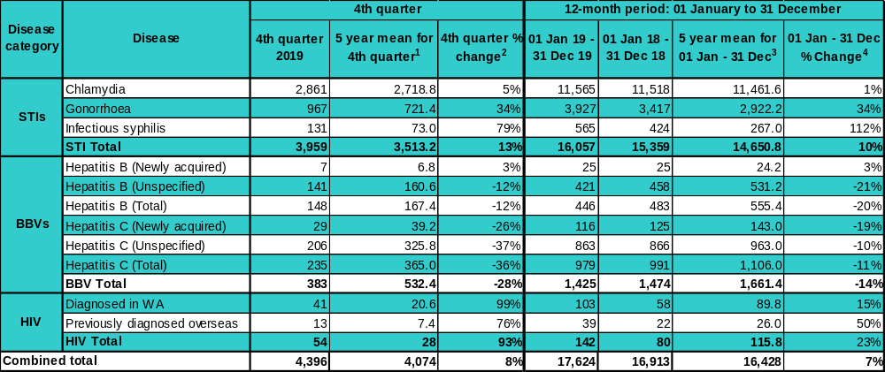
Notes: ¹ Historical five-year mean (i.e. from 2014 to 2018) for the current quarter.
² Percentage change of the number of notifications in the current quarter compared to the historical five-year mean of the same quarter. Positive values indicate an increase compared to the historical five-year mean of the same quarter. Negative values indicate a decrease compared to the historical five-year mean of the same quarter.
³ Historical five-year mean (i.e. from 2014 to 2018) for the current 12-month period.
⁴ Percentage change of the number of notifications in the current 12-month period compared to the historical five-year mean for the same 12-month period. For interpretation of positive and negative values, see note 2.

Chlamydia
Figure 1 Number of chlamydia notifications in WA by month, for the two most recent 12-month periods
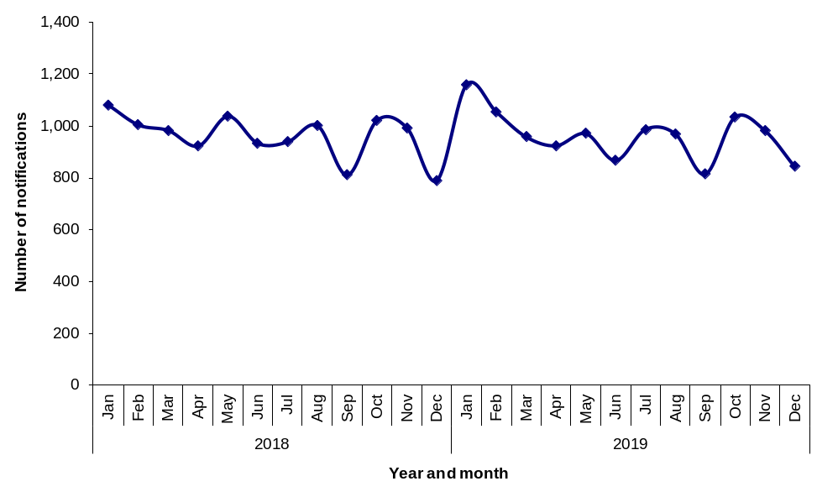
- The number of chlamydia notifications for the 12-month period from January 2019 to December 2019 was comparable to the previous 12-month period and the previous five-year mean, reflecting relative stability in chlamydia notifications over this period (Table 1).
Table 2 Number and proportion of chlamydia notifications in WA by sex, for the two most recent 12-month periods
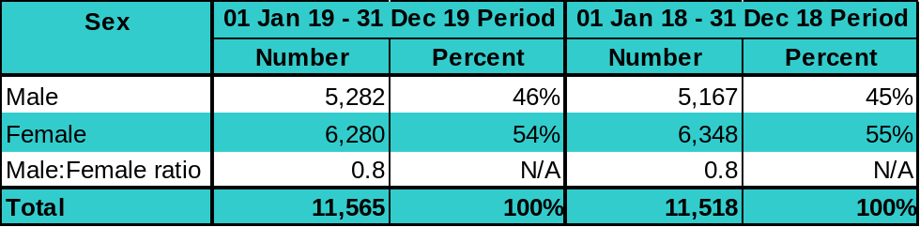
Notes: N/A = Not applicable
In addition to the number of notifications above, there were three notifications among transgender people in the 12-month period from January 2019 to December 2019 and three notifications among transgender people in the 12-month period from January 2018 to December 2018
Table 3 Number and proportion of chlamydia notifications in WA by age group, for the two most recent 12-month periods
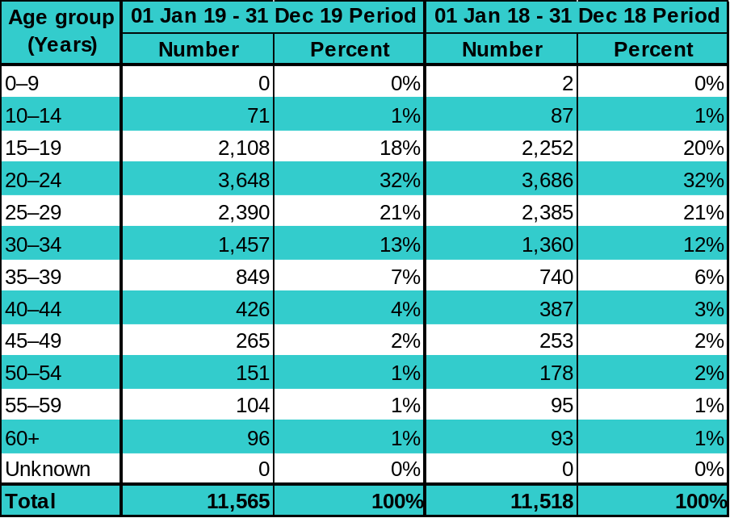
- The largest proportion of chlamydia notifications was among 20 to 24 year olds, and notifications among this age group remained stable in comparison to the previous 12-month period. Notifications among 15 to 19 year olds decreased by 6%.
Table 4 Number and crude rate of chlamydia notifications in WA by Aboriginality, for the two most recent 12-month periods
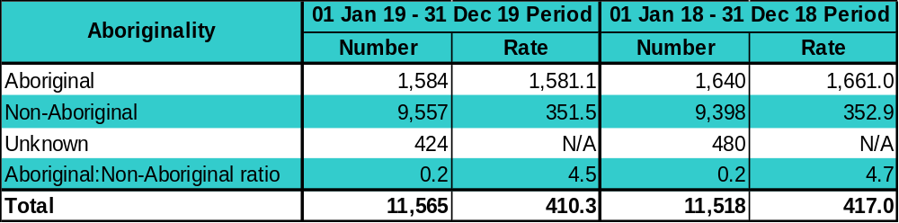
Notes: Rate = Crude notification rate per 100,000 population
N/A = Not applicable

Table 5 Number and crude rate of chlamydia notifications in WA by region, for the two most recent 12-month periods
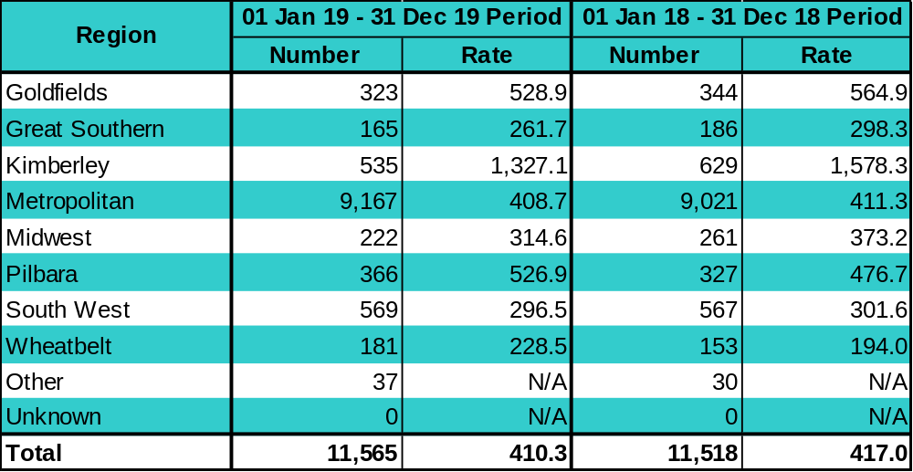
Notes: Rate = Crude notification rate per 100,000 population
Metropolitan = East Metropolitan + North Metropolitan + South Metropolitan
Other = Overseas residents diagnosed in WA
Unknown = Unknown residential address within WA
N/A = Not applicable
- While chlamydia notification rates declined or remained relatively stable in many regions, there was an increase in the Pilbara and Wheatbelt regions.

Gonorrhoea
Figure 2 Number of gonorrhoea notifications in WA by month, for the two most recent 12-month periods
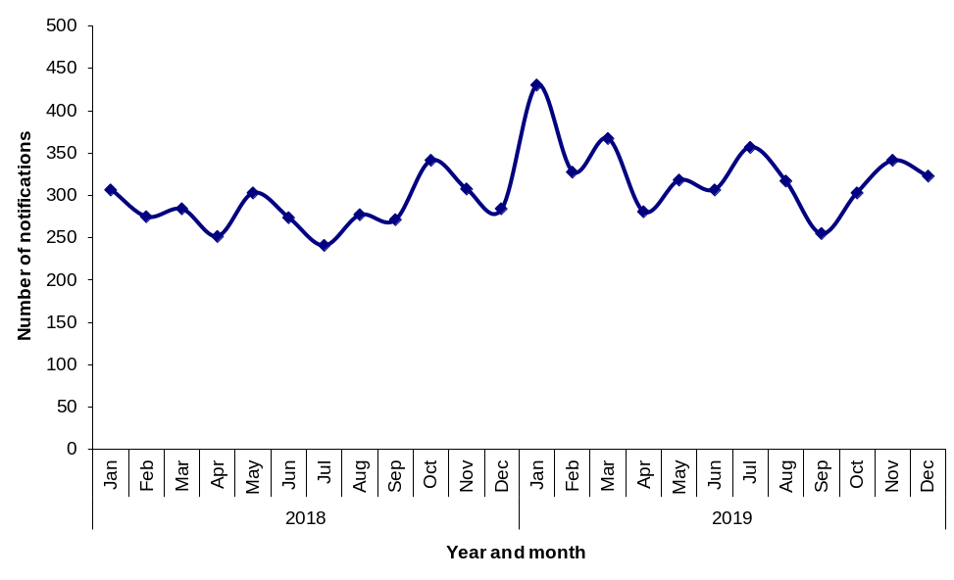
- The total number of gonorrhoea notifications in the most recent 12-month period was 15% higher in comparison to the previous 12-month period and 34% higher than the previous five-year mean (Table 1).
- In the current 12-month period, 59% of notifications had a completed enhanced surveillance form provided by notifying clinicians, compared to the previous five-year mean of 81%.
Table 6 Number and proportion of gonorrhoea notifications in WA by sex, for the two most recent 12-month periods
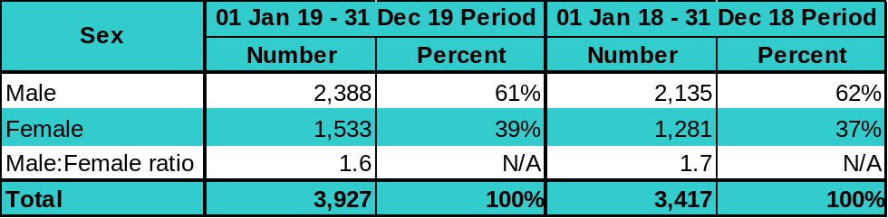
Notes: N/A = Not applicable
In addition to the number of notifications above, there were six notifications among transgender people in the 12-month period from January 2019 to December 2019 and one notification among transgender people in the 12-month period from January 2018 to December 2018
Table 7 Number and proportion of gonorrhoea notifications in WA by age group, for the two most recent 12-month periods
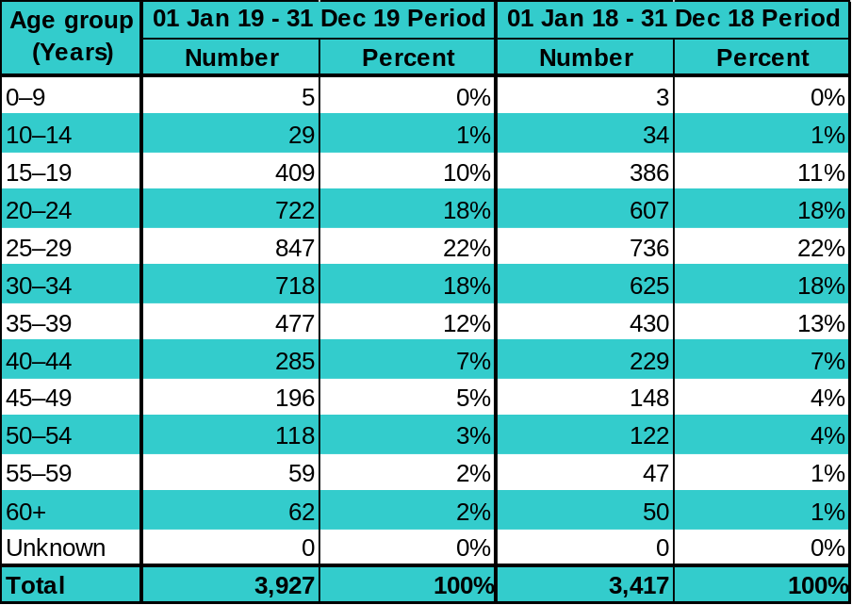
- The 20 to 34 year age group comprised 58% of gonorrhoea notifications and increased by 16% in comparison to the previous 12-month period.
Table 8 Number and crude rate of gonorrhoea notifications in WA by Aboriginality, for the two most recent 12-month periods
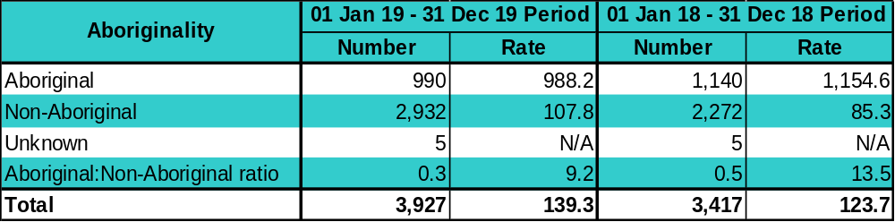
Notes: Rate = Crude notification rate per 100,000 population
N/A = Not applicable
- The gonorrhoea notification rate decreased by 14% among Aboriginal people and increased by 26% among non-Aboriginal people, resulting in a lower rate ratio compared to the previous 12-month period.
Table 9 Number and crude rate of gonorrhoea notifications in WA by region, for the two most recent 12-month periods
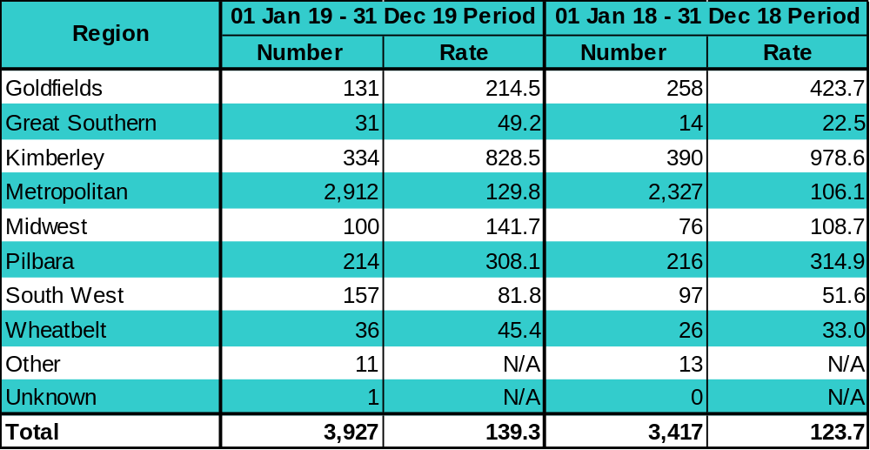
Notes: Rate = Crude notification rate per 100,000 population
Metropolitan = East Metropolitan + North Metropolitan + South Metropolitan
Other = Overseas residents diagnosed in WA
Unknown = Unknown residential address within WA
N/A = Not applicable
- Gonorrhoea notification rates increased in most regions, and most notably in the Great Southern, where the rate doubled. There was a significant decrease in the Goldfields region (49%) and a smaller decrease in the Kimberley region (15%).

Infectious syphilis
Figure 3 Number of infectious syphilis notifications in WA by region and exposure category, for the two most recent 12-month periods
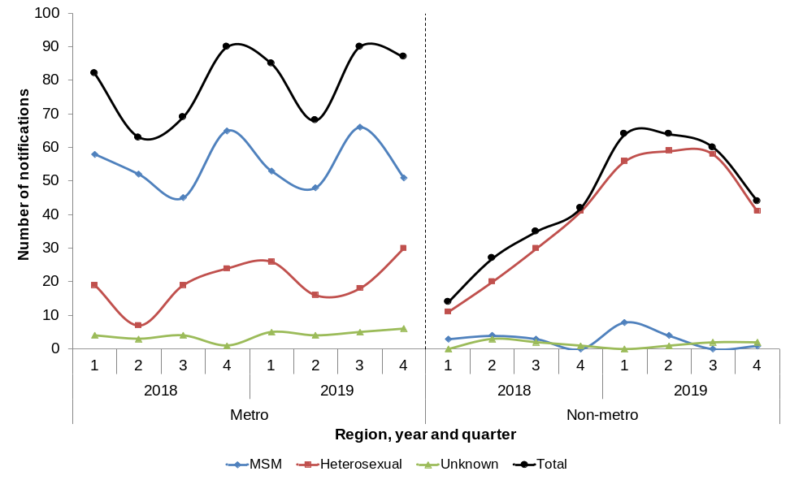
Notes: In addition to the number of notifications above, there were two notifications among transgender people in the 12-month period from January 2019 to December 2019 and three notifications among transgender people in the 12-month period from January 2018 and December 2018
- One congenital syphilis case was reported in the first quarter of 2019 in an Aboriginal child in the Pilbara region.
- The total number of infectious syphilis notifications was 33% higher than the previous 12-month period and double the previous five-year mean (Table 1).
- In the current 12-month period, 88% of notifications had a completed enhanced surveillance form provided by notifying clinicians, which was comparable to the previous five-year mean of 91%.
- In the Perth metropolitan area, the number of notifications categorised as MSM remained relatively stable in comparison to the previous 12-month period (n=218 vs. 220) and was 42% higher than the previous five-year mean of 154 cases per 12-month period.
- The number of notifications in the Perth metropolitan area with an unknown exposure category was 67% higher than the previous 12-month period (n=20 vs. 12), and more than three-times higher than the previous five-year mean of six cases per 12-month period.
Table 10 Number and crude rate of infectious syphilis notifications by Aboriginality for the two most recent 12-month periods, WA
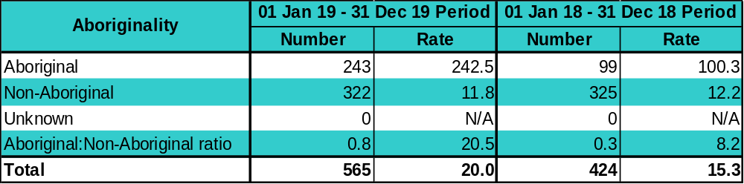
Notes: Rate = Crude notification rate per 100,000 population
N/A = Not applicable
- The infectious syphilis notification rate more than doubled among Aboriginal people and remained relatively stable among non-Aboriginal people, resulting in a higher rate ratio compared to the previous 12-month period.
Table 11 Number and crude rate of infectious syphilis notifications by region for the two most recent 12-month periods, WA
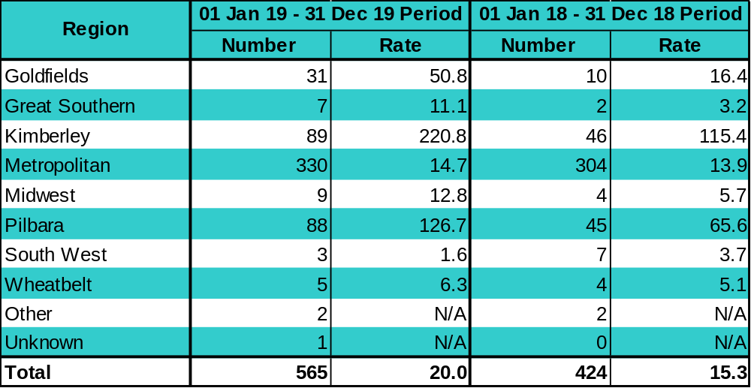
Notes: Rate = Crude notification rate per 100,000 population
Metropolitan = East Metropolitan + North Metropolitan + South Metropolitan
Other = Overseas residents diagnosed in WA
Unknown = Unknown residential address within WA
N/A = Not applicable
- The infectious syphilis notification rate remained highest in the Kimberley region and increased by 91% in comparison to the previous 12-month period. The rate more than doubled in the Midwest and increased by more than three-fold in the Goldfields and Great Southern regions. The rate remained relatively stable in the Perth metropolitan region.
- In the Kimberley region, a total of 284 infectious syphilis cases (118 male, 166 female) were notified from the beginning of the outbreak in the region in June 2014 to December 2019. Prior to 2014, there had been no infectious syphilis notifications in the region for two years.
- In the Pilbara region, a total of 133 infectious syphilis cases (63 male, 70 female) were notified from the beginning of the outbreak in the region in February 2018 to December 2019. Prior to February 2018, there had been on average 2 infectious syphilis notifications per 12-month period in the region.
- In the Goldfields region, a total of 31 infectious syphilis cases (14 male, 17 female) were notified from the beginning of the outbreak in the region in January to December 2019.
- The increased notifications in the Kimberley, Pilbara and Goldfields regions are part of a larger outbreak in northern Australia that commenced in January 2011 in the Northern Territory. Further information about the infectious syphilis outbreak affecting Aboriginal people living in northern Australia is available from: http://www.health.gov.au/internet/main/publishing.nsf/Content/ohp-infectious-syphilis-outbreak.htm.

HIV
- The following analysis of HIV notifications data includes cases diagnosed for the first time in WA and excludes notifications of HIV cases previously diagnosed overseas.
Figure 4 Number of HIV notifications in WA by quarter, for the two most recent 12-month periods (excludes cases previously diagnosed outside WA)
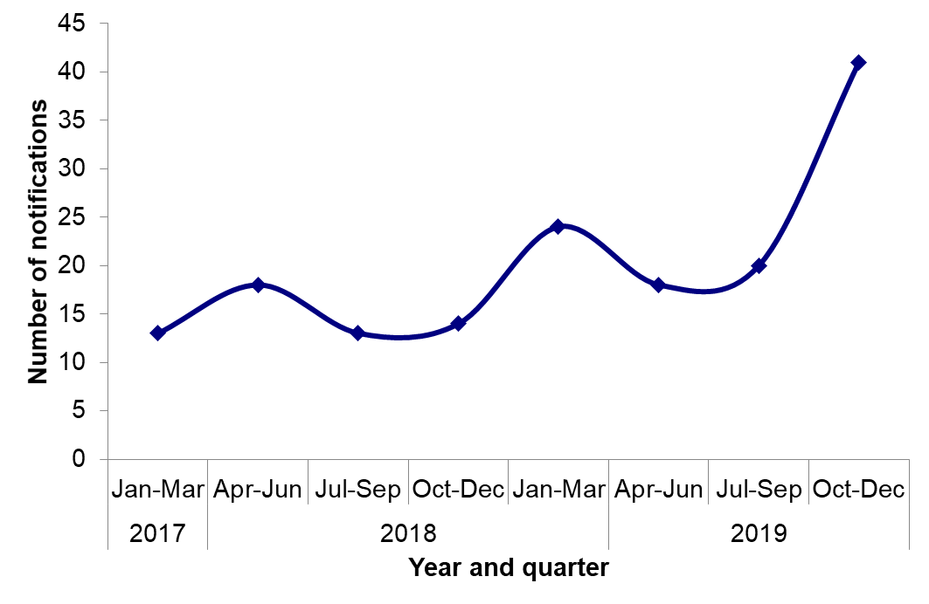
- There were 103 HIV cases notified in the January to December 2019 period, a 78% increase compared to the previous 12-month period (n=58) (Table 1).
- There were 41 HIV cases notified in the October to December 2019 quarter, which was twice the number reported in the previous quarter (20 to 41 cases) (Figure 4).
- Over the two 12-month reporting periods, the number of male HIV cases increased by 77% (47 to 83 cases) while a nine-case increase was observed for females (11 to 20 cases). The male: female ratio for new HIV diagnoses remained stable over the two periods (4.2 vs 4.3).
Table 12 Number and proportion of HIV notifications in WA by age group, for the two most recent 12-month periods (excludes cases previously diagnosed outside WA)
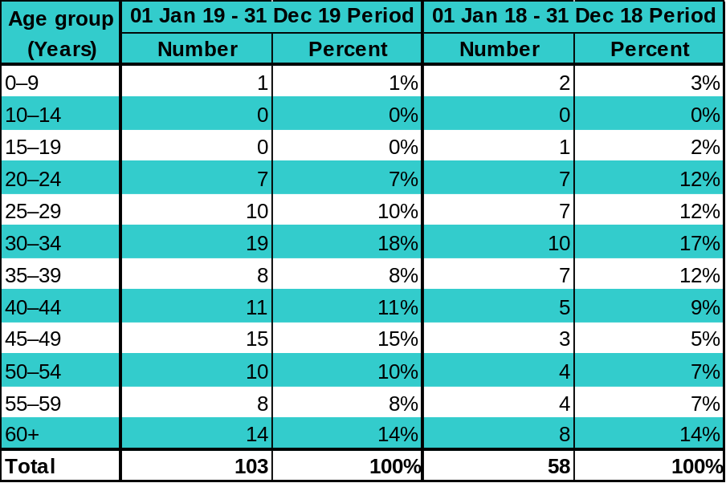
- Compared to the previous 12-month reporting period, the number HIV notifications increased across most age groups. In particular, the number of notifications in those aged 40 years and above had more than doubled over the two reporting periods (24 to 58) (Table 12).
- The median age of HIV notifications in the January to December 2019 period was 42 years (range: 7 to 72 years) and 5.5 years older than the median age reported for the previous 12-month period (36.5 years; range: less than 1 year to 73 years).
Table 13 Number and crude rate of HIV notifications in WA by Aboriginality, for the two most recent 12-month periods (excludes cases previously diagnosed outside WA)
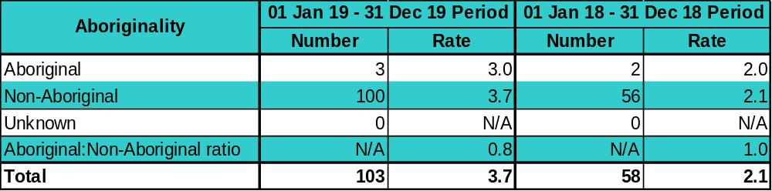
Note: Rate = Crude notification rate per 100,000 population
- The number of Aboriginal people diagnosed with HIV in WA remained stable at three cases (Table 13).
Table 14 Number and proportion of HIV notifications in WA by exposure, for the two most recent 12-month periods (excludes cases previously diagnosed outside WA)
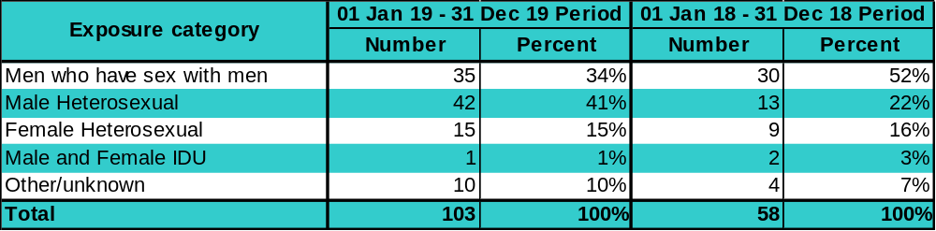

- There was a five-cases increase in the number of HIV notifications in MSM in the most recent 12-month reporting period (Table 14). Most MSM who were newly diagnosed with HIV in the current period reported acquiring their infection in Australia (69%; n=24).
- The number of male heterosexual HIV cases was just over three-times the number reported in the previous 12-month period (Table 14). The majority of these cases were men who acquired HIV overseas (74%; n=31), of whom the majority acquired HIV in South-East Asia (62%; n=21).
- In the most recent 12-month period, almost all of the male heterosexual cases who acquired HIV in South-East Asia were either born in Australia (62%; n=13), or in another country outside South-East Asia (29%; n=6). Of the 15 cases who reported a reason for visiting South-East Asia in the current reporting period, most stated they were on holiday when the likely exposure to HIV had occurred (60%; n=9).
- In addition, the majority of males reporting heterosexual acquisition in South-East Asia in the current reporting period were aged 50 years or older (57%; n=12), representing an older cohort of cases in comparison to total HIV cases reported in WA.
- There was a six-case increase in the number of female HIV notifications attributed to heterosexual exposures, compared to the previous 12 months (Table 14). The majority of these cases had acquired HIV overseas (60%;n=9).

Hepatitis B
Figure 5 Number of hepatitis B notifications in WA by disease status, for the two most recent 12-month periods
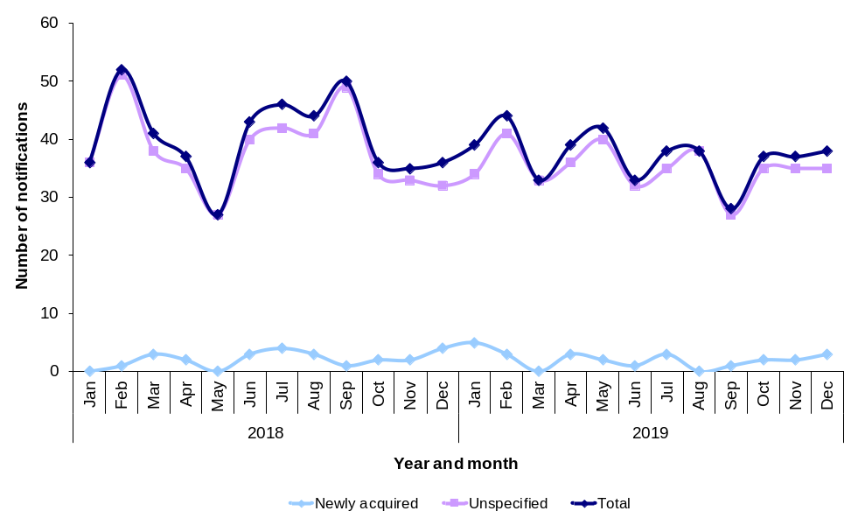
Table 15 Number of newly acquired and unspecified hepatitis B notifications in WA, for the two most recent 12-month periods
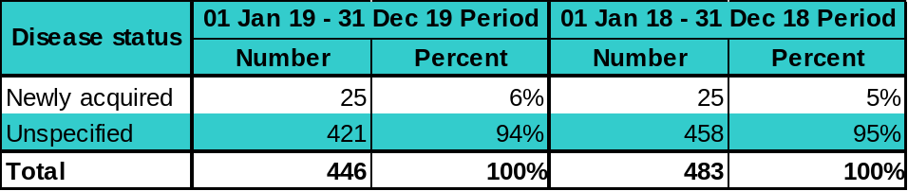
- The number of newly acquired hepatitis B notifications remained relatively stable while the number of unspecified hepatitis B notifications decreased by 8% in comparison to the previous 12-month period.
Table 16 Number and proportion of hepatitis B notifications (newly acquired + unspecified) in WA by sex, for the two most recent 12-month periods
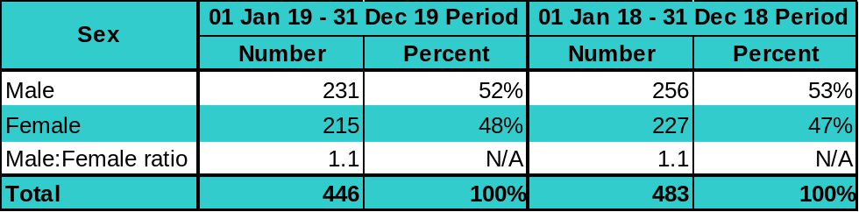
Note: N/A = Not applicable

Table 17 Number and proportion of hepatitis B notifications (newly acquired + unspecified) in WA by age group, for the two most recent 12-month periods
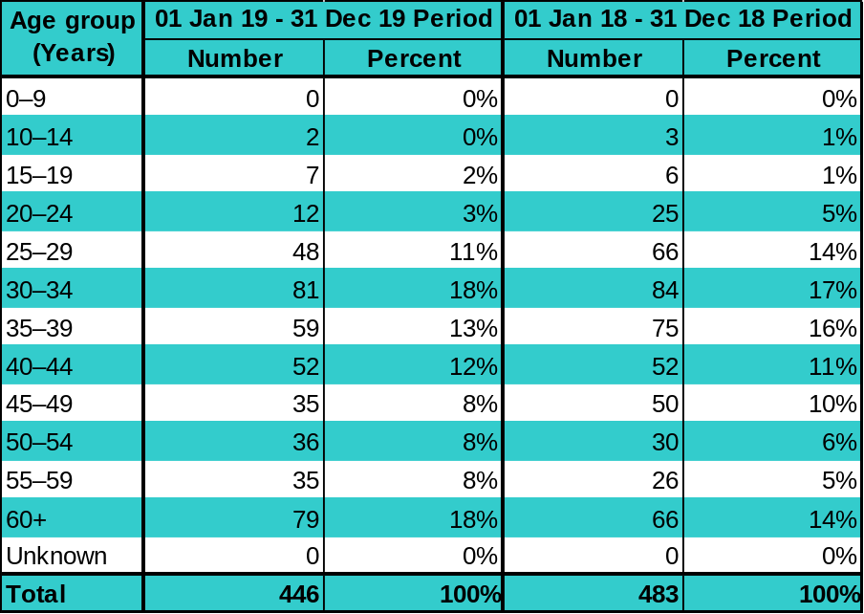
- The largest proportion of total hepatitis B notifications was among 30 to 39 year olds (33%) and notifications among this age group decreased by 12% in comparison to the previous 12-month period.
Table 18 Number and crude rate of hepatitis B notifications (newly acquired + unspecified) in WA by Aboriginality, for the two most recent 12-month periods
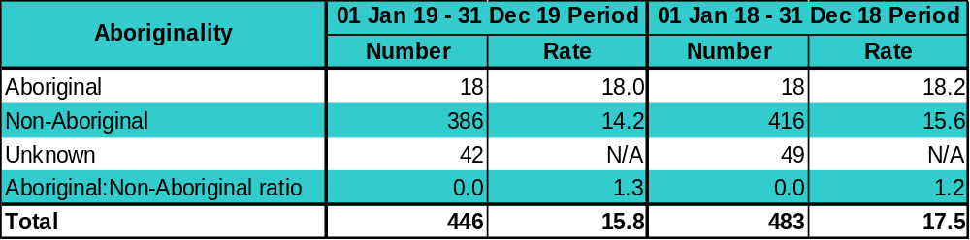
Notes: Rate = Crude notification rate per 100,000 population
N/A = Not applicable
- The total hepatitis B notification rate remained stable among Aboriginal people and decreased by 9% among non-Aboriginal people compared to the previous 12-month period.
Table 19 Number and crude rate of hepatitis B notifications (newly acquired + unspecified) in WA by region, for the two most recent 12-month periods
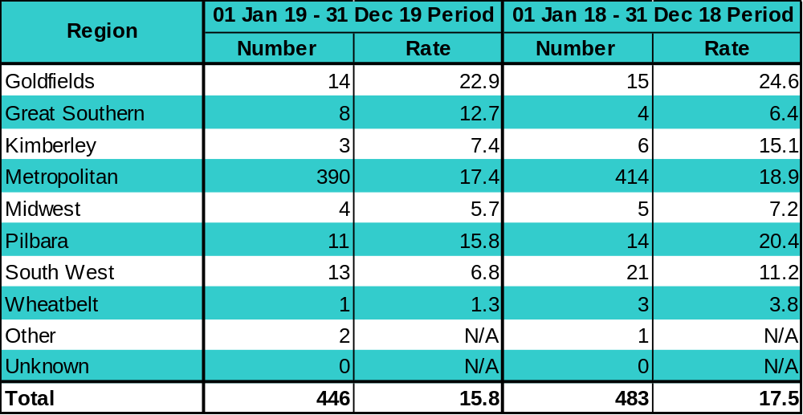
Notes: Rate = Crude notification rate per 100,000 population
Metropolitan = East Metropolitan + North Metropolitan + South Metropolitan
Other = Overseas residents diagnosed in WA
Unknown = Unknown residential address within WA
N/A = Not applicable
- Trends in the total hepatitis B notification rate varied between regions and the small number of notifications in most non-metropolitan regions makes it difficult to interpret any changes in trends.
Hepatitis C
Figure 6 Number of hepatitis C notifications in WA by disease status, for the two most recent 12-month periods
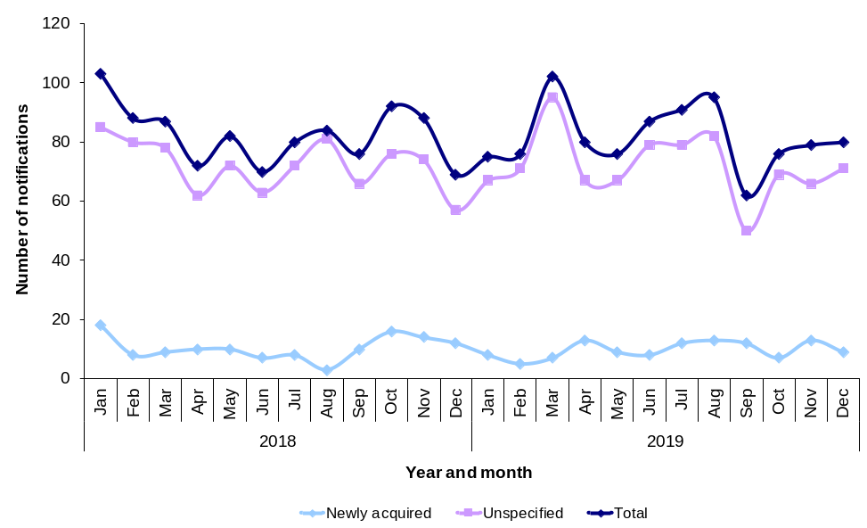
Table 20 Number of hepatitis C notifications in WA by disease status, for the two most recent 12-month periods
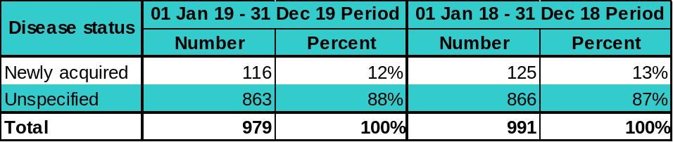
- The number of newly acquired hepatitis C notifications decreased by 7% while the number of unspecified hepatitis C notifications remained relatively stable in comparison to the previous 12-month period.
Table 21 Number, proportion and ratio of hepatitis C notifications (newly acquired + unspecified) in WA by sex, for the two most recent 12-month periods
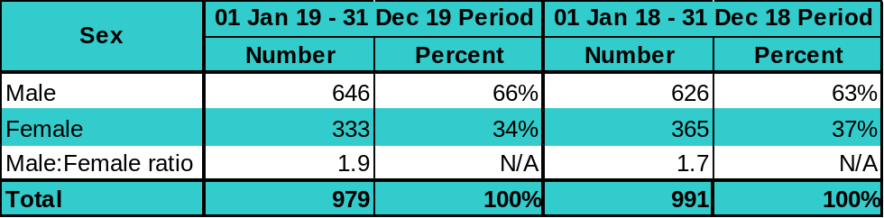
Note: N/A = Not applicable

Table 22 Number and proportion of hepatitis C notifications (newly acquired + unspecified) in WA by age group, for the two most recent 12-month periods
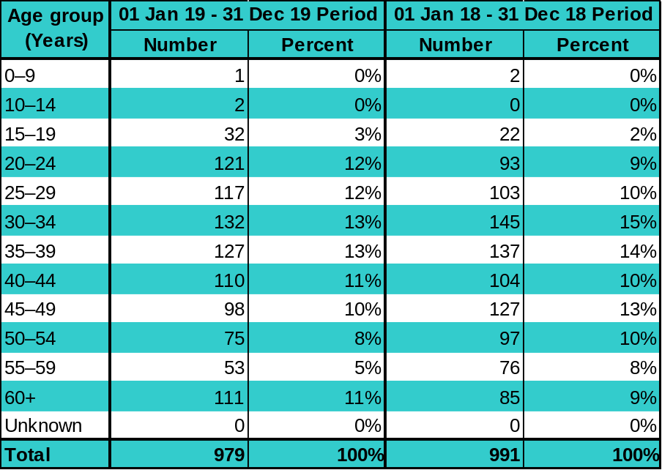
- The age distribution of total hepatitis C notifications was similar to the previous 12-month period, although there was a 25% decrease in notifications among 45 to 59 year olds.
Table 23 Number and crude rate of hepatitis C notifications (newly acquired + unspecified) in WA by Aboriginality, for the two most recent 12-month periods
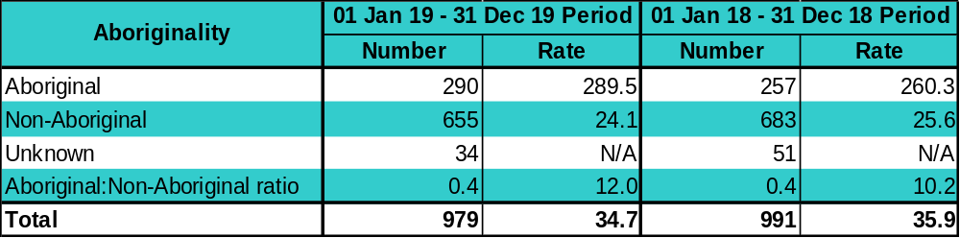
Notes: Rate = Crude notification rate per 100,000 population
N/A = Not applicable
- The total hepatitis C notification rate increased by 11% among Aboriginal people and decreased by 6% among non-Aboriginal people, resulting in a higher rate ratio compared to the previous 12-month period.

Table 24 Number and crude rate of hepatitis C notifications (newly acquired + unspecified) in WA by region, for the two most recent 12-month periods
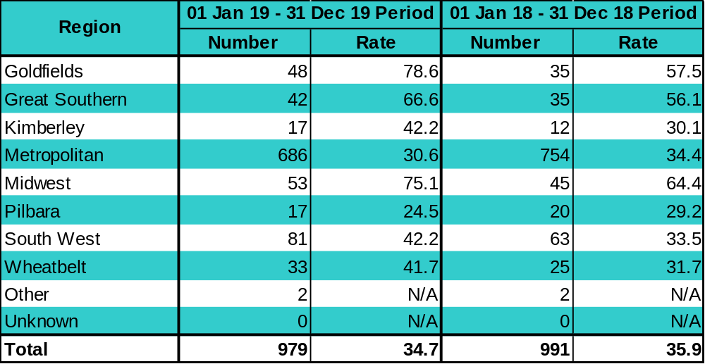
Notes: Rate = Crude notification rate per 100,000 population
Metropolitan = East Metropolitan + North Metropolitan + South Metropolitan
Other = Overseas residents diagnosed in WA
Unknown = Unknown residential address within WA
N/A = Not applicable
- Total hepatitis C notification rates increased in most regions but decreased in the Perth metropolitan and Pilbara regions.
This document can be made available in alternative formats on request for a person with a disability.

© Department of Health 2020

