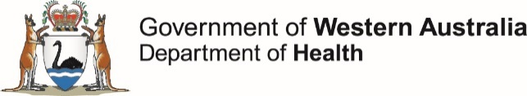

Monkeypox awareness campaign

Communications toolkit for stakeholders

The Department of Health monkeypox awareness campaign raises awareness of the symptoms of monkeypox, how to avoid it, and what to do if you think you have caught it.

Monkeypox is usually a rare viral illness that can become serious. Cases have been increasing internationally and in Australia, including Western Australia.

Cases are largely returned travellers from places with high case numbers of monkeypox (UK, USA, Spain, Portugal, Canada). The campaign targets men who have sex with men (MSM), particularly returned travellers from high prevalence areas.

People returning from overseas, or in close contact with people returning from overseas should look out for symptoms, avoid intimate contact with someone with symptoms, and seek medical advice if they suspect they have monkeypox.

For more information see www.healthywa.wa.gov.au/Monkeypox

Campaign materials
This toolkit includes recommended social media graphics and messaging for you to share to help us to reach our intended target audiences.
Please be in touch if you need alternative formats at communications@health.wa.gov.au
Thank you for your support.

Social media

Facebook content – General Awareness
Title | Blurb
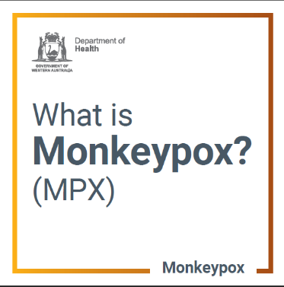 | There is currently a multi-country outbreak of MPX.  Most cases in Australia have acquired MPX overseas, however some infections have been acquired in Australia.  MPX belongs to the same family as the smallpox virus but generally causes a milder illness.  Most people recover within 2–4 weeks.  Severe illness can develop in a small percentage of people.  www.healthywa.wa.gov.au/Monkeypox
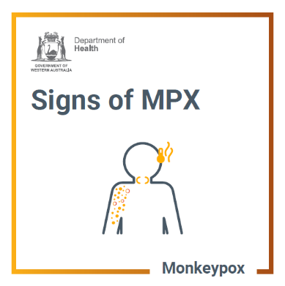 | Symptoms of monkeypox usually start within 3 weeks of exposure to the virus.  Symptoms include sores, a rash, bumps or pimples (that can be very painful) on any part of the body.  Some people also have a fever, chills, muscle aches, backache, exhaustion, headaches, and/or swollen lymph glands.  If you have symptoms, call your GP or the sexual health helpline:  - metro 9227 6178  - country 1800 198 205  www.healthywa.wa.gov.au/Monkeypox
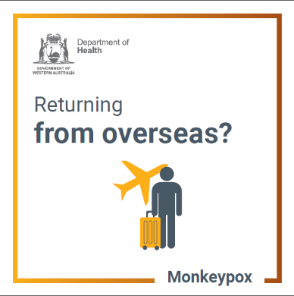 | Returning from overseas?  If you have recently travelled to an area with monkeypox, look out for symptoms. Particularly if you have had a new sexual partner whilst overseas.  Symptoms include sores, a rash, bumps or pimples (that can be very painful) on any part of the body.  Some people also have a fever, chills, muscle aches, backache, exhaustion, headaches, and/or swollen lymph glands.  If you have symptoms, call your GP or the sexual health helpline:  - metro 9227 6178  - country 1800 198 205  www.healthywa.wa.gov.au/Monkeypox
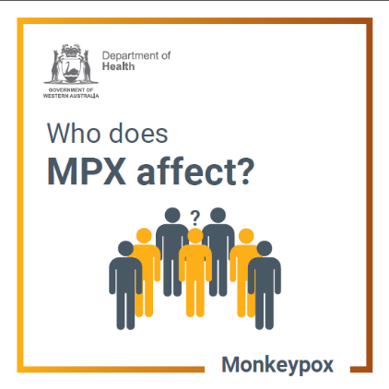 | Monkeypox can affect anyone who comes into close contact with someone with the virus.  Many of the cases in the current outbreak are in men who have sex with men.  Most cases in Australia have acquired MPX overseas, however some infections have been acquired locally, usually from a recently returned traveller.  Countries with high numbers of monkeypox include the UK, USA and Europe.  www.healthywa.wa.gov.au/Monkeypox
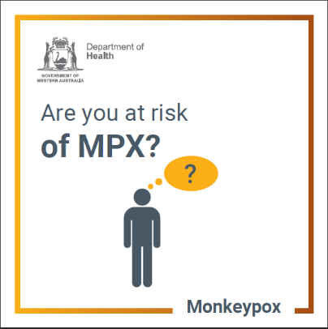 | Monkeypox can affect anyone who comes into close contact with someone with the virus.  Many of the cases are in men who have sex with men.  Most cases in Australia have been acquired overseas. However, some have acquired their infection locally, usually from a recently returned traveller.  www.healthywa.wa.gov.au/Monkeypox
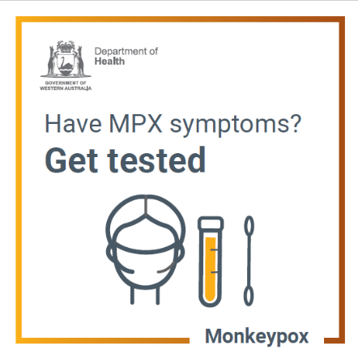 | Symptoms of MPX include sores, a rash, bumps or pimples (that can be very painful) on any part of the body.  Some people also have a fever, chills, muscle aches, backache, exhaustion, headaches, and/or swollen lymph glands.  If you have symptoms, you will need to get tested.  Call your GP or the sexual health helpline:  - metro 9227 6178  - country 1800 198 205  Remember to phone ahead and wear a mask if attending a clinic.  www.healthywa.wa.gov.au/Monkeypox
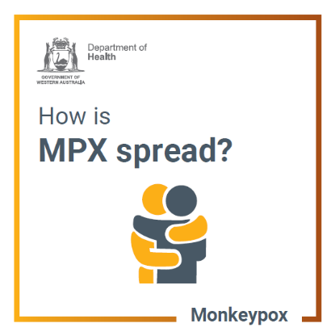 | MPX is most often spread through:  - skin-to-skin contact with someone who has MPX (including during sex)  - prolonged face-to-face contact via respiratory droplets (such as coughs and sneezes)  - contact with clothing or linens (such as bedding and towels) used by someone with MPX.  www.healthywa.wa.gov.au/Monkeypox
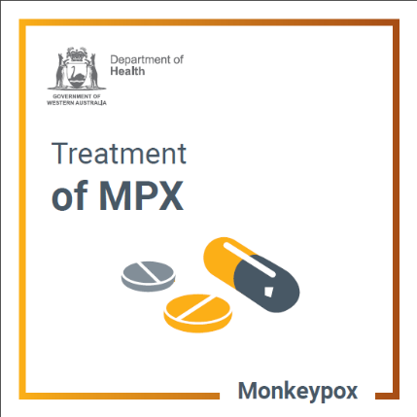 | Most people with monkeypox will recover without any specific treatments.  The illness is usually mild, and recovery takes a few weeks.  In some people the sores can be very painful.  Over-the-counter pain medications and keeping up oral fluids help to manage symptoms.  Antiviral medications may be considered for people with severe symptoms.  For advice about MPX testing and treatment call your GP or the sexual health helpline:  - metro 9227 6178  - country 1800 198 205  Remember to phone ahead and wear a mask if attending a clinic.  www.healthywa.wa.gov.au/Monkeypox
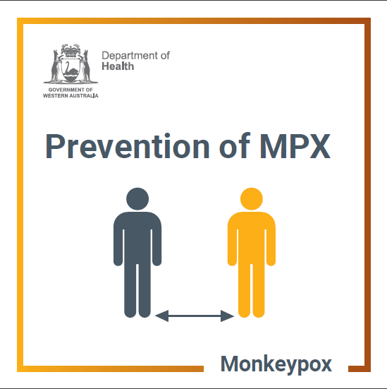 | To prevent getting monkeypox:  - Avoid skin-to-skin contact with people with suspected or confirmed monkeypox.  - Do not handle or touch the bedding, towels, or clothing of a person with monkeypox.  - Wash your hands often with soap and water or use an alcohol-based hand sanitizer.  - Maintain physical distance and avoid skin-to-skin contact when at events attended by people likely to be at increased risk of having monkeypox.  www.healthywa.wa.gov.au/Monkeypox
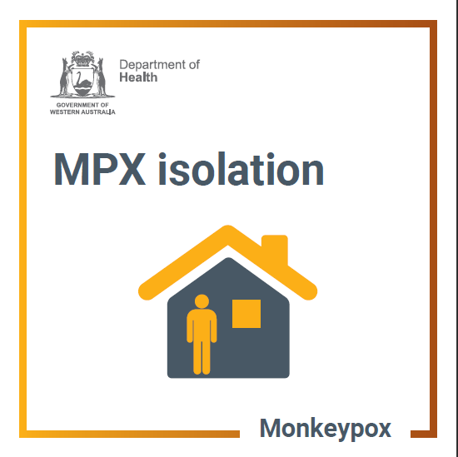 | If you suspect you have monkeypox, isolate at home and avoid contact with others.  For advice about monkeypox testing and treatment call your GP or the sexual health helpline:  - metro 9227 6178  - country 1800 198 205  Public health will contact you to provide you with advice on when you can leave isolation.  www.healthywa.wa.gov.au/Monkeypox
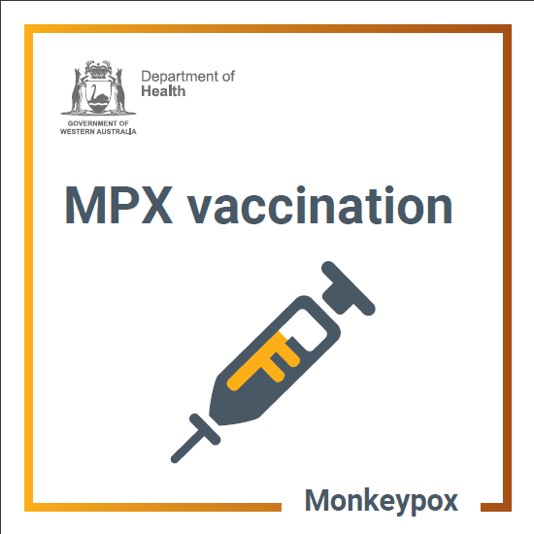 | The best time for eligible people to receive the monkeypox (MPX) vaccine is before they are exposed to the virus.  Although one dose of the JYNNEOS® MPX vaccine provides substantial benefit, two doses given at least 28 days apart will ensure optimal protection against infection.  Those who are at-risk and planning to attend festivals, events, or to travel to a country experiencing a significant MPX outbreak, should aim to start the 2 dose vaccination series 4–6 weeks prior.  Find out more about monkeypox vaccination and eligibility at www.healthywa.wa.gov.au/monkeypox
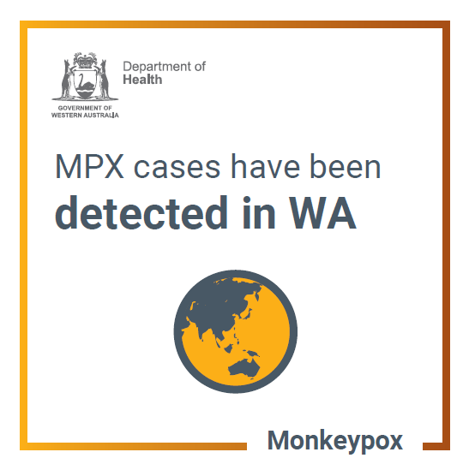 | Cases of MPX have been recorded in WA.  While the risk to the community from monkeypox is very low, monitor for symptoms if you have been overseas – particularly if you have visited an area with confirmed monkeypox cases and had sex with a new partner overseas.  www.healthywa.wa.gov.au/Monkeypox
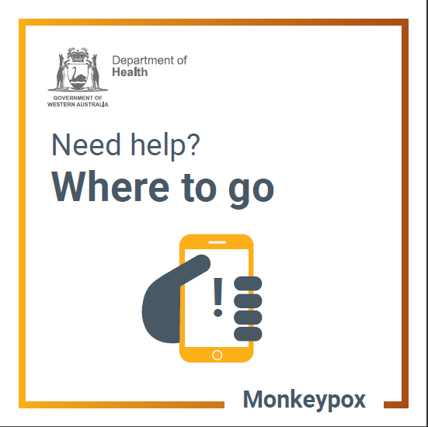 | Have questions about monkeypox?  Call your GP or the sexual health helpline:  metro 9227 6178  country 1800 198 205  For more information visit www.healthywa.wa.gov.au/Monkeypox
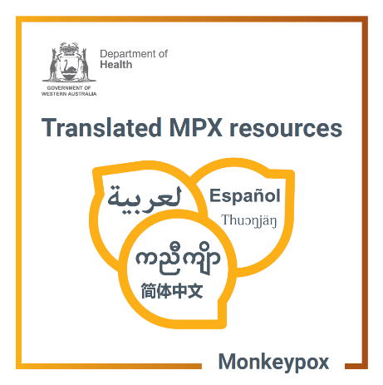 | You can access monkeypox information in your language.  If someone you know has a monkeypox question and needs an interpreter, call the Translating and Interpreting Service on 131 450 to request an interpreter in your preferred language.  www.healthywa.wa.gov.au/Monkeypox

This document can be made available in alternative formats
on request for a person with disability.
© Department of Health 2022
Copyright to this material is vested in the State of Western Australia unless otherwise indicated. Apart from any fair dealing for the purposes of private study, research, criticism or review, as permitted under the provisions of the Copyright Act 1968, no part may be reproduced or re-used for any purposes whatsoever without written permission of the State of Western Australia

