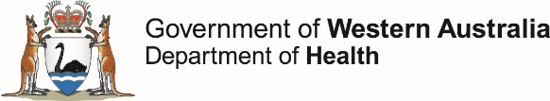

This report describes enteric disease surveillance and investigations carried out during the second quarter of 2020 (2Q20) by OzFoodNet WA in conjunction with other Western Australian Department of Health agencies and local governments.

Some of the increase in notifications is likely to be due to the introduction of polymerase chain reaction (PCR) testing of faecal specimens which has greater sensitivity than culture techniques.

**OzFoodNet Enteric Disease Surveillance Report 2nd Quarter 2020**

**Enhancing foodborne disease surveillance across Australia**

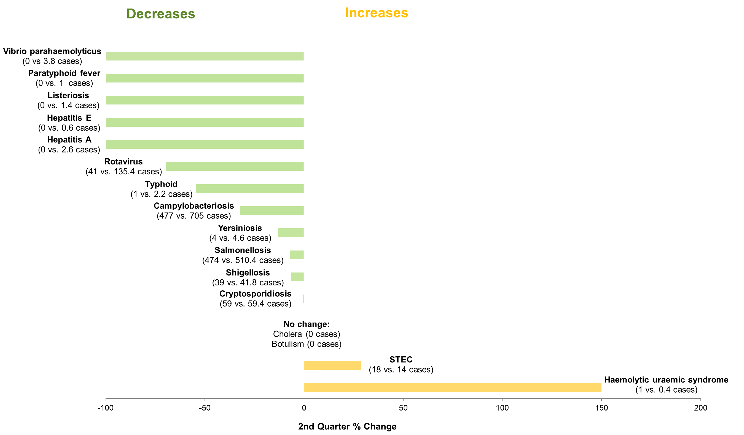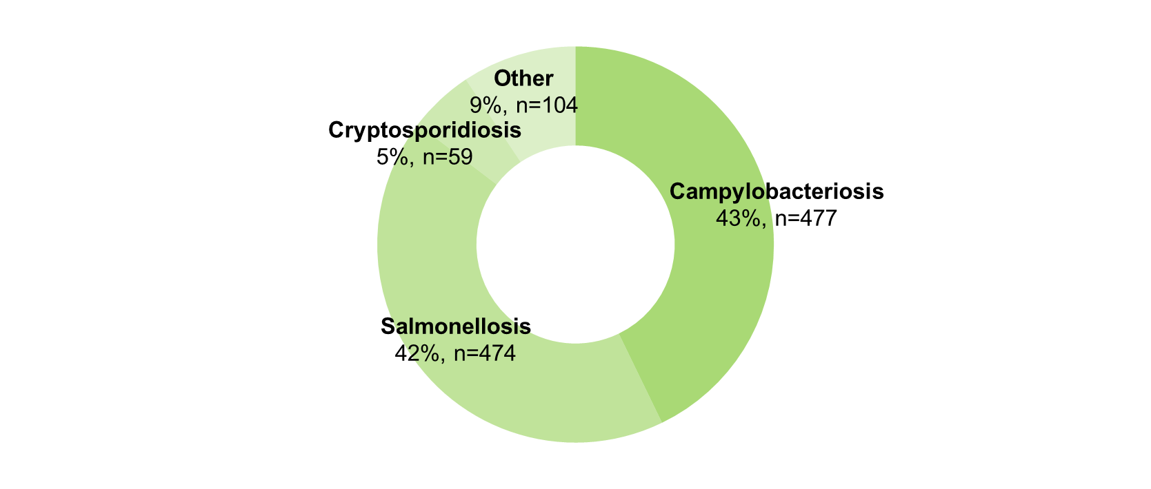

**Most common enteric disease notifications in Quarter 2 2020**

**Appendix 1** Enteric diseases by public health region:

<https://ww2.health.wa.gov.au/-/media/Corp/Documents/Health-for/Infectious-disease/OZfoodnet/Word/WA-OzFoodnet-appendix1-2020-Q2.docx>

*Percentage change in the number of notifications in the current quarter compared to the historical 5-year mean for the same quarter. Positive values indicate an increase when compared to the historical 5-year mean of the same quarter. Negative values indicate a decrease when compared to the historical 5-year mean of the same quarter. Percentage change should be interpreted with caution when the number of cases is small.

**Change in enteric disease notifications (%)\***

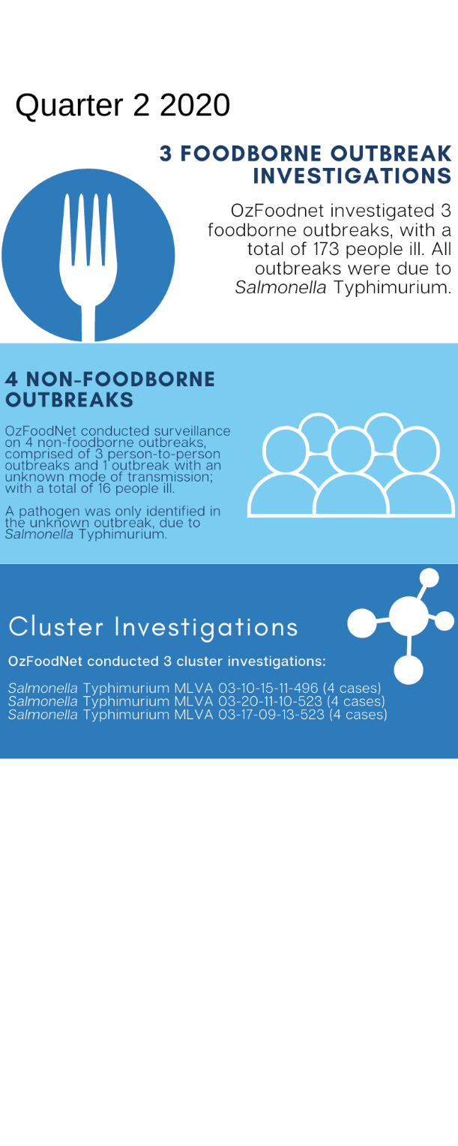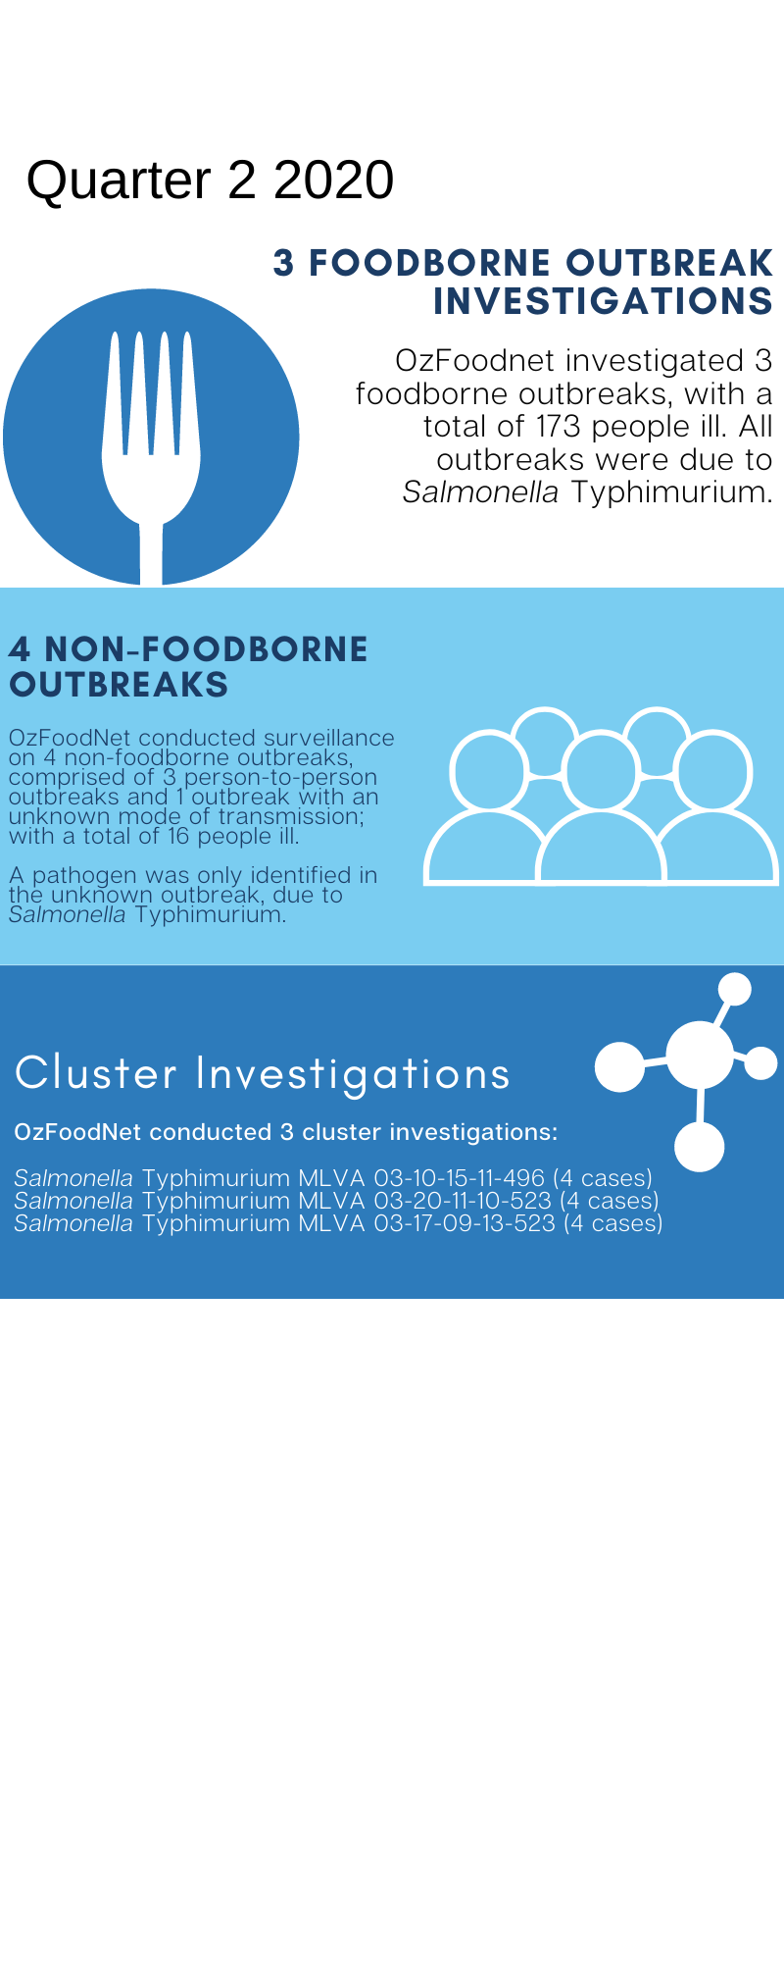**Outbreaks in Quarter 2 2020**



**Appendix 2** Details of foodborne outbreaks investigated in Quarter 2, 2020:

<https://ww2.health.wa.gov.au/-/media/Corp/Documents/Health-for/Infectious-disease/OZfoodnet/Word/WA-OzFoodnet-appendix2-2020-Q2.docx>

**Key trends from Quarter 2 2020**

***Salmonella* Typhimurium (STM) MLVA 03-17-09-12-523**

STM MLVA 03-17-09-12-523 has been under investigation since the type emerged in September 2016. From September 2016 to June 2020 there were 1701 cases notified, including 119 cases in 2Q20. This MLVA type was the single most common MLVA type notified in 2Q20, constituting 33% of STM notifications for the quarter. Of the 119 cases, 6 (5%) were part of a point source outbreak identified in 2Q20. Tiramisu containing raw eggs was implicated in the outbreak. Of the remaining 113 cases, most (89%) resided in the Perth metropolitan area. Hospitalisation data were confirmed for 101 community cases; 29% were hospitalised.



Figure: Notifications of *Salmonella* Typhimurium MLVA 03-17-09-12-523 in WA, 2016 to June 2020

**COVID-19 impact on enteric disease notifications**

Based on 2Q20 data presented above the number of notifications for 12 out of the 16 notifiable enteric diseases decreased compared to the five-year mean for this quarter. Several changes in March because of the COVID-19 pandemic likely contributed to the decrease which included a ban on international travel, limits on the size of gatherings, venue closures including swimming pools and restaurants, increased handwashing as well as other social distancing measures. The decrease may also be due to a reduction in the number of individuals being tested for enteric diseases. Data from pathology clinics in WA recorded a lower number of faecal specimens tested from April 2020 compared to 2019.

**Haemolytic uraemic syndrome (HUS)**

One HUS case was notified in 2Q20. This case was culture positive for STEC (serotype O157:H7).

**Shiga toxin producing *E. coli* (STEC)**

Thirteen of the 18 notifications were culture positive, the most common serotype was O128:H2 (n=4). No point-source outbreaks were identified in 2Q20. Some of the increase is likely due to PCR testing of all faecal specimens by one private laboratory since the fourth quarter of 2018.