Template for the Health Service Provider Strategic Asset Plan (HSAP)
Foreword
Purpose of the HSAP
HSAP is the Health Service Provider developed Strategic Asset Plan (SAP). The SAP is the Department of Health (agency) SAP consolidated from the HSAPs and with priorities agreed by executive for submission to Treasury as the whole of Health SAP position for the year.
The purpose of the HSAP is to provide Health Senior Executive with the HSP strategic asset portfolio and objectives and will be utilised in strategic decision making. Strategic Asset requirements will be prioritised, with HSP representation, to present a considered position to government outlining WA Health’s short, medium and long term strategic asset planning requirements.
The template
The template should not be altered, and all sections must be completed unless approval has been granted—at HSP request and by the Director MHPI—that completion of a section is unable to be achieved for the 2024-25 transitional year.
Grey text provides guidance, a HSP must provide a response in relation to ‘grey text’ then delete ‘grey text’ prior to submission.
HSAP update
HSPs must prepare their HSAP using the template.
The next full HSAP is 2025-26, as part of the Budget Submission to align with the 2025 State Election.
Annual SAP milestones | Feb | May | July | October | December | January
What | HSPs have template | HSAP submission to DoH | Collation SAP | Prioritisation & consultation | Feedback | Submission
Who | DoH | HSP | HSP & DoH | DoH & HSP | Treasury | DoH to Treasury

Budget Submission Year | 2024-25 | 2025-26 | 2026-27 | 2027-28 | 2028-29
Type of SAP | Interim | Full | Update | Update | Update

[HSP Title]
HSP Strategic Asset Plan

Approval
Name/Title | Signature | Date
Chief Executive Officer
Chief Finance Officer
Senior Asset Manager
Chief Information Officer

Contact Officer
Name/Title | Email | Phone

Version Control
Version | Date | Status/Action/Change | Approved By
Draft 1
Draft 2
Final

Contents
Executive Summary 1
Strategic Context 1
HSP Objectives 1
Strategic Alignment 1
Forecasting 1
Environmental Scan 1
Demand Forecasting 2
Scenario Planning 2
Asset Management Objectives 2
Asset Portfolio Review 3
Portfolio Stocktake 3
Asset Portfolio Evaluation 4
Risk Assessment 6
Asset Portfolio Plan 7
Asset Disposal 7
Maintenance and Operation 8
Acquisition 8
Resourcing Plan 9
Approved Capital 9
Approved Recurrent 9
Proposed Variations 9
Continuous Improvement 10
Appendix 1 – 4 pillar objectives 11
Appendix 2 – List of HSP new strategic asset initiatives prioritised 13
Appendix 3 – HSAP requirements by year 14
Appendix 4 - 16
Asset Disposal table 16

Executive Summary

Strategic Context
This section outlines the HSP’s objectives and the external factors (e.g. demand for services) that have the potential to affect the HSP’s asset portfolio.

HSP Objectives
Provide a summary of the HSP’s core purpose and corporate objectives.

Strategic Alignment
Articulate how the objectives of the HSP are aligned with whole-of-government state strategic plans, infrastructure strategies and Government policies and priorities.

Forecasting
identify and assess external factors and drivers, implications for service demand, and capacity of the asset portfolio to meet demand across the short, medium, and long-term horizons.

Environmental Scan
Environmental scans are formal and systematic investigations that explore changes in society, technology, economic outlook, environment, climate and political dynamics that have implications for the HSP.
A high-level assessment is to be made of external factors and drivers that have the potential to impact on the HSP’s objectives, demand for services and asset requirements over the next 10 years and beyond.

Demand Forecasting
Explore the range of impacts that the environmental scan drivers will have on future demand for services and align where possible to Health’s Demand and Capacity model. Support with quantitative methods, or a mix of quantitative and qualitative methods.

Scenario Planning
Present the potential range of impacts that the demand forecasts and environmental scan outcomes may have on the HSP’s assets and services. This assessment considers the composition and capacity of the existing asset portfolio to service future demand and potential service delivery changes. This assessment is to identify in broad terms how the HSP’s needs are likely to change over the next 10 years and beyond.

Asset Management Objectives
Align HSP asset objectives to WA Health strategy and objectives under themes: safety, reliability, cost effectiveness, and compliance.

Asset Portfolio Review
Assets are to be considered in the HSAP under the following categories:
- Land & Property
- Plant & Equipment
- Medical Equipment
- ICT
Describe the HSP’s existing asset portfolio, its characteristics (e.g. number and size), the current and forecast performance (fitness-for-purpose, cost and utilisation), highlight performance gaps, and significant risks include risks to strategy achievement.

Portfolio Stocktake
Provide aggregated and disaggregated levels of detail and an overview of the number, age and value of the assets held by the HSP by category.
- Land & Property – detail property type e.g. hospital, health centre, accommodation and separate tables should be provided for Owned, Leased In, Leased Out and Vacant Land. In addition, where possible provide an overview of the size of the portfolio by Gross Floor Area (GFA) and the age profile of the property portfolio.
- Plant & Equipment – detail the number of items in key equipment categories, age of the equipment and the estimated value
- Medical Equipment – detail number of items in the portfolio and the estimated value, identify medical equipment and medical imaging equipment separately, make note of items within useful life and items that exceed useful life.
- ICT – detail hardware (number and value) and software (value).

Identify any uncertainties (ownership) and management steps to rectify.

Asset Portfolio Evaluation
- Identify:
- performance measures for HSP assets
- gaps between current performance and required performance
- analyse results, identify performance gaps, trends and opportunities to be addressed in the Asset Portfolio Plan

Asset Management Objectives | Performance measure | Current Performance | Target/ Benchmark
1
2
3
4

- List asset condition assessments
Provide details of the outcomes of the most recent building condition assessments undertaken for their property portfolio, noting the age, condition and key risks identified as part of the assessment.

Building/Campus | Year of construction | Condition | Key Risks Identified

Risk Assessment
Outline key risks impacting:
- the HSP asset portfolio,
- capital projects in progress and proposed.

Asset Portfolio Plan

Asset Disposal
- Identify:
- significant assets that are surplus to requirements,
- not cost effective to maintain and operate, and/or
- not fit for purpose,
- Obtain HSP governance in-principle approval to dispose. List in the HSAP as an asset for disposal by category, identify the anticipated disposal timeframe.
- Comment on:
- The asset’s residual value and include costs of decommissioning and disposal
- Impacts to services and how services will be transitioned to alternative or new assets
- Stakeholder and community impacts and sensitivities of disposal or repurposing
- Potential for land to be repurposed with consideration of ay presence of hazardous materials

Maintenance and Operation
Provide a summary of planned maintenance works over the short term and explain how the planned maintenance works has been prioritised.
Prioritise, outline the highest priority maintenance, minor works and operational activities planned for the short term.

Acquisition
Provide a summary of the HSP Capital Investment Plan over the short, medium and long term.
Prioritise projects at the HSP level and in consultation with the clinical planning team.
Provide a separate table to summarise funding required for minor works across the next four years and an explanation as to how minor works projects have been prioritised.

Resourcing Plan
Summarise planned resource implications of:
- investment to maintain existing assets,
- future asset delivery and
- disposal of surplus assets.
Ensure the plan is consistent with the WA Health budget submission and forward estimates period including:
- The approved 10-year AIP as recorded in the Strategic Information Management System (SIMS) Asset Investment Module (AIM) including rolling programs of works.
- The HSP’s estimated expenditure on preventative maintenance, breakdown repairs and minor improvements and refurbishments (Budget and forward estimates period).
- The proposed variations to the AIP, new spending proposals and recommendations for disposal or spending efficiencies, consistent with the budget submission.

Approved Capital
Provide a summary of the HSP approved 10-year Asset Investment Program.

Approved Recurrent
Provide a summary of the agency’s approved recurrent expenditure allocations, and actual expenditure incurred for the previous 3 years across maintenance and operational activities. Itemise allocations to preventative maintenance, breakdown repairs and minor improvements and refurbishments where:
- Preventative maintenance is planned work to preserve the asset.
- Breakdown repairs are carried out on demand to reinstate service delivery.
- Minor improvements and refurbishments are to ensure that assets remain fit for purpose

Proposed Variations
Provide a summary of variations from approved capital and recurrent funding allocations, including:
- proposed variations to the AIP and recurrent spending from within approved funding limits.
- new spending proposals and recommendations for disposal, consistent with the Budget submission.

Continuous Improvement
Include a brief statement of the HSP’s plan to improve its asset management systems and practices. Include an:
- outline of asset management system achievements for the past year and
- a concise plan for the short-term asset management improvements.

Appendix 1 – 4 pillar objectives
The Western Australia (WA) health system’s vision is to deliver safe, high quality and sustainable services that support and improve the health of Western Australians. This vision is delivered through the objectives outlined below:
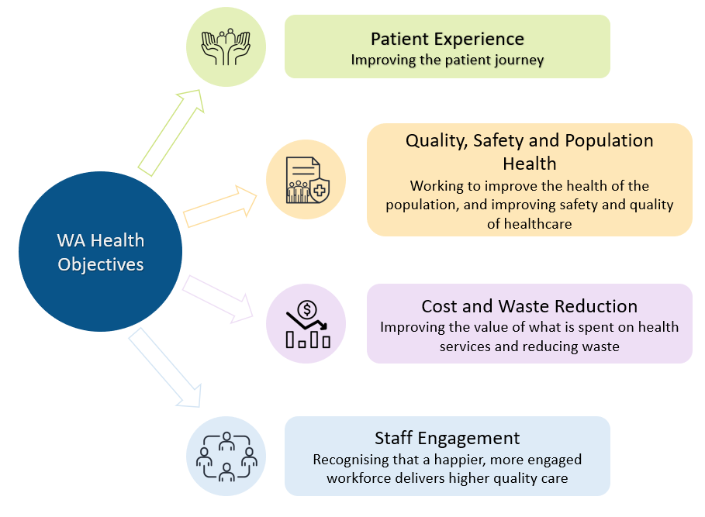

Appendix 2 – List of HSP new strategic asset initiatives prioritised

Project Name/Asset Acquisition | Brief description | Priority | Proposed start year | Proposed completion year | Indicative total project cost ($000)

Appendix 3 – HSAP requirements by year
Sections | Transition SAP  2024-25 | Full SAP  2025-26 | SAP update  2026-27 | SAP update  2027-28 | SAP update  2028-29
 | Preliminary | Year 1 | Year 2 | Year 3 | Year 4
Executive Summary
Strategic Context
HSP Objectives
Strategic Alignment | Ideal
Forecasting | Ideal
Environmental Scan | Ideal
Demand Forecasting
Scenario Planning
Asset Management Objectives | Ideal
Asset Portfolio Review
Portfolio Stocktake | Ideal
Asset Portfolio Evaluation
Risk Assessment
Asset Portfolio Plan
Asset Disposal
Maintenance and Operation
Acquisition
Resourcing Plan
Approved Capital
Approved Recurrent
Proposed Variations
Continuous Improvement
Continuous Improvement
HSPs must advise the Department by 30 June of material amendments on the update years.

Appendix 4 - Asset Disposal table
Asset details | Residual value | Decommissioning or disposal costs (if known) | Impact on service and transition plan (if applicable) | Stakeholder/  community impact | Can land be repurposed? | Estimated timeframe (ST/MT/LT)
Land & Property
Plant & Equipment
Medical Equipment
ICT

See related document ‘Time-line’ phase 4.
See appendix 1
See ‘Supporting Information – Guidelines’ for examples.
Include industry benchmarks for example emission control targets, financial performance (cost of service, operating cost, maintenance cost by type), service performance (functionality, liveability, fit for purpose), technical performance (conformity to standards, asset condition, number of failures, capacity and/or utilisation).
Exclude low value/low risk. See p 13 Supporting Document ‘Guildelines’ for example.
Utilise the WA Health’s risk framework to evaluate asset risk - Risk Management Policy (health.wa.gov.au). Risks might include workplace health and safety, environment, key stakeholders, reputation, regulatory requirements and achievement of value for money outcomes.
Lifecycle asset management, includes: planning, acquisition, maintenance, operations and disposal. The timeframes considered are short term (budget and forward estimates), medium term (4-9 years) and longer term (10 years and beyond)
Refer to Appendix 4 - short term (1-4 years), medium term (5 – 9 years) and long term (10 years+)
consider available resources and asset management objectives
Use the templated provided at Appendix 2.
A prioritisation tool is in-development and will be applied by the Department in conjunction with the SAP Working Party to determine the health system-wide priority of SAP acquisitions
This may be downloaded from the Treasury AIM module in SIMS
due to construction delays/material cost increases) to estimated expenditure of capital projects where funding has already been approved. Should be consistent with budget submissions.
four pillars of sustainability in the WA Health SHR which outlines the strategic direction for the whole health system
The Department will be utilising a prioritisation tool to support acquisition planning (page 4 above). The prioritisation tool includes an environmental component that will inform evaluation of project priorities. HSPs are required to consider contemporary sustainability initiatives and targets in strategic asset planning.
Proposed start year is the date the HSP anticipates finalisation and submission of the budget process business case. HSPs will determine this date in consideration of other projects commencing in the same year, and along with other resource availability.

