c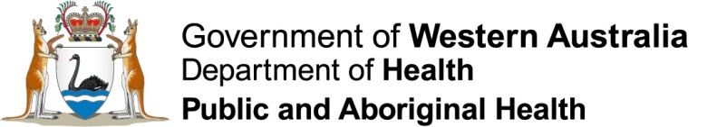

Prescribing Stimulant Medicines

Prescribers
The prescribing of stimulant medicines is restricted to medical practitioners who are:
- authorised in writing by the Department of Health;
- practicing in Western Australia or interstate providing a telehealth consultation for a Western Australian resident (where the prescription was issued on or after 13 December 2023);
- in a category of approved specialist medical practitioner; and
- treating approved indications.

Approved Conditions and Specialists
Stimulant prescribing must be for an approved condition and by the relevant type of specialist.
Approved Condition | Approved Specialist
ADHD | Paediatrician  Neurologist  Paediatric neurologist  Psychiatrist  Child and adolescent psychiatrist
Acquired brain injury | Psychiatrist  Child and adolescent psychiatrist  Neurologist  Paediatric neurologist  Rehabilitation physician  Paediatric rehabilitation physician
Depression | Psychiatrist  Child and adolescent psychiatrist
Narcolepsy | Neurologist  Paediatric neurologist  Respiratory and sleep physician  Thoracic medicine physician
Binge eating disorder | Psychiatrist

Approved Ages
To be eligible for notification, patients must be within the approved age criteria. Outside these criteria, individual patient authorisation must be sought in each case.
Approved prescriber | Patient Age
Stimulant prescriber(s) specialising in children | between 4 years and 19 years or  between 19 and 25 years (if the patient was treated by the prescriber prior to reaching 19)
Stimulant prescriber(s) specialising in adults | patients aged 17 years and over

Maximum Doses
For notification, patients must be within the approved maximum dosing. Outside these criteria individual patient authorisation must be sought.
Stimulant | Maximum Dose
 | Patients <18 years | Patients ≥18 years
Dexamfetamine | 1mg/kg/day, up to a maximum of 60mg/day | Up to 60mg/day
Lisdexamfetamine | Over 6 years of age – commence at 30mg/day, up to a maximum of 70mg/day | Up to 70mg/day
Methylphenidate | 2mg/kg/day, up to a maximum of 120mg/day | Up to 120mg/day
Combined medicine(s) | 1mg/kg/day (in dexamfetamine equivalents), up to a maximum of 60mg/day | Dexamfetamine equivalent of up to 60mg/day
If a combination of dexamfetamine, methylphenidate, and lisdexamfetamine are prescribed together then the dose of all agents must be converted to an equivalent daily dose of dexamfetamine and added together.

Dexamfetamine Calculator

Notification
Approved prescribers must notify the Department of Health whenever commencing a patient on stimulant medicines, even if the patient has previously been treated by another prescriber.
A new notification is only required for changes in:
- patient name;
- nominated co-prescriber (s) or co-prescriber practice details;
- approved stimulant prescriber (i.e. taking over patient care).
- cessation of treatment.

Co-prescribers
A stimulant prescriber may appoint co-prescribers. Co-prescribers must be medical practitioners practicing in WA. The co-prescriber(s) details must be included in the notification to the Department and the specialist must forward a copy to the co-prescriber at the time of appointment. The stimulant prescriber must review a patient under the care of a co-prescriber at least once annually.

More information
Contact the Schedule 8 Medicines Prescriber Information Service on (08) 9222 2483 from Monday to Friday 8.30am to 4.30pm.

