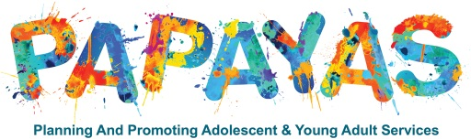
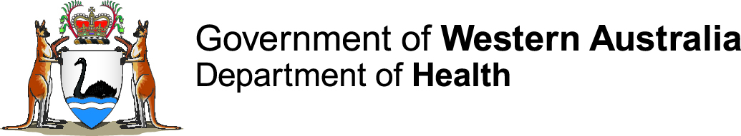
Audit Tool for Youth Friendly Health Services
Instructions for completion
This audit tool has been developed as a resource to assist health services in Western Australia to evaluate how accessible a service is for young people (aged 10-24). This audit aligns with the WA Youth Health Policy 2018-2023 (the Policy).
Who is this checklist for?
This audit tool can be used by any health service that young people access. This includes services whose primary consumers may not be young people. This audit tool is relevant to all health services including primary, secondary and tertiary health services encompassing those in the community, healthcare and inpatient settings.
Why is this audit needed?
- Young people may be reluctant consumers of health services. Services need to be inclusive of, available and accessible to young people.

- Young people need to be able to access appropriate healthcare as independently as possible, when needed.

- This audit will collect information on the current accessibility of health services for young people.

- Results can be used to inform strategies for improving access for young people to your service.

- The information collected will be used by the Child and Youth Health Network to guide development of resources for a toolkit that can be used by health services to improve accessibility for young people.
How to use this checklist:
- The assessor should answer each question by selecting ‘yes’, ‘no’, ‘partly’ or ‘unsure’. Please answer all questions. Each question has space for optional comments, such as current approach or plan for improvement.

- This audit can be completed by an individual on behalf of a service. It is recommended the audit is completed in collaboration with a young person (aged 10-24) as co-assessor.

- Multiple audits can be undertaken in different areas within a health service. The area being assessed should be identifiable within the service area name field (item 1.2 of the tool).

  - For example, 1.1 Perth Children’s Hospital, 1.2 Emergency Department
1.1 Another Medical Centre, 1.2 Waiting room
- This audit can be used as a standalone tool for a service or in conjunction with the Youth Friendly Health Service Checklist

- Section 4 offers the opportunity for the assessors to provide their recommendations for resource development.

- This audit will provide a score; services that are more youth friendly will have a higher score. However, given service variation, scores are not comparable across services but aim to provide a measurement to monitor improvements in youth friendliness over time.

- This audit can be saved electronically, enabling sharing, collation and tracking.

- By collating results, areas can identify recurring themes that can be addressed through collaborative projects and sharing resources to improve services.

- Repeated use of the audit can capture improvements over time.

- Send the completed audit to the Child and Youth Health network via email, subject: Child and Youth Health Network, Service Name, Service Area, Audit Tool. Your stored responses will not be shared directly with other service providers. De-identified information may be shared to show progress with Youth Friendliness of Health Services.

- Send a copy of the completed audit to the Executive sponsor listed in item 1.11 of the audit tool.
Need help?
For further information regarding this audit visit the Child and Youth Health Network webpage where you will find the WA Youth Health Policy 2018-2023, the Companion Resource and WA’s Young People Have a Say: Community Conversation Report.
The Child and Youth Health Network are developing a toolkit for policy implementation. If you have any queries about this audit, or would like to suggest resources to be developed as part of this toolkit, please contact Health Networks via email or call 9222 0200.

Acknowledgement
The Child and Youth Health Network of the Western Australian Department of Health would like to acknowledge Dr Rachel Collins Chief Registrar/Paediatric Fellow, Perth Children’s hospital/ Co-Lead Project PAPAYAS and Dr Ali Buckland Clinical Leadership Registrar, Sir Charles Gairdner Hospital / Co-Lead Project PAPAYAS for the development of this tool.
Audit Tool for Youth Friendly Health Services
1. Service details
- Service name: Click here to enter text. |  | - Service area: Click here to enter text.
- Site address: Click here to enter text. |  | - Service phone: Click here to enter text.
- Date: Click here to enter text. |  | - Assessor name: Click here to enter text.
- Assessor position: Click here to enter text. |  | - Assessor email: Click here to enter text.
1.10 Co-assessor name:  (Consumer) Click here to enter text. |  | 1.10 Co-assessor representative of :  (Name of youth advisory council if applicable) Click here to enter text.
1.11 Executive sponsor name: Click here to enter text. |  | 1.12 Executive sponsor position: Click here to enter text.
 | 2. Environment |  | Yes  2 | Part  1 | No  0 | Unsure  0
 | 2.1 The service is easily accessed by public transport:
 | 2.1.2 The bus or train comes directly to the health service grounds
 | 2.1.3 The bus or train is within walking distance (500m) to the health service
 | Comment: Click here to enter text.
 | 2.2 Free Wi-Fi access is available
 | Comment: Click here to enter text.
 | 2.3 Gender neutral facilities are available:
 | 2.3.1 bathroom
 | 2.3.2 parent room
 | 2.3.3 changing room
 | Comment: Click here to enter text.
 | 2.4 Confidentiality and privacy rights are widely promoted and marketed:
 | 2.4.1 clearly visible within service area
 | 2.4.2 available in an accessible format
 | 2.4.3 available online via the services' website
 | Comment: Click here to enter text.
 | 2.5 The service area has health promotion materials that appeal to young people
 | Comment: Click here to enter text.
 | 2.6 The service is inclusive and welcoming of all young people:
 | 2.6.1 The service area displays signage which clearly shows that diverse groups of young people are included and valued by the service. E.g. LGBTI Safe Place symbol, Aboriginal flag, disability access
 | 2.6.2 Organisational policies which clearly state that diverse groups of young people are included and valued by the service are available. E.g. disability access and inclusion policies
 | 2.6.3 The service area displays signage in languages other than English
 | 2.6.4 There is access to written information in languages other than English e.g. leaflets
 | 2.6.5 There is access to interpreter services
 | 2.6.6 There is access to Aboriginal workers for Aboriginal young people
 | Comment: Click here to enter text.
 | Score: Click here to enter text.
 | Total: Click here to enter text.

3. Service | Yes  2 | Part  1 | No  0 | Unsure  0
3.1 Services are free or low cost
Comment: Click here to enter text.
3.2 The service is open when a young person can access it:
3.2.1 outside of school hours e.g. 0800-1530
3.2.2 outside of normal working hours e.g. 0900-1700
3.2.3 weekends
3.3 Longer consults are available for young people who need them
Comment: Click here to enter text.
3.4 Appointments are available at short notice for young people
Comment: Click here to enter text.
3.5 A telehealth service option is available if clinically appropriate
Comment: Click here to enter text.
3.6 An option is available to receive booking confirmations and reminders by SMS
Comment: Click here to enter text.
3.7 Appointment requests are addressed:
3.7.1 clinician gender can be requested
3.7.2 a person of the same gender (as the patient) can be requested to be present
during an appointment
3.7.3 a peer may be present during an appointment if requested
3.7.4 young people are offered full or part appointments without their parent/carer
Comment: Click here to enter text.
3.8 Young people, their family and carers are provided opportunities to give feedback:
3.8.1 the process of providing feedback is clearly visible
3.8.2 the feedback tool is easy to use
Comment: Click here to enter text.
3.9 Online resources relating to the health service are available:
3.9.1 contains information about the services it provides
3.9.2 contains information about the health service facilities e.g. parking
3.9.3 contains information about public transport links
3.9.4 contains linkages to other related services
3.9.5 contains images that reflect the diversity of young people who may access the service
3.9.6 online booking requests can be made
3.9.7 an app specific to this service is available
Comment: Click here to enter text.
Score: Click here to enter text.
Total: Click here to enter text.

4. Recommendations for resource development:
Click here to enter text.

This document can be made available in alternative formats
on request for a person with disability.
© Department of Health 2018
Copyright to this material is vested in the State of Western Australia unless otherwise indicated. Apart from any fair dealing for the purposes of private study, research, criticism or review, as permitted under the provisions of the Copyright Act 1968, no part may be reproduced or re-used for any purposes whatsoever without written permission of the State of Western Australia.
health.wa.gov.au

