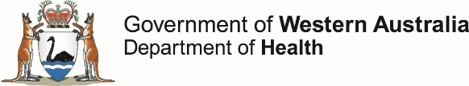

**OzFoodNet Enteric Disease Surveillance Report 1st Quarter 2019**

This report describes enteric disease surveillance and investigations carried out during the first quarter of 2019 (1Q19) by OzFoodNet WA in conjunction with other Western Australian Department of Health agencies and local governments.

Some of the increase in notifications is likely to be due to the introduction of polymerase chain reaction (PCR) testing of faecal specimens which has greater sensitivity than culture techniques.

**Enhancing foodborne disease surveillance across Australia**

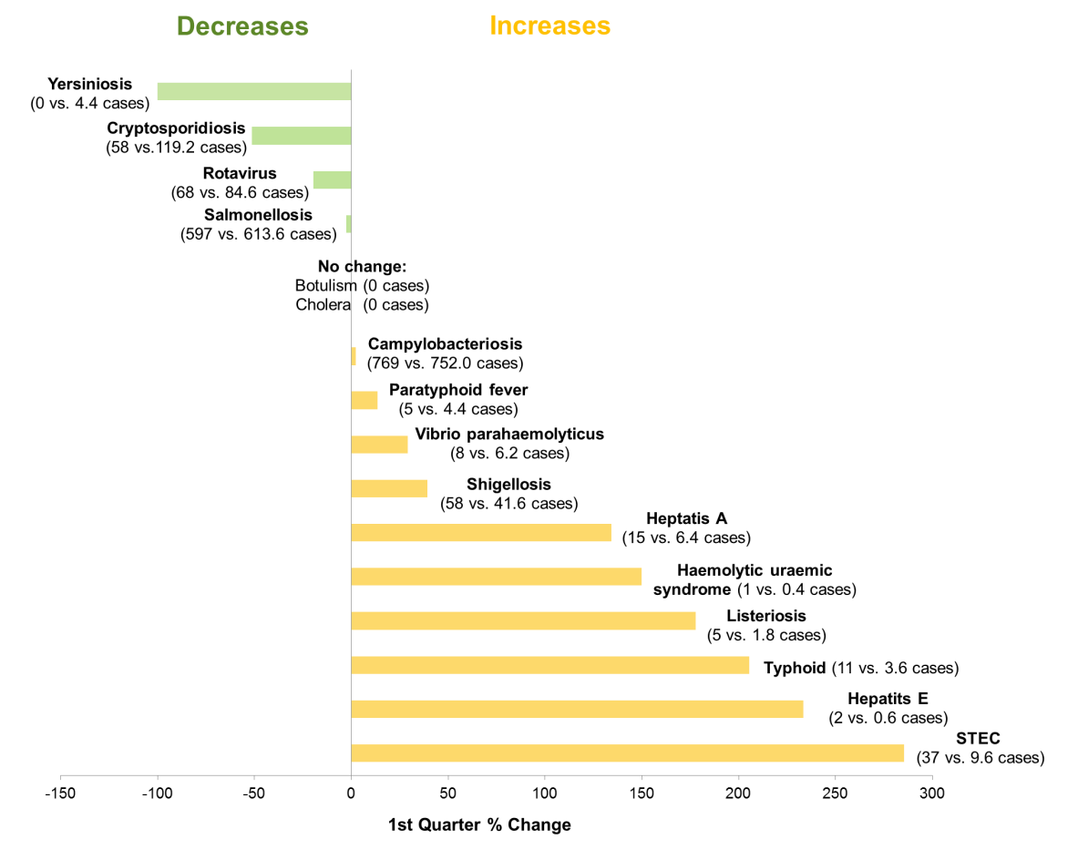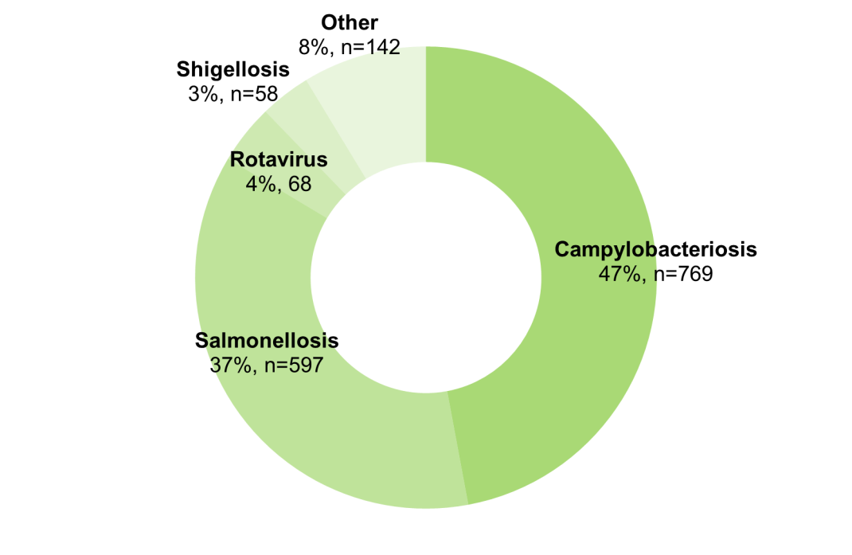

**Appendix 1** Enteric diseases by public health region: <https://ww2.health.wa.gov.au/~/media/Files/Corporate/general%20documents/Infectious%20diseases/Word/OzFoodNet/WA-OzFoodnet-appendix1-2019-Q1.doc>

*Percentage change in the number of notifications in the current quarter compared to the historical 5-year mean for the same quarter. Positive values indicate an increase when compared to the historical 5-year mean of the same quarter. Negative values indicate a decrease when compared to the historical 5-year mean of the same quarter. Percentage change should be interpreted with caution when the number of cases is small.

**Change in enteric disease notifications (%)\***

**Most common enteric disease notifications in Quarter 1 2019**

**Outbreaks in Quarter 1 2019**

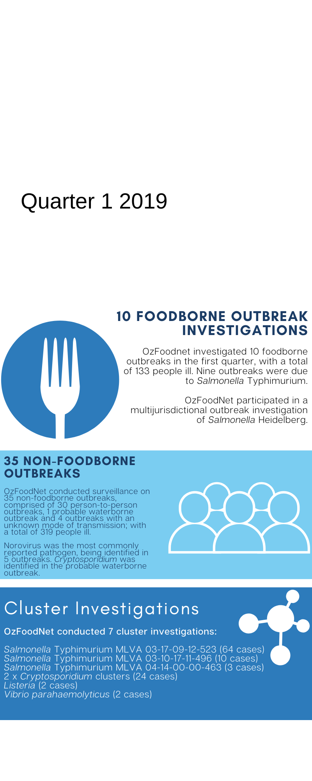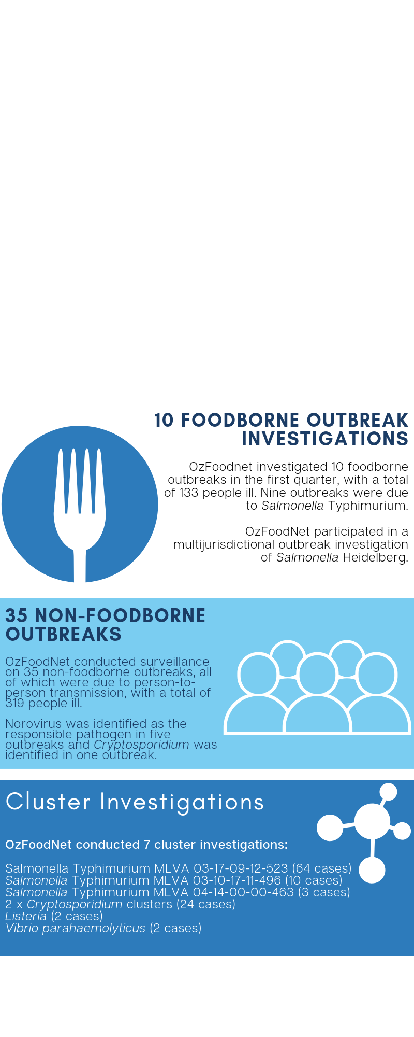

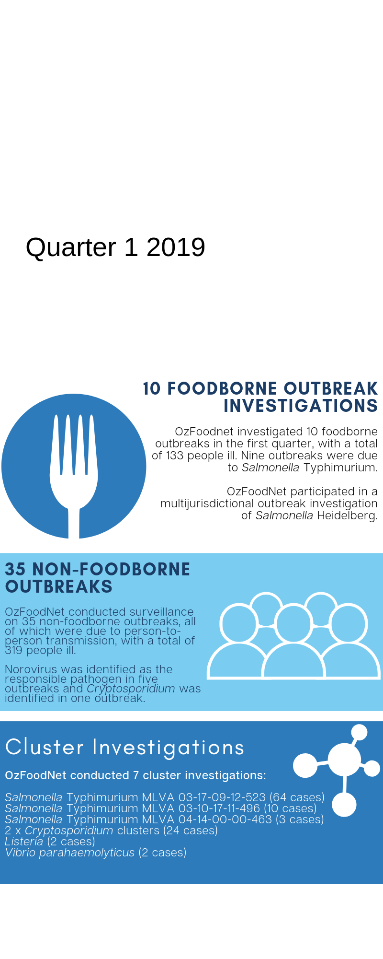

**Appendix 2** Details of foodborne outbreaks investigated in Quarter 1, 2019:

<https://ww2.health.wa.gov.au/~/media/Files/Corporate/general%20documents/Infectious%20diseases/Word/OzFoodNet/WA-OzFoodnet-appendix2-2019-Q1.doc>

**Key trends from Quarter 1 2019**

***Salmonella* Typhimurium (STM) MLVA 03-17-09-12-523**

STM MLVA 03-17-09-12-523 has been under investigation since the type emerged in September 2016. From September 2016 to March 2019 there were 1186 cases notified, including 77 cases in 1Q19. This MLVA type was the single most common MLVA type notified in 1Q19, constituting 23% of STM notifications for the quarter. Of the 77 cases, 13 (17%) were part of three separate point source outbreaks in 1Q19. Dishes that contained raw or undercooked eggs were implicated in one outbreak; the vehicle was unknown in the other 1Q19 outbreaks of this MLVA type.Of the remaining 64 cases, most (89%) resided in the Perth metropolitan area. Hospitalisation data was confirmed for 61 community cases; 36% were hospitalised.

Figure: Notifications of *Salmonella* Typhimurium MLVA 03-17-09-12-523 in WA, 2016 to March 2019

Travel associated infection

Overseas acquisition was reported in 302 (18%) of enteric disease notifications in the 1Q19:

* The most commonly reported country of acquisition was Indonesia (48%).
* The second most common country reported was India (14%), accounting for 10/11 **Typhoid** and 4/5 **Paratyphoid** notifications in the first quarter 2019.

**Shiga toxin producing *E. coli* (STEC)**

Fourteen out of 37 isolates were cultured positive, the most common serotype was O157 (n=4). No point source outbreaks were identified in 1Q19. The large increase is likely due to increased PCR testing by one private laboratory.

**Listeriosis**

One materno-fetal pair notified in 1Q19. Two individual cases notified were highly related by WGS. The cases were also identified as potentially related to three human cases notified in 2012, 2017 and 2018. The source of infection could not be confirmed.

**Haemolytic Uraemic Syndrome**

One case notified, 12 year old female from the South West region. Had recent gastroenteritis with bloody diarrhoea, not diagnosed.

**Hepatitis A infection**

Eleven of the fifteen cases reported overseas travel in 1Q19, including three sibling pairs. Of the four locally acquired cases, three were secondary transmission from a known travel associated case.

**Shigellosis**

There was an increase in the number of notifications of shigellosis. This was driven by an increase in *S. flexneri* 2B, predominately in Aboriginal people in the Kimberley, Goldfields and Pilbara regions.

***Vibrio parahaemolyticus***

Four locally acquired cases were reported in the 1Q19. Two were associated with eating oysters and two had wound infections following swimming in local waterways.

**Cryptosporidiosis**

Outbreak of *Cryptosporidium* in the Broome Township, six cases linked to local aquatic centre.