Foodborne disease surveillance and outbreak investigations in Western Australia, first quarter 2017

**Enhancing foodborne disease surveillance across Australia**



**Communicable Disease Control Directorate**



OzFoodNet, Communicable Disease Control Directorate

**Acknowledgments**

Acknowledgement is given to the following people for their assistance with the activities described in this report: Mr Damien Bradford, Ms Lyn O’Reilly, Ms Marilina Chiari and the staff from the enteric, PCR and food laboratories at PathWest Laboratory Medicine WA; Mr John Coles and other staff from the Food Unit of the Department of Health, Western Australia; Public Health Nurses from the metropolitan and regional Population Health Units; and Local Government Environmental Health Officers.

**Contributors/Editors**

Nevada Pingault, Barry Combs and Niki Foster

Communicable Disease Control Directorate

Department of Health, Western Australia

PO Box 8172

Perth Business Centre

Western Australia 6849

Email: [OzfoodnetWA@health.wa.gov.au](mailto:OzfoodnetWA@health.wa.gov.au)

Telephone: (08) 9388 4999

Facsimile: (08) 9388 4877

Web:

OzFoodNet WA Health [www.public.health.wa.gov.au/3/605/2/ozfoodnet_enteric_infections_reports.pm](http://www.public.health.wa.gov.au/3/605/2/ozfoodnet_enteric_infections_reports.pm)

OzFoodNet Department of Health

[www.ozfoodnet.gov.au/](http://www.ozfoodnet.gov.au/)

**Disclaimer**:

Every endeavour has been made to ensure that the information provided in this document was accurate at the time of writing. However, infectious disease notification data are continuously updated and subject to change.

This publication has been produced by the **Department of Health, Western Australia**.

# Executive summary

During the first quarter of 2017, the Western Australian (WA) OzFoodNet team conducted surveillance of enteric diseases, undertook investigations into outbreaks and was involved with ongoing enteric disease research projects. The most common notifiable enteric infections in WA were salmonellosis (n=919), campylobacteriosis (n=895), cryptosporidiosis (n=244) and rotavirus infection (n=112) (Figure 1). Notifications of salmonellosis were 99% higher, campylobacteriosis were 46% higher, cryptosporidiosis were 136% higher and rotavirus infection were 85% higher than the 5-year first quarter mean. The large increase in salmonellosis was primarily driven by the increase in *S.* Typhimurium MLVA type 03-17-09-12-523 notifications. This is the first time on record that the number of *Salmonella* notifications has surpassed the number of *Campylobacter* notifications. There were 12 foodborne outbreaks investigated in the first quarter, with 11 due to *Salmonella* Typhimurium. The number of foodborne outbreaks in the 1Q17 was 3.75 times higher than the first quarter 5-year mean (n=3.2). OzFoodNet also conducted surveillance of 37 non-foodborne outbreaks. Of these, the most common mode of transmission was person-to-person (19 outbreaks), with a total of 385 people ill. Norovirus was the most commonly reported pathogen in these outbreaks (identified in 12 outbreaks). Non-foodborne outbreaks also included the investigation of three *Cryptosporidium* probable waterborne outbreaks.

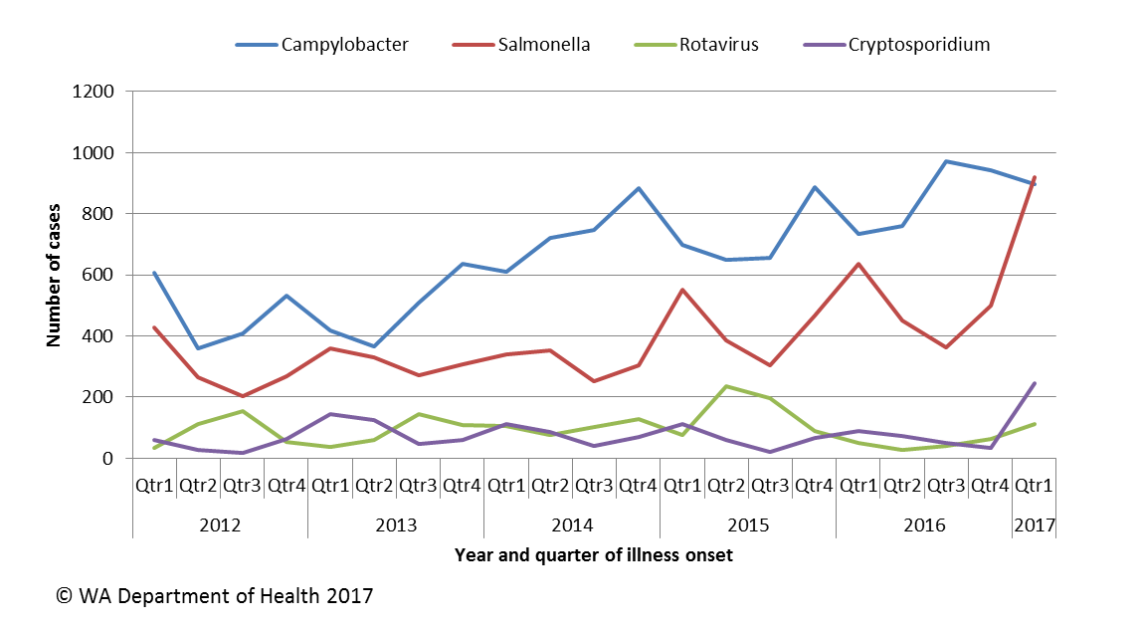

Figure 1 Notifications of the four most common enteric diseases by quarter from 2012 to 2017, WA

**Table of Contents**

Executive summary 2

1 Introduction 5

2 Incidence of notifiable enteric infections 6

2.1. Methods 6

2.2. Salmonellosis 6

2.3. Campylobacteriosis 8

2.4. Cryptosporidiosis 9

2.5. Rotavirus infection 9

2.6. Other enteric diseases and foodborne illness 10

3 Foodborne and probable foodborne disease outbreaks 12

3.1. Restaurant Outbreak, *Salmonella* Typhimurium (outbreak code 042-2017-001) 12

3.2. Café Outbreak, *Salmonella* Typhimurium (outbreak code 042-2017-002) 13

3.3. Mine Site outbreak, *Salmonella* Typhimurium (outbreak code 042-2017-004) 13

3.4. Nasi Lemak, *Salmonella* Typhimurium (outbreak code 042-2017-005) 14

3.5. Restaurant outbreak, *Salmonella* Typhimurium (outbreak code 042-2017-006) 15

3.6. Café outbreak, *Salmonella* Typhimurium (outbreak code 042-2017-007) 15

3.7. Cruise Ship outbreak, *Salmonell*a Typhimurium (outbreak code 042-2017-008) 15

3.8. Restaurant outbreak, *Salmonella* Typhimurium (outbreak code 042-2017-009) 16

3.9. Mine Site outbreak, *Salmonella* Typhimurium (outbreak code 042-2017-011) 16

3.10. Mine Site outbreak, *Salmonella* Typhimurium (outbreak code 042-2017-015) 17

3.11. Wedding outbreak, *Salmonella* Paratyphi b var Java (outbreak code 042-2017-010) 17

3.12. Arancini outbreak, *Salmonell*a Typhimurium (outbreak code 042-2017-012) 18

4 Cluster investigations 18

4.1. *Salmonella* Typhimurium PFGE 0001, PT 9 18

4.2. *Salmonella* Typhimurium MLVA 03-17-09-12-523 19

4.3. *Shigella sonnei* biotype A 21

4.4. *Salmonella* Typhimurium MLVA 05-14-14-11-490 21

4.5. *Salmonella* Poona 21

5 Non-foodborne disease outbreaks and outbreaks with an unknown mode of transmission 22

5.1. Person-to-person outbreaks 22

5.2 Probable waterborne outbreaks 23

5.2.1 Water park, *Cryptosporidium* (outbreak code 081-2017-001) 23

5.2.2 Pool, *Cryptosporidium* (outbreak code 081-2017-002) 23

5.2.3 Pool, *Cryptosporidium* (outbreak code 081-2017-003) 23

5.3. Outbreaks with unknown mode of transmission 23

6 Site activities 24

7 References 25

**List of Tables**

Table 1 Number of salmonellosis notifications, 1st quarter 2017, WA, by region 7

Table 2 Number of campylobacteriosis notifications, 1st quarter 2017, WA, by region 8

Table 3 Number of cryptosporidiosis notifications, 1st quarter 2017, WA, by region 9

Table 4 Number of rotavirus notifications, 1st quarter 2017, WA, by region 10

Table 5 Summary of number of notified cases of enteric notifiable diseases in WA in the first quarter 2017 compared to historical means 12

Table 6 Outbreaks with non-foodborne transmission, 1st Quarter 2017, WA 22

**List of Figures**

Figure 1 Notifications of the four most common enteric diseases by quarter from 2012 to 2017, WA 2

Figure 2 Notifications of *Salmonella* Typhimurium PFGE 0001 in WA, 2013 to March 2017 19

**Notes:**

1. All data in this report are provisional and subject to future revision.
2. To help place the data in this report in perspective, comparisons with other reporting periods are provided. As no formal statistical testing has been conducted, some caution should be taken with interpretation.

Copyright to this material is vested in the State of Western Australia unless otherwise indicated. Apart from any fair dealing for the purposes of private study, research, criticism or review, as permitted under the provisions of the Copyright Act 1968, no part may be reproduced or re-used for any purposes whatsoever without written permission of the State of Western Australia.

# Introduction

It has been estimated that there are 5.4 million cases of foodborne illness in Australia each year at a cost of $1.2 billion per year1. This is likely to be an underestimate of the total burden of gastrointestinal illness as not all enteric infections are caused by foodborne transmission. Other important modes of transmission include person-to-person, animal-to-person and waterborne transmission. Importantly, most of these infections are preventable through interventions at the level of primary production, commercial food handling, households and institution infection control.

This report describes enteric disease surveillance and investigations carried out during the first quarter of 2017 by OzFoodNet WA, other WA Department of Health (WA Health) agencies and local governments. Most of the data are derived from reports by doctors and laboratories to WA Health of 16 notifiable enteric diseases. In addition, outbreaks caused by non-notifiable enteric infections are also documented in this report, including norovirus, which causes a large burden of illness in residential (mostly aged) care facilities (RCF) and the general community.

OzFoodNet WA is part of the Communicable Disease Control Directorate (CDCD) within WA Health, and is also part of the National OzFoodNet network funded by the Commonwealth Department of Health2. The mission of OzFoodNet is to enhance surveillance of foodborne illness, including investigating and determining the cause of outbreaks. OzFoodNet also conducts applied research into associated risk factors and develops policies and guidelines related to enteric disease surveillance, investigation and control. The OzFoodNet site based in Perth is responsible for enteric disease surveillance and investigation in WA.

OzFoodNet WA regularly liaises with staff from: Public Health Units (PHUs); the Food Unit in the Environmental Health Directorate of WA Health; and the Food Hygiene, Diagnostic and Molecular Epidemiology laboratories at PathWest Laboratory Medicine WA.

PHUs are responsible for a range of public health activities, including communicable disease control, within their respective administrative regions. The PHUs monitor RCF gastroenteritis outbreaks and provide infection control advice. The PHUs also conduct follow-up of sporadic cases of important enteric diseases including typhoid, paratyphoid and hepatitis A.

The Food Unit liaises with Local Government (LG) Environmental Health Officers (EHO) during the investigation of food businesses. The Food Hygiene, Diagnostic and Molecular Epidemiology laboratories at PathWest Laboratory Medicine WA provide public health laboratory services for the surveillance and investigation of enteric disease.

# Incidence of notifiable enteric infections

## Methods

Enteric disease notifications were extracted from the Western Australian Notifiable Infectious Diseases Database (WANIDD) by optimal date of onset (ODOO) for the time period 1st January 2012 to 31st March 2017. The ODOO is a composite of the ‘true’ date of onset provided by the notifying doctor or obtained during case follow-up, the date of specimen collection for laboratory notified cases, and when neither of these dates is available, the date of notification by the doctor or laboratory, or the date of receipt of notification, whichever is earliest. Rates were calculated using estimated resident population data for WA from Rates Calculator version 9.5.5 (WA Health, Government of Western Australia), which is based on 2011 census data. Rates calculated for this report were annualised (rates for the quarter multiplied by four) and have not been adjusted for age.

## Salmonellosis

Salmonellosis was the most commonly notified enteric disease in WA in the 1Q17, with 919 notifications and a rate of 135 cases per 100 000 population per year (Table 1). The number of salmonellosisnotifications in the first quarter 2017 (1Q17) was 99% higher compared with the 5-year first quarter mean (1QM) (n=463), with substantial increases seen in most PHUs (Table 1). This is the first time on record that the number of *Salmonella* notifications has surpassed the number of *Campylobacter* notifications.

Place of acquisition of infection was reported for 81% (n=742) of cases, of which 86% (n=637) were locally acquired, 13% (n=98) were acquired overseas and 1% (n=7) were acquired interstate.

The most commonly reported *Salmonella* serotype was *S*. Typhimurium (STM) (n=568, 62%), and of those cases with information on place of acquisition (n=478, 84%), 98% of cases (n=467) were locally acquired. Pulsed-field gel electrophoresis (PFGE) was previously used for subtyping of STM in WA, but as of the beginning of 2016, multi locus variable number tandem repeat analysis (MLVA) has replaced PFGE. The most common MLVA types for 1Q17 were 03-17-09-12-523 (n=298, 52%, PFGE type 0043), 03-17-10-12-523 (n=39, 7%, PFGE type 0043), 03-12-11-10-523 (n=20, 4%, PFGE type 0039) and 03-20-09-12-523 (n=18, 3%, PFGE type 0043). The MLVA type 03-17-09-12-523 emerged in the 4Q16 and has been associated with a number of point source outbreaks in 1Q17 (Sections 3 and 4). There has also been an ongoing community wide outbreak of PFGE 0001 in WA over the past two years (Section 4).

Table 1 Number of salmonellosis notifications, 1st quarter 2017, WA, by region



**\***Percentage change in the number of notifications in the current quarter compared to the historical 5-year mean for the same quarter. Positive values indicate an increase when compared to the historical 5-year mean of the same quarter. Negative values indicate a decrease when compared to the historical 5-year mean of the same quarter. Percentage change should be interpreted with caution when the number of cases is small.

*S*. Enteritidis was the second most common *Salmonella* serotype (n=42, 5%), with most (n=37, 88%) infections acquired overseas, primarily after travel to Indonesia (n=27, 64%), and almost exclusively to Bali.

There were 33 notifications of *Salmonella* that had no serotype. Most (61%) of these notifications were from one laboratory that first uses PCR screening for enteric pathogens. Specimens that are subsequently culture negative remain as a “PCR only” notification.

*Salmonella* Paratyphi B bv javawas the next most common serotype (n=25), with 56% of cases acquired in WA and 12% acquired overseas. Most of the locally acquired cases were part of a point source outbreak, described in Section 3.10. There were also 24 notifications of *Salmonella* Singapore and most (71%) of these notifications were acquired in WA.

## Campylobacteriosis

Campylobacteriosis was the second most commonly notified enteric disease in WA during the first quarter of 2017 (1Q17), with 895 notifications and a rate of 132 cases per 100 000 population per year (Table 2). There was a 46% increase in campylobacteriosisnotifications in the 1Q17 compared with the 1QM of 613 notifications. The increase appeared to be due to sporadic disease, as there were no identified *Campylobacter* outbreaks during the 1Q17. At least some of the increase is likely to be due to the introduction by one large private pathology laboratory of polymerase chain reaction (PCR) testing of faecal specimens, which has greater sensitivity than culture techniques.

The place of acquisition of infection was reported for 57% (n=514) of cases, of which 79% (n=406) were locally acquired and 20% (n=102) were acquired overseas.

Table 2 Number of campylobacteriosis notifications, 1st quarter 2017, WA, by region



**\***Percentage change in the number of notifications in the current quarter compared to the historical 5-year mean for the same quarter. Positive values indicate an increase when compared to the historical 5-year mean of the same quarter. Negative values indicate a decrease when compared to the historical 5-year mean of the same quarter. Percentage change should be interpreted with caution when the number of cases is small.

## Cryptosporidiosis

In the 1Q17 there were 244 cryptosporidiosis notifications (36 cases per 100 000 population per year), a 136% increase compared to the 1QM (Table 3). This increase was driven by a number of point source outbreaks, described in Section 5.2.

The place of acquisition of infection was reported for 84% (n=205) of cases of which 93% (n=191) were locally acquired.

Table 3 Number of cryptosporidiosis notifications, 1st quarter 2017, WA, by region



**\***Percentage change in the number of notifications in the current quarter compared to the historical 5-year mean for the same quarter. Positive values indicate an increase when compared to the historical 5-year mean of the same quarter. Negative values indicate a decrease when compared to the historical 5-year mean of the same quarter. Percentage change should be interpreted with caution when the number of cases is small.

## Rotavirus infection

In the 1Q17 there were 112 notifications of rotavirus infection (16 cases per 100 000 population per year), an 85% increase compared with the mean of the previous 5 years (Table 4). Notifications were predominantly seen in the Perth metropolitan area in the 1Q17, although increases were noted in the Goldfields, Midwest and Pilbara regions. Of the cases with known Aboriginality status, most (79%) cases were non-Aboriginal. The median age was 2 years old (range <1 years to 90 years).

Table 4 Number of rotavirus notifications, 1st quarter 2017, WA, by region



*Percentage change in the number of notifications in the current quarter compared to the historical 5-year mean for the same quarter. Positive values indicate an increase when compared to the historical 5-year mean of the same quarter. Negative values indicate a decrease when compared to the historical 5-year mean of the same quarter. Percentage change should be interpreted with caution when the number of cases is small.

NA: not applicable as there is a 0 value in the calculation for the 1st quarter % change

## Other enteric diseases and foodborne illness

During the 1Q17, other enteric disease notifications included:

* **Shigellosis**: There were 43 shigellosis notifications in 1Q17 that were culture positive, which was 81% higher than the 1QM (n=23.8) (Table 5). *Shigella* *sonnei* was the most commonly notified species (39/43), with 34 cases of *S. sonnei* biotype A and 5 cases of *S. sonnei* biotype B. There was also one case each of *S. flexneri* 1a and *S. boydii*. Species information was not available for two cases. Of the 43 cases, 25 (58%) were Aboriginal people and 18 (42%) were non-Aboriginal people. Cases in the Midwest region accounted for 53% of *Shigella* cases in the 1Q17, this cluster investigation is detailed in Section 4.3. The place of acquisition of infection was reported for 86% (n=37), and of these cases, 86% (n=32) were acquired in Western Australia.
* **Hepatitis A infection:** Six hepatitis A cases were notified in 1Q17, with one case each acquiring their infection overseas in Vietnam, India and Thailand. The remaining three cases were linked to a refuge where a case returning from Afghanistan was thought to be the likely source of two locally acquired cases.
* **Yersiniosis:** There were two cases of culture-positive yersiniosis notified in 1Q17, in 2 and 46 year old males.
* **Shiga toxin *E. coli* (STEC):** Eighteen cases were notified in 1Q17 compared to the 1QM of 1.4 cases. Prior to 2016, STEC was only diagnosed in one laboratory and this was by culture. The increase in cases in 1Q17 was likely due to the introduction in 2016 of PCR testing for STEC on stool samples with bloody diarrhoea at that laboratory and PCR testing of any stool sample on request in another laboratory. The 18 cases include 12 females and six males, ranging in age from 1-88 years (median 46 years). All cases had an acute illness with a specific onset date and 14 of these cases had bloody diarrhoea. One case developed HUS. One case was overseas acquired following travel to Thailand, while the remaining cases were locally acquired.
* **Typhoid fever:** One case, who had travelled to India during their incubation period.
* **Paratyphoid fever:** Three cases of Paratyphi A were notified. Two cases had travelled to India, while the third had travelled to Pakistan.
* ***Vibrio parahaemolyticus*:** There were seven *V. parahaemolyticus* notifications in 1Q17. There were six males and one female with ages ranging from 21 to 73 years old. One case acquired their infection in Western Australia and six acquired infections overseas including Indonesia (n=3), Singapore (n=1), Malaysia (n=1) and Thailand (n=1).
* **Hepatitis E:** One case, who had travelled to India during their incubation period.
* **Listeriosis:** One case undergoing immunocompromising treatment had consumed numerous high risk foods during the incubation period. This case died.
* **Haemolytic Uraemic Syndrome:** Two cases notified in 1Q17. The first case had no obvious food risk factors and was negative for STEC. The second case was culture positive for non-O157 STEC and had eaten a number of high risk foods.

There were no notifications forbotulism or cholera in the first quarter.

Table 5 Summary of number of notified cases of enteric notifiable diseases in WA in the first quarter 2017 compared to historical means



NA: not applicable as there is a 0 value in the calculation for the 1st quarter % change

# Foodborne and probable foodborne disease outbreaks

There were twelve foodborne or probable foodborne outbreaks investigated in this quarter. This was 3.75 times higher than the first quarter 5-year mean (n=3.2).

## Restaurant Outbreak, *Salmonella* Typhimurium (outbreak code 042-2017-001)

A family of three had dinner on 20/1/17 at an Asian restaurant. Dishes included honey chicken, beef in black bean, special fried rice, satay king prawns, combination noodles and omelette. Leftovers were eaten the next day for lunch by all three and an extended family member. All four became ill, with three diagnosed with STM 03-17-09-12-523. This was the only meal the extended family member had eaten with the group in the previous two weeks. All meals were eaten by all four people except the extended family member did not eat the king prawns and one family member did not eat the combination noodles or omelette on either occasion. The eggs used at the restaurant were from WA egg producer 1I. The dishes had been packed into separate takeaway containers. There was a further case in a child who ate at the restaurant with their parents and two siblings on 27/1/17. All ate the same food (fried rice, noodles and soup) but no other members of the family were ill. The food vehicle responsible for the outbreak was unknown. The mode of transmission was probable foodborne.

## Café Outbreak, *Salmonella* Typhimurium (outbreak code 042-2017-002)

At least six people were ill with diarrhoea after eating food from the same café. Of these, five were diagnosed with STM MLVA type 03-25-16-12-523. Cases were interviewed using a hypothesis generating questionnaire containing questions about their illness and food they ate. People became ill between 26/12/2016 and 03/01/2017 and the incubation period was 61 hours. Symptoms included diarrhoea (100%), bloody diarrhoea (n=40%), vomiting (n=20%) and fever (100%) and one case was admitted to hospital. All the cases had breakfast dishes containing eggs. The eggs used at the café were free range eggs from a WA egg producer 1F. Egg dishes sampled were negative for *Salmonella*. Food safety officers investigated the food business and found satisfactory food handling and hygiene practices. Since December 2015, this STM type and similar types (same MLVA or differ by one repeat difference at a locus) have caused seven other point source outbreaks and egg dishes were the implicated food. The evidence suggests that illness was due to probable foodborne transmission.

## Mine Site outbreak, *Salmonella* Typhimurium (outbreak code 042-2017-004)

Interviewing of STM MLVA 03-17-09-12-523 cases identified a case that had worked on a mine site during the incubation period. The case reported that others on site had been ill also. The site nurse had records of 22 people being ill with gastroenteritis between 13/1/17 and 8/2/17. There were 520-620 people on site at the mine, giving a minimum attack rate of 3.5-4.2%.

A questionnaire was distributed to the ill workers, but only 10 interviews were returned. Symptoms reported included diarrhoea (10/10), abdominal pain (9/10), headache (6/10), tiredness (6/10), joint/muscle pain (3/10), chills (2/10), bloody diarrhoea (2/10) and fever (1/10). The median duration of illness was 1.5 days (range 1-21 days) and one person was hospitalised. A total of two *Salmonella* cases (both STM MLVA 03-17-09-12-523) were identified. The following food consumption was reported by cases: eggs (8/10), bacon (8/10), chicken (6/10), raw vegetables (6/10), sausages (4/10), BBQ chicken (4/10), pancakes (4/10), cheesecake (2/10) and chocolate mousse (1/10). For the people that reported eating eggs, 5/8 ate fried eggs, 2/8 ate scrambled eggs and 5/8 ate poached eggs. Swabs collected from the site kitchen on 23/2/17 were negative for *Salmonella*. The eggs used at the site were from WA egg producer 1B, which is implicated in the STM 03-17-09-12-523 cluster (see section 4). The food vehicle responsible for the outbreak was unknown. The mode of transmission was probable foodborne.

## Nasi Lemak, *Salmonella* Typhimurium (outbreak code 042-2017-005)

Following a complaint from a notified *Salmonella* case, and doctor notifications detailing consumption of nasi lemak or food from an Asian grocer, an outbreak related to nasi lemak consumption was identified in February. Further cases were identified during interviews of STM 03-17-09-12-523 cases as part of an ongoing community wide outbreak.

A total of 23 cases were diagnosed with *S.* Typhimurium (20 cases with MLVA 03-17-09-12-523, 2 cases with 03-16-09-12-523 and 1 case with 03-17-09-11-523). A further case was PCR positive for *Salmonella*. There were 12 males and 12 females with a median age of 48.5 years (range 14-67 years).

Twenty three diagnosed cases were interviewed using a structured questionnaire. An analytical study was not performed due to the low number of well people able to be identified that had consumed the nasi lemak. Onset dates ranged from 4/2/17 to 7/2/17. The median incubation period was 11.5 hours. Ten cases were hospitalised. Symptoms reported included: diarrhoea: (23/23), bloody diarrhoea (4/23), fever (18/23), abdominal pain (20/23) and vomiting (15/23).

Nasi lemak was purchased from three Asian grocers between the 4/2/17 and 5/2/17. Most cases reported consuming a particular type of nasi lemak (coconut rice, cucumber, anchovies, omelette, peanuts and sambal wrapped in a triangular brown paper bag). A few cases described a variation on this version of nasi lemak (contained chicken or fish or boiled egg, in plastic takeaway rather than in the brown bag).

The LGA EHO reported that an unregistered food business had supplied a food business in a different LGA, who in turn supplied a number of Asian grocers, including those implicated in the outbreak. The unregistered food business was ordered to stop production of the nasi lemak. The nasi lemak was being made once per week and the food business owner was not able to recall the brand of eggs used. No sampling was able to be conducted.

## Restaurant outbreak, *Salmonella* Typhimurium (outbreak code 042-2017-006)

Six cases of STM MLVA 05-14-14-11-490 reported that during their incubation period they had visited a restaurant in common between 5/1/2017 and 11/1/2017. The median incubation period was 1.8 days, with median duration of diarrhoea of 8.5 days. One case was hospitalised. Food consumed at the restaurant was available for five cases and 4/5 ate BBQ pork dishes and 3/5 had noodles. The fifth case only had bubble tea. EHO investigation found evidence of non-compliances including potential for cross contamination due to poor separation of raw meats and other ready to eat food products in the cool room. Transmission was probable foodborne.

## Café outbreak, *Salmonella* Typhimurium (outbreak code 042-2017-007)

Three cases of STM MLVA 03-26-16-11-523 reported that during their incubation period they had visited a café in common on the same day 28/01/2017. The average incubation period was 1 day, with median duration of diarrhoea of 6 days. No cases were hospitalised. All cases had eaten breakfast egg dishes with hollandaise sauce at the cafe. A hollandaise sauce sample from the café was also positive for the same type of *Salmonella*. Eggs used in the hollandaise sauce were from WA egg producer 1G. Transmission was foodborne.

## Cruise Ship outbreak, *Salmonell*a Typhimurium (outbreak code 042-2017-008)

Interviewing of STM MLVA 03-17-09-12-523 cases identified eight cases who had been on the same cruise ship during their incubation period. Affected people were identified on two consecutive cruises. There were at least 14 passengers (out of 1134) and two crew members (out of 288) who became ill with gastroenteritis symptoms.

A total of 12 passengers were diagnosed with STM MLVA 03-17-09-12-523. A further case was PCR positive for *Salmonella*. The 13 diagnosed cases were interviewed using a structured questionnaire. An analytical study was not performed due to the low number of cases and low number of well co-travellers to use as controls.

There were five males and eight females with median age of 58 years (range 33-67 years). Onset dates were from 28/1/17-3/2/17 for cruise #1 and 31/1/17-3/2/17 for cruise #2. No cases were hospitalised. Symptoms reported included: diarrhoea (13/13), bloody diarrhoea (4/13), fever (12/13) and vomiting (3/13). The median duration of illness was 7 days.

Omelette and/or scrambled eggs were eaten by 12/13 interviewed cases. These dishes were made using a pasteurised egg product from egg producer WA 1B. Three cases also ate fried or poached eggs made from shell eggs from a non-WA egg producer 1E. Food, water and environmental samples collected from the ship were negative for *Salmonella*. No compliance issues were identified. The mode of transmission was probable foodborne.

## Restaurant outbreak, *Salmonella* Typhimurium (outbreak code 042-2017-009)

At least 42 people became ill after eating at an Asian restaurant during the period from 27/2/2017-08/03/2017. Of these 42 people, 26 were diagnosed with STM MLVA 03-17-09-12-523. This *Salmonella* type has caused other point source outbreaks, with illness associated with egg dishes. For this outbreak there were 23 (55%) males and 19 (45%) females, with a median age of 14. All cases had diarrhoea, 30% had bloody diarrhoea, one case was hospitalised and the median incubation period was 1 day. A cohort study was conducted and foods associated with illness were spring rolls (eaten by 7/17 cases, P value=0.02) and fried rice (eaten by 17/17 cases, P value< 0.01). Honey chicken was approaching significance (eaten by 11/17 cases, P value=0.06). Samples of raw pork (used for sweet & sour pork) and pre-cooked chicken were positive for the outbreak strain. Eggs from WA producer 1I, egg omelette and fried rice were negative for *Salmonella*. The environmental health investigation found several non-compliances including poor food handler hygiene and the food business ceased the practice of using pre-cooked chicken. Mode of transmission was foodborne.

## Mine Site outbreak, *Salmonella* Typhimurium (outbreak code 042-2017-011)

At least 62 of approximately 600 people became ill in March and April 2017 after staying at long term workers’ accommodation. Of these 62 cases, 21 were diagnosed with STM MLVA type 03-20-09-12-523 and one was diagnosed with MLVA type 03-17-09-12-523. The cases included 52 (84%) males and 10 females (16%), with a median age of 37. All cases had diarrhoea, five reported bloody diarrhoea and five were hospitalised. The onset of illness was from 10/3-6/4/2017. The median incubation period could not be obtained as workers were at the accommodation for long periods of time. Food was prepared at a canteen and included a large range of breakfast, lunch, dinner, hot and cold foods. A case control study was conducted and eating boiled eggs from WA egg producer 1B was the only food that was significantly associated with illness by univariate analysis and approached significance in multivariate analysis (eaten by 53% of cases, (multivariate: Odds ratio 3.65, LCI 0.99, UCI 13.5, P value=0.052)). An environmental health team investigated the canteen kitchens and non-compliance issues were not identified. Food and water samples were negative for *Salmonella*. MLVA types 03-20-09-12-523 and 03-17-09-12-523 are closely genetically related. Mode of transmission was foodborne.

## Mine Site outbreak, *Salmonella* Typhimurium (outbreak code 042-2017-015)

At least nine of approximately 500 people became ill in March 2017 after staying at long term workers’ accommodation. Of these nine cases, four were diagnosed with *Salmonella*. Two were typed as STM MLVA 03-17-09-12-523 while the other two cases were PCR positive only. The cases included seven males, two females, with a median age of 38. All cases had diarrhoea, two reported bloody diarrhoea and none were hospitalised. Onset of illness was from 11/3-19/3/2017. The median incubation period could not be obtained as workers were at the accommodation for long periods of time. Food was prepared at a canteen and included a large range of breakfast, lunch, dinner, hot and cold foods. Cases were interviewed to describe symptoms and help determine a hypothesis for the cause of illness. Seven cases provided a food history, with 6/7 cases eating a number foods including fried/poached eggs, salad, cheese, lettuce and tomato. WA egg producer 1I supplied eggs to this workers’ accommodation. An environmental health team investigated the canteen kitchens and non-compliances issues were not identified. Food and water samples were negative for *Salmonella*. Mode of transmission was probable foodborne.

## Wedding outbreak, *Salmonella* Paratyphi b var Java (outbreak code 042-2017-010)

At least 15 of 135 people became ill after eating at a wedding on 12/3/2017. Of these 15 people, six were diagnosed with *Salmonella* Paratyphi B var Java. At the wedding there were approximately 100 females and 35 males and all cases were male, with a median age of 20. All cases had diarrhoea, no bloody diarrhoea and two cases was hospitalised. The median incubation period was 22 hours. Food available at the wedding included lamb, rice, chicken curry, salad, pasta and wedding cake. A case control study was conducted and the chicken curry (eaten by 86% of cases, P value<0.01) was associated with illness. The women ate in a separate room to the men (and boys). All the food eaten by males and females was the same, apart from the chicken curry which was only available for the men. As this was a private catered function there was no environmental investigation by a local government environmental health officer. Mode of transmission was foodborne.

## Arancini outbreak, *Salmonell*a Typhimurium (outbreak code 042-2017-012)

Four people were ill with gastroenteritis after eating arancini prepared by a family member on 27/3/17. Arancini were taken home to five households for consumption. A fifth person, who did not eat the arancini, became ill three days after the onset of a household contact, indicating secondary transmission. Ill people were from four of the five households which consisted of 14 people in total. It is unknown how many people ate the food. Three people were hospitalised. Three cases were positive for STM 03-17-09-12-523. The four ill people who had eaten the arancini had not eaten together recently. The arancini were prepared with eggs sourced directly from WA egg producer 1H that was implicated in the STM 03-17-09-12-523 cluster (Section 4).

# Cluster investigations

There were two ongoing and two new cluster investigations during the first quarter of 2017.

## *Salmonella* Typhimurium PFGE 0001, PT 9

Since the beginning of 2014, there has been an ongoing investigation of a community-wide outbreak in WA of notifications of MLVA types analogous to STM PFGE 0001 (Figure 2). PFGE 0001 includes multiple MLVA types. This has been the largest *Salmonella* outbreak ever investigated in WA. From January 2014 to March 2017 there was 943 cases notified, which includes 66 cases with onset dates in the 1st quarter of 2017. Of the 66 cases, 5 were part of two point source outbreaks (see section 3, outbreaks: 042-2017-002, 042-2017-007). The remaining 61 cases, comprising 52% males and 48% females, ranged in age from <1 to 95 years (average 25 years), and most (85%) resided in the Perth metropolitan area.

From January 2015 there have been 17 point source outbreaks due to STM PFGE 0001 and of these, egg dishes have been the implicated food in 16 outbreaks. Raw eggs were part of the implicated dishes for 11 outbreaks, and in five outbreaks, eggs were served as part of the meals. In 13 of these outbreaks, the egg producer was known. In seven outbreaks, eggs were from producer 1C, and in one outbreak each, eggs were from producers 1A, 1B, 1D, 1E, 1F and 1G. Eggs from these producers are available in WA retail outlets.

Independent of the outbreak investigations, samples have been collected from eggs, egg laying chickens and retail chicken meat. STM PFGE 0001 has been isolated on five occasions from eggs or egg laying chickens from producer 1C, twice from egg producer 1B and twice from egg producer 1A. Retail chicken meat sampled in September 2014 was also positive for PFGE 0001.

From February 2015 to March 2016, non-point source outbreak cases (community cases) were investigated as part of a case-control study of STM PFGE 0001 illness. Final analysis of the case control data showed that eating raw eggs was statistically associated with illness.

This evidence suggests eating raw/runny eggs is the cause of STM PFGE 0001 point source outbreaks in WA and it is very likely the cause of many of the community cases.

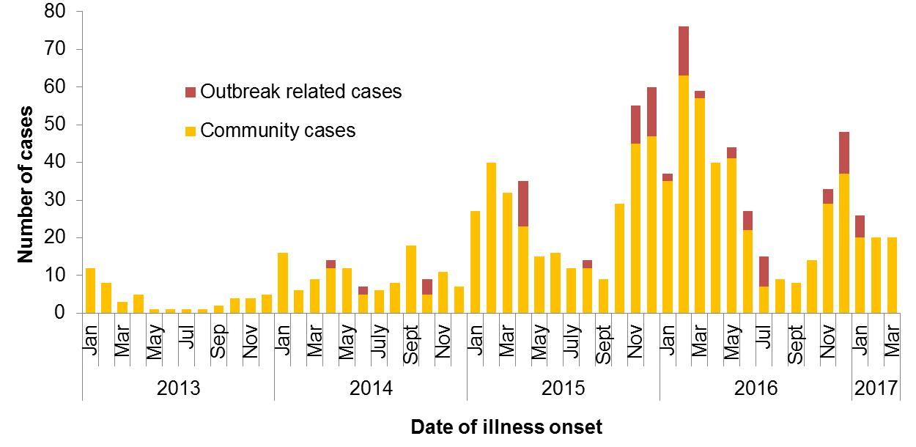

Figure 2 Notifications of *Salmonella* Typhimurium PFGE 0001 in WA, 2013 to March 2017

## *Salmonella* Typhimurium MLVA 03-17-09-12-523

*Salmonella* Typhimurium MLVA 03-17-09-12-523 has been under investigation since the type emerged in 2016 following a single case in September (see 4Q16 report). From September 2016 to March 2017 there were 378 cases notified including 298 cases in 1Q17 (Figure 3). This MLVA type was the single most common MLVA type in 1Q17 constituting 52% of *Salmonella* Typhimurium notifications for the quarter. Of the 298 cases, 71 were part of seven point source outbreaks. These outbreaks are detailed in Section 3. The remaining 227 cases, comprising 52% males and 48% females, ranged in age from <1 to 92 years (median 26 years), and most (86%) resided in the Perth metropolitan area. Hospitalisation data was confirmed for 155 community cases; 23% were hospitalised.

Eggs were implicated in three point source outbreaks of STM 03-17-09-12-523 in the 1Q17. The egg producer (1H) from one outbreak was common to an outbreak of this MLVA type in the 4Q16 when an egg dish was implicated. The egg producer (IB) from the second outbreak had not previously been implicated in a point source outbreak of this MLVA type. The egg producer was unknown for the third outbreak.

The vehicle was unknown for the other four outbreaks, however egg-containing dishes were commonly eaten by cases and eggs used in three of these outbreaks were from a third producer (1I). Eggs used in one of these outbreaks were from producer 1B.

Of the 227 cases not part of these point source outbreaks, 153 were interviewed regarding egg consumption; 70% had consumed eggs in their incubation period, 22% had not, and 8% were unsure. Several different egg brands were reported by cases including the brands of eggs implicated in the point source outbreaks.

In the 1Q17, STM MLVA 03-17-09-12-523 was isolated from four environmental samples from a farm of egg producer 1B. This producer also had a farm environmental sample positive for this MLVA type in 4Q16. This MLVA type was also isolated from a post-mortem sample from a duckling at an unrelated site.

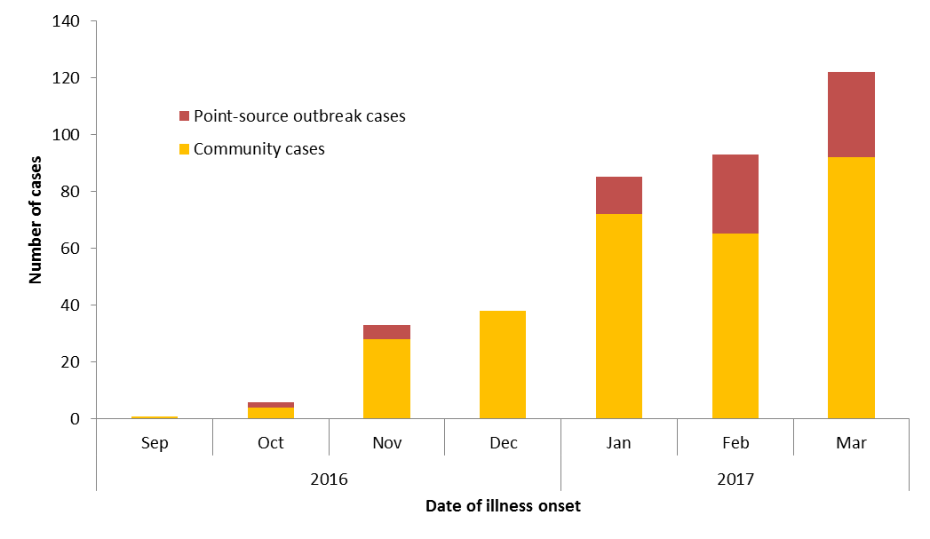

Figure 3 Notifications of *Salmonella* Typhimurium MLVA 03-17-09-12-523 in WA, 2016 to March 2017

## *Shigella sonnei* biotype A

Ten cases of *Shigella sonnei* biotype A were notified in one regional PHU between 03/1/2017 and 04/2/2017. Cases resided in three towns within the PHU, with six cases in one town. Cases comprised 8 females and 2 males, with a median age of 9 years (range 1-59 years). All cases were Aboriginal. Interviews with cases showed that five of the cases were linked, although the original source of the infection was not able to be determined.

## *Salmonella* Typhimurium MLVA 05-14-14-11-490

Seven cases were notified in January. In the last two years only four cases were reported per year. The median age was 21 years old, with five male and two female cases. Four cases were interviewed but a hypothesis for the cause of illness was not able to be established.

## *Salmonella* Poona

Seven cases of *S.* Poona were notified between the 30/1/2017 and 31/1/2017. The 5 year average for *S.* Poona in WA was 5.4 cases per year. An investigation by the laboratory identified a contamination issue that resulted in six false positive results.

# Non-foodborne disease outbreaks and outbreaks with an unknown mode of transmission

There were 37 outbreaks of enteric disease in this quarter that appeared to be non-foodborne (Table 6). Of these, 19 outbreaks were ascribed to person-to-person transmission, three were probable waterborne and 15 outbreaks had an unknown mode of transmission.

Table 6 Outbreaks with non-foodborne transmission, 1st Quarter 2017, WA



1 Deaths temporally associated with gastroenteritis, but contribution to death not specified

## Person-to-person outbreaks

In the 19 non-foodborne outbreaks that were suspected to be due to person-to-person transmission, 16 (84%) outbreaks occurred in RCFs, two (10%) were in child care centres, and one (5%) was in a hospital. The causative agent for 12 (63%) outbreaks was confirmed as norovirus. The remaining seven (37%) outbreaks were of unknown aetiology as specimens were either not collected (n=5) or were negative for common bacterial and viral pathogens (n=2).

A total of 385 people were affected in these 19 outbreaks, with 6 reported hospitalisations. The number of person-to-person outbreaks in the 1Q17 was 50% lower than the first quarter 5-year mean (n=38).

## 5.2 Probable waterborne outbreaks

There were three probable waterborne outbreaks in the 1Q17, all linked to recreational water exposure. In early February there was an increase in *Cryptosporidium* notifications in metropolitan Perth and cases were interviewed with a specific questionnaire for *Cryptosporidium* infections.

### 5.2.1 Water park, *Cryptosporidium* (outbreak code 081-2017-001)

There were 25 cases with onsets of illness from 2/1/2017 to 9/3/2017 who had visited the water park during their incubation period (median 7 days, range 1-13 days). There were 12 males and 13 females with median age of 9 years (range <1-54 years). Environmental Health officers visited the water park and provided advice on upgrading facilities to help reduce the risk of further transmission. Mode of transmission was probable waterborne.

### 5.2.2 Pool, *Cryptosporidium* (outbreak code 081-2017-002)

There were 21 cases with onsets of illness from 24/1/2017-15/3/2017 who had visited a public pool in common during their incubation period (median 7 days, range 1-13 days). There were 9 males and 12 females with median age of 6 years (range 1-40 years). Environmental Health officers visited the pool and provided advice on upgrading facilities to help reduce the risk of further transmission. Mode of transmission was probable waterborne.

### 5.2.3 Pool, *Cryptosporidium* (outbreak code 081-2017-003)

There were 6 cases with onsets of illness from 9/2/2017-26/3/2017 who had visited a public pool in common during their incubation period (median 3.5 days range 1-8 days). There was 1 male and 5 female cases with a median age of 5 years (range 2-9 years). Mode of transmission was probable waterborne.

## Outbreaks with unknown mode of transmission

There were 15 outbreaks in this quarter with an undetermined mode of transmission, with 117 people ill and one reported hospitalisation. Ten of these outbreaks were in RCFs, where the predominant or only symptom was diarrhoea. These outbreaks were unlikely to be due to norovirus due to no or limited vomiting reported. In eight of the 10 outbreaks, the specimens collected were negative for common bacterial and viral pathogens; in one outbreak no specimens were collected; and in one outbreak specimens were negative for common bacterial pathogens, but testing for viral pathogens was not requested.

Five outbreaks with an unknown mode of transmission were in child care centres.

* In two outbreaks diarrhoea was the predominant or only symptom reported and no specimens were collected.
* For one outbreak, diarrhoea was the only symptom reported and the one specimen collected was positive for *Salmonella* Havana. However, it was not able to be established whether the *Salmonella* was acquired at the centre or independent of the centre.
* In one outbreak the only symptom was vomiting and no specimens were collected.
* In one outbreak both diarrhoea and vomiting was reported, with onsets occurring over a two day period. There was insufficient information to determine the mode of transmission. The one specimen collected was negative for common bacterial and viral pathogens.

# Site activities

During the first quarter of 2017, the following activities were conducted at the WA OzFoodNet site:

* Ongoing surveillance of foodborne disease in WA.
* Monitoring culture-independent nucleic acid amplification diagnostic testing in private laboratories and impact on notification rates.
* Investigation of twelve foodborne and probable foodborne outbreaks.
* Investigation and monitoring of 19 person-to-person gastroenteritis outbreaks, 15 outbreaks with unknown mode of transmission and three probable waterborne outbreaks.
* Ongoing investigation of community-wide increases in *Salmonella* Typhimurium PFGE 0001 and MLVA 03-17-09-12-523, and investigation of two other clusters.
* Interviewing *Salmonella* Enteritidis cases regarding travel status and attempting to identify risk factors in locally acquired cases.
* Membership of OzFoodNet working groups on:
  + Outbreak register
  + Foodborne disease tool kit
  + Culture-independent diagnostic testing
* In March, attended the 51st National OzFoodNet face-to-face meeting in Brisbane.
* Participation in combined Food Unit, OzFoodNet and PathWest meeting to help improve surveillance and investigation
* Participation in monthly national OzFoodNet teleconferences.

# References

1. Hall G, Kirk MD, Becker N, Gregory JE, Unicomb L, Millard G, et al. Estimating foodborne gastroenteritis, Australia. Emerg Infect Dis 2005;11(8):1257-1264.
2. OzFoodNet Working Group. A health network to enhance the surveillance of foodborne diseases in Australia. Department of Health and Ageing 2013. www.ozfoodnet.gov.au/internet/ozfoodnet/publishing.nsf/Content/Home-1 [14/03/2012].

This document can be made available in alternative formats on request for a person with a disability.

© Department of Health 2016