Foodborne disease surveillance and outbreak investigations in Western Australia, third quarter 2016

**Enhancing foodborne disease surveillance across Australia**



**Communicable Disease Control Directorate**



OzFoodNet, Communicable Disease Control Directorate

**Acknowledgments**

Acknowledgement is given to the following people for their assistance with the activities described in this report: Mr Damien Bradford, Ms Lyn O’Reilly, Ms Marilina Chiari and the staff from the enteric, PCR and food laboratories at PathWest Laboratory Medicine WA; Mr John Coles and other staff from the Food Unit of the Department of Health, Western Australia; Public Health Nurses from the metropolitan and regional Population Health Units; and Local Government Environmental Health Officers.

**Contributors/Editors**

Niki Foster, Barry Combs, and Nevada Pingault

Communicable Disease Control Directorate

Department of Health, Western Australia

PO Box 8172

Perth Business Centre

Western Australia 6849

Email: [OzfoodnetWA@health.wa.gov.au](mailto:OzfoodnetWA@health.wa.gov.au)

Telephone: (08) 9388 4999

Facsimile: (08) 9388 4877

Web:

OzFoodNet WA Health [www.public.health.wa.gov.au/3/605/2/ozfoodnet_enteric_infections_reports.pm](http://www.public.health.wa.gov.au/3/605/2/ozfoodnet_enteric_infections_reports.pm)

OzFoodNet Department of Health

[www.ozfoodnet.gov.au/](http://www.ozfoodnet.gov.au/)

**Disclaimer**:

Every endeavour has been made to ensure that the information provided in this document was accurate at the time of writing. However, infectious disease notification data are continuously updated and subject to change.

This publication has been produced by the **Department of Health, Western Australia**.

# Executive summary

During the third quarter of 2016, the Western Australian (WA) OzFoodNet team conducted surveillance of enteric diseases, undertook investigations into outbreaks and was involved with ongoing enteric disease research projects.

The most common notifiable enteric infections in WA were campylobacteriosis (n=961), salmonellosis (n=357), cryptosporidiosis (n=51) and rotavirus infection (n=41) (Figure 1). Notifications of campylobacteriosis, salmonellosis and cryptosporidiosis were 52%, 28% and 46% higher, respectively than the 5-year third quarter mean, while rotavirus notifications were lower. The increase in salmonellosis was driven by an increase in notifications of *S*. Typhimurium PFGE 0001.

Three foodborne and two probable foodborne outbreaks were investigated in the third quarter, with four due to *Salmonella* and associated with the consumption of raw egg dishes.

OzFoodNet also conducted surveillance of 62 non-foodborne outbreaks and most (n=40) were in aged care facilities. Of these, the most common mode of transmission was person-to-person (60 outbreaks), with a total of 1558 people ill. Norovirus was the most commonly reported pathogen in these outbreaks (identified in 43 outbreaks).

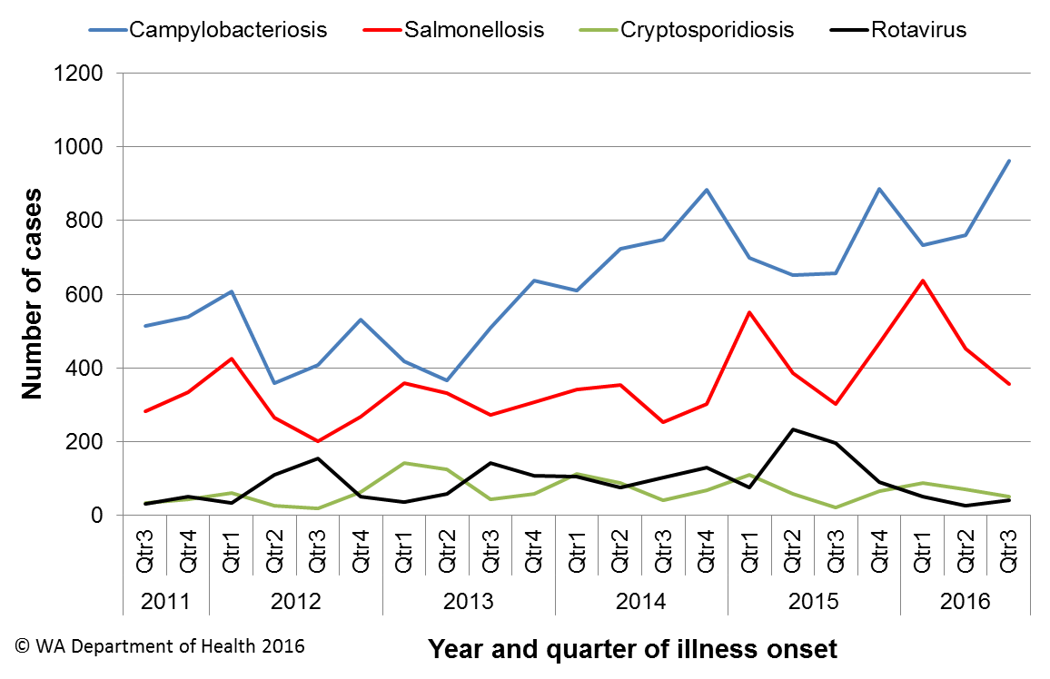

Figure 1 Notifications of the four most common enteric diseases by quarter from 2011 to 2016, WA

**Table of Contents**

1 Executive summary 2

1 Introduction 5

2 Incidence of notifiable enteric infections 6

2.1. Methods 6

2.2. Campylobacteriosis 6

2.3. Salmonellosis 7

2.4. Cryptosporidiosis 8

2.5. Rotavirus infection 9

2.6. Other enteric diseases and foodborne illness 10

3 Foodborne and probable foodborne disease outbreaks 12

3.1 Workplace outbreak, *Salmonella* Typhimurium (outbreak code 042-2016-010) 12

3.2 MJOI, *Salmonella* Hvittingfoss (outbreak code 042-2016-011) 12

3.3 Private function outbreak, *Salmonella* Typhimurium (outbreak code 042-2016-013) 12

3.4 Café outbreak, *Salmonella* Typhimurium (outbreak code 042-2016-014) 13

3.5 Restaurant outbreak, *Campylobacter* sp. (outbreak code 011-2016-001) 13

4 Cluster investigations 14

4.1. *Salmonella* Typhimurium PFGE 0001, PT 9 14

4.2. *Salmonella* Kentucky 15

4.3. *Shigella sonnei* 16

4.4. Yersiniosis 16

5 Non-foodborne disease outbreaks and outbreaks with an unknown mode of transmission 16

5.1. Person-to-person outbreaks 17

5.2. Outbreaks with unknown mode of transmission 17

5.2.1. Playcentre, Unknown aetiology (Outbreak code 09/16/LCH) 17

5.2.2. Restaurant, Unknown aetiology (Outbreak code 09/16/ROT) 18

6 Site activities 18

7 References 20

**List of Tables**

Table 1 Number of campylobacteriosis notifications, 3rd quarter 2016, WA, by region 7

Table 2 Number of salmonellosis notifications, 3rd quarter 2016, WA, by region 8

Table 3 Number of cryptosporidiosis notifications, 3rd quarter 2016, WA, by region 9

Table 4 Number of rotavirus notifications, 3rd quarter 2016, WA, by region 9

Table 5 Summary of number of notified cases of enteric notifiable diseases in WA in the 3rd quarter 2016 compared to historical means 11

Table 6 Outbreaks with non-foodborne transmission, 3rd quarter 2016, WA 17

**List of Figures**

Figure 1 Notifications of the four most common enteric diseases by quarter from 2011 to 2016, WA 2

Figure 2 Notifications of *Salmonella* Typhimurium PFGE 0001 in WA, 2012 to September 2016 15

**Notes:**

1. All data in this report are provisional and subject to future revision.
2. To help place the data in this report in perspective, comparisons with other reporting periods are provided. As no formal statistical testing has been conducted, some caution should be taken with interpretation.

Copyright to this material is vested in the State of Western Australia unless otherwise indicated. Apart from any fair dealing for the purposes of private study, research, criticism or review, as permitted under the provisions of the Copyright Act 1968, no part may be reproduced or re-used for any purposes whatsoever without written permission of the State of Western Australia.

# Introduction

It has been estimated that there are 5.4 million cases of foodborne illness in Australia each year at a cost of $1.2 billion per year1. This is likely to be an underestimate of the total burden of gastrointestinal illness as not all enteric infections are caused by foodborne transmission. Other important modes of transmission include person-to-person, animal-to-person and waterborne transmission. Importantly, most of these infections are preventable through interventions at the level of primary production, commercial food handling, households and institution infection control.

This report describes enteric disease surveillance and investigations carried out during the third quarter of 2016 by OzFoodNet WA, other WA Department of Health (WA Health) agencies and local governments. Most of the data are derived from reports by doctors and laboratories to WA Health of 16 notifiable enteric diseases. In addition, outbreaks caused by non-notifiable enteric infections are also documented in this report, including norovirus, which causes a large burden of illness in residential (mostly aged) care facilities (RCF) and the general community.

OzFoodNet WA is part of the Communicable Disease Control Directorate (CDCD) within WA Health, and is also part of the National OzFoodNet network funded by the Commonwealth Department of Health2. The mission of OzFoodNet is to enhance surveillance of foodborne illness, including investigating and determining the cause of outbreaks. OzFoodNet also conducts applied research into associated risk factors and develops policies and guidelines related to enteric disease surveillance, investigation and control. The OzFoodNet site based in Perth is responsible for enteric disease surveillance and investigation in WA.

OzFoodNet WA regularly liaises with staff from: Public Health Units (PHUs); the Food Unit in the Environmental Health Directorate of WA Health; and the Food Hygiene, Diagnostic and Molecular Epidemiology laboratories at PathWest Laboratory Medicine WA.

PHUs are responsible for a range of public health activities, including communicable disease control, within their respective administrative regions. The PHUs monitor RCF gastroenteritis outbreaks and provide infection control advice. The PHUs also conduct follow-up of sporadic cases of important enteric diseases including typhoid, paratyphoid and hepatitis A.

The Food Unit liaises with Local Government (LG) Environmental Health Officers (EHO) during the investigation of food businesses. The Foods Hygiene, Diagnostic and Molecular Epidemiology laboratories at PathWest Laboratory Medicine WA provide public health laboratory services for the surveillance and investigation of enteric disease.

# Incidence of notifiable enteric infections

## Methods

Enteric disease notifications were extracted from the Western Australian Notifiable Infectious Diseases Database (WANIDD) by optimal date of onset (ODOO) for the time period 1st July 2011 to 30th September 2016. The ODOO is a composite of the ‘true’ date of onset provided by the notifying doctor or obtained during case follow-up, the date of specimen collection for laboratory notified cases, and when neither of these dates is available, the date of notification by the doctor or laboratory, or the date of receipt of notification, whichever is earliest. Rates were calculated using estimated resident population data for WA from Rates Calculator version 9.5.5 (WA Health, Government of Western Australia), which is based on 2011 census data. Rates calculated for this report have not been adjusted for age.

## Campylobacteriosis

Campylobacteriosis was the most commonly notified enteric disease in WA during the third quarter of 2016 (3Q16), with 961 notifications and a rate of 145 cases per 100 000 population per year (Table 1). There was a 52% increase in campylobacteriosisnotifications in the 3Q16 compared with the 5-year 3rd quarter mean (3QM) of 633 notifications. The increase appeared to be due to sporadic disease, however one outbreak of *Campylobacter* was identified during the 3Q16 (see Section 3). At least some of the increase is likely to be due to the introduction by one large private pathology laboratory of polymerase chain reaction (PCR) testing of faecal specimens, which has greater sensitivity than culture techniques.

The place of acquisition of infection was reported for 62% (n=596) of cases, of which 75% (n=445) were locally acquired, 24% (n=144) were acquired overseas and 1% (n=7) were acquired interstate.

Table 1 Number of campylobacteriosis notifications, 3rd quarter 2016, WA, by region



**\***Percentage change in the number of notifications in the current quarter compared to the historical 5-year mean for the same quarter. Positive values indicate an increase when compared to the historical 5-year mean of the same quarter. Negative values indicate a decrease when compared to the historical 5-year mean of the same quarter. Percentage change should be interpreted with caution when the number of cases is small.

## Salmonellosis

Salmonellosis was the second most commonly notified enteric disease in WA in the 3Q16, with 357 notifications and a rate of 54 cases per 100 000 population per year (Table 2). The number of salmonellosisnotifications in the 3Q16 was 28% higher than the 3QM (n=278).

Place of acquisition of infection was reported for 73% (n=259) of cases, of which 54% (n=139) were acquired overseas, 45% (n=117) were locally acquired, and 1% (n=3) were acquired interstate.

The most commonly reported *Salmonella* serotype was *S*. Typhimurium (STM) (n=92, 26%), and of those cases with information on place of acquisition (n=60, 65%), 90% of cases (n=54) were locally acquired. Pulsed-field gel electrophoresis (PFGE) was previously used for subtyping of STM in WA, but as of the beginning of 2016, multi locus variable number tandem repeat analysis (MLVA) has replaced PFGE. The most common MLVA types for 3Q16 were 03-24-13-14-523 (n=9, 10%), 03-25-16-11-523 (n=7, 8%), 03-26-16-11-523 (n=7, 8%), 03-13-11-10-523 (n=7, 8%). MLVA types 03-25-16-11-523 and 03-26-16-11-523 are analogous with PFGE 0001. There has been an ongoing community wide outbreak of PFGE 0001 in WA over the past two years (see Section 4), including many identified point source outbreaks of this STM PFGE type and two in 3Q2016 (see Section 3). MLVA type 03-13-11-10-523, which is analogous with PFGE 39, was also associated with an outbreak in 3Q16 (see Section 3).

Table 2 Number of salmonellosis notifications, 3rd quarter 2016, WA, by region



**\***Percentage change in the number of notifications in the current quarter compared to the historical 5-year mean for the same quarter. Positive values indicate an increase when compared to the historical 5-year mean of the same quarter. Negative values indicate a decrease when compared to the historical 5-year mean of the same quarter. Percentage change should be interpreted with caution when the number of cases is small.

*S*. Enteritidis was the second most common *Salmonella* serotype (n=69, 19%), with most (n=66, 96%) cases acquired overseas, primarily after travel to Indonesia (n=50, 76%), and almost exclusively to Bali.

*Salmonella* Paratyphi B bv javawas the next most common serotype (n=22) and, of those with acquisition known (n=15, 68%), all were acquired overseas. In addition, there were 15 notifications of *Salmonella* that had no serotype. Most (80%) of these notifications were from one laboratory that uses PCR and reflex culture.

## Cryptosporidiosis

In the 3Q16 there were 51 cryptosporidiosis notifications (8 cases per 100 000 population per year), a 46% increase compared to the 3QM (Table 3). The increase occurred primarily in the north metropolitan region.

The place of acquisition of infection was reported for 69% (n=35) of cases of which 71% (n=25) were locally acquired.

Table 3 Number of cryptosporidiosis notifications, 3rd quarter 2016, WA, by region



**\***Percentage change in the number of notifications in the current quarter compared to the historical 5-year mean for the same quarter. Positive values indicate an increase when compared to the historical 5-year mean of the same quarter. Negative values indicate a decrease when compared to the historical 5-year mean of the same quarter. Percentage change should be interpreted with caution when the number of cases is small.

NA: not applicable as the 5-year mean was 0.

## Rotavirus infection

In the 3Q16 there were 41 notifications of rotavirus infection (6 cases per 100 000 population per year), a 73% decrease compared with the 3QM of the previous 4 years (Table 4). Notifications were predominantly seen in the Perth metropolitan area in the 3Q16. Of the cases with known Aboriginality status, most (92%) cases were non-Aboriginal. The median age was <1 year old (range <1 years to 85 years).

Table 4 Number of rotavirus notifications, 3rd quarter 2016, WA, by region



*Percentage change in the number of notifications in the current quarter compared to the historical 4-year mean for the same quarter. Comparison was to four years (2012-2015) of data only because laboratory testing and notification practices (increased use of more specific PCR over antigen testing) have changed since the beginning of 2012. Positive values indicate an increase when compared to the historical 4-year mean of the same quarter. Negative values indicate a decrease when compared to the historical 4-year mean of the same quarter. Percentage change should be interpreted with caution when the number of cases is small.

## Other enteric diseases and foodborne illness

During the 3Q16, other enteric disease notifications included:

* **Shigellosis**: There were 23 shigellosis notifications in 3Q16 that were culture positive, which was 62% higher than the 3QM (n=14) (Table 5). *Shigella* *sonnei* was the most commonly notified species (n=18), with *S. sonnei* biotype G the most common subtype (9/14 biotyped isolates). Four cases of *S. flexneri* andone case of *S. boydii* were notified in 3Q16. Of the notified cases, three (13%) were Aboriginal people and 20 (87%) were non-Aboriginal people. The place of acquisition of infection was reported for 65% (n=15), and 53% (n=8) were acquired overseas.
* **Shiga toxin *E. coli* (STEC):** Nine cases were notified in 3Q16, comprising five males and four females, ranging in age from 2-82 years. This was 350% higher than the 3QM (n=2). The case definition for STEC changed in July 2016 to include PCR only notifications and non-bloody specimens. Two cases were culture positive (serotypes 0157:H- and 026:H-, both cases had bloody diarrhoea), three were culture-negative (consisting of two cases with no bloody diarrhoea), and culture was not performed on four cases (consisting of three cases with no bloody diarrhoea). Two cases were acquired overseas in Indonesia and Papua New Guinea. All remaining cases appeared to be sporadic as no common venues or foods were identified.
* **Yersiniosis:** There were eight cases of culture-positive yersiniosis notified in 3Q16, comprising five females and three males, ranging in age from <1-84 years. This was twice the five year 3QM (n=4). Seven were notified in the Perth metropolitan area. Four cases were interviewed as part of a cluster investigation (see Section 4.4).
* **Hepatitis A infection:** Five hepatitis A cases were notified in 3Q16, with four cases acquiring their infection overseas (in Malaysia, India, Cambodia and Bangladesh) and one case acquiring their infection in NSW.
* **Typhoid fever:** Five cases were notified in this quarter; in adult travellers to India (n=3), Indonesia and Myanmar.
* **Listeriosis:** Four cases were notified in 3Q16, all were female and two were a mother and baby. The MLVA subtypes were the same for the mother and baby and differed for the other cases. The mother had a variety of high risk foods in the incubation period. The other two cases were immunocompromised; one case was a vegetarian with minimal high risk food exposures besides lettuce and bagged lettuce and the other case had consumed a number of high risk foods.
* **Paratyphoid fever:** Three cases of *Salmonella* Paratyphi A and one of *Salmonella* Paratyphi B were notified in 3Q16, with all four cases acquiring their infection overseas (two in India and two in Indonesia).
* **Haemolytic uraemic syndrome:** One case in a female child (under 6 years) with *E. coli* 026:H-. The case was locally-acquired.
* **Hepatitis E infection:** One case in an adult male who had travelled to India.
* ***Vibrio parahaemolyticus*:** One case in an adult male who had travelled to Vietnam.

There were no notifications ofbotulism or cholera.

Table 5 Summary of number of notified cases of enteric notifiable diseases in WA in the 3rd quarter 2016 compared to historical means



**\*** Rotavirus first quarter change compared to the 4-year mean 2012-2015 as previously described in Section 2.5.

NA: not applicable as the 5-year mean was 0.

# Foodborne and probable foodborne disease outbreaks

There were three foodborne and two probable foodborne outbreaks investigated in this quarter.



## Workplace outbreak, *Salmonella* Typhimurium (outbreak code 042-2016-010)

At least nine of 15 people became ill after attending the same workplace on the 27th June. Six of these ill people were diagnosed with STM and genotyped as MLVA 03-26-16-12-523. Symptoms included diarrhoea (n=9), fever (n=8), vomiting (n=6) and bloody diarrhoea (n=1) with a median incubation period of 21 hours. Two people were hospitalised. Of 15 staff at the workplace, 14 completed a structured questionnaire about their illness and food they ate on 27th June. Food consumed included a home-made chocolate and mouse cake, which included raw egg ingredients. Of 14 staff, 13 consumed the cake and of these, nine became ill. The eggs used were from a WA free range egg producer and were purchased from a supermarket. STM with an identical MVLA to that identified in the cases was identified in a sample of left over chocolate and mousse cake. Food safety officers did not investigate as the food was prepared in a private residence which is not covered by the Food Act 2008. The evidence suggests that illness was due to foodborne transmission.

## MJOI, *Salmonella* Hvittingfoss (outbreak code 042-2016-011)

In June and July 2016, there was an increase in *Salmonella* Hvittingfoss notifications in multiple jurisdictions. In WA, there were nine cases in June (n=3) and July (n=6) and the 5-year average was 3.8 cases/year. NSW led a multi-jurisdictional outbreak investigation (MJOI) and five of the WA cases were confirmed as outbreak cases. The evidence from the MJOI identified that the source of the *Salmonella* was contaminated rockmelons. The mode of transmission was foodborne.

## Private function outbreak, *Salmonella* Typhimurium (outbreak code 042-2016-013)

At least 12 of 50 people were reportedly ill after attending a private function on July 23rd 2016. Five of these ill people were diagnosed with STM and were genotyped as MLVA 03-25-16-11-523. A sixth person diagnosed with STM MLVA 03-25-16-11-523 did not attend the function on July 23rd, but consumed a home-made tiramisu (which included raw egg ingredients) that was eaten at the function. Function attendees were emailed a structured questionnaire containing questions about their illness and food they ate. Of the 50 attendees who were emailed the questionnaire, 15 completed the questionnaire. Of the 15 attendees, nine reported becoming ill; symptoms included diarrhoea (n=9), fever (n=7), vomiting (n=3) and bloody diarrhoea (n=1) with a median incubation period of 25 hours. One person was hospitalised. A raw egg tiramisu was served at the function and a sample of this was positive for STM MLVA 03-25-16-11-523. The eggs used in the tiramisu were from a WA egg producer and were purchased from a supermarket. Food safety officers did not investigate as the food was prepared in a private residence which is not covered by the Food Act 2008. The evidence suggests that illness was due to foodborne transmission.

## Café outbreak, *Salmonella* Typhimurium (outbreak code 042-2016-014)

There were seven cases of *Salmonella* Typhimurium MLVA type 03-13-11-10-523 in July (n=3) and August (n=4) with only three others in the year to date. The three most recent cases (age 9-32 years) with onset dates mid to late August and residing in the same public health region were interviewed. All three cases had eaten lunch at the same café on the same date. Symptoms included fever (n=3), vomiting (n=3), abdominal pain (n=3), headache (n=3), diarrhoea (n=3), lethargy (n=3), nausea (n=3) and joint or muscle pain (n=1), with duration of diarrhoea ≥7 days. One case was hospitalised. The cases consumed a variety of foods from the café but all dishes appeared to contain sauces. An environmental investigation noted the use of raw egg in the sauces and the use of the egg shell to separate the egg. Sauces were stored for 3 days in the refrigerator. No leftovers were available for testing however samples (chicken, sauces and environmental swabs) collected three weeks after exposure were negative for *Salmonella*. The use of an egg separator or pasteurised eggs was suggested to the vendor as an alternative to reduce risk of contamination of sauces. The mode of transmission was probable foodborne.

## Restaurant outbreak, *Campylobacter* sp. (outbreak code 011-2016-001)

Seven people in four separate groups developed gastroenteritis with five diagnosed with *Campylobacter* after eating at a restaurant. One group visited the restaurant on 10th August and three groups visited the restaurant on the 2nd September. One group reported that four of seven people became ill and the only common food eaten by the group was liver pate and bruschetta. Three cases were each in separate groups who attended the restaurant but the cases were the only ones who ate chicken liver pate. In total seven people were ill, with five diagnosed with *Campylobacter* after visiting the restaurant. Of the seven ill, the median duration of diarrhoea was six days, with other symptoms including abdominal pain (86%), fever (57%), chills (43%) and vomiting (14%). One case was hospitalised. The median incubation period was 2 days. An environmental investigation found that the liver pate was cooked in-house but not at a sufficiently high temperature to kill bacteria. Chicken livers at the restaurant were positive for *Campylobacter* but these samples were not from the same batch as eaten by cases. The owner of the restaurant decided to no longer make the pate. The mode of transmission was probable foodborne.



# Cluster investigations

There was one ongoing and three new cluster investigations during the third quarter of 2016.

## *Salmonella* Typhimurium PFGE 0001, PT 9

Since the beginning of 2014, there has been an ongoing investigation of a community-wide outbreak in WA of notifications of MLVA types analogous to STM PFGE 0001 (Figure 2). This has been the largest *Salmonella* outbreak ever investigated in WA. From January 2014 to June 2016 there was 750 cases notified, with an additional 31 cases in the 3rd quarter of 2016. Eight of the 31 cases were part of two point source outbreaks (see Section 3). The remaining 23 cases, comprising 35% males and 65% females, ranged in age from <1 to 69 years (average 24 years), and most (78%) resided in the Perth metropolitan area.

From January 2015 there have been 14 point source outbreaks due to STM PFGE 0001 and of these, egg dishes have been the implicated food in 12 outbreaks. Raw eggs were part of the implicated dishes for ten outbreaks, and in two outbreaks eggs were served as part of breakfast meals. In 10 of these outbreaks, the egg producer was known. In six outbreaks, eggs were from producer C, and in one outbreak each, eggs were from producers A, B, D and E. Eggs from these producers are available in WA retail outlets. Environmental sampling at producer A in May 2015 did not isolate *Salmonella*. At the time of writing, no environmental samples have been taken from WA egg producers B.

Independent of the outbreak investigations, samples have been collected from eggs, egg laying chickens and retail chicken meat. STM PFGE 0001 has been isolated on five occasions from eggs or egg laying chickens from producer C, twice from egg producer B and once from egg producer A. Retail chicken meat sampled in September 2014 was also positive for PFGE 0001.

From the 25/2/2015 onwards, non-point source outbreak cases (community cases) have been investigated as part of a case-control study of STM PFGE 0001 illness. Final analysis of the case control data has shown that eating raw eggs is statistically associated with illness.

This evidence suggests eating raw/runny eggs is the cause of STM PFGE 0001 point source outbreaks in WA and it is very likely the cause of many community or non-point source cases.

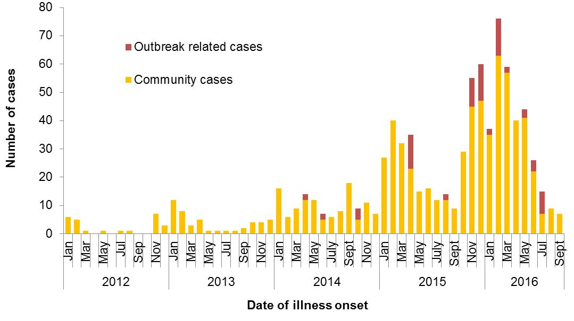

Figure 2 Notifications of *Salmonella* Typhimurium PFGE 0001 in WA, 2012 to September 2016

## *Salmonella* Kentucky

Seven cases of *Salmonella* Kentucky were notified with ODOO in July 2016, compared to a historical 5-year average for the same period of <1 case. Cases included two males and five females from metropolitan Perth (n=5) and rural areas (n=2), with a median age of 36 years (range <1-64 years). Five cases were followed up with the notifying doctor for their travel history and all had acquired their infection overseas in Indonesia (n=3), India (n=1) or Vietnam (n=1).

## *Shigella sonnei*

Ten cases of *Shigella sonnei* were notified with ODOO in July 2016, compared to a historical 5-year average for the same period of 3 cases. Cases included five males and five females, with a median age of 28. All cases were from the Perth metropolitan area. The biotypes included G (n=5) and A (n=1) and biotypes were not available for four cases. Nine cases were followed up with the notifying doctor for their travel history and four cases, including three with biotype G, had acquired their infection overseas in Indonesia (n=3) and Thailand (n=1).

## Yersiniosis

There were seven cases of Yersinia in July-August 2016 compared to the 5-year average of 1 case. Cases included two males and five females, average age of 26 years (range <1-84 years) and most (6/7) cases lived in metropolitan Perth. Four cases were interviewed and while infections were locally acquired, no hypothesis for the cause of illness was established.

# Non-foodborne disease outbreaks and outbreaks with an unknown mode of transmission

There were 62 outbreaks of enteric disease in this quarter that appeared to be non-foodborne (Table 6). Of these, 60 outbreaks were ascribed to person-to-person transmission and two outbreaks had an unknown mode of transmission.

Table 6 Outbreaks with non-foodborne transmission, 3rd quarter 2016, WA



1 Deaths temporally associated with gastroenteritis, but contribution to death not specified

NA: Not applicable as all hospitalised or unknown

## Person-to-person outbreaks

In the 60 non-foodborne outbreaks that were suspected to be due to person-to-person transmission, 40 (67%) outbreaks occurred in RCFs, 12 (20%) were in child care centres and eight (13%) were in hospitals. The causative agent for 43 (72%) outbreaks was confirmed as norovirus. The remaining 17 (28%) outbreaks were of unknown aetiology as specimens were either not collected (n=13), viral tests were not requested (n=3) or were negative for common viral and bacterial pathogens (n=1).

A total of 1558 people were affected in these 60 outbreaks, with 26 reported hospitalisations and nine associated deaths. The number of person-to-person outbreaks in the 3Q16 was 200% higher than the 3QM (n=20).

## Outbreaks with unknown mode of transmission

There were two outbreaks in this quarter with an undetermined mode of transmission, with 20 people ill and no reported hospitalisations. One of these outbreaks was at a restaurant.

## Playcentre, Unknown aetiology (Outbreak code 09/16/LCH)

Ten adults and one child from a group of 22 (12 adults and 10 children) became ill with gastroenteritis symptoms following a function held at a playcentre in September 2016 but no specimens were collected. All food was provided by the playcentre. A questionnaire was distributed and six responses were received including 4 people who were ill (3 adults and 1 child) and two who were well (1 adult and 1 child). The incubation period was 1-2 days. Symptoms included nausea (n=4), fatigue (n=4), vomiting (n=3), chills (n=3), headache (n=2), diarrhoea (n=1), fever (n=1), and abdominal pain (n=1). The duration of illness was 1-2 days. There were no hospitalisations. The number of respondents was too low for statistical analysis. No respondents had known of anyone ill beforehand, only two cases had used the toilet facilities, and no foods were common to all cases. The most common foods consumed among cases were the rice paper rolls (n=3) and the banana muffins (n=3). No well people had eaten the rice paper rolls and one well person had eaten the banana muffins. An environmental investigation noted that the premises was only suitable for heat and serve, low risk foods. The rice paper rolls had been prepared on site and the chicken had been cooked the night before in an unregistered kitchen. The proprietor had only taken over the premises in August 2016. The proprietor was advised to attend the LG in-house food handling training course. The aetiology and mode of transmission was unknown.

## Restaurant, Unknown aetiology (Outbreak code 09/16/ROT)

Nine patrons from a group of ten reported gastroenteritis symptoms after eating at a restaurant in September 2016 but no specimens were collected. This was the only meal attended by all ill patrons, and ill patrons were from more than one household. A questionnaire was distributed to the group and 8 questionnaires were returned including 7 from ill patrons. Ill patrons had a median age of 32 and 43% were male. Symptoms included nausea (n=7), abdominal cramps (n=7), diarrhoea (n=5), fever (n=2), and vomiting (n=1). The median incubation period was 3 hours (range 2-3.5 hours) and median duration of diarrhoea was 2 days (range 1.5-3 days). There were no hospitalisations. No ill patrons had been ill prior to the dinner or been in contact with another ill person in the week before. All ill patrons had eaten a lightly battered fish main meal with aioli and rocket. The well patron had a beef burger main with chips and did not have any sauces. The restaurant was inspected the week of the complaint. The restaurant was aware of the complaint and had not received any other complaints. No compliance issues were noted. The aetiology and mode of transmission was unknown.

# Site activities

During the third quarter of 2016, the following activities were conducted at the WA OzFoodNet site:

* Ongoing surveillance of foodborne disease in WA.
* Monitoring culture-independent nucleic acid amplification diagnostic testing in private laboratories and impact on notification rates.
* Investigation of three foodborne outbreaks and two probable foodborne outbreaks.
* Investigation and monitoring of 60 person-to-person gastroenteritis outbreaks and two outbreaks with unknown mode of transmission.
* Ongoing investigation of a community-wide increase in *Salmonella* Typhimurium PFGE 0001 and investigation of three other clusters.
* Responded to national OzFoodNet enteric disease surveillance requests.
* Attended the Illumina Workshop on whole genome sequencing (WGS) held at the Australian Society for Microbiology Annual Scientific Meeting 2016 in July.
* Met with the Deputy Director of MDU, in July to discuss the potential and implementation of WGS in enteric disease surveillance in WA, with a PathWest laboratory representative.
* Presented on *Salmonella* Typhimurium and Eggs for the PathWest Continuing Education Program in August.
* Prepared and distributed in August a gastroenteritis alert to childcare centres and RCFs regarding a recent increase in gastroenteritis outbreaks occurring in these facilities.
* Lectured on foodborne pathogens to Masters students at University of Western Australia in September.
* Interviewed *Salmonella* Enteritidis cases regarding travel status and attempted to identify risk factors in locally acquired cases.
* Interviewed locally acquired Campylobacter cases as part of a collaborative pilot study on *Campylobacter* typing and quantitative recovery from retail chicken meat with PathWest and Murdoch University.
* Assisted with updating of the cryptosporidiosis information sheet for the Healthy WA website
* Contributed data and text for the discussion paper on the Review of the Food Act 2008
* Membership of OzFoodNet working groups on:
  + Outbreak register
  + Foodborne disease tool kit
  + Egg-related outbreaks
  + Culture-independent testing
  + 50th Face-to-face meeting
* Participation in monthly national OzFoodNet teleconferences
* Participation in combined Food Unit, OzFoodNet and PathWest meeting to help improve surveillance and investigation

# References

1. Hall G, Kirk MD, Becker N, Gregory JE, Unicomb L, Millard G, et al. Estimating foodborne gastroenteritis, Australia. Emerg Infect Dis 2005;11(8):1257-1264.
2. OzFoodNet Working Group. A health network to enhance the surveillance of foodborne diseases in Australia. Department of Health and Ageing 2013. www.ozfoodnet.gov.au/internet/ozfoodnet/publishing.nsf/Content/Home-1 [14/03/2012].

This document can be made available in alternative formats on request for a person with a disability.

© Department of Health 2016