Foodborne disease surveillance and outbreak investigations in Western Australia 2014 annual report



**Enhancing foodborne disease surveillance across Australia**



OzFoodNet, Communicable Disease Control Directorate

**Acknowledgments**

Acknowledgement is given to the following people for their assistance with the activities described in this report: Mr Damien Bradford, Ms Lyn O’Reilly, Ms Jenny Green, Mr Ray Mogyorosy and the staff from the enteric, PCR and food laboratories at PathWest Laboratory Medicine WA; Mr Stan Goodchild, Mrs Anna Anagno and other staff from the Food Unit of the Department of Health, Western Australia; Public Health Nurses from the metropolitan and regional Population Health Units; and Local Government Environmental Health Officers.

**Contributors/Editors**

Barry Combs, Nevada Pingault, Sarojini Monteiro

Communicable Disease Control Directorate

Department of Health, Western Australia

PO Box 8172

Perth Business Centre

Western Australia 6849

Email: [OzfoodnetWA@health.wa.gov.au](mailto:OzfoodnetWA@health.wa.gov.au)

Telephone: (08) 9388 4999

Facsimile: (08) 9388 4877

Web:

OzFoodNet WA Health [www.public.health.wa.gov.au/3/605/2/ozfoodnet_enteric_infections_reports.pm](http://www.public.health.wa.gov.au/3/605/2/ozfoodnet_enteric_infections_reports.pm)

OzFoodNet Department of Health and Ageing

[www.ozfoodnet.gov.au/](http://www.ozfoodnet.gov.au/)

**Disclaimer**:

Every endeavour has been made to ensure that the information provided in this document was accurate at the time of writing. However, infectious disease notification data are continuously updated and subject to change.

PUBLISHED BY

This publication has been produced by the **Department of Health, Western Australia**.

# Executive summary

This report is a summary of enteric disease surveillance activities and outbreak investigations in Western Australia (WA) in 2014.

Enteric disease causes a large burden of illness in the WA community and there are 16 notifiable enteric infections. The Department of Health through OzFoodNet (OFN) and other agencies conducts enteric disease surveillance and investigates outbreaks so that targeted interventions can be used to help prevent further transmission.

In WA, there was 5071 enteric disease notifications in 2014 with a rate of 200 cases per 100 000 population which is 10% higher than the average for the previous five years. The age group with the highest rate was <1-4 years with a rate of 556 cases per 100 000 population. Aboriginal people had enteric disease rates 54% higher than non-Aboriginal people. Of the notified enteric infections with a know place of acquisition, 70% reported acquiring their infection in WA and 28% reported overseas travel. Of the enteric notifications reporting overseas travel, most (57%) had travelled to Indonesia.

Figure A: WA enteric diseases for 2014 by disease; number of notifications

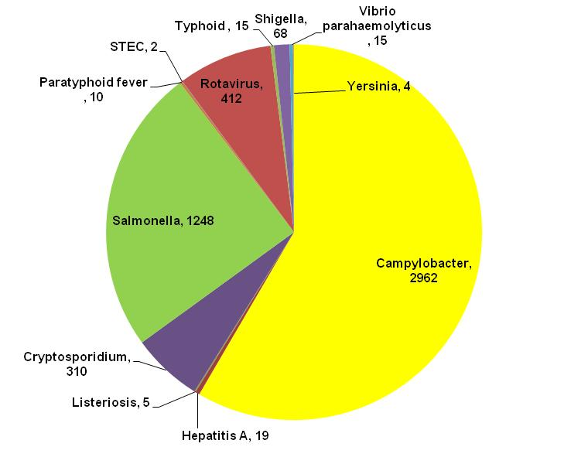

Campylobacteriosiswas the most (n=2962) notified enteric disease in 2014 followed by salmonellosis (n=1248) and rotavirus (n=412) (Figure A). Most enteric diseases had similar or lower rates of notifications compared to the previous five years except for campylobacteriosis that was 26% higher in 2014.

**Foodborne and suspected foodborne outbreaks**

In 2014, there were 13 outbreaks of foodborne or suspected foodborne disease investigated in WA that caused at least 139 cases of illness (Figure B). Seven of these outbreaks were caused by *Salmonella* species, two by *Clostridium perfringens*, three by norovirus, one each by *Listeria* and hepatitis A and three outbreaks the infectious agent or toxin was unknown.

Of the 13 outbreaks, food(s) were implicated for eight outbreaks which included meat dishes (n=3), salads (n=2), Nasi-lemak (n=1) and multiple dishes (n=2). Among outbreaks in the previous five years when a food was implicated, dishes containing eggs (9/31) was the most common food vehicle.

Figure B: Foodborne outbreaks investigated in WA by causative pathogen

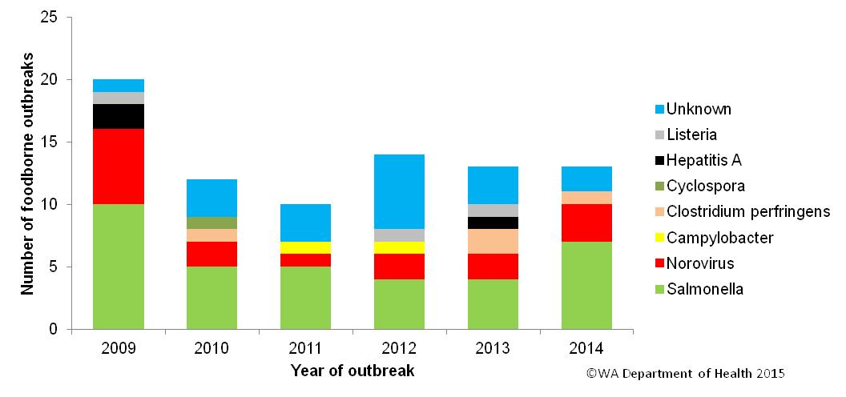

**Non foodborne enteric disease outbreaks**

Person to person enteric disease outbreaks and outbreaks with unknown mode of transmission are a major cause of illness especially in institutions such as residential care facilities (RCF). There were 186 non-foodborne outbreaks reported in 2014 which resulted in 4002 ill people, 74 hospitalisations and 14 deaths. Most of these outbreaks were in RCF (63%) and due to person to person transmission (76%). Of those outbreaks with a known cause, most were due to norovirus (88%).

**Table of contents**

Executive summary 3

1. Introduction 7

2. Data sources and methods 9

2.1. Data sources 9

2.2. Data changes 10

2.3. Data collection by Aboriginality 10

2.4. Regional boundaries 10

2.5. Calculation of rates 11

2.6. Definitions: 11

3. Site activities including prevention measures during the year 12

3.1. Surveillance and investigation 12

3.2. Activities on enhancing laboratory and epidemiological surveillance 12

3.3. Activities to assist enteric disease policy development 13

3.4. Strengthening skills and capacity for enteric disease surveillance and investigation 14

3.5. Conference meetings and presentations 14

3.6. Joint authors on publications 14

3.7. Special projects to describe the risk factors of enteric diseases (see section 6 for full description) 14

4. Incidence of specific enteric diseases 15

4.1. Campylobacteriosis 15

4.2. Salmonellosis 18

4.3. Cryptosporidiosis 24

4.4. Rotavirus infection 22

4.5. Shigellosis infection 26

4.6. Hepatitis A virus infection 30

4.7. Typhoid and paratyphoid fever 30

4.8. Listeriosis 31

4.9. *Vibrio parahaemolyticus* infection 31

4.10.*Yersinia* infection 32

4.11.STEC/HUS infection 32

4.12.Cholera, botulism and HUS 32

5. Gastrointestinal disease outbreaks and investigations 33

5.1. Foodborne/suspected foodborne outbreaks 33

5.2. Outbreaks due to non-foodborne transmission or with an unknown mode of transmission 37

5.3. Cluster investigations 41

6. OzFoodNet WA research projects 42

6.1. National descriptive study of *Salmonella* Enteritidis 42

7. References 43

Appendix 1: Number of notifications, notification rate and ratio of current to historical mean by pathogen/condition, 2009 to 2014, WA 49

**List of tables**

Table 1. Number and proportion of the top 10 *Salmonella* serotypes notified in WA, 2014, with comparison to the 5-year average 21

Table 2 Foodborne and suspected foodborne outbreaks, 2014 36

Table 3. Outbreaks due to non-foodborne transmission or unknown mode of transmission in WA by setting and agent, 2014 40

Table 4. Cluster investigations in WA by month investigation started, setting and agent, 2014 42

List of figures

Figure 1. Number of cases of campylobacteriosis by year and month of onset, WA, 2009 to 2014. 16

Figure 2. Campylobacteriosis notification rates by sex, WA, 2009 to 2014 16

Figure 3: Age-specific notification rates for campylobacteriosis by sex, WA, 2014 17

Figure 4. Campylobacteriosis notification rates by region and Aboriginality, WA, 2014 17

Figure 5. Number of cases of salmonellosis by year and month of onset, WA, 2009 to 2014 18

Figure 6. Age-specific notification rates for salmonellosis by sex, WA, 2014 19

Figure 7. Salmonellosis notification rates by region and Aboriginality, WA, 2014 20

Figure 8. Number of cases of *S.* Enteritidis by year of onset, WA, 2009 to 2014 21

Figure 9. Proportion of salmonellosis cases acquired overseas, by year of onset, 2009 to 2014 22

Figure 10. Number of cases of rotavirus infection by year and month of onset, WA, 2009 to 2014 23

Figure 11. Age-specific notification rates for rotavirus by sex, WA, 2014 23

Figure 12. Rotavirus notification rates by region and Aboriginality, WA, 2014 24

Figure 13. Number of cases of cryptosporidiosis by year and month of onset, WA, 2009 to 2014 25

Figure 14. Age-specific notification rates for cryptosporidiosis by sex, WA, 2014 26

Figure 15. Cryptosporidiosis notification rates by region and Aboriginality, WA, 2014 26

Figure 16. Number of cases of shigellosis by year and month of onset, WA, 2009 to 2014 27

Figure 17. Age-specific notification rates for shigellosis by sex, WA, 2014 28

Figure 18. Shigellosis notification rates by region and Aboriginality, WA, 2014 28

Figure 19. Year of onset and public health region of residence, for Aboriginal and non-Aboriginal shigellosis cases 29

Figure 20. Place of acquisition for shigellosis cases, 2009 to 2014 29

Figure 21. Place of acquistion for hepatitis A cases, 2009 to 2014 30

Figure 22. Notifications of listeriosis showing non-pregnancy related infections and deaths, and materno-foetal infections and deaths, WA, 2009 to 2014. 32

Figure 23. Number of gastroenteritis outbreaks designated as non-foodborne or with unknown mode of transmission reported in WA, in 2014 39

Figure 24. Number of gastroenteritis outbreaks due to suspected person to person transmission 2009 to 2014 in WA. 39

# Introduction

It has been estimated that there are 5.4 million cases of foodborne illness in Australia each year and that the cost of this illness is estimated at $1.2 billion per year1. This is likely to be an underestimate of the cost of enteric illness in Australia as not all enteric infections are caused by foodborne transmission. Other modes of transmission are also very important causes of enteric infection including person to person, animal to person and waterborne transmission. Importantly, most of these infections are preventable through interventions at the level of primary production, commercial food handling, households and institution infection control.

This report describes Western Australian enteric disease surveillance and investigations carried out in 2014 by OzFoodNet WA (OFN) and other Western Australian Department of Health agencies. Most of the data presented in this report is derived from enteric disease notifications from doctors and laboratories received by the Department of Health, WA (WA Health) and are likely to underestimate the true incidence of disease. This data nevertheless remain the most important information on incidence of these infections for surveillance purposes in WA. In addition, norovirus which is not notifiable, is the cause of a large burden of illness in residential care facility (RCF) and also in the general community.

OFN is part of the Communicable Disease Control Directorate (CDCD) of WA Health. OFN in Western Australia is also part of a National OFN network funded by the Commonwealth Department of Health and Ageing 2. The mission of OFN is to enhance surveillance of foodborne illness in Australia and to conduct applied research into associated risk factors. The OFN site based in Perth is responsible for the whole of WA, which has a total population of approximately 2.5 million. Collaboration between states and territories is facilitated by circulation of fortnightly jurisdictional enteric surveillance reports, monthly teleconferences, tri-annual face-to-face meetings and through the informal network. This network also includes communication and consultation with Food Standards Australia New Zealand, the Commonwealth Department of Health and Ageing, the National Centre for Epidemiology and Population Health, the Communicable Diseases Network of Australia (CDNA) and the Public Health Laboratory Network.

The primary objectives of OFN nationally are to:

* estimate the incidence and cost of foodborne illness in Australia,
* investigate the epidemiology of foodborne diseases, by enhancing surveillance and conducting special studies on foodborne pathogens,
* collaborate nationally to coordinate investigations into foodborne disease outbreaks, particularly those that cross State, Territory and country borders,
* train people to investigate foodborne illness.

On a local level, OFN WA conducts surveillance of enteric infections to identify clusters and outbreaks of specific diseases and conducts epidemiological investigations to help determine the cause of outbreaks. OFN WA also conducts research into the risk factors for sporadic cases of enteric diseases and develops policies and guidelines related to enteric disease surveillance, investigation and control. OFN WA regularly liaises with staff from the Population Health Units (PHUs), the Food Unit (FU) in the Environmental Health Directorate of WA Health; and the Food Hygiene, Diagnostic and Molecular Epidemiology laboratories at PathWest Laboratory Medicine WA.

CDCD maintains and coordinates the WA notifiable disease surveillance system (WANIDD) and provides specialist clinical, public health and epidemiological advice to all PHUs. The WA notifiable diseases surveillance system relies on the mandatory reporting by doctors and laboratories for the surveillance of 16 notifiable enteric diseases and syndromes.

PHUs are responsible for public health activities, including communicable disease control, in their WA administrative health regions. There are 9 PHUs in WA: North Metropolitan, South Metropolitan, Kimberley, Pilbara, Midwest and Gascoyne, Wheatbelt, Goldfields, SouthWest, and Great Southern. The PHUs monitor RCF gastroenteritis outbreaks and provide infection control advice. The PHUs also conduct follow up of single cases of important enteric diseases including typhoid, paratyphoid, hepatitis A and E, cholera and *Shigella* *dysenteriae*. OFN will also assist with the investigation of these enteric diseases if there is a cluster and/or they are locally acquired, and will investigate RCF outbreaks if they are suspected to be foodborne.

The FU liaises with Local Government (LG) Environmental Health Officers (EHO) during the investigation of food businesses, and coordinates food business investigations when multiple LGs are involved.

The Food Hygiene, Diagnostic and Molecular Epidemiology laboratories at PathWest Laboratory Medicine WA provide public health laboratory services for the surveillance and investigation of enteric disease.

# Data sources and methods

## **Data sources**

Data on WA cases of notifiable enteric diseases were obtained from WANIDD. The notifications contained in WANIDD are received from medical practitioners and pathology laboratories under the provisions of the Health Act 1911 and subsequent amendments, and are retained in WANIDD if WA (for diseases not nationally notifiable) 3 or national case definitions are met 4.

Notifiable enteric diseases included in this report are campylobacteriosis, salmonellosis, rotavirus infection, cryptosporidiosis, shigellosis, hepatitis A infection, listeriosis, typhoid fever, shiga-toxin producing *E. coli* (STEC) infection, *Vibrio parahaemolyticus* infection, yersiniosis, hepatitis E infection, paratyphoid fever, cholera, haemolytic uraemic syndrome (HUS) and botulism. In March 2014, data for these diseases were extracted from WANIDD by optimal date of onset (ODOO) for the time period 01/01/2009 to 31/12/2014, and exported to Microsoft® Excel 2007. The ODOO is a composite of the ‘true’ date of onset provided by the notifying doctor or obtained during case follow-up, the date of specimen collection for laboratory notified cases, and when neither of these dates is available, the date of notification by the doctor or laboratory, or the date of receipt of notification, whichever is earliest.

Notification data extracted for this report may have been revised since the time of extraction. Subsequent minor changes to the data would not substantially affect the overall trends and patterns.

Information on *Salmonella* serotypes and *Shigella* species was obtained from PathWest Laboratory Medicine WA, the reference laboratory for *Salmonella* isolates in WA. Phage typing, multi-locus variable-number-tandem-repeat analysis (MLVA) and other specialised diagnostic data were obtained from the Microbiological Diagnostic Unit (MDU), University of Melbourne; the Australian Salmonella Reference Laboratory, Institute of Medical and Veterinary Science (Adelaide); and the National Enteric Pathogens Surveillance Scheme. Pulsed field gel electrophoresis (PFGE) typing was carried out at PathWest Laboratory Medicine WA.

Information on RCF outbreaks was collected by PHU nurses who forward collated epidemiological and laboratory data to OFN.

## **Data changes**

No changes to the WANIDD have been noted.

## **Data collection by Aboriginality**

For the purposes of this report, the term ‘Aboriginal’ is used in preference to ‘Aboriginal and Torres Strait Islander’ to recognise that Aboriginal people are the original inhabitants of WA.

In WA, there is considerable mobility of Aboriginal people, both within WA and across the Northern Territory and South Australia borders, which means that some Aboriginal people will be patients of more than one health service. Due to the small size of the Aboriginal population in WA (3.2% of the total population in 2014) and the large number of cases reported in Aboriginal people, inaccuracies in the population estimates of Aboriginal people can have a disproportionate impact on calculated rates. In the preparation of this report, these factors are acknowledged as limitations. Information on Aboriginality is also missing in many instances.

## **Regional boundaries**

Notification data are broken down by regions that are based on PHU boundaries, reflecting WA Health administrative regions. PHU contact numbers and details are outlined at the website location in reference 5.

## **Calculation of rates**

WA’s estimated resident population figures used for calculation of rates were obtained from Rates Calculator version 9.5.5 (WA Health, Government of Western Australia). The Rates Calculator provides population estimates by age, sex, Aboriginality, year and area of residence, and is based on population figures derived from the 2011 census. The estimated population for WA in 2014 was 2,532,956 persons. Rates calculated for this report have not been adjusted for age.

## **Definitions:**

**Foodborne outbreak** is an incident where two or more persons experience a similar illness after consuming a common food or meal and epidemiological analyses implicate the meal or food as the source of illness.

**Suspected foodborne outbreak** is an incident where two or more persons experience a similar illness after consuming a common food or meal and a specific meal or food is suspected, but another mode of transmission cannot be ruled out.

**Person to person outbreak** is an incident where two or more persons experience a similar illness after exposure to an infected person.

**Unknown outbreak transmission** is an incident where two or more persons experience a similar illness but the mode of transmission is unable to be determined.

# Site activities including prevention measures during the year

During 2014 the following activities and prevention measures were conducted at the WA OFN site.

## **Surveillance and investigation**

* Ongoing surveillance of infectious enteric disease in WA.
* Investigation of four local foodborne outbreaks, nine suspected foodborne outbreaks, seven salmonellosis clusters, one cluster of cryptosporidiosis and one cluster of multiple organisms.
* Investigation of five *Listeria* *monocytogenes* cases.
* Surveillance of 15 typhoid and 10 paratyphoid cases.
* Investigation of *S.* Enteritidis cases with unknown travel history and interviews of 18 locally acquired cases with a hypothesis generating questionnaire to identify risk factors for the cause of illness.
* Investigation of 157 suspected person to person gastroenteritis outbreaks, 97 of which occurred in RCFs, 39 in child care centres, six in hospitals, five in institutions, two on cruises and in schools; and single outbreaks in a camp, community, function, train, ship and private residence setting. Investigation of 28 gastroenteritis outbreaks with unknown mode of transmission were conducted with 20 occurring at RCFs, two each in child care centres, restaurants and in community settings; and one each at a function and at a swimming event centre. One suspected water-borne outbreak was investigated.
* Participation in monthly national OFN teleconferences.

## **Activities on enhancing laboratory and epidemiological surveillance**

* Ongoing meetings with PathWest staff on laboratory issues including PCR testing of specimens for STEC and MLVA typing of *S*. Typhimurium.
* Provided enteric disease data, interpretation and advice upon request to local government environmental health officers, laboratory and public health unit staff.
* Monitoring enteric disease notifications in WA since the introduction of culture independent testing (e.g. PCR) of enteric pathogens.
* Participating in national working group to develop and complete a proposal for an enhanced shiga toxin producing *E. coli* surveillance system.
* Developed reporting forms for childcare gastroenteritis outbreaks.
* Assisted OzFoodNet Central to collate data on *Salmonella* infection increase in jurisdictions.
* Sent out an alert to residential care and childcare facilities regarding increased norovirus infections.
* Membership of OzFoodNet working groups on:
  + National STEC surveillance.
  + Outbreak register.
  + Foodborne disease tool kit.
  + Culture independent testing.
* Membership of national working groups on the:
  + Review of the Series of National Guidelines for Hepatitis A.
  + Rotavirus Surveillance.
* Chair of the Series of National Guidelines committee for *Listeria*.
* Participation in monthly national OzFoodNet teleconferences.

## **Activities to assist enteric disease policy development**

* Finalised WA Department of Health operational directive [OD 0490/14 Public health followup of sporadic enteric disease notifications](http://www.health.wa.gov.au/circularsnew/circular.cfm?Circ_ID=13056).
* Ongoing monthly meetings with the Department of Health FU to improve foodborne disease investigation and provide evidence for food safety implementation and policy in WA.
* Working with the Food Unit to update and release new [enteric disease fact sheets](http://www.healthywa.wa.gov.au/Health-conditions).
* Six monthly meeting with Environmental Health, Communicable Disease Control Directorate (including OzFoodNet) from the Department of Health and the Department of Agriculture and Food to discuss zoonotic diseases in WA.
* Participating in national working group on the review of egg outbreaks in Australia to support future safety policy on reducing salmonellosis due to consumption of eggs.
* Developing joint project to write a paper on Burden of GE among Aboriginal and Torres Strait Islanders in NT, SA and WA.

## **Strengthening skills and capacity for enteric disease surveillance and investigation**

* Organised the national OzFoodNet planning day (as part of Perth OzFoodNet Face to Face meeting) in March, 2014 and continued development of the national OzFoodNet strategic plan.
* In November, 2014 presented at an Environmental Health Officers workshop on foodborne outbreak investigations.

## **Conference meetings and presentations**

* Organised the National OzFoodNet Face-to-Face meeting in Perth in March 2014.
* Attended OFN face-to-face meetings in Sydney in July and Brisbane in December and was joint author on the presentation: “Options paper for CDNA on HUS surveillance, STEC testing and STEC surveillance” presented in Brisbane.
* Presented lectures and a practical on foodborne disease to Masters-level students from University of Western Australia.
* Co-author on presentation “Investigation of a diarrhoea only outbreak in a residential care facility” for the WA Public Health Nurses Update Meeting, in November, 2014.
* Presentation on *Salmonella* foodborne outbreak to PathWest laboratory staff.
* Produced slides for acting Scientist-in-Charge of PathWest Enteric Laboratory to present at the Australian *Salmonella* Reference Meeting in June, 2014.

## **Joint authors on publications**

[Ng-Hublin, J.S.Y.](http://researchrepository.murdoch.edu.au/view/author/Ng,%20Josephine.html), Hargrave, D., Combs, B. and [Ryan, U.](http://researchrepository.murdoch.edu.au/view/author/Ryan,%20Una.html) (2014) Investigation of a swimming pool-associated cryptosporidiosis outbreak in the Kimberley region of Western Australia*.* Epidemiology and Infection, vol 143(5), pp1037-1041.

## **Special projects to describe the risk factors of enteric diseases (see section 6 for full description)**

* National descriptive study of *Salmonella* Enteritidis.

# Incidence of specific enteric diseases

In 2014, there were 5071 notifications of enteric disease in WA, which was an annual rate of 200 per 100 000 population. This rate was 10% higher than the mean rate for the previous five years of 180 per 100 000 population. The overall rate is heavily influenced by *Campylobacter* and *Salmonella* infections which comprise 58% and 25% of notifications, respectively.

# Campylobacteriosis

Campylobacteriosis was the most commonly notified enteric infection in 2014 with 2962 notifications and a rate of 117 per 100 000 population. This notification rate was 50% higher than the 2012 rate, and 25% higher than the previous five years average (Appendix 1 and Figure 1). In 2014, the campylobacteriosis notification rate for males was higher than for females (128 and 105 per 100 000 population, respectively), and gender difference was more pronounced in 2014 compared to the previous five years (Figure 2). The age group with the highest notification rate was the 75-79 years group (204 per 100 000 population), followed by the <1-4 years group (176 per 100 000 population). Notification rates decreased in age groups older than the <1-4 years group but peaked again in the 20-24 age group (143 per 100 000 population). Rates then progressively increased from the 55-59 year age group onwards driven partly by higher notifications in males (Figure 3).

The notification rate for non-Aboriginal people was 84% higher than the rate for Aboriginal people (107 and 58 per 100 000 population, respectively), which also differs from most other enteric infections, as generally notification rates are higher for Aboriginal people. The 2014 notification rate for campylobacteriosis was highest in the South West region (147 per 100 000 population) followed by the Great Southern region (136 per 100 000 population). The region with the lowest rate was the Pilbara (66 per 100 000 population). Of those campylobacteriosis cases with known place of acquisition, most (74%) people acquired their illness in WA with 24% of people acquiring their illness overseas.

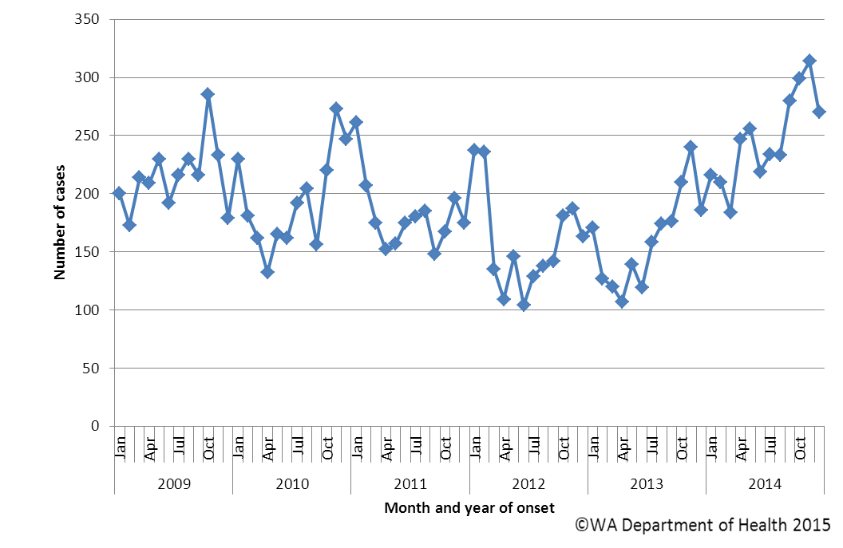

Figure 1. Number of cases of campylobacteriosis by year and month of onset, WA, 2009 to 2014.

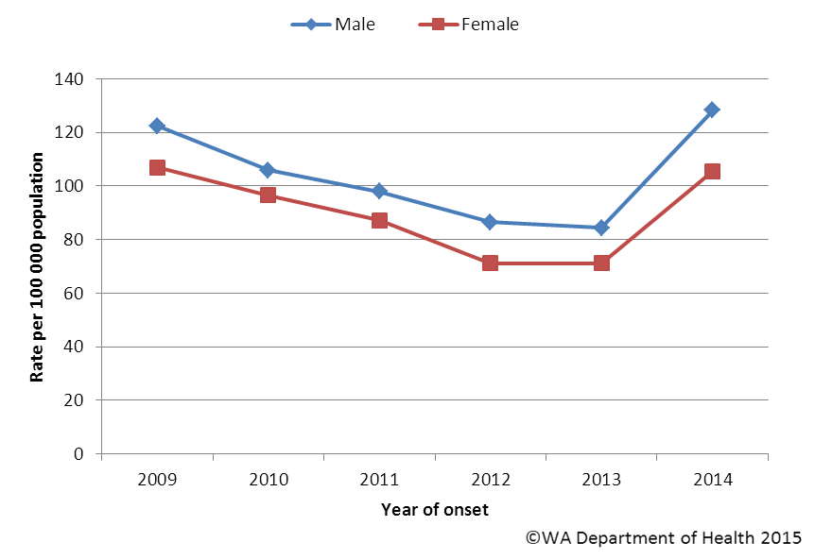

Figure 2. Campylobacteriosis notification rates by sex, WA, 2009 to 2014

Figure 3: Age-specific notification rates for campylobacteriosis by sex, WA, 2014

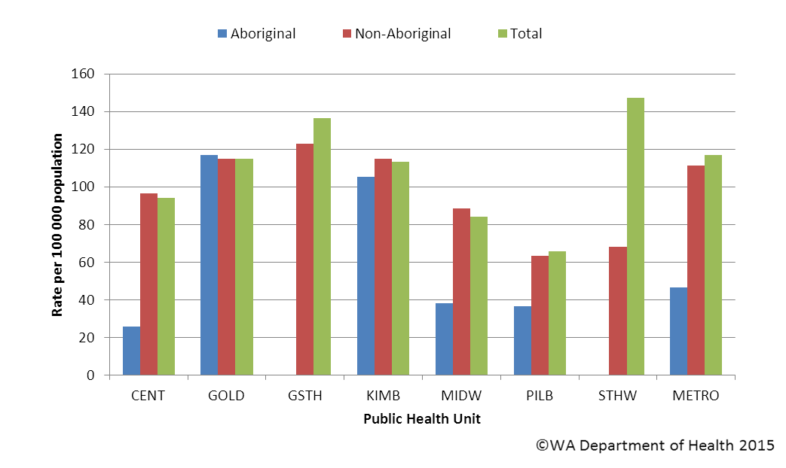

Figure 4. Campylobacteriosis notification rates by region and Aboriginality, WA, 2014

# Salmonellosis

Salmonellosis, which is an infection due to *Salmonella,* was the second most commonly notified enteric infection in WA in 2014, with 1248 cases (Appendix 1). The salmonellosis notification rate for 2014 was 49.3 cases per 100 000 population which is 5% lower than the previous five year average (52 cases per 100 000 population). The number of salmonellosis notifications was generally highest in the summer months but peaked in the autumn months in 2014 (Figure 5).

The notification rate for females and males was similar (48.6 and 50 per 100 000 population, respectively). As in previous years, the <1- 4 year age group had the highest notification rate (165 per 100 000 population) (Figure 6). The young adult age groups of 20 to 24 years, and 25 to 29 years, had the next highest notification rates (51.7 and 55.1 per 100 000 population, respectively).

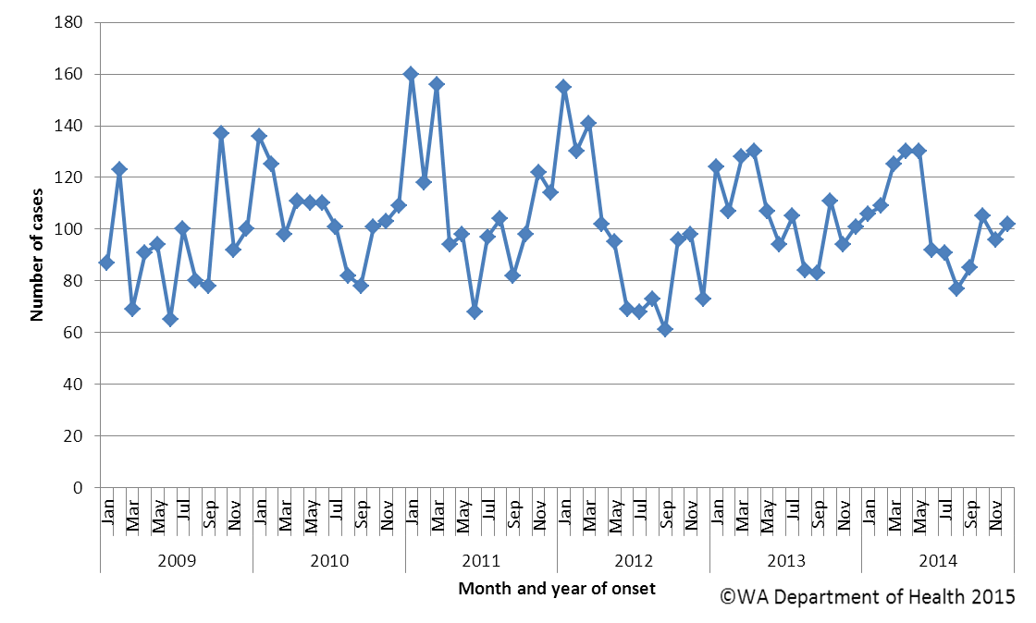

Figure 5. Number of cases of salmonellosis by year and month of onset, WA, 2009 to 2014

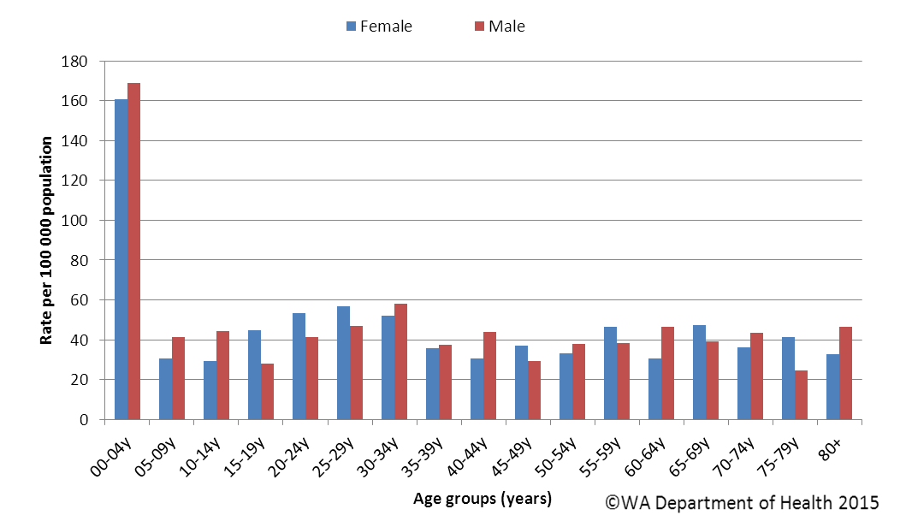

Figure 6. Age-specific notification rates for salmonellosis by sex, WA, 2014

The overall salmonellosis notification rate for Aboriginal people was 111 cases per 100 000 population, which was 2.5 times the notification rate for non-Aboriginal people at 44 cases per 100 000 population.

The Kimberley region had the highest notification rate in 2014 (231 per 100 000 population) which was 7.7 times the rate for the Great Southern region, which had the lowest notification rate at 30 cases per 100 000 population. In the Kimberley, rates were higher for both Aboriginal and non-Aboriginal people when compared with other regions (Figure 7).

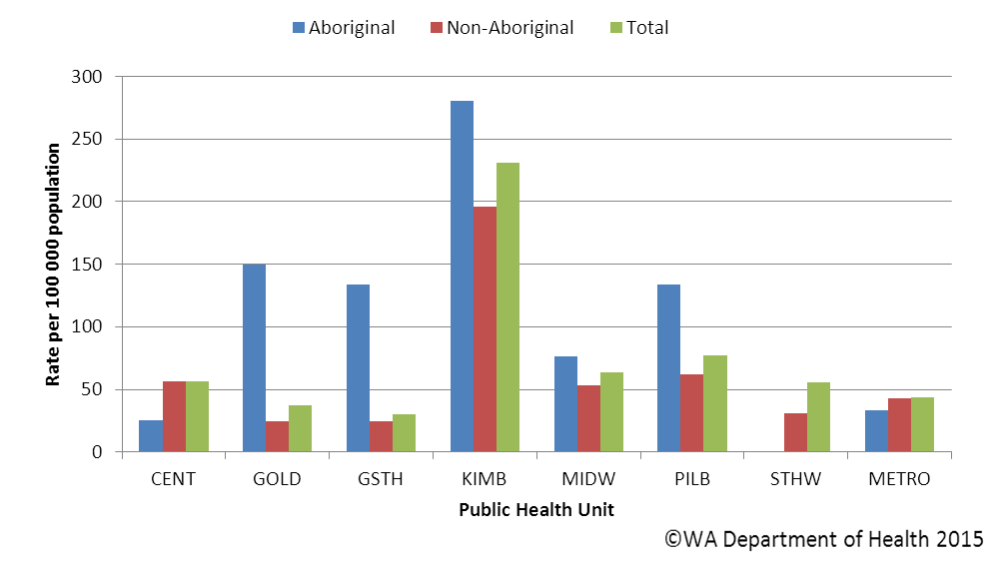

Figure 7. Salmonellosis notification rates by region and Aboriginality, WA, 2014

The most commonly notified *Salmonella* serotype in WA in 2014 was *S.* Typhimurium (STM), with 367 notifications (Table 1), which was 6% higher than 2013 and the same as the mean of the previous five years. There were four foodborne or suspected foodborne outbreaks caused by STM (described in Section 5.1).

The second most commonly notified serotype was *S*. Enteritidis (SE) with 203 notifications. There was a steady increase in SE notifications up until 2010 which had 336 SE notifications, followed by a progressive decrease in notifications (Figure 8). In 2014, 89% (181/203) of cases with *S*. Enteritidis infection travelled overseas during their incubation period and of these cases, 68% (n=123) had travelled to Indonesia. There were 18 (9%) cases of *S*. Enteritidis that appeared to be locally acquired and these were interviewed to determine possible risk factors for the cause of illness, but no common source was identified.

Notifications for *S*. Chester*, S*. Virchow and *S*. Infantis were substantially higher in 2014 compared to the five year mean. Most cases of these serotypes acquired their illness in Western Australia. Of those *Salmonella* cases with known travel history, the proportion of overseas acquired cases peaked in 2010 at 53%, with 40% of cases in 2014 acquiring their illness overseas (Figure 9).

Table 1. Number and proportion of the top 10 *Salmonella* serotypes notified in WA, 2014, with comparison to the 5-year average

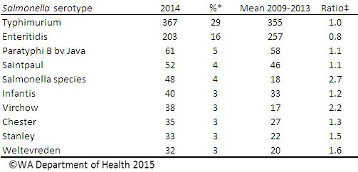

*Percentage of total *Salmonella* cases notified in 2014

‡Ratio of the number of reported cases in 2014 compared to the five year mean of 2009-2013.

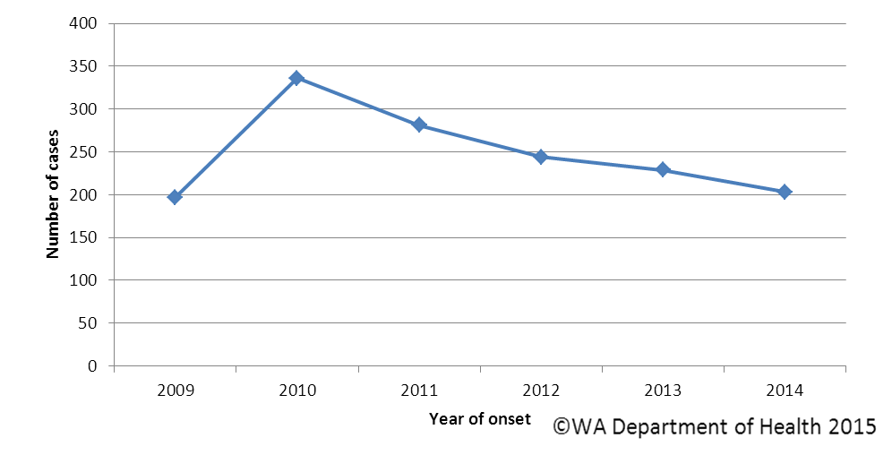

Figure 8. Number of cases of *S.* Enteritidis by year of onset, WA, 2009 to 2014

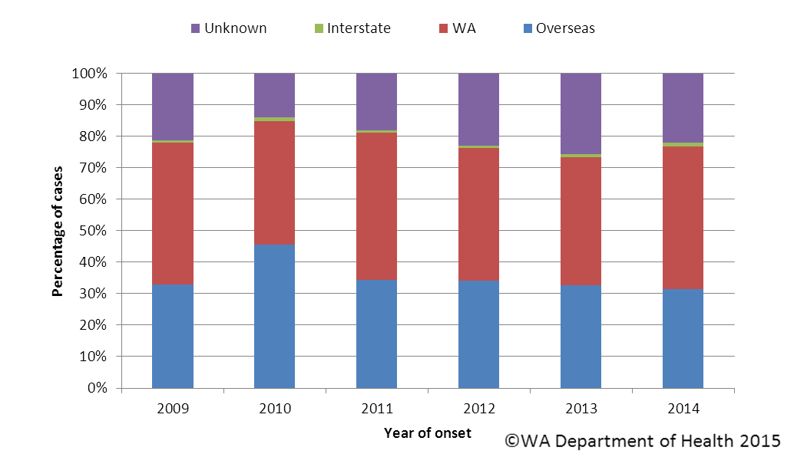

Figure 9. Proportion of salmonellosis cases acquired overseas, by year of onset, 2009 to 2014

# Rotavirus infection

There were 412 cases of rotavirus infection in WA in 2014 (16.3 per 100 000 population), making rotavirus the third most commonly notified enteric infection. The notification rate in 2014 was consistent with the previous five year average of 16.4 cases per 100 000 population per year (Appendix 1). Historically, rotavirus notifications typically peak in the winter months (Figure 10). However, over the last two years the seasonal variation has been less marked.

As in previous years, the age group with the highest rotavirus notification rate in 2014 was the <1- 4 years group (140 cases per 100 000 population), the age cohort for which vaccination was available, followed by the oldest age group, the 80+ years group (46 cases per 100 000 population) (Figure 11). The overall notification rate was similar for females and males (16.7 and 15.9 per 100 000 population, respectively).

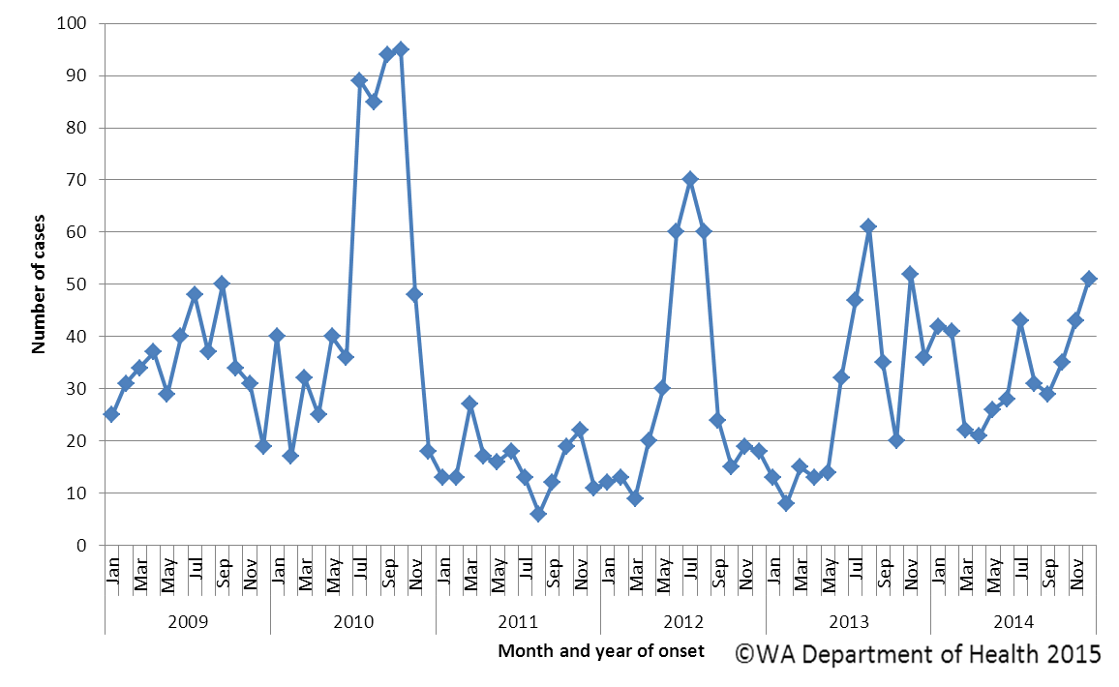

Figure 10. Number of cases of rotavirus infection by year and month of onset, WA, 2009 to 2014

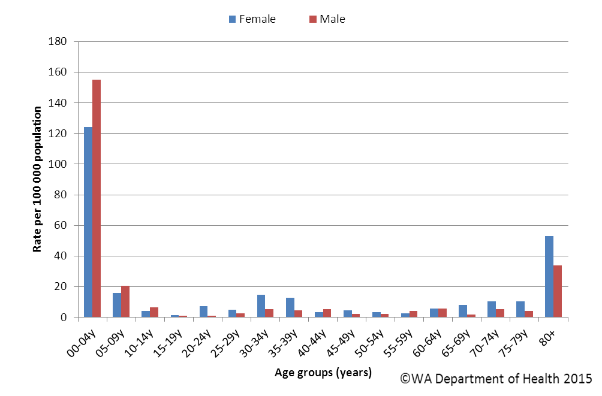

Figure 11. Age-specific notification rates for rotavirus by sex, WA, 2014

The regions with the highest rotavirus notification rates in 2014 were the Kimberley and Pilbara (42 and 37 cases per 100 000 population, respectively) (Figure 12). Overall notification rates were 2.6 times higher for Aboriginal than for non-Aboriginal people (38 and 14 per 100 000 population, respectively). Of those rotavirus cases with known place of acquisition, most (90%) people acquire their illness in WA with 8% of people acquiring their illness overseas.

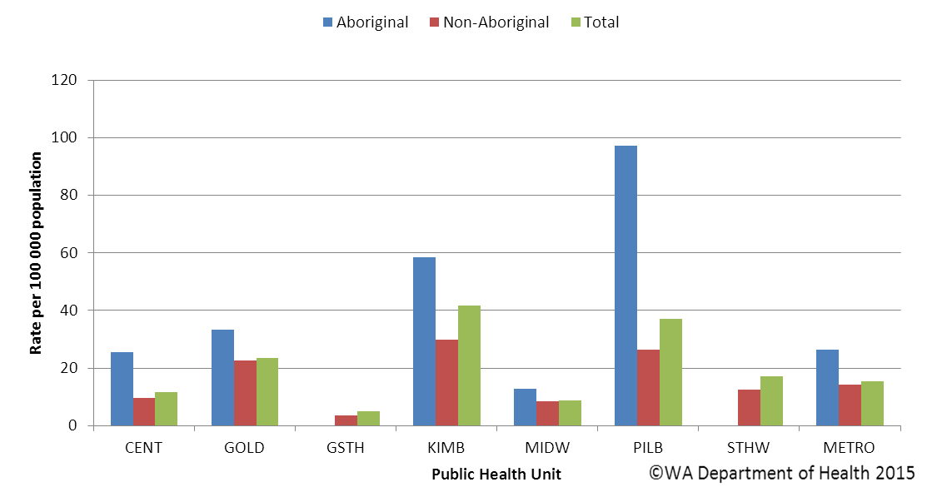

Figure 12. Rotavirus notification rates by region and Aboriginality, WA, 2014

# Cryptosporidiosis

There were 310 cryptosporidiosis cases notified in 2014, which was the fourth most common notifiable enteric disease. The notification rate (12.2 cases per 100 000 population) was consistent with the mean of the previous five years (11.5 cases per 100 000 population) (Appendix 1). In each of the years from 2009 to 2014 cryptosporidiosis case numbers were higher in the late summer through to autumn (Figure 13). An increase in cases in November was due, in part, to a swimming pool associated outbreak of *Cryptosporidium* (see section 5.2).

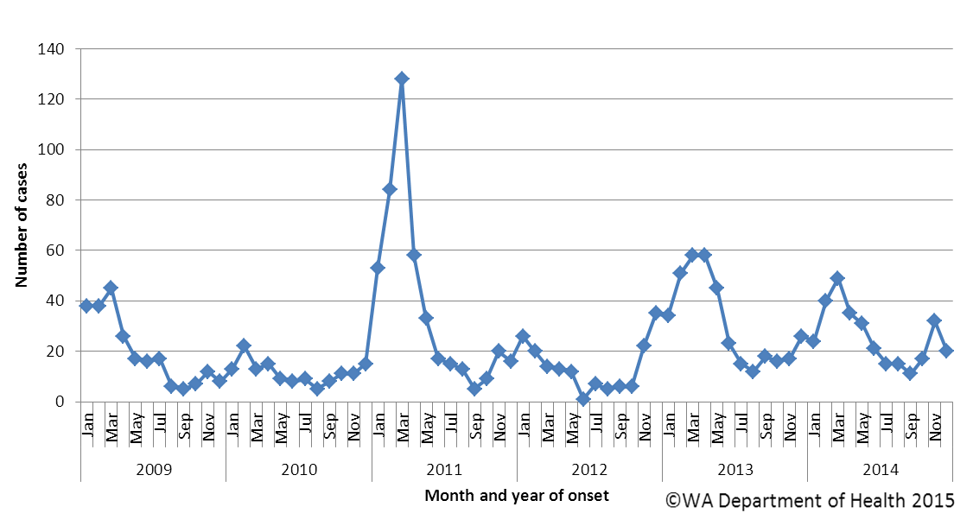

Figure 13. Number of cases of cryptosporidiosis by year and month of onset, WA, 2009 to 2014

The cryptosporidiosis notification rate was 20% higher in females than males in 2014 (13.4 and 11.1 per 100 000 population, respectively). The <1- 4 years age group had the highest notification rate (66 per 100 000 population), and accounted for 37% of all cryptosporidiosis notifications (Figure 14). The overall notification rate for the Aboriginal population was 4.5 times the rate for the non-Aboriginal population (46.7 and 10.4 cases per 100 000 population, respectively). The Kimberley region had the highest notification rate (64 cases per 100 000 population), and the Great Southern region the lowest notification rate (10 cases per 100 000 population) (Figure 15). Of those cryptosporidiosis cases with known place of acquisition, most (87%) people acquire their illness in WA with 12% of people acquiring their illness overseas.

Figure 14. Age-specific notification rates for cryptosporidiosis by sex, WA, 2014

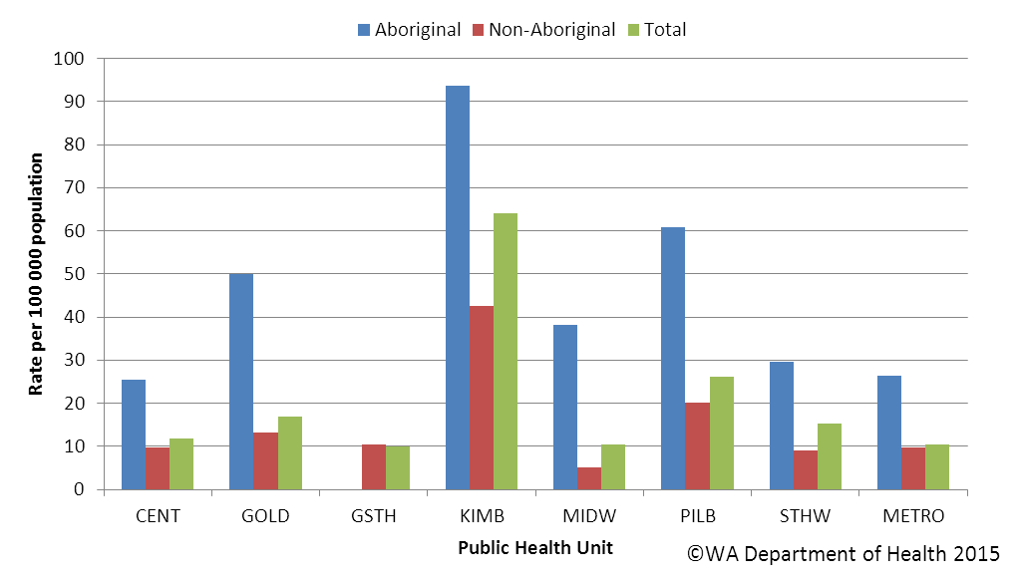

Figure 15. Cryptosporidiosis notification rates by region and Aboriginality, WA, 2014

# Shigellosis infection

There were 68 shigellosis notifications in 2014, with a notification rate of 2.7 per 100 000 population, 30% lower than the previous five year average (Appendix 1). The number of notifications varied from month to month, with no clear seasonal pattern (Figure 16).

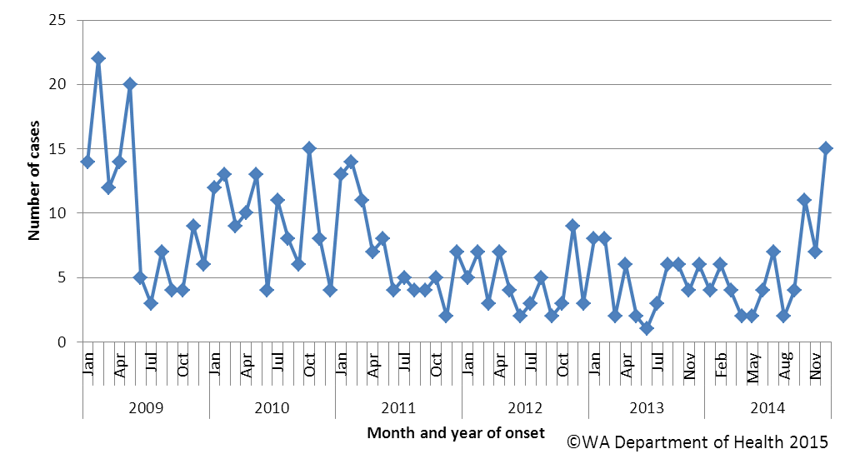

Figure 16. Number of cases of shigellosis by year and month of onset, WA, 2009 to 2014

The shigellosis notification rate was higher for males than for females in 2014 (3.1 and 2.3 per 100 000 population, respectively). Males in the 70-74 year age group had the highest rate of infection, however, the number of cases with shigellosis was small and rates should be interpreted with caution (Figure 17). The population health region with the highest notification rates was the Kimberley (42 cases per 100 000 population), due in part to an outbreak at an Aboriginal community. There were no cases of shigellosis notified in the Central or Midwest region of WA (Figure 18).

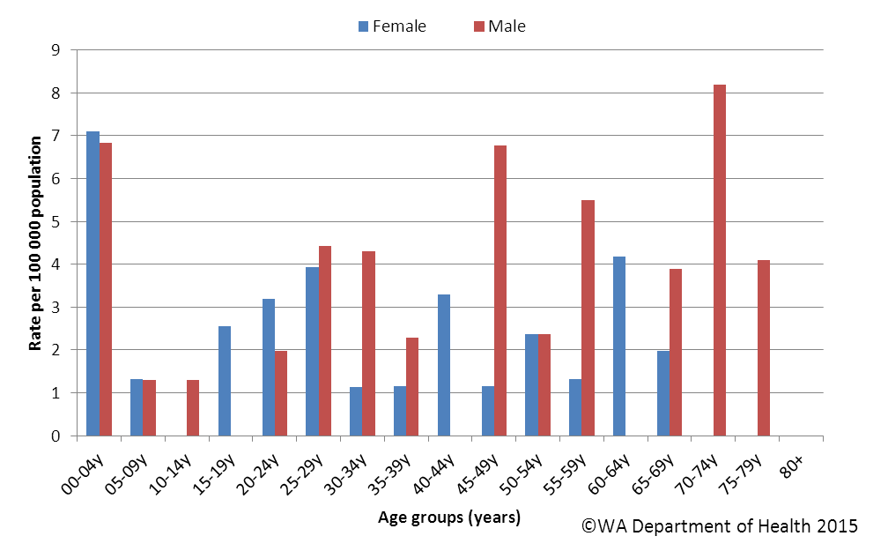

Figure 17. Age-specific notification rates for shigellosis by sex, WA, 2014

In 2014, the notification rate was 11 times higher for the Aboriginal population as compared to the non-Aboriginal population (22.7 and 2.0 per 100 000 population, respectively). There was a 72% reduction in the number of shigellosis notifications for Aboriginal people in 2014 compared to 2009, and most of this reduction occurred in the remote regions of WA (Kimberley, Pilbara, Goldfields and Midwest) (Figure 19).

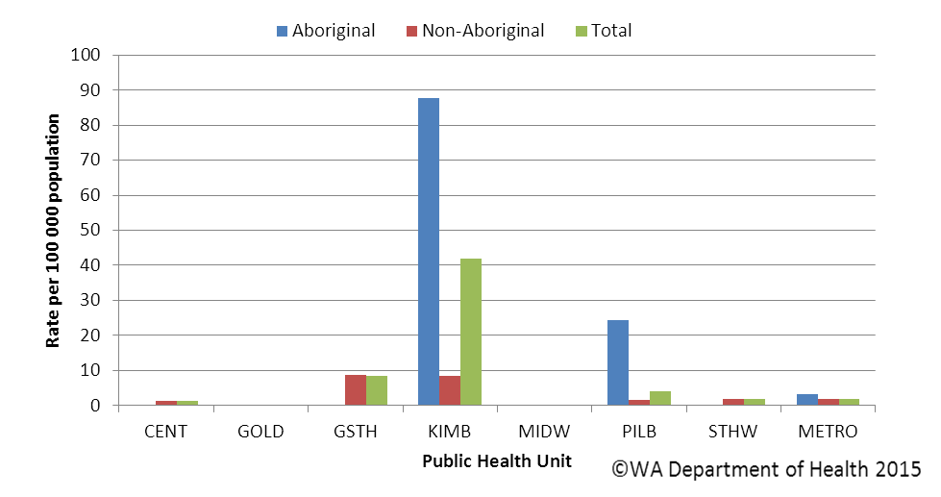

Figure 18. Shigellosis notification rates by region and Aboriginality, WA, 2014

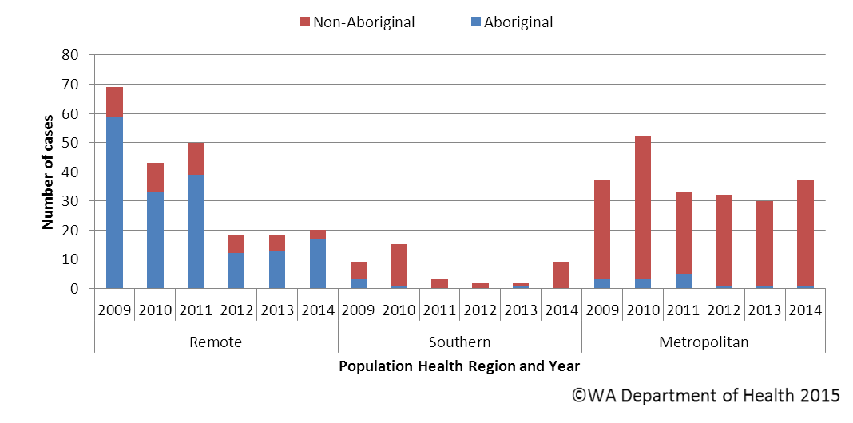

Figure 19. Year of onset and public health region of residence, for Aboriginal and non-Aboriginal shigellosis cases

In 2014, approximately half of all *Shigella* notifications were overseas acquired (Figure 20). *Shigella sonnei* was the most common species (n=49, 72%), with *S. sonnei* biotypes A and G affecting a similar proportion of people (41% and 38%, respectively). The second most common *Shigella* species was *S. flexneri* with 17 notifications (25%) and there were two notifications of *S. boydii.* No cases of *S. dysenteriae* were reported in WA in 2014.

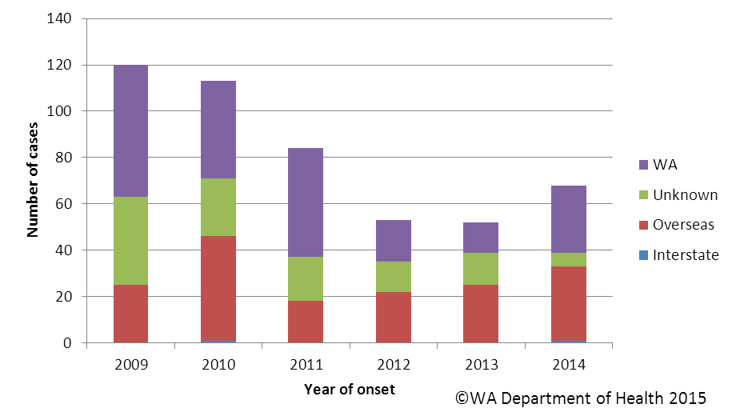

Figure 20. Place of acquisition for shigellosis cases, 2009 to 2014

# Hepatitis A virus infection

There has been a marked reduction in the locally acquired hepatitis A cases in WA since 2009 (Figure 21). There were 19 cases of hepatitis A notified in 2014 with a rate of 0.8 cases per 100 000 population, which is a 20% reduction from the mean rate of the previous five years (Appendix 1).

The age range for the 2014 cases was 2 to 56 years (median age of 31 years), with 12 males and 7 female notifications. Most (12, 63%) notifications in 2014 were acquired overseas. Countries of acquisition were Indonesia (4 cases), Philippines (3 cases), India (2 cases), Somalia (2 cases) and a single case who travelled to South Africa. Four locally acquired cases (two mother/child pairs) were known to each other socially, but a common source of illness was not identified. The source of illness for the other two locally acquired cases was unknown.

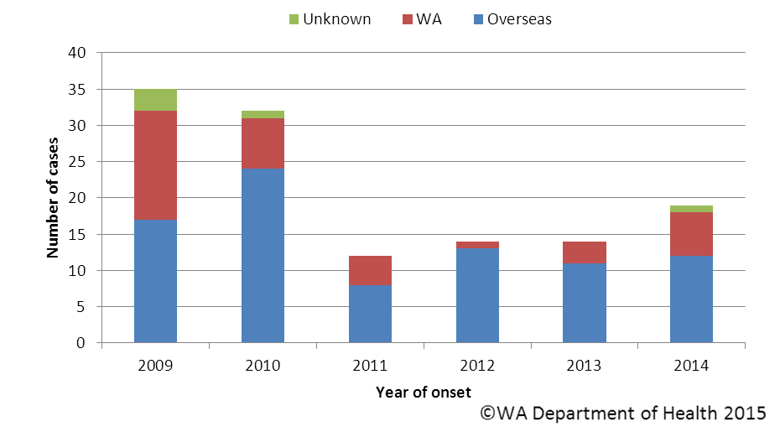

Figure 21. Place of acquistion for hepatitis A cases, 2009 to 2014

# Typhoid and paratyphoid fever

In 2014, there were 15 reported cases of typhoid fever (caused by *Salmonella* Typhi) with a rate of 0.6 cases per 100 000 population which was a 13% increase in the mean rate of the previous five years (Appendix 1). All cases had recently travelled overseas prior to illness and countries included India (n=8), Indonesia (n=3) and one case each travelling to Pakistan, Philippines, Myanmar and Sri Lanka.

Ten cases of paratyphoid fever were notified in 2014 with a rate of 0.4 cases per 100 000 population which was similar to the mean rate of the previous five years (Appendix 1). The paratyphoid fever cases included nine cases of *S*. ParatyphiA (PT 1 (n=3), PT2 (n=1), PT13 (n=3), two not phage typed) and one case of *S*. Paratyphi B. Nine cases had overseas acquisition and countries included India (n=5), Indonesia (n=1), Cambodia (n=1), Nepal (n=1) and Myanmar (n=1). One case, an 83 year old male had not travelled for 10 years and symptoms including only two loose stools.

# *Vibrio parahaemolyticus* infection

There were 15 cases of *Vibrio parahaemolyticus* infection in 2014 compared to the five year average of 12 cases per year. Of the 15 cases, 67% were male and the median age was 44 years (range 9-79 years). Ten cases reported travel overseas during their incubation period (Indonesia [4], Thailand [3], Vietnam [2] and Philippines [1]) and five cases acquired their illness in Western Australia.

# Listeriosis

There were five cases of listeriosis due to *Listeria monocytogenes* infection in 2014, with a rate of 0.2 cases per 100 000 population, which is similar to the five year average rate of 0.3 cases per 100 000 (Appendix 1). All cases were non-pregnancy related, 40% were females and ranged in age from 47 – 91 years (Figure 22) and had immunocompromising illnesses.

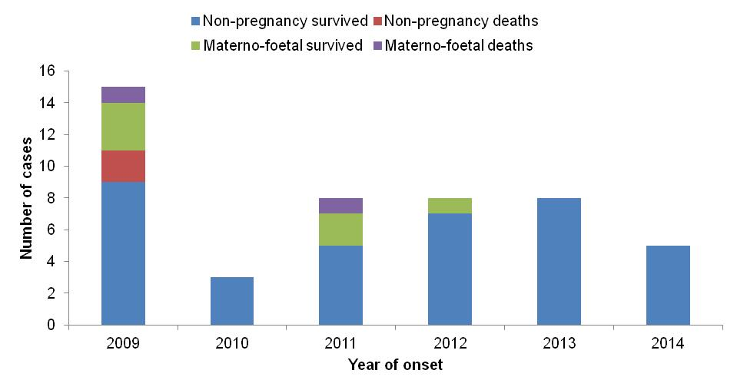

Figure 22. Notifications of listeriosis showing non-pregnancy related infections and deaths, and materno-foetal infections and deaths, WA, 2009 to 2014.

# *Yersinia* infection

There were four case of *Yersinia* *enterocolitica* infection notified in 2014, which is similar to the previous five year mean of three cases per year. Three cases were female and one case was male with ages ranging between 20 and 83 years. One case had acquired the infection in Indonesia, one case had acquired their illness in WA and place of acquisition was unknown for two cases.

# STEC/HUS infection

In 2014, there were two cases of STEC serotype O157 were notified, which is lower than the previous five year mean of four cases per year. The two cases acquired their infection locally with one case (81 year old male) residing in Perth metropolitan area and one case (41 year old female) residing in the Great Southern Region. The female case also developed haemolytic uraemic syndrome.

# Cholera, botulism and hepatitis E

There were no cases of hepatitis E, cholera and botulism notified in WA in 2014.

# Gastrointestinal disease outbreaks and investigations

# Foodborne/suspected foodborne outbreaks

There were 13 foodborne or suspected foodborne gastroenteritis outbreaks investigated in WA in 2014 (Table 2). The 13 foodborne outbreaks caused at least 139 WA cases and 4 hospitalisations. Short descriptions of these outbreaks are described in [**2014 quarterly reports**](http://ww2.health.wa.gov.au/Articles/F_I/Infectious-disease-data/Enteric-infection-reports-and-publications-OzFoodNet). In the previous five years (2009 to 2013) there was an average of 13 (range 9-19) foodborne or suspected foodborne outbreaks per year.

**Aetiology**

Of the 13 outbreaks, four outbreaks each were due *Salmonella* Typhimurium (STM PFGE 0001 [n=2], 0003, 0526) and three outbreaks due to norovirus, two outbreaks each were caused by *S.* Infantis and unknown pathogens and one outbreak each was caused by *Clostridium perfringens* and *S.* Singapore. Faecal specimens were not collected in the two outbreaks with unknown aetiology. The clinical symptoms, duration of illness and incubation period of one of these outbreaks suggested it was due to norovirus and the characteristics of the other outbreak suggested a toxin producing bacteria.

In the previous five years, *Salmonella* species caused most (n=26, 39%) outbreaks, followed by norovirus (n=13, 20%). *Clostridium perfringens* caused three outbreaks, *Campylobacter* species, *hepatitis A and Listeria monocytogenes* caused two outbreaks each and *Cyclospora* species caused one outbreak*.* Fifteen outbreaks were caused by unknown pathogens.

**Food vehicles**

The investigations of the 13 outbreaks identified food vehicles for seven outbreaks. The *Salmonella* Typhimurium PFGE 0001 outbreaks were associated with eating lamb shanks and pork hocks and one of the *Salmonella* Infantis outbreaks was associated with eating nasi-lemak. Two norovirus outbreaks were associated with eating salads. One outbreak each was associated with the following foods: roast meats (suspected toxin mediated) and multiple foods (unknown pathogen).

In the previous five years there were 66 foodborne or suspected foodborne outbreaks and food vehicles were identified for 31 (47%) outbreaks. Of these 31 outbreaks, the most commonly implicated foods were dishes containing eggs in nine outbreaks, chicken in five outbreaks, fresh produce in six outbreaks, eight outbreaks implicating a range of dishes, and multiple dishes in three outbreaks. Of the 35 outbreaks with unknown food vehicles, the aetiological agents included *Salmonella* (n=14), norovirus (n=7), *Campylobacter* (n=1), *Cyclospora* (n=1), *Clostridium perfringens* (n=2) and unknown aetiology (n=10).

**Epidemiological investigation and evidence**

The evidence that supported that the 13 investigations of enteric outbreaks were due to foodborne or suspected foodborne transmission was obtained using analytical studies for six outbreaks and descriptive cases series (DCS) for seven outbreaks. The analytical studies involved interviewing those people who were at the meal using a questionnaire on all foods/drinks available. For the outbreaks investigated as a DCS, there was strong circumstantial evidence to support suspected foodborne transmission including ill people eating a common meal (4 outbreaks) or visiting a common food business (3 outbreaks).

For the previous five years the evidence used to support that 66 outbreaks were due to foodborne transmission was obtained using analytical studies for 22 (33%) outbreaks and seven outbreaks found an association between illness and a food. There were 42 (64%) outbreaks investigated as DCS. No formal study was carried out for two outbreaks.

**Food preparation settings**

The setting where food was prepared for the 13 foodborne outbreaks in 2014, included five (39%) restaurants (caused by norovirus [n=2], *S*. Typhimurium [n=2], and *S*. Infantis [n=1]), one aged care (caused by *Clostridium perfringens*), two commercial caterers (caused by *S*. Infantisand unknown aetiology), two private residences (*S*. Typhimurium [n=2]), one takeaway (unknown aetiology), one at a camp (norovirus) and one possibly due to primary produce (*S*. Singapore).

In the previous five years, the most common setting where food was prepared among the foodborne outbreaks was restaurants (n=30, 45%), followed by commercial caterers (n=7, 11%), aged care (n=5, 8%), takeaway (n=5, 8%), private residence (n=4, 6%), bakery (n=2, 3%), camp (n=2, 3%), primary produce (n=2, 3%) and cruises/ships (n=2, 3%).

**Major factors for contamination of food**

The major factors for the contamination of food for the 13 outbreaks in 2014 was person to food to person transmission (n=3), which involved sick people handling food. These three outbreaks were due to norovirus. Contributing factors for the other outbreaks included cross contamination with raw ingredients (n=2), and inadequate cleaning of equipment (n=1). No contamination factors could be identified for seven outbreaks.

The major factors for contamination of food in the 66 outbreaks in the previous five years was also person to food to person transmission (n=15, 23%). Of these 15 outbreaks, eight were due to norovirus. There were eight outbreaks where the contributing factor was ingestion of contaminated raw products and four of these outbreaks were due to *Salmonella* species. Two outbreaks were caused by cross contamination with raw ingredients and both due to *Salmonella*. There were 35 outbreaks with no identified contributing factor.

Table 2 Foodborne and suspected foodborne outbreaks, 2014



1Month of outbreak is the month the outbreak was first reported or investigated, whichever is earliest

*PT = phage type, PFGE=pulsed field gel electrophoresis

# D = descriptive, M= microbiological, A=Analytical, DK=Don’t know

# Outbreaks due to non-foodborne transmission or with an unknown mode of transmission

In 2014, there were 186 outbreaks of gastroenteritis investigated that were not classified at foodborne disease outbreaks. These outbreaks included 157 outbreaks associated with suspected person to person transmission, one outbreak due to suspected waterborne transmission and 28 outbreaks were the mode of transmission was unclear or unknown (Figure 23).

**Suspected person to person outbreaks**

Of the 157 suspected as person to person (PTP) transmission, 97 (62%) occurred in residential care facilities, 39 (25%) in child care centres, six (4%) in hospitals, five (3%) in institutions, two outbreaks each on cruises and schools; and single outbreaks in a camp, community, function, train, ship and private residence setting. (Table 3). The causative agent for 86 (55%) of the outbreaks was confirmed as norovirus, with three outbreaks each being caused by *Cryptosporidium* and rotavirus, and single outbreaks caused by *Campylobacter*, sapovirus, *Shigella sonnei* and STM. In the remaining outbreaks (38%) the causative agent was unknown, either because a pathogen was not identified during testing, specimens were not collected, or viral testing was not requested. A total of 3721 people were affected by these outbreaks, with 70 hospitalisations and 13 deaths.

The number of PTP outbreaks in 2014 was a 62% increase on the number of outbreaks in 2013 (n=97), and 43% higher than the average of the previous five years (n=111) (Figure 24). In 2014, the number PTP outbreaks peaked in spring, which is consistent with previous years (Figure 23).

**Outbreaks with unknown mode of transmission**

In the remaining 28 outbreaks the likely mode of transmission was unclear or unknown, with 20 (71%) occurring in aged care facilities, two each (7%) in child care centres, restaurants and in community settings; and one each (4%) at a function and at a swimming event centre (Table 3). Below are descriptions of these outbreaks according to site of outbreak.

* There were 20 outbreaks in aged care facilities where the predominant symptom was diarrhoea and the proportion of cases reporting vomiting was low. These symptoms were not norovirus-like and therefore described as unknown rather than person-to-person. Most of the outbreaks (15/20) had specimens tested which were negative for common bacterial and viral pathogens (including norovirus).
* There were two outbreaks at child care centres where diarrhoea was the predominant symptom. No specimens were collected.
* There were two outbreaks at restaurants, one caused by norovirus and one by *S.* Weltevreden. In the *S.* Weltevreden outbreak two confirmed cases reported attended the same function. No other guests reported illness. The two cases had no other common exposure. It was thought that the cases had contracted their illness at the function but the mode of transmission was unknown due to no other attendees being ill. In the norovirus outbreak guests at a wedding reported illness following the event. It was unclear whether guests contracted the infection from the food or from an environmental source.
* There were two community outbreaks, one caused by hepatitis A and the other by norovirus. There were two locally acquired hepatitis A infections in a mother and child, with onset dates indicating person to person transmission had not occurred between these two cases. Two further cases in a mother and child, with onset dates not indicative of person to person transmission were notified. The four cases knew each other socially but did not have contact with each other during the incubation period of the latter two cases. The source of hepatitis A infection for the four cases was not identified.

Three people from a group of three couples who dined at a restaurant subsequently became ill with gastroenteritis. Two couples which included the three ill had also attended a dance, while the third couple who were not ill did not attend the dance. One faecal specimen was positive for norovirus. The source of the gastroenteritis outbreak could not be determined.

* A norovirus outbreak following a function attended by respite clients. Staff reported that an entertainer at the function had gastroenteritis at the time but did not report any interaction with clients. As all attendees were served the same food an, analytical study was not conducted. There were no reports of attendees ill at the event. The mode of transmission was unknown.
* In January, a rural club attended a swimming event in Perth and subsequently eight club members from four families developing gastroenteritis on the same day. Approximately 200 children plus parents attended the event. There were reports of people from other rural swimming clubs becoming ill with gastroenteritis following attendance at the event.

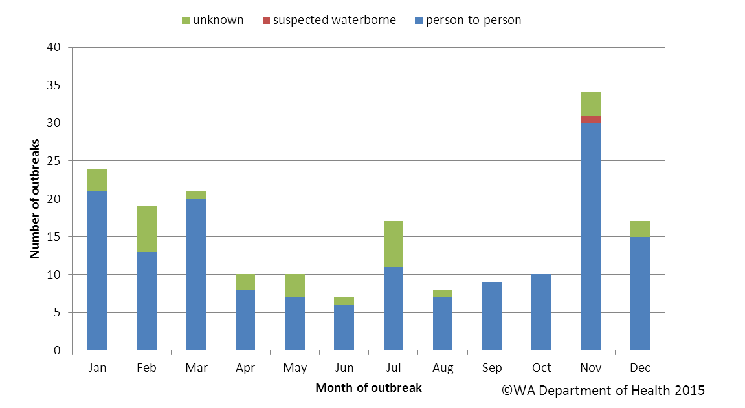

**Figure 23. Number of gastroenteritis outbreaks designated as non-foodborne or with unknown mode of transmission reported in WA, in 2014**

**Figure 24. Number of gastroenteritis outbreaks due to suspected person to person transmission 2009 to 2014 in WA.**

**Table 3. Outbreaks due to non-foodborne transmission or unknown mode of transmission in WA by setting and agent, 2014**



1 Deaths temporally associated with gastroenteritis, but contribution to death not specified, NA not applicable

# Cluster investigations

In 2014, there were eight *Salmonella* clusters and one cluster with multiple organisms investigated (see Table 4) which are described in [2014 quarterly reports](http://ww2.health.wa.gov.au/Articles/F_I/Infectious-disease-data/Enteric-infection-reports-and-publications-OzFoodNet).

**Significant clusters**

**Multiple Organisms**

There were three cases notified with three different organisms (*Campylobacter*, *S.* Infantis and *Cryptosporidium*) that were linked to a single farm and had illness onsets between 30/05/14 and 12/06/14. The cases included one male and two females, ranging in age from <1 to 14 years. Two cases resided on the farm and one visited, and all had contact with pets including alpacas, sheep, chickens, dogs, cats and cattle during their incubation period. The source of infection could not be identified.

***Salmonella* Typhimurium PFGE type 39, phage type 135a**

There were 12 cases of *S*. Typhimurium PFGE type 0039 with specimen dates between 15/10/14 and 18/11/14. The cases comprised 9 males and 3 females, with ages ranging from <1-52 years. Five of the cases were fly-in fly-out workers at mine sites in the Pilbara region, with 2 cases at same mining camp. The mining camps were operated by different companies, with different catering companies. Two cases were in Queensland for their incubation period. All cases reported eating eggs in the incubation period. Eleven samples were referred to Queensland for MLVA typing. Seven isolates had the MLVA profile 03-12-12-09-523, which was the dominant MLVA profile seen in Queensland during 2014 and linked to egg outbreaks. The source of the *Salmonella* illness could not be established.

***Salmonella* Typhimurium PFGE type 1, phage type 9**

For 2014, there were 122 cases of *S*. Typhimurium PFGE type 1, with 48% of cases female, median age was 27 years. 83% lived in metropolitan Perth, 5% were Aboriginal people, 2% had acquired their illness overseas and 32% were hospitalised. Of the 122 cases 85% were interviewed and the hypothesis for the cause of illness was egg and/or chicken consumption. Investigation is ongoing with a case control study.

Table 4. Cluster investigations in WA by month investigation started, setting and agent, 2014



* PFGE=pulsed field gel electrophoresis

# OzFoodNet WA research projects

## National descriptive study of *Salmonella* Enteritidis

*Salmonella* Enteritidis is globally important as it can infect the internal contents of eggs, and causes a large burden of illness in countries where this *Salmonella* is endemic in egg laying flocks. Surveillance to date shows that *S*. Enteritidis is not endemic in Australian chickens. However, *S*. Enteritidis is the second most commonly notified Salmonella in Australia with the majority of cases acquiring their infection overseas. The aim of the project is to describe the epidemiology of the recent increase in *S*. Enteritidis notifications in Australia.  This will help inform public policy regarding prevention and control measures for *S*. Enteritidis infection.  Data collection from jurisdictions was complete in February 2014 and analysis of data is continuing.

# References

1. Hall G, Kirk MD, Becker N, Gregory JE, Unicomb L, Millard G, et al. Estimating foodborne gastroenteritis, Australia. Emerg Infect Dis 2005;11(8):1257-1264.
2. OzFoodNet Working Group. A health network to enhance the surveillance of foodborne diseases in Australia. Department of Health and Ageing 2013. www.ozfoodnet.gov.au/internet/ozfoodnet/publishing.nsf/Content/Home-1 [14/03/2012]
3. Western Australian Department of Health. A-Z list of case definitions. Western Australian Department of Health 2013. www.public.health.wa.gov.au/2/243/3/infectious_diseases_az_for_health_professionals.pm [14/3/2012]
4. National notifiable disease surveillance system. National case definitions. Department of Health and Ageing 2013. www.health.gov.au/internet/main/publishing.nsf/content/cda_surveil-nndss-dislist.htm [14/03/2012]
5. Western Australian Department of Health. Contact details for regional population / public health units. Western Australian Department of Health 2013. http://www.public.health.wa.gov.au/3/280/2/contact_details_for_regional_population__public_he.pm [05/04/3012].

# Appendix 1: Number of notifications, notification rate and ratio of current to historical mean by pathogen/condition, 2009 to 2014, WA



Abbreviations: STEC: Shiga-toxin producing *E. coli*; HUS: Haemolytic Uraemic Syndrome. Rate is cases per 100 000 population. Mean of rates between 2008 and 2012.

This document can be made available in alternative formats on request for a person with a disability.

© Department of Health 2015