|  |  |  |  |  |  |  |  |  |  |  |  |  |  |  |  |  |  |  |  |  |  |  |  |
| --- | --- | --- | --- | --- | --- | --- | --- | --- | --- | --- | --- | --- | --- | --- | --- | --- | --- | --- | --- | --- | --- | --- | --- |
| **Please complete on first session, unless referred from ACAT /DTU /RITH and have access to assessment form** | | | | | | | | | | | | | | | | | | | | | | | |
| **Client informed consent for assessment and sharing of information:**  **Yes**  **No** | | | | | | | | | | | | | | | | | | | | | | | |
| Assessment Date: | | | | | Assessor: | | | | | | | | | | | Referral source: | | | | | | | |
| NOK/Main Contact: | | | | | Tel: | | | | | | | | | | | Relationship: | | | | | | | |
| Usual GP: | | | | | GP Tel: | | | | | | | | | | | Fax: | | | | | | | |
| **Reason for Referral:** | | | | | | | | | | | | | | | | | | Initial | | | | Date | |
|  | | | | | | | | | | | | | | | | | |
| Current history /precautions: | | | | | | | | | | | | Past medical history: | | | | | | | | | | | |
|  | | | | | | | | | | | |  | | | | | | | | | | | |
|  | | | | | | | | | | | |  | | | | | | | | | | | |
|  | | | | | | | | | | | |  | | | | | | | | | | | |
|  | | | | | | | | | | | |  | | | | | | | | | | | |
|  | | | | | | | | | | | |  | | | | | | | | | | | |
|  | | | | | | | | | | | |  | | | | | | | | | | | |
| **Social & Domestic Assessment** | | | | | | | | | | | | | | | | | | Initial | | | | Date | |
| Employment status:**□** | | | **□** Employed | | | | | | | **□** Unemployed | | | | | **□** Retired for age -Pension / Self-funded | | | | | | | | |
| **□** Retired for disability | | | | | | | Please state previous employment: | | | | | | | | | | | | | | | | |
| Marital status:**□**  **□** Married | | | | | | | | | | | Driving Status: | | | | | | | | | | | | |
| Living arrangements:**□** | | **□** Spouse/partner | | | | | | | | | **□** Relative/friend | | | | | | | | **□** Alone | | | | |
| Carer: **□** Yes **□** No Carers Name: Relationship: . | | | | | | | | | | | | | | | | | | | | | | | |
| Age >70yr: **□** Yes **□** No Carer living-in: **□** Yes **□** No Uses respite: **□** Yes **□** No Employed: **□** Yes **□** No | | | | | | | | | | | | | | | | | | | | | | | |
| Carers health: . | | | | | | | | | | | | | | | | | | | | | | | |
| Frequency of contact with client (inc phone) | | | | | | | | | **□** Daily | | | | **□** 1x per wk | | | **□** 2-3x per wk | | | | **□** Variable | | | |
| Type of help provided by carer: . | | | | | | | | | | | | | | | | | | | | | | | |
| Carers perception of major issues: | | | | | | | | | | | | | | | | | | | | | | | |
|  | | | | | | | | | | | | | | | | | | | | | | | |
| Advanced Health Directive /EPA /EPG: **□** Yes, please provide details: | | | | | | | | | | | | | | | | | | | | | | | **□** No |
| Personal Alarm: **□** Yes **□** No | | | | | | DVA: **□** Yes – circle type:*White* /*Gold* **□** No DVA | | | | | | | | | | | | | | | | | |
| Previous ACAT assessment: **□** Yes - assessment date: / /_____ **□** No ACAT **□** TCP | | | | | | | | | | | | | | | | | | | | | | | |
| Approval type | **□** Residential | | | **□** High Care  **□** Low Care | | | | **□** Residential Respite | | | | | | **□** High Care  **□** Low Care | | | **□** Home Care Packages | | | | **□** Level 1 + 2 | | |
| **□** Level 3 + 4 | | |
| Service provider: | | | | | | | | Service type/care provided: | | | | | | | | | | | | | | | |
| Comments | | | | | | | | | | | | | | | | | | | | | | | |
| **If any concern, please refer to Social Worker Referral completed:**  **Yes**  **No** | | | | | | | | | | | | | | | | | | | | | | | |

|  |  |  |  |  |  |  |  |
| --- | --- | --- | --- | --- | --- | --- | --- |
| **Current Observations / System Review** | | | | Initial | | | Date |
| Pain**□** | **□** No **□** Yes | | Details: | | | | |
| Dizziness**□** | **□** No **□** Yes | | Details: | | | | |
| Short breath on exertion/rest**□** | **□** No **□** Yes | | Details: | | | | |
| Visual impairment**□** | **□** No **□** Yes – refer to OT | | Details : | | | | |
| Glasses**□** | **□** No **□** Yes | | Eyes tested in last 2yrs**□□□** No **□** Yes | | | | |
| Hearing impairment**□** | **□** No **□** Yes – hearing aids? **□** No **□** Yes | | Details: | | | | |
| Smoking**□** | **□** Never **□** Quit date: / /____ Consumption: | | | | | | |
| Alcohol**□** | **□** Never **□** Quit date: / / Consumption: type: | | | | | | |
| Sleep/rest pattern | Problem falling asleep **□** Yes **□** No | | | | | | |
|  | Problem staying asleep **□** Yes **□** No | | | | | | |
|  | Sleeping tablets taken? **□** Yes **□** No If *‘yes’* please specify below: | | | | | | |
|  | Type: How often: | | | | | | |
| Comments | | | | | | | |
|  | | | | | | | |
| **Medication** | | | | Initial | | Date | |
| Administration**□** | | **□** Self **□** Supervised **□** Assistance, please specify: | | | | | |
| Concern expressed about compliance | | **□** No **□** Yes | | | | | |
| Aids/support used**□** | | **□** Webster/blister pack **□** Dosette Box **□** Boxes/bottles **□** Timer | | | | | |
| 5 or more medications**□** | | **□** No **□** Yes | | | | | |
| Difficulties swallowing medication**□** | | **□** No **□** Yes | | | | | |
| **If any concern, action taken:Advised visit GP****OT referral****SW referral**  **discuss in team meeting**  | | | | | | | |
| **Communication & Swallowing** | | | | Initial | | Date | |
| Do you have any difficulties swallowing food, fluids or medications? e.g. coughing, choking. | | | | | **□** Yes **□** No | | |
| Have you noticed any changes to your speech/voice?  e.g. less clear, more effortful, difficulty thinking of or saying words. | | | | | **□** Yes **□** No | | |
| Are you having difficulty understanding language or writing?  e.g. difficulty making sense of a sentence, conversation or written information. | | | | | **□** Yes **□** No | | |
| **If any concern please refer to Speech Pathologist Referral completed?**  **Yes**  **No** | | | | | | | |
| **Mobility** | | | | Initial | | Date | |
| Transfers **□** | **□** Independent **□** Requires assistance Aids: | | | | | | |
| Indoor ambulation**□** | **□** Independent **□** Requires assistance Aids: | | | | | | |
| Outdoor ambulation**□** | **□** Independent **□** Requires assistance Aids: | | | | | | |
| Stairs**□** | **□** Independent **□** Requires assistance Aids: | | | | | | |
| **If any concern please refer to Physio Referral completed?**  **Yes**  **No** | | | | | | | |

|  |  |  |  |  |  |  |  |  |  |  |  |
| --- | --- | --- | --- | --- | --- | --- | --- | --- | --- | --- | --- |
| **FROP- Com Falls Screen** | | | | | | | Initial | | Date | | |
| Falls History | | How many falls in last 12months?  **□ 0 =** None **□ 1 =** Fall **□ 2 =** 2 Falls **□ 3 =** 3 or more falls | | | | | | | | | **Score** |
| ____ |
| Function ADL Status | | Prior to this fall, how much assistance was required for IADLs?  e.g. cooking, housework, laundry  **□ 0 =** None, completely independent **□ 1 =** Supervision  **□ 2 =** Some assistance **□ 3 =** Completely dependent | | | | | | | | ____ | |
| Balance | | Observe the client walk a few meters, turn and sit down. Client is to use walking aid if normally used. Score 3 if unable to walk due to injury.  **□ 0 =** Steady**□ 1 =** Unsteady but safe**□ 2 =** unsteady, supervision **□ 3 =** Needs hands on assistance | | | | | | | | | ____ |
| Screen Score Please circle score total on chart below   |  |  |  |  |  |  |  |  |  |  |  | | --- | --- | --- | --- | --- | --- | --- | --- | --- | --- | --- | | Total Score | 0 | 1 | 2 | 3 | 4 | 5 | 6 | 7 | 8 | 9 | | Grading of falls Risk | **0 - 3 Low Risk** | | | | **4 - 9 High Risk** | | | | | |   **If score of >3, liaise with PT/OT re appropriate action/referral. PT/OT Referral completed? □ Yes □ No** | | | | | | | | | | | |
| **Home Environment** | | | | | | | Initial | | Date | | |
| Do you have any difficulty getting in/out of the entrances of your home? | | | | | | | | **□** No **□** Yes | | | |
| Do you have any handrails in your home? | | | | | | | | **□** No **□** Yes | | | |
| Do you have any difficulty to manage in the shower or toilet? | | | | | | | | **□** No **□** Yes | | | |
| Are you having any other difficulties getting on/off bed/chair in your home? | | | | | | | | **□** No **□** Yes | | | |
| Comments: | | | | | | | | | | | |
| **If any concern, please refer to OT Referral completed?**  **Yes**  **No** | | | | | | | | | | | |
| **Cognition** | | | | | | | Initial | | Date | | |
| Documented cognitive Impairment? **□** Yes **□** No If *‘yes’* please provide details: | | | | | | | | | | | |
|  | | | | | | | | | | | |
| MMSE: / 30 Date: | | | GDS: Date: | | | AMTS: Date: | | | | | |
| Recent change in cognitive status? **□** Yes **□** No Self/carer reported cognitive problems? **□** Yes **□** No | | | | | | | | | | | |
| Mental health issues, previous/current | | | | | | | | | | | |
| **Referral to Memory Clinic completed?**  **Yes**  **No Discussed with GP/consultant?**  **Yes**  **No** | | | | | | | | | | | |
| **Continence** | | | | | | | Initial | | Date | | |
| Urinary incontinence | **□** No **□** Yes | | | Continence aids used | **□** No **□** Yes details: | | | | | | |
| Faecal incontinence | **□** No **□** Yes | | | Constipation | **□** No **□** Yes | | | | | | |
| Comments | | | | | | | | | | | |
| **If any concern, please refer to: Nursing coordinator**  **Continence advisor**  **discuss in team meeting**  | | | | | | | | | | | |

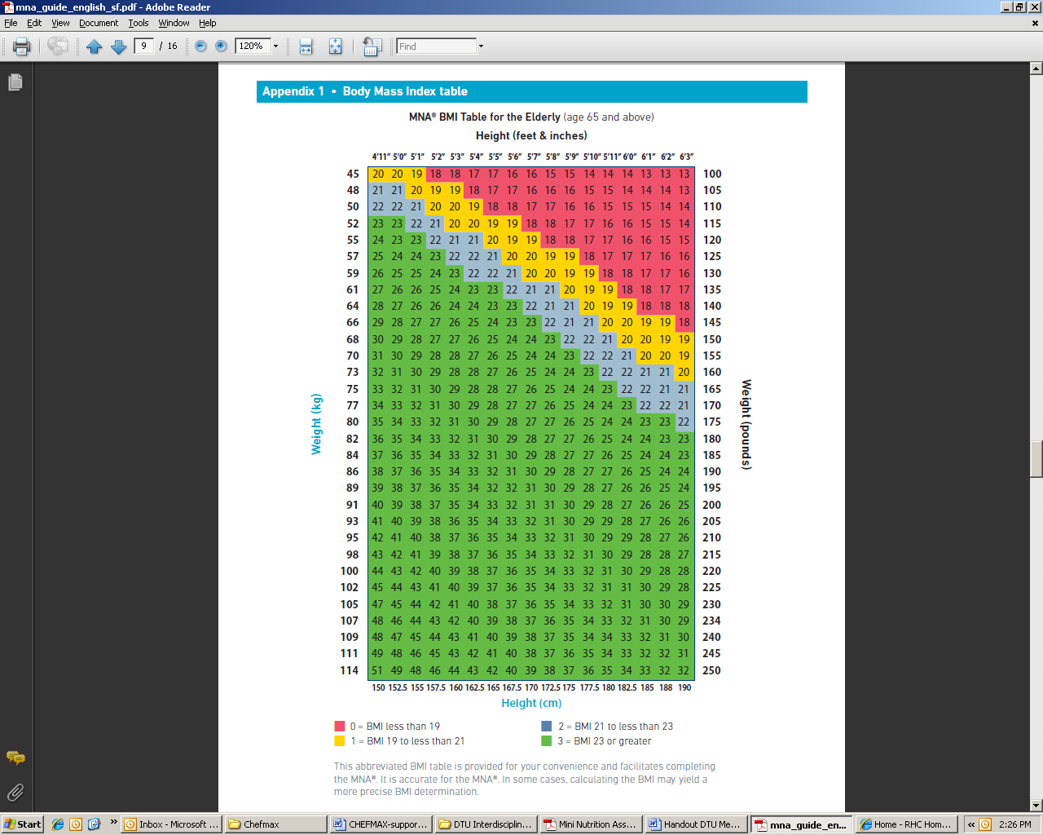

|  |  |
| --- | --- |
| **Mini Nutritional Assessment (MNA)** | **Score** |
| **A** Has food intake declined over the past 3 months due to loss of appetite, digestive problems, chewing or swallowing difficulties?  0 = severe loss of appetite  1 = moderate loss of appetite  2 = no loss of appetite |  |
| **B** Weight loss during the last 3 months  0 = weight loss greater than 3 kg (6.6 lbs)  1 = does not know  2 = weight loss between 1 and 3 kg (2.2 and 6.6 lbs)  3 = no weight loss |  |
| **C** Mobility  0 = bed or chair bound  1 = able to get out of bed/char but does not go out  2 = goes out |  |
| **D** Has suffered psychological stress or acute disease in the past 3 months?  0 = yes 2 = no |  |
| **E** Neuropsychological problems  0 = severe dementia or depression  1 = mild dementia  2 = no psychological problems |  |
| **F**. Body mass index (BMI)(weight in kg)/(height in m2)  0 = BMI less than 19  1 = BMI 19 to less than 21  2 = BMI 21 to less than 23  3 = BMI 23 or greater |  |
| **Screening Score** | **Total** |
| **12 – 14**  Normal – no further action required  **8 – 11**  At risk of malnutrition – refer to dietitian  **0 – 7**  Malnourished – refer to dietitian |  |

|  |  |  |  |
| --- | --- | --- | --- |
| Name | Profession | Signature | Date |
|  |  |  |  |