RECENT DEVELOPMENTS IN SUBACUTE CARE IN WA

The subacute care sector of the WA health system has undergone significant change in recent years. This change has been driven by agreements at a national level to improve access to subacute care services.
In November 2008, the first agreement was signed between the Australian Government and all State Premiers at COAG for dedicated funding to enhance subacute care provision through the COAG Council reform process. The funding was formalised through the National Partnership Agreement on Hospital and Health Workforce Reform; Schedule C – Subacute Care, 2009 – 2013.
A second agreement followed in August 2011, with the signing of the National Health Reform Agreement (NHRA) on Improving Public Hospital Services; Schedule E – Subacute Care 2010-2014.
Subacute domains as defined by the National Partnership Agreements are:
- Rehabilitation
- Geriatric evaluation and management (GEM),
- Psycho-geriatric and
- Palliative care services

1. NPA on Hospital and Health Workforce Reform; Schedule C – Subacute Care
WA received $48.6 million over the four year period 2008/09-2012/13 to develop and implement programs across the four subacute care domains with a focus on key gaps in service provision.

The key objectives of the “Plan” were to:
- Increase the range subacute care services and increase access to pathways for earlier discharge from acute hospitals;
- Shift the focus from the tertiary level acute hospital to the secondary/generalist hospital level;
- Strengthen non-admitted ambulatory care and community based services, with a strong rehabilitation therapy focus in many areas and
- Address projected demand pressures for admitted hospital services due to an ageing population by increasing the range of subacute care services across WA.

The key requirement of Schedule C was the achievement of 20% growth in subacute care activity or an average of 5% per year across the four subacute care domains over the period 2009-2013.
WA achieved a growth rate of 45% over the four year period with an average increase of 11.25% per year from the baseline year of commencement in 2007-2008

Country Health Service (WACHS) Regional Areas – Schedule C Initiatives
In addressing the gaps in subacute care service provision, significant gaps in service provision across rural and remote areas were recognised. As a result, a major focus of Schedule C was the strengthening services in key regional centres. The services established are described below:
- Expansion and strengthening of the visiting consultant geriatrician service to Albany, Kalgoorlie, Esperance, Geraldton, Meekatharra, Carnarvon, Narrogin, Northam, Merredin, Moora, Port Hedland, Broome and Kununurra with formal links to specific metropolitan hospital aged care departments;
- Establishment of a visiting consultant psycho-geriatrician service to Albany, Bunbury, Kalgoorlie, the Wheatbelt, Geraldton, Port Hedland, Broome and Kununurra with formal links to specific metropolitan hospital older adult mental health teams. The service is conducted in parallel to the geriatrician visiting service to regional sites;
- Appointment of a permanent geriatrician physician, establishment of integrated subacute rehabilitation and restorative program at Bunbury Regional Hospital with 10 new beds linked to a Day Therapy Unit to serve the South West;
- Establishment of dedicated clinics for Falls and Neurological conditions at the Bunbury Day Therapy Unit;
- Establishment of Community Rehabilitation programs at Albany, Bunbury, Collie, Busselton, Manjimup, Geraldton and Kalgoorlie;
- Establishment of “Day Therapy Units” at Albany, Bunbury, Geraldton and Kalgoorlie;
- Establishment of Community Physiotherapy Services at Northam;
- Establishment of subacute secondary rehabilitation units in Albany (6 beds) Bunbury (10 beds) Geraldton (6 beds) and Kalgoorlie (minimum 4 beds) where population projections indicated demand and
- Enhanced utilisation of tele-health centres in regional areas.

Downstream benefits have accrued in respect to the development of a stronger rural and regional allied health workforce and recognition of the benefits to the health system generated by access to subacute services.
Metropolitan hospitals are now more confident in discharging to rural hospitals with respect to rehabilitation, geriatric and psycho-geriatric management.

Metropolitan Services WA – Schedule C Initiatives
- Establishment of specialist rehabilitation secondary stroke units at Osborne Park Hospital (10 beds) and Bentley Hospital (14 beds).
- Early supported discharge program for stroke patients at Osborne Park Hospital and outpatient stroke clinics at Osborne Park Hospital and Bentley Hospital;
- Establishment of specialist consultant rehabilitation non-admitted services for amputee patients at Sir Charles Gairdner and Fremantle Hospital tertiary hospital sites;
- Establishment of Parkinson’s Disease outreach multi-disciplinary, non admitted clinics at Armadale, Bentley Fremantle and Rockingham hospitals;
- Establishment of GEM subacute units at Fremantle Hospital (10 beds) and Sir Charles Gairdner Hospital (14 beds) to promote throughput of patients at the tertiary hospital sites;
- Increased service delivery levels and diversification of ambulatory care “Day Therapy Services” at all metropolitan hospital sites;
- Increased Rehabilitation in the Home (RITH) across north and south metropolitan regions to promote earlier discharge from hospital;
- Expanded general rehabilitation services for the younger patient (<65 years).

Workforce Training and Development – Schedule C Initiatives
Schedule C funding also focussed on targetted investment in the subacute care workforce with funding for two advanced trainee positions in the metropolitan region and one base trainee medical registrar trainee the South West in the domain of rehabilitation.
Discharge planning for patients with fractured neck of femur has also been improved with the funding of positions at Shenton Park Hospital and Osborne Park Hospital to promote more effective discharge planning and reduce length of stay in hospital.
Palliative care training has also been strengthened through capacity building initiatives to support residential care facilities to care for elderly people who require palliation and who can be cared for at the residential care facility in place of transfer to a hospital.

TRACS WA
A major benefit derived from Schedule C funding has been the establishment of a state-wide service dedicated to clinical skills development and training for staff employed across the subacute care sector in WA. The TRAining Centre for Subacute Services WA, (TRACS WA), responds to identified gaps in training for staff working in subacute care settings. It is the only centre of its kind in Australia. As a statewide Clinical Training Centre, TRACS leverages partnerships and resources to provide training to the North and South Metropolitan Health Services and the WA Country Health Service. TRACS provides grants from a Subacute Learning Fund to support staff attending training courses and also maintains a central directory of training, accessible via its website and newsletters. To extend the reach of its training, TRACS summarises and publishes course and seminar materials and all clinicians who deliver training resourced through the Subacute Learning Fund are required to delivery summaries of their training to the subacute care community.

2. National Partnership Agreement 2011-2014 – Schedule E
The NHRA NPA on Improving Public Hospital Services; Schedule E – Subacute Care provided funding to expand physical beds and community based bed day equivalents across the four subacute care domains.
WA received $166.4 million over the period 2011/12 to 2014/15 to develop 135 new additional beds across the four subacute care domains.
The major focus of NPA Schedule E was to build on the developments that occurred through NPA Schedule C and address gaps in service provision generated by increased demand for such services.
As a result, services in both the admitted and non-admitted sector across the regional resource centres of Bunbury, Albany, Geraldton and Kalgoorlie were further strengthened. Investment in non-admitted stroke services was a major feature of expansion in services across regional and remote areas.
In the metropolitan area, investment in rehabilitation beds took place across the secondary rehabilitation hospitals, particularly in the South Metropolitan Health Region.
Further investment in psycho-geriatric services also occurred, both in regional and metropolitan areas. In a major development, the Southwest can now offer a full multi-disciplinary Older Adult Mental Health service that is co-located with the Aged Care Team in Bunbury.

The services established are described in the following table:
Metropolitan Area – Inpatient Services
Rockingham General Hospital – 10 GEM/Rehabilitation beds
Rockingham General Hospital - 10 Psychogeriatric beds
Armadale-Kelmscott Hospital – 16 Rehabilitation beds
Bentley Hospital – 18 Rehabilitation beds
Joondalup Health Campus – 30 GEM/ Rehabilitation beds
Fremantle Hospital Refurbishment of Rehabilitation Ward
Metropolitan Area – Ambulatory Services
Princess Margaret Hospital Paediatric Step down Rehabilitation Program
South Metropolitan Health Service Area Wide Falls Specialist Service
South Metropolitan Health Service Area Wide Community Rehabilitation Services
South Metropolitan Health Service Area Wide Day Therapy Unit Expansions
South Metropolitan Health Service Area Wide Rehabilitation in the Home
South Metropolitan Health Service Area Ambulatory Palliative Care
Peel Community Psychogeriatric Team
North Metropolitan Health Service Rehabilitation in the Home based at Swan Districts Hospital
North Metropolitan Health Service Area Wide Falls Specialist Service
WA Country Health Services – Inpatient Services
South West - Bunbury Regional Hospital – 10 Rehabilitation beds
Great Southern – Albany Regional Hospital – 6 Rehabilitation beds
WA Country Health Services - Outpatient Services
South West - Bunbury Regional Hospital – Construction of Day Therapy Unit
Goldfields - Kalgoorlie Hospital Day Therapy Unit Development
Stroke Resource Centres: Bunbury, Albany, Kalgoorlie, Geraldton, Northam
South West – Older Adult Mental Health Multi-Disciplinary Team
Great Southern – Mental Health Day Therapy Unit
Midwest – Expansion of Day Therapy Services

The key requirement of Schedule E is the achievement of 135 subacute care beds or community based bed equivalents over the period 2011-2014.
Progress as at 31st October, 2013 is recorded in the table below:
 | 2010 – 2011 | 2011-2012 | 2012-2013 | 2013-2014 | TOTAL
Funding | $24.1 million | $32.1 million | $45.9 million | $64.3 million | $166.4 million
Bed Target | 32.1 | 67 | 101 | 135 | 135
Achieved | 0 | 55.2 | July - December 2013  106 bed equivalents  January – June 2013  154 bed equivalents

Going Forward
Not since the completion of the State Government Nursing Home Restructure Project in 2000 has the WA health system benefitted from targeted investment in subacute care services across the four domains and on such a large scale.
The subacute care sector has clearly developed and matured due to recent targeted funding through Schedule C and Schedule E funding.
As a result the WA Health system is well placed to meet the challenges of operating in an Activity Based Funding/Management funding model.
- National Partnership Agreement Hospital and Health Workforce Reform, Schedule C NPA1 Subacute Growth for WA

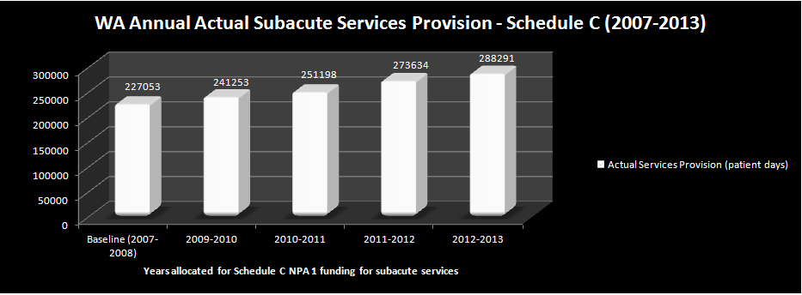
Figure 1: Annual actual subacute care services provision from baseline (2007/2008) to the end of Schedule C NPA1 funding (2012/2013), measured in patient days.

Overall, WA has demonstrated a consistent increase in the number of actual subacute services provision measured in patient days, across the years that Schedule C received NPA1Commonwealth funding from 2009 to 2013.

These services were provided across the four domains of subacute care and include: Rehabilitation, Geriatric Evaluation and Management, Palliative Care and Psycho-Geriatric services.

- National Partnership Agreement Hospital and Health Workforce Reform, Schedule C NPA1 Subacute Growth for WA
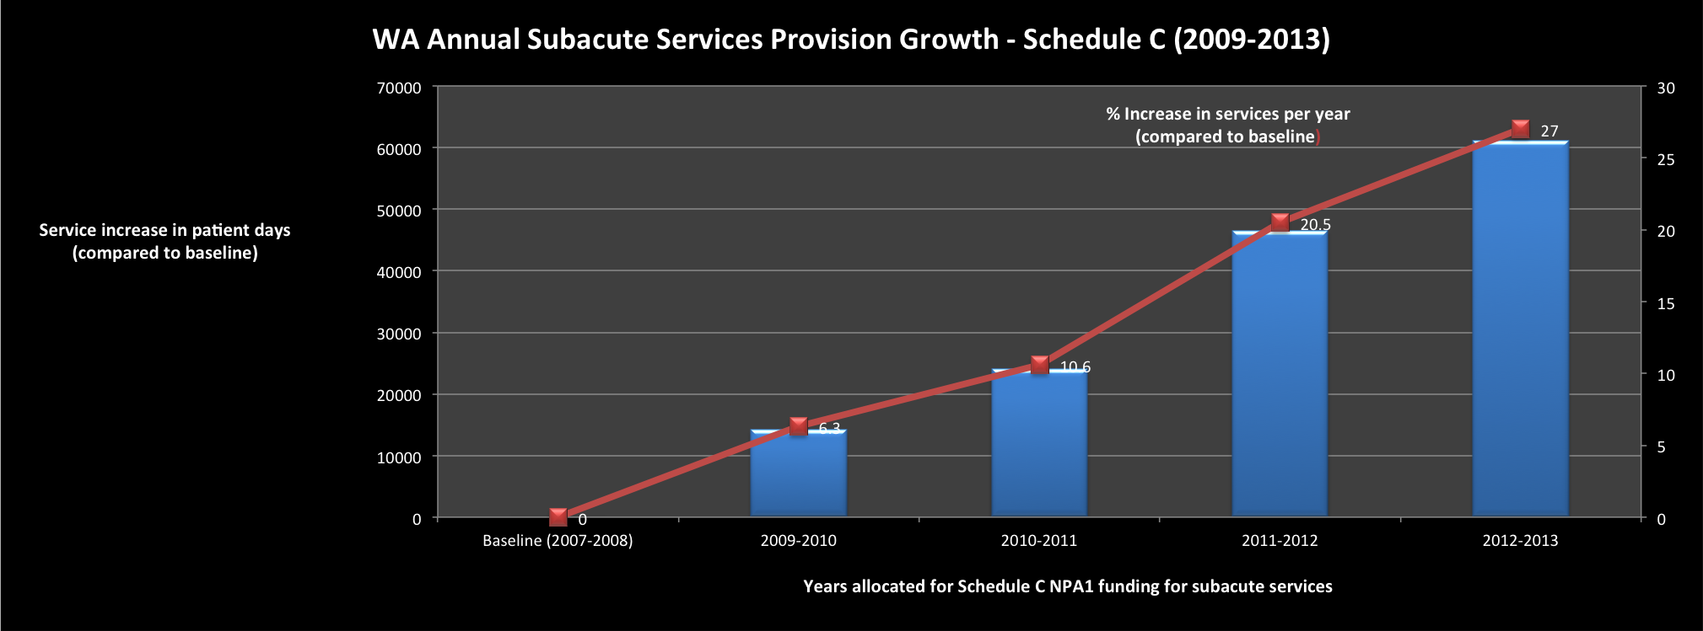
Figure 2: Annual growth in WA subacute care service provision compared to baseline (2007/2008) over the period 2009-2013, measured in patient days; and corresponding percentage increase in subacute care activity compared to baseline (2007/2008)

Over the period 2009-2013, WA demonstrated consistent increases in subacute care service provision as measured by the percentage increase in services per year when compared to the baseline activity level of services provided in 2007/2008 (measured in patient days). At the end of the final year of Schedule C NPA 1 funding (2012- 2013), WA demonstrated an overall growth in subacute care activity of 27% compared to the baseline year of 2007-2008.

- National Partnership Agreement Hospital and Health Workforce Reform, Schedule C NPA1 Subacute Growth for WA
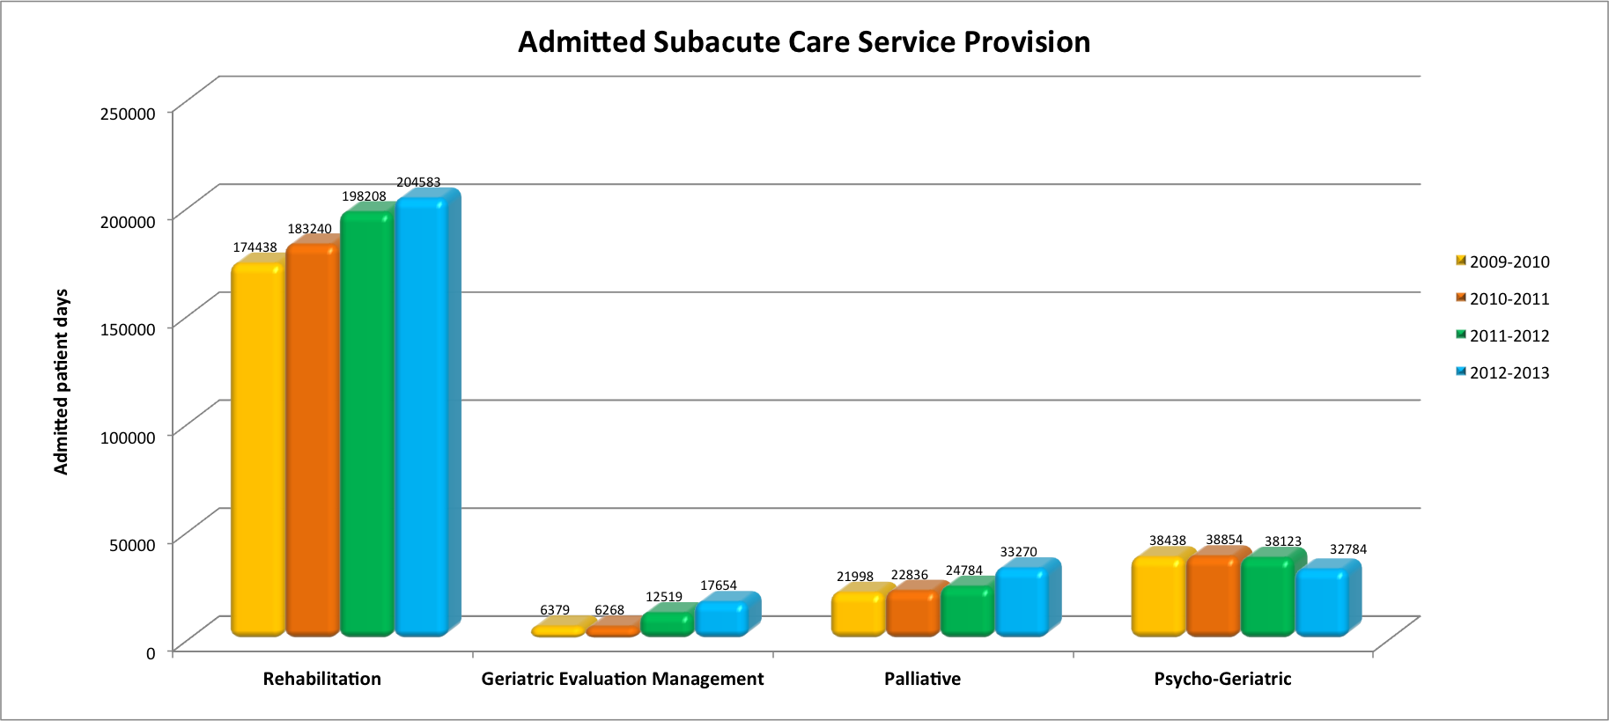
Figure 3: WA annual subacute care services provision for ADMITTED services for the period 2009-2013, measured in patient days across the four domains comprising subacute care services.

WA has demonstrated consistent growth in the provision of admitted subacute care services across all four domains as measured in patient days, with the exception of Psycho-Geriatric services where a slight drop in service provision was noted from 2011 to 2013.
- National Partnership Agreement Hospital and Health Workforce Reform, Schedule C NPA1 Subacute Growth for WA
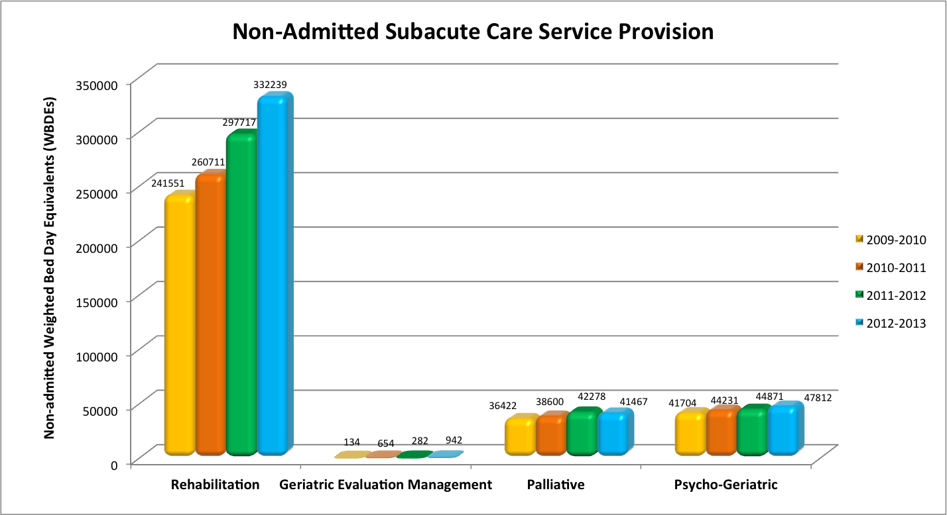
Figure 4: WA annual subacute care services provision for NON-ADMITTED services for the period 2009-2013, measured in weighted bed day equivalents (WBDEs) across the four subacute care services domains.
WA demonstrated growth in the provision of non-admitted subacute care services across all four domains combined as measured in weighted bed day equivalents (WBDEs).
On a domain by domain basis, the palliative care domain recorded a slight decrease in service provision in 2013 compared to the previous year of 2011-2012. Service provision in the Geriatric Evaluation and Management domain also recorded a decrease in 2011/2012.
However, Geriatric Evaluation and Management service provision exceeded all previous years in the final year of funding of 2012/2013.
- National Partnership Agreement Hospital and Health Workforce Reform, Schedule C NPA1 Subacute Growth for WA
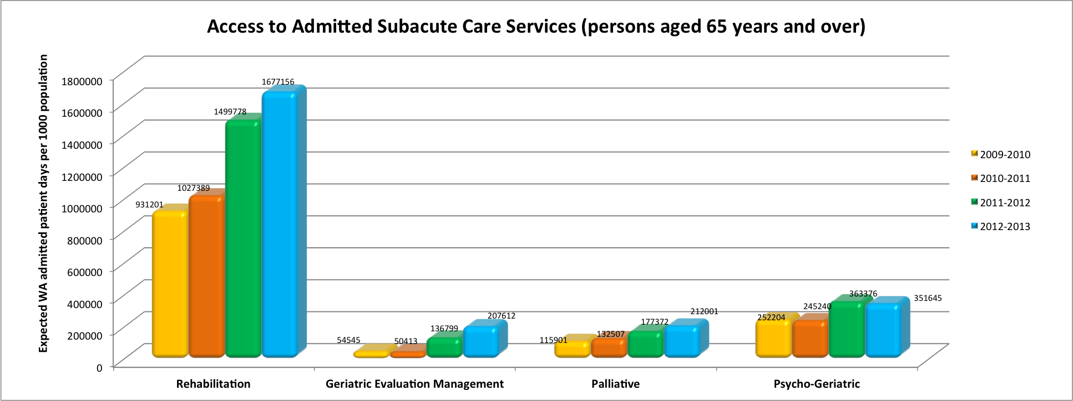
Figure 5: Annual access to admitted subacute care services for all persons aged 65 years and over for the period 2009 – 2013, measured in expected admitted patient days per 1000 for the WA population, across the four subacute care domains.

For persons aged 65 years and older, WA successfully demonstrated consistent and marked increases in access to admitted subacute care services across the four domains per 1000 population over the period 2009-2013.

Access to admitted subacute Psycho-Geriatric services decreased slightly from previous years in 2010/2011 and 2012/2013. However, overall a significant increase in access to Psycho-Geriatric services was noted from baseline to 2012/2013.

*Footnote: Definition of “expected” admitted patient days per 1000 population:
Actual number of patient days for WA /expected number of patient days by age group standardised to Australian national population by age groups.

Additional Notes - Performance Indicator Collection Template, Western Australia, 2012/13:
- Age standardised death rates enable the comparison of death rates between populations with different age structures by relating them to a standard population.
- The current Australian Bureau of Statistics standard population is all persons in the Australian population at 30 June 2001.
- Standardised death rates (SDRs) are expressed per 100,000 persons. SDRs in this table have been calculated using the direct method, age standardised by 5 year age group to 95 years and over.
Rates calculated using the direct method are not comparable to rates calculated using the indirect method.

- National Partnership Agreement Hospital and Health Workforce Reform, Schedule C NPA1 Subacute Growth for WA
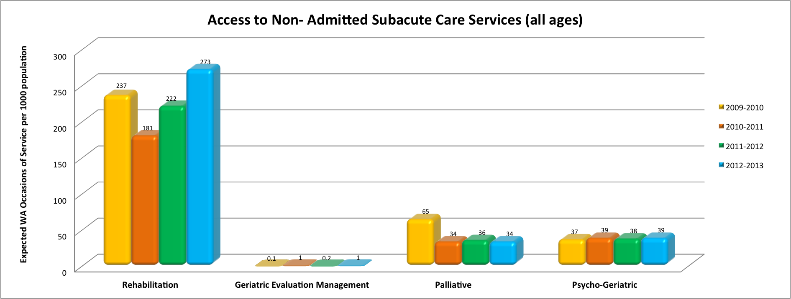
Figure 6: Annual access to non-admitted subacute care services for all over the period 2009-2013, measured in expected occasions of service per 1000 for the WA population, across the four subacute care services domains.

While a drop in access to non-admitted rehabilitation services was recorded in 2010-2011, an increase in access was demonstrated in the succeeding two-year period of Schedule C funding.

Access to non-admitted Palliative Care services dropped by almost half compared with the first year of Schedule C NPA1 funding in 2009-2010.

Access to non-admitted Psycho-Geriatric services remained consistent across all four years. Geriatric Evaluation and Management fluctuated for each alternate year of funding with an increase and decrease in access of 90% and 80% respectively, from the previous year.

*Footnote: Definition of “expected occasions of services” per 1000 of population:
“Actual number of occasions of service for WA /expected number of occasions of service by age group standardised to Australian national population by age groups”

Additional Notes - Performance Indicator Collection Template, Western Australia, 2012/13:
- Age standardised death rates enable the comparison of death rates between populations with different age structures by relating them to a standard population.
- The current Australian Bureau of Statistics standard population is all persons in the Australian population at 30 June 2001.
- Standardised death rates (SDRs) are expressed per 100,000 persons. SDRs in this table have been calculated using the direct method, age standardised by 5 year age group to 95 years and over.
Rates calculated using the direct method are not comparable to rates calculated using the indirect method.

- National Partnership Agreement Hospital and Health Workforce Reform, Schedule C NPA1 Subacute Growth for WA
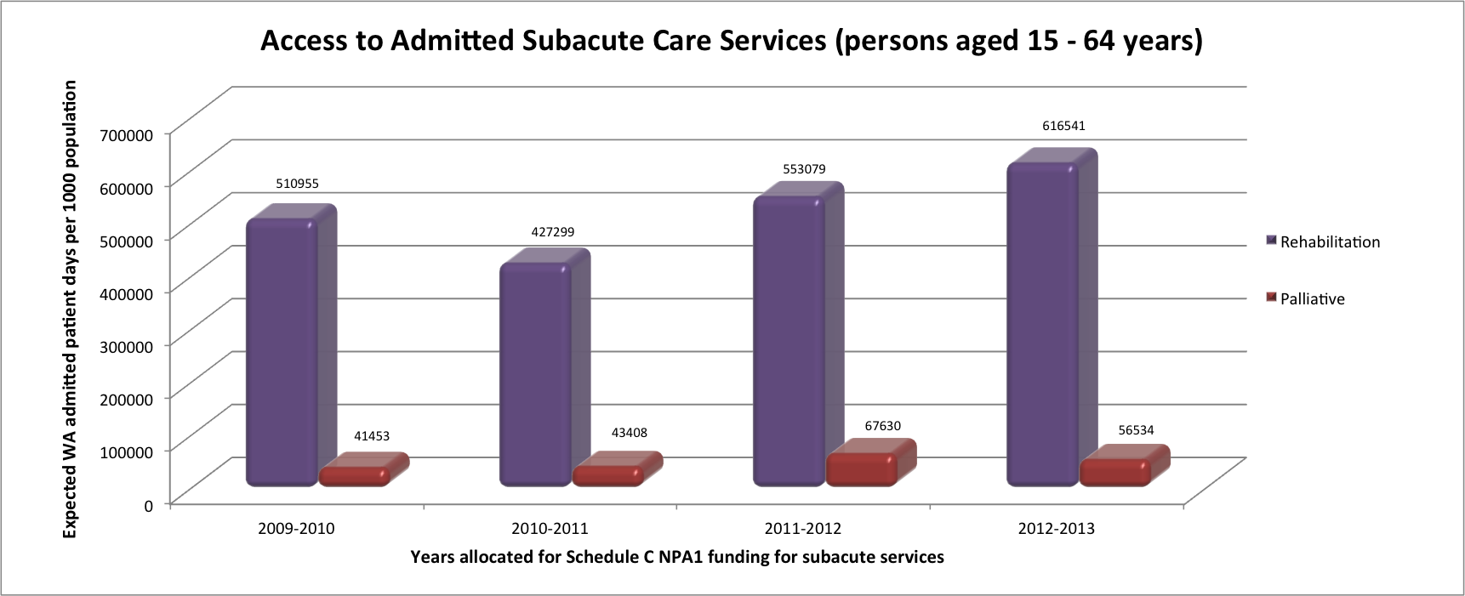
Figure 7: Annual access to admitted subacute care services for all persons aged 15 years to 64 years over the period 2009-2013, measured in expected admitted patient days per 1000 for the WA population, across rehabilitation and palliative subacute care services.

WA has demonstrated an overall increase in access to admitted Rehabilitation services amongst persons aged 15 to 64 years as measured in admitted patient days with the exception of a 16.4% decrease in access in the year 2010/2011.

Palliative Care services demonstrated an overall increasing trend in access to services with the exception of a slight decrease in access to admitted patients days by 16.4% for the final year of funding (2012/2013).

Additional Notes - Performance Indicator Collection Template, Western Australia, 2012/13:
- Age standardised death rates enable the comparison of death rates between populations with different age structures by relating them to a standard population.
- The current Australian Bureau of Statistics standard population is all persons in the Australian population at 30 June 2001.
- Standardised death rates (SDRs) are expressed per 100,000 persons. SDRs in this table have been calculated using the direct method, age standardised by 5 year age group to 95 years and over.
- Rates calculated using the direct method are not comparable to rates calculated using the indirect method.

- National Partnership Agreement Hospital and Health Workforce Reform, Schedule C NPA1 Subacute Growth for WA
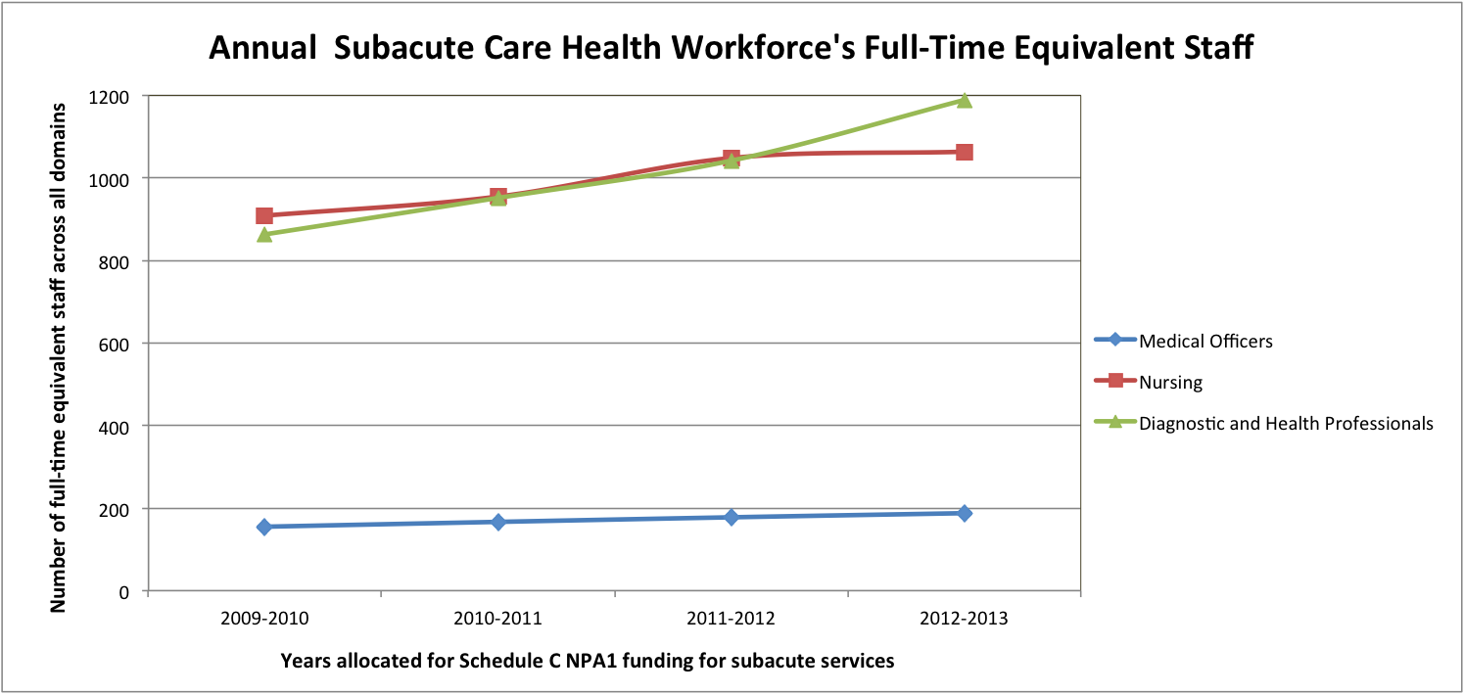
Figure 8: WA subacute care health workforce full-time equivalent (FTE) staff across the four subacute care domains for the period 2009-2013

On an annual basis, the subacute care health workforce showed consistent increases in the number of full-time equivalent staff across the four domains of subacute care over the four-year period of Schedule C funding.

The number of full-time equivalents was significantly higher for diagnostic, allied health professionals and nursing staff compared to medical officers. The largest increase in the number of full-time equivalent staff across all domains was evident amongst diagnostic and allied health professionals’ staff over the four-year period of Schedule C funding.

Additional Notes - Performance Indicator Collection Template, Western Australia, 2012/13:
- Workforce is the calculated number of full-time equivalent (FTE) staff. FTE measures the number of standard-hour workloads worked.
- A medical officer is a medical practitioner employed as a primary care practitioner, hospital non-specialist, specialist or specialist-in-training in a clinical or non-clinical role (METeOR 270722, Codes A01 – A06).
- Nursing workforce: registered or enrolled nurses employed in nursing or midwifery in a clinical or non-clinical role (METeOR 270722, Codes C01 – C12, C98 and C99).
- Diagnostic and health professionals are qualified staff (other than qualified medical and nursing staff) engaged in duties of a diagnostic, professional or technical nature (but also including diagnostic and health professionals whose duties are primarily or partly of an administrative nature), including all allied health professionals. (METeOR 270495, Guide for use).
- Designated services and programs includes admitted and non-admitted care across all four domains of subacute care.
  - Non-admitted care covers hospital outpatients, hospital outreach and community-based services.
  - Non-admitted and admitted care includes publicly contracted services provided by private hospitals and non-government community organisations.

- National Partnership Agreement Hospital and Health Workforce Reform, Schedule C NPA1 Subacute Growth for WA
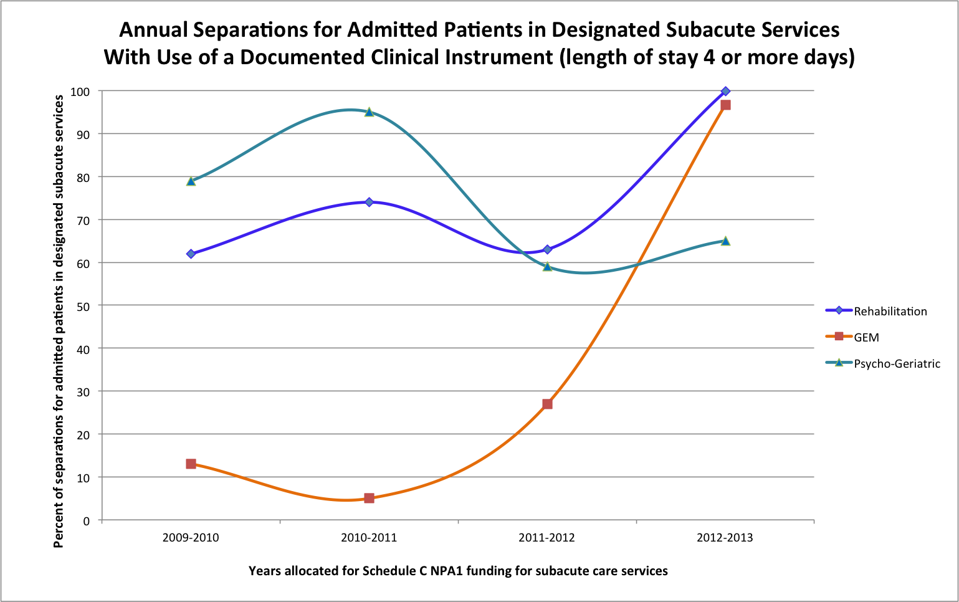
Figure 9: Annual percentage of admitted patient subacute care separations with documented use of a clinical instrument and a length of stay of four or more days, over the period 2009 – 2013

WA has successfully demonstrated an increase in the percentage of annual separations for admitted rehabilitation and GEM patients with a length of stay of four days or longer and have documented evidence of the use of a clinical instrument.

Additional Notes - Performance Indicator Collection Template, Western Australia, 2012/13:
- Separation - the process by which an episode of care for an admitted patient ceases. A separation may be formal or statistical (METeOR 327268).
- Standardised clinical assessment instrument - a recognised, validated, rigorous, reliable, evidenced based tool used to measure patient outcomes
- That is clinically relevant to each care type.
- Designated subacute care services include publicly contracted services provided by private hospitals and non-government community organisations.

- National Partnership Agreement Hospital and Health Workforce Reform, Schedule C NPA1 Subacute Growth for WA
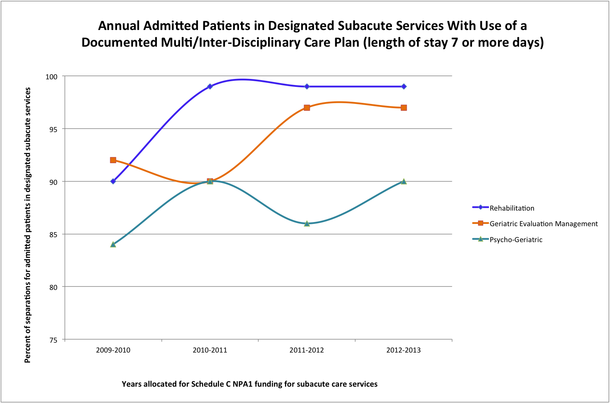
Figure 10: Annual percentage of admitted subacute care patients in designated subacute with documented use of a multidisciplinary and/or interdisciplinary care plan within a seven day timeframe and a length of stay of seven or more days over the period 2009-2013.
WA has successfully demonstrated an overall increase in percentage rates of annual subacute care admitted separations in the domains of Rehabilitation, Geriatric Evaluation and Management and Psycho-Geriatric services with a documented multi-disciplinary or inter-disciplinary care plan for those patients with a length of stay of seven days or longer.

Additional Notes - Performance Indicator Collection Template, Western Australia, 2012/13:
- Separation - the process by which an episode of care for an admitted patient ceases. A separation may be formal or statistical (METeOR 327268).
- Designated subacute care services include publicly contracted services provided by private hospitals and non-government community organisations.
- Timely means within 7 days of initial patient admission or referral.
- Any care plan commenced within the patient stay is eligible for inclusion.
- Interdisciplinary care is assessment and/or treatment services provided jointly by a team that consists of a number of health care professionals who are members of different disciplines dedicated to the ongoing and integrated care of one patient, set of patients or clinical condition. It also requires access to other disciplines for consultation and referral as required and a mechanism for ongoing interdisciplinary review.
- Multidisciplinary care is assessment and/or treatment services provided by a group of health care professionals who are members of different disciplines working together to deliver comprehensive patient care.
- Multi-disciplinary/interdisciplinary plan (METeOR 270174. Guide for use):
  - Rehabilitation, Geriatric Evaluation and Management and Psycho-Geriatric care – a management plan which includes negotiated goals and indicative time frames which are evaluated by periodic assessment;
  - Palliative care – a management plan covering the physical, psychological, emotional and spiritual needs of the patient.

Notes – Growth Activity and Performance Indicator Collection Template, Western Australia, 2012/13: The following notes apply to all subsequent figures. Additional notes are mentioned where they specifically apply to certain figures.

- All counts were prepared using the latest data available.
- All figures prepared using WA wide subacute data that is sourced from patient-level electronic records.
- Admitted data were sourced from the WA Health Hospital Morbidity Data Collection (Coded Data Extract).
- The WA methods used for 2012/13 reporting are consistent with those used to produce the 2007/08 baseline counts (that were revised in 2011).
- In WA, mental health services are provided under three programme streams: Child and Adolescent Mental Health Services, Adult and Older Adults.
- The Non-admitted count of activity excluded public patients treated at private hospitals under contractual arrangements.

Definitions

Subacute care
- Rehabilitation, palliative care, geriatric evaluation and management and psychogeriatric care, as defined in the most recent version
of the National Health Data Dictionary.

Admitted Care
- Patient days – the total number of days for all patients who were admitted for an episode of care and who separated during a
specified reference period (METeOR 270045).
- Hospital-in-the-home (HITH) – provision of care to hospital admitted patients in their place of residence as a substitute for hospital
accommodation. Place of residence may be permanent or temporary (METeOR 327308).
- Hospital based – admitted subacute care services provided in acute, non-acute and subacute hospitals or same-day establishments
or through Hospital-in-the-home (HITH) or Rehabilitation-in-the-home (RITH) care.
- Rehabilitation-in-the-home (RITH) – provision of care to hospital admitted patients in their place of residence as a substitute for hospital
accommodation. Place of residence may be permanent or temporary. Please note that from 1 July 2013, RITH services are classified as non-admitted.

Non-admitted Care
- Occasions of service (OOS) – the number of occasions of examination, consultation, treatment or other service provided to a patient (METeOR 291061)
- Group sessions – care or assistance simultaneously being provided to more than one person (METeOR 294406), either as an occasion of service or episode.
- Centre based – subacute care services provided in non-admitted settings including hospital outpatient clinics and hospital outreach and hospital-auspiced community health facilities.
- Home based – subacute care services provided to non-admitted patients in their place of residence through a hospital outpatient,
hospital outreach or hospital-auspiced community health program.
- Episode of care - A period of health care with a defined start and end date (METeOR 268978).

Weighted Bed Day Equivalents (WBE)
- The WBE is the ratio of the admitted bed day cost to the non-admitted count cost.

